Atlanta Youth Dressage Challenge
Jump Sponsorship Agreement
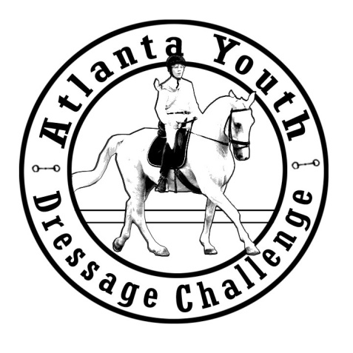
The purpose of this endeavor it to bring back cross country to the Georgia International Horse Park. While most cross country courses are held on private property owned by horse people involved in our sport of Eventing, the GIHP is government owned and public property maintained by landscaping crew and event managers that know nothing about our sport or horses. This requires a paradigm shift in working with them and managed expectation that starts with the fact that AYDC must build our own jumps. We have this beautiful land just sitting there, along with a high demand for 3-phase competition, but we have a lot of work to do. After our trial run of hosting a 3-phase in February using derby style fences mixed with elements of the old XC course, the Horse Park and AYDC have agreed that only portable jumps must be used and taken down after each show but may be stored outside at the Park. This is great news indeed. We will start with building Beg Nov and Novice XC fences on skids made by a professional jump builder. Our goal is to make our June show a 3-phase, then Fall of 2017 kick off a winter schooling series. Therefore, we have taken this initiative to have the following Sponsorship Requests:
Gold Medal $500: We will permanently name the fence we have built after your farm or business name. Regardless where it goes on course, it will be your fence. Named jumps will be “Featured” in prize list language and other promotional material.
Silver Medal $250: Shared names permanently, and as above.
Bronze Medal $100 or other amount: Listed with Sponsors and announced at the current/next show. (Used towards cost or water or other fill in materials).
Additionally, AYDC pledges to provide updates with photos and other news of course development (as fences get built). Have a jump already made you’re willing to donate? Great news as well!
Name: ______________________________ Business or Farm Name: ____________________________
Email Address:________________________ Phone: _________________________________________
Level of Sponsorship:____________________________________________________________________

AYDC: Liz Molloy 6715 Pirkle Dr., Cumming, GA 30028
AYDC THANKS ALL our Sponsors as we enter our now 3rd year of the
Horse Show Series at the Horse Park.

