During a game, you may have seen a second ball mistakenly thrown or kicked into the field, possibly from another field nearby. If this happens, the referee will stop play, remove the second ball, and restart the game with a dropped ball. What’s a dropped ball?

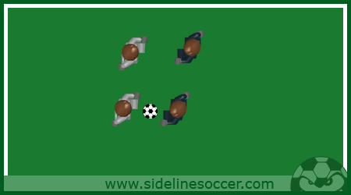

If, while the ball is in play, the referee must stop play temporarily, the match is restarted with a dropped ball.

One player from each team is needed for the dropped ball. The referee drops the ball, in between the two players, at the place where it was located when play was stopped. As soon as the ball touches the ground, both players may try to gain possession of the ball by passing it to a teammate nearby.

If the ball is touched by a player before it touches the ground, the ball must be dropped again. If the ball leaves the field of play before a player touches the ball, the ball must be dropped again.

Another common use of a dropped ball is when a referee needs to stop play due to a player being injured. Your opponent is in possession of the ball but your teammate is on the ground injured. The referee makes the decision that your teammate needs attention and stops play. Once your teammate has been attended to, the referee resumes play using a dropped ball at the place where it was located when play was stopped.

Under the above circumstances, it shows great sportsmanship on your part if you tell the opponent that you will kick the ball back to them since they had possession of the ball at the time play was stopped.