Travels with Anzie – Cadaques and Dali
March 2020
We’re in Dali country. He’s the local hero. One km. outside of Cadaques, in Port Lligat, lies his house where he lived with his wife, Gala, for almost 30 years. Ten miles west, in Fiqueres, is the Dali Museum which houses a most amazing collection of his creations.
But Dali is by no means the only reason to visit this area; thus the reason for this journal. 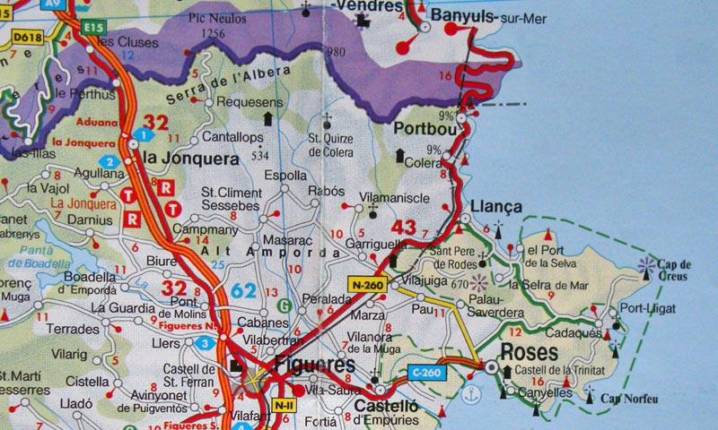

Cadaques is located on a peninsula on the Mediterranean only 30 miles from the border with France. I can see why so many artists hung out here. The seaside and the countryside just beg to be painted.
Some good restaurants: We like La Gritta. Across the street from the beach, they offer an ever changing menu of gourmet plates at non-gourmet prices. Our landlady recommends La Maritime Bar. Located on the beach, we found it to be a bit pricey.
A good walk that Rick Steves mentions in his book on Barcelona includes the Casino, a bit uphill from the beach, and the old Jewish Quarter, now the site of art galleries.
Not to be missed, about 4 miles north lies Cap Creus, a truly amazing site, both geographically and geologically. This rocky peninsula juts out into the sea with photo-worthy scenes on all sides. One finds quirky zoomorphic and anthropomorphic rock formations throughout the area with names like Camel, Eagle, Turtle. The rock is truly noteworthy. It’s full of holes, like Swiss cheese. It looks as if, when it was first formed, gaseous bubbles were emitted. It appears surreal. You’ll find it in Dali’s paintings.
On one of the points a plaque memorializes the site of a former Club Med, which closed in 2008 and was virtually effaced in 2010. Our Anzie went there in 1973 on R&R during her Peace Corps days.
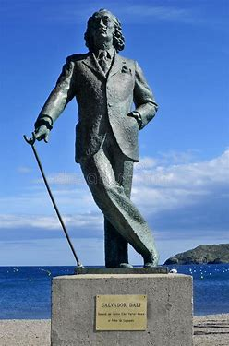
Back to Dali. He bought his house in Port Lligat in 1930 and lived there until Gala’s death in 1982. Originally it was a simple fisherman’s shack onto which he added over the years until it became a sprawling, multi-level mansion. It’s filled with kookie “objets”: a stuffed upright polar bear, Dali’s iconic three ft. high white egg, A Mae West giant lips sofa, a swimming pool shaped like a penis, the 20x10 ft. sculpture entitled “Christ of the Garbage” made of junk, including the remains of a wooden rowboat.
There’s also a famous painting of a bare-breasted Gala. Our guide intimated that Gala, a Russian, was known to have lovers, with Dali’s consent, and that Dali was, perhaps, gay.
We spent only three days here. It’s a good base of operations to explore this northeast portion of Spain. So, pack your suitcase, and get over here!
More photos of Cadeques https://photos.app.goo.gl/aNcXHtGCpGmqA76z8
Hasta la proxima,
Chuck & Anzie

