RSAI Position Paper: Adequate Education Funding 2020
http://www.rsaia.org/legislative.html
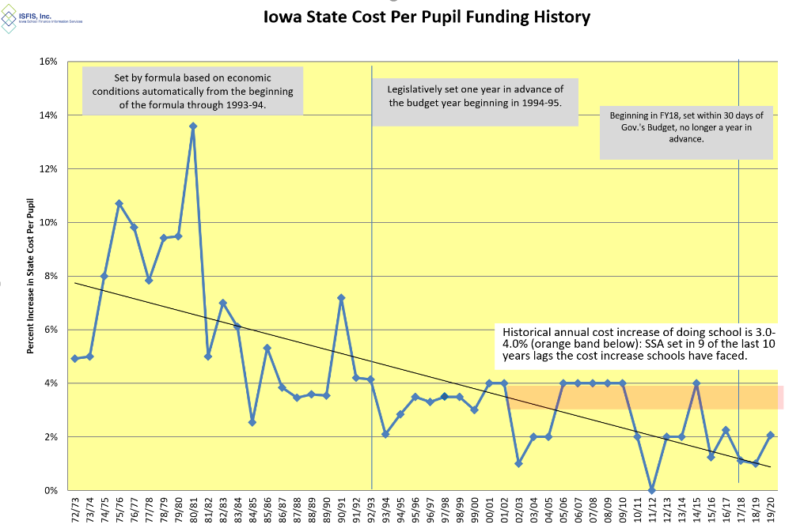
There is a cumulative impact to low per pupil funding increases in Iowa over many years. This chart shows the historical percentage increase in Iowa’s state cost per pupil, previously called Allowable Growth, now State Supplemental Assistance, since the funding formula began in 1972-73:
Current reality: Annual cost increases have not been enough to pay for staff salaries sufficient to compete with the private sector, employee benefits, and all of the other costs of operating schools and meeting student needs. Low funding impacts the weightings, or multipliers, assigned to students with special education needs, English-language learner supports, college credit courses and preschool.
The funding percentage is also applied to Teacher Salary, Professional Development, Teacher Leadership and Compensation (TLC) and the new Transportation Supplements. Although the transportation funds are for any general fund purpose, the other expenditures are strictly regulated for specific purposes. AEA special education and school improvement is also dependent on an adequate increase in the per pupil cost. Unfunded mandates from the state and federal level are paid from the per pupil amount. When the costs of doing the business of school increase more than funding, program and staff reductions follow. Declining enrollment requires even further reduction.
Benchmarks/Economic Measures for Comparison: When comparing the state cost per pupil to economic benchmarks and other states, Iowa school funding falls short. For example:
- The Gross Domestic Product (GDP) for Iowa grew 20% controlling for inflation, 2011 to 2017, compared to the state cost per pupil which grew 14% without controlling for inflation (means the gap is even larger.) https://www.legis.iowa.gov/docs/publications/FTNO/966760.pdf
- Expressing the state cost per pupil as a percentage of one billion GDP shows a disturbing trend. In the 1990s, the SCPP ranged between 52-44% of one billion GDP. In the 2000s, the SCPP ranged from 45-37% of one billion GDP. Since 2010, the SCPP has ranged from 37-34% of one billion GDP; the last 4 years show the lowest comparison in the formula’s history.
- Iowa Per Capita Personal Income increased 31.5%, 2010-2018 https://fred.stlouisfed.org
- Historical Real Median Family Income for Iowa (controlling for inflation) increased by $6,440 or 9.8%, 2010-2017. https://www.deptofnumbers.com/income/iowa/

Recent Iowa Investments in Education: Some have touted the investment in elementary and secondary education of $864 million since 2012, which is a 35% increase in state funding. Some additional context explains how school leaders understand this statistic:
State funding did increase by $864 million over those 8 years. However, $90 million of that was state money that offset reductions in property taxes (see HF 2230 fiscal note 2018); $159 million was the Teacher Leadership Program; $86 million paid for new teachers and classrooms for 13,802 new students (enrollment data from DE Education Statistics web site https://educateiowa.gov/education-statistics). Although $529 million still sounds like a lot of money, this remaining amount supporting the regular education classroom, over 8 years and divided by student enrollment, translates into 66 cents per student per instructional day.
Other State Comparisons: First, from 2017 US Census data updated May 2019 https://www.census.gov/data/tables/2017/econ/school-finances/secondary-education-finance.html
- Iowa ranks 25th in per pupil public elementary and secondary school system revenue, which is $742 below the national average.
- Iowa ranks 22nd in state sources of revenue, which is $595 higher per pupil than the national average (Iowa’s local taxpayers contribute $1,138 per pupil less than in other states).
- Although Iowa per pupil spending on Salaries for Instruction is $167 above the national average, Iowa per pupil spending on employee benefits (pension and health insurance, etc.) is $400 per pupil below the national average. Iowa’s total instructional spending is $458 below the national average. Iowa per pupil spending on School Administration is $26 below the national average.
A true apples-to-apples comparison is found if you consider what percent of total state resources are spent on education. NASBO (National Association of State Budget Officers) State Expenditure Report analyzes all state expenditures:
- In FY 2018, Iowa’s education expenditures were 16.9% of total state expenditures. Plains states averaged 20.5%. All states averaged 19.6%.
- Iowa ranks compared to all 50 states: FY15 Iowa ranked 33rd. FY16 Iowa ranked 36th. FY17 Iowa ranked 34th. FY18 Iowa ranked 32nd.
- RSAI calculates it would take an additional $612.4 million for Iowa to reach the national average of 19.6% which is $1,194 per pupil.
Impact: Iowa has seen slight growth in NAEP scores despite significant growth in poverty and ELL students. Iowa continues to rank first in the nation in graduation, with over 91% of our students graduating with their class in four years. Schools are committed to school improvement efforts, such as TLC, early literacy and STEM initiatives. More students are taking higher level courses and achieving college credit while in high school. These efforts will be compromised if the basic foundation of school funding is not sustained. There are not enough qualified applicants to fill jobs, generally indicating that the profession of teaching is being outpaced in the marketplace. Class sizes are going up. Programs are being eliminated. Districts are offering fewer extracurricular and fine arts opportunities for students, especially in middle school. SSA is the life-blood of rural schools. Declining enrollment combined with low SSA means more rural schools will have to consolidate or face closure by the state.
Adequate School Resources: RSAI supports adequate base funding. The increased per pupil cost known as SSA is especially critical to rural students due to distance from school/opportunities, economies of scale, mandates, the need for AEA support, and the ability to attract and retain staff. Rural schools depend on an investment of meaningful new resources to prepare students for a successful future. The rate of increase in SSA should be no lower than anticipated growth in state revenue (adjusted for legislated tax cuts), should keep up with other economic factors such as personal income or state gross domestic product over the long term, should maintain a balance of state and local property taxes, provide predictability, and be set timely to assure adequate notice for budget planning and staffing. The SSA rate for the 2020-21 school year should be set no lower than 3.75%, if the revenue adjustment controlling for tax cuts is lower than 3.75%.
Margaret Buckton, RSAI Professional Advocate margaret@iowaschoolfinance.com, (515) 251-5970

