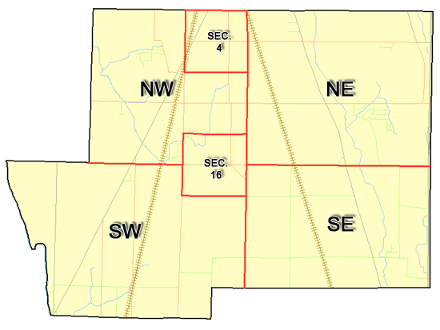 | Pleasant Township  Zoning Commission Minutes  1035 Owens Rd W.  Marion, Ohio 43302
Meeting called by: | Scheduled | Type of meeting: | Regular Monthly
Chairperson: | Mr. Holler | Secretary: | Stephanie Barkley
Timekeeper: |  | Date: Mar 16th, 2023 | Time 7:30 pm
Call to Order by: | Mr. Holler Moment of silence followed by the pledge to the flag.
Roll Call: | Jack Dean, Harry Holler, Tom Leib, Dwight Williams, Joe Thompson, Tyron Canterbury  Stephanie Barkley
Minutes: | Read and approve minutes from previous meeting.  Motion to approve minutes by: Mr. Williams Seconded by Mr. Leib: All approved
Attendees Address Board: Have sign in sheet on desk by door.
Type in attendees and addresses: see attached
.
----- Agenda Topics -----
Business
Zoning Reports: | Zoning Inspector goes over reports and provides copy to board.
Unfinished:
New:
Announcements: | Next meeting will be April 20th ,2023
Adjournment: | Motion to adjourn by: Mr. Williams and seconded by Mr. Thompson, all in favor all approved

Pleasant Township
Zoning Commission Minutes

1035 Owens Rd W.
Marion, Ohio 43302
Business Notes:

 | Discussion:
 | Conclusions:
 | Action items: |  | Minutes signed by: | Date approved:
 | Provide copy of approved minutes to Zoning |  | Chairperson:
 | Inspector. File original in township office. |  | Secretary:
Other Information
Trustees Present: |  | Mr. Schrote
Zoning Inspector: |  | Mr. Baker
Special Guests:

Minutes
The Pleasant Township Zoning Commission met for their regularly scheduled monthly meeting March 16th, 2023 at the Pleasant Township Senior Centre Zoning Commission Board Members were present: Mr. Dean, Mr. Leib, Mr. Thompson, Mr. Williams, Mr. Canterbury and Mr. Holler, and Secretary Miss Barkley and trustee Mr. Schrote and Zoning Inspector Mr. Baker was present.
- Minutes were read from the Feb 16th,2023 regularly scheduled Zoning Commission meeting. There were no corrections to be made. A motion to approve the minutes was made by Mr. Williams and seconded by Mr. Leib. All members present agreed to passage of the minutes.
- Mr. Tom Baker Pleasant Township Zoning Inspector present the report for February. There were no permits in February to report. The nursing home is still making progress on changes through the engineer’s office on lay out on the nursing home. Possibly 1-2 appeals for April.
- The next meeting going to start placing zoning items in sections of the book. There being no additional business for discussion Mr. Williams made motion to adjourn, seconded by Mr. Thompson Board Members in attendance agreed and the meeting was adjourned. The next Board Meeting will be held on April 20th ,2023 at 7:30 PM.

