**Cy-Fair FFA**

**Country Christmas Craft Show**

Frequently Asked Questions - 2018

* All of the funds raise by the Cy-Fair FFA Booster Club will be used to fund programs for our FFA students, as well as single semester scholarships for college bound seniors.
* Preference will be given to Vendors with handmade and hand crafted merchandise.
* Acceptance to the show will be a booth number on a cashed check and/or email notification.
* All Booth spaces are 10x10 unless noted on floor plan. Floor plan is not to scale.
* We reserve the right to refuse registration acceptance to maintain quality of the craft show. We reserve the right to ask a Vendor to leave the show, if deemed necessary at any time, without refund.
* Direct Sale merchandise (Avon, Scentsy, Thirty-One, Tupperware, etc), will be limited to one vendor
* Booth space is assigned on a first come, first serve basis, subject to availability upon receipt of the Craft Show Application and Booth fee. Checks payable to Cy-Fair FFA Booster Club. Returned Check fee is $35.
* Backup Applications: As our show typically sells out each year, the number of booths accepted for certain types of merchandise sold, such as jewelry, ladies fashions, accessories, woodworking, etc. can be limited. Backup applications are accepted on a first come, first serve basis. If merchandise type has been limited, then backup will only be filled if there is a cancellation of that limited type. Backup applications do not need to send in payment.
* If items are not listed on the vendor registration form, you may be asked to remove them at show.
* The building is secured Friday and Saturday nights with paid law enforcement on duty during the night.
* The show is held in a large barn, as a result control over building temperatures are limited and at times beyond control. Large roll up doors may or may not be opened. The back 3 buildings do not have a/c only large, sometimes noisy in ceiling blower fans, please prepare accordingly.
* Vendors are asked to notify craft show coordinators by the Wednesday before the show if they are not able to attend. Failure to notify or No Shows will risk not be allowed to return to the show.
* Vendors are expected to donate to our Silent Auction during check-in. Please have your item(s) ready at that time.
* There are NO REFUNDS.
* Vendors can NOT RESALE THEIR BOOTHS.
* Early Bird Registration
  + 9 am – Noon on First Sunday in December @ Vendor Registration Booth during show.
  + Line up no earlier than 8:45 am. Register for the SAME BOOTH for next year. Booth quantity can be decreased. This is the only way to be guaranteed your same location and size for next year. $10 discount will be applied ($100 for single booth, $200 for double, $90 for outside, etc.)
* Open EB Registration
  + 1:00 pm – 3 pm on First Sunday in December @ Vendor Registration Booth during show.
  + First come first serve, line up no earlier than12:45 pm. Add additional booth space, location changes. New registrations will be accepted.
  + $10 discount will be applied ($100 for single booth, $200 for double, $90 for outside, etc.)
  + Registration will open again on the second Monday in January.
* Open Registration – Starting the second Monday in January to November 1st.
  + Indoor booths are $110 per booth
  + Outdoor booths are $100 per booth
  + After November 1st, prices increase by $20 each, if space is available and application is approved. Applications postmarked after Nov 1 will only be reviewed if needed to fill space after backup applications have been processed.
* The Concrete Lot on the West side of the Center is reserved for Customers on Saturday and Sunday. It may be used at other times for unloading and loading.
* 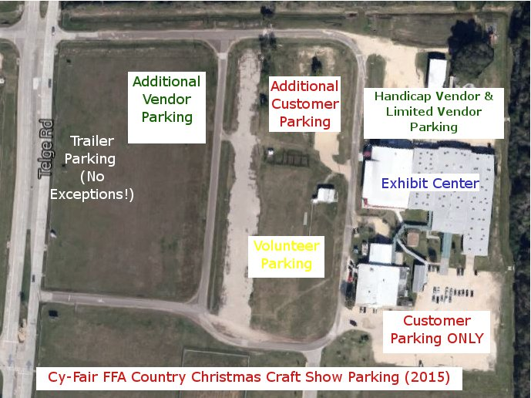Designated Vendor parking is to the East of the Center in the gravel lot and with the Volunteer Parking. Limited Vendor Handicap parking will be provided. No Trailer parking in the gravel lot or on the concrete.
* Trailer Parking is in the grass along the outer road parallel to Telge Road.
* Please leave your booth are Broom Clean by picking up any trash, tied downs, boxes etc. on departure.
* To assure all vendors have a great show, we request that booth tear down activities do not take place until the end of show on Sunday. Failure to comply will risk not be allowed to return to the show.
* Students Volunteers are available to help during the show for Restroom Break, Coffee and Donut orders, Lunch orders. They will also be available after 3 pm on Friday and for tear down on Sunday.
* Limited electricity is available. Vendors must supply their own UL approved extension cords and/or power strips.
* Vendors must supply their own tables, chairs and displays.
* Students Volunteers will be available at the close of the show to load boxed items on to carts and take them to vehicles.  Students are NOT ALLOWED to pack merchandise. Students are not responsible for breakage or damage. Packing up your booth prior to 4 pm and failure to be completely out of the building by 6 pm will risk not be allowed to return to the show in the following years.

**\*ALL VENDORS MUST BE MOVED OUT NO LATER THAN 6:00 P.M. ON SUNDAY EVENING.**