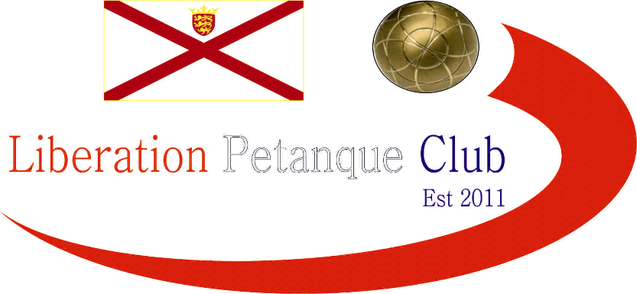
This years Open played at the Weighbridge Garden terrains in glorious sunshine saw 28 of the Islands best players battle it out to become this years champion.
Players were placed in 4 groups of 7 with the top 2 qualifying for the quarter finals which mean’t players could lose 1 or 2 games and still be in with a chance of qualifying, this proved the case with last years champion Chris Romeril who lost his first match against Nathan Wheller who only started playing the sport a month ago but despite this won his next 5 matches to finish second in group 2 but only by 1 point over Alan Oliveira after he lost his last match to group winner Matt Pinel.
Group 1 also went down to the last match with Carrefour Petanque club President beating Liberation chairman Toby Northern to top the group with Toby finishing runner up on points difference over Colin Vibert.
Group 3 again went down to the last match but with both Ross Payne and Alan Lahiffe already qualifying for the quarter finals after both won all of their first 5 matches but Ross didn’t let up winning convincingly 13-1 to top the Group.
Group 4, was probably the toughest of all but current Liberation Singles league champion Matt Ryan again showed why he is regarded as one of the best in the Island by topping the Group with another Liberation player Keith Pinel finishing runner up.
This mean’t the Liberation clubs players had 6 of the 8 quarter final places.
Matt Ryan (Liberation PC) v Chris Romeril (Liberation PC)
Ross Payne (Liberation PC) v Keith Pinel (Liberation PC)
Michel Morel (Carrefour PC) v Alan Lahiffe (Independent)
Matt Pinel (Liberation PC) v Toby Northern (Liberation PC)
In probably one of the fastest games in history especially considering the score line saw Toby Northern beat one of the pre-tournament favourites Matt Pinel 13-10 in less than 5 minutes with some excellent placing with the match tied at 10 all placed 3 perfect shots to seal the victory.
Ross Payne the only quarter finalist not to have lost a match in the group stages continued his fine form winning fairly comfortably against Keith Pinel 13-8, Michel Morel a regular in the latter stages of major competitions again sealed a semi-final spot beating Alan Lahiffe.
Matt Ryan was looking for revenge over Chris Romeril after his defeat in last year’s semi-final and kept his fine form going to just seal the win knocking out last year’s winner and 2012 best player.
The Semi Finals
Ross Payne v Matt Ryan
Toby Northern v Michel Morel
At this stage of the competition players knew which terrain they preferred and the toss of a coin could have an impact and this proved the case as Ross Payne won his semi-final with ease over Matt Ryan on the same terrain he’d won his previous 4 games on, this time 13- 4, 2 years in a row Ross has knocked Matt out of the tournament.
Also winning the toss of the coin was Michel Morel and having won 5 in a row on the terrain he choose, including a victory over his semi-final opponent Toby Northern would have been confident of making the final and leading 5-2 and then 7-4 this again looked likely, but Toby had other ideas only losing 1 more point turning the game around to win 13-8 as the Liberation chairman out did his Carrefour counterpart for the first time in a major competition.
This mean’t the final was between Toby Northern and Ross Payne.
These 2 players started playing the sport together 5 years ago and regularly practice together, they will also be playing together as a doubles team in the European Company Sports Games in Prague in June under the banner of the Liberation Petanque club (3 doubles teams in total) and will be Jersey’s only teams representing the Island in any sport in a competition three times the size of the Island Games. This mean’t they knew each other’s games inside and out.
Ross won the toss and again chose the terrain that he won his quarter and semi-final games on and with the terrain proving difficult for Toby, Ross looked to be cruising at 10-4 up knowing none of his previous opponents had got into double figures but Toby came back to 8-11 and 10-12 as he got used to the terrain and only fitting then made it 12 all as the final went down to the very last end, but Ross’s excellent placing sealed his 2nd Singles title in the last 12 months (after winning last years Carrefour Singles tournament) winning every game on the way to a well deserved title. Matt Ryan took 3rd place after beating Michel Morel.
1st Ross Payne (Liberation Petanque Club)
2nd Toby Northern (Liberation Petanque Club)
3rd Matt Ryan (Liberation Petanque Club)
Many thanks to David and Brigitte Ibitson for running the competition on the day, and also Colin Myers for setting up the terrains with help from Alan Oliveira.
Full list of results below.
Group 1
1st Michel Morel 5 wins + 20
2nd Toby Northern 4 wins + 15
3rd Colin Vibert 4 wins + 7
4th Elaine Paisnel 3 wins + 0
5th Brian Harris 2 wins - 6
6th Brigitte Ibitson 2 wins – 7
7th Matthew Buesnel 1 win - 29
Group 2
1st Matt Pinel 5 wins + 26
2nd Chris Romeril 4 wins + 19
3rd Alan Oliveira 4 wins + 18
4th Nathan Wheller 3 wins + 3
5th Craig Kelly 3 wins - 8
6th Lorna Limbrick 1 win – 22
7th Penny Foster 1 win - 36
Group 3
1st Ross Payne 6 wins + 59
2nd Alan Lahiffe 5 wins + 25
3rd Ian Foster 3 wins - 4
4th Brendan Jones 2 wins – 4
5th Colin Myers 2 wins - 20
6th Steve Simpkin 2 wins - 26
7th Andrew Le Breton 1 win - 30
Group 4
1st Matt Ryan 5 wins + 30
2nd Keith Pinel 5 wins + 22
3rd Jake Romeril 4 wins + 13
4th Keith Boleat 3 wins + 5
5th Neil Selby 3 wins + 4
6th Alex Stewart 1 win – 36
7th Brian Corbel 0 wins - 39
Quarter Finals
Matt Ryan (Liberation PC) 13 v 10 Chris Romeril (Liberation PC)
Ross Payne (Liberation PC) 13. v 8. Keith Pinel (Liberation PC)
Michel Morel (Carrefour PC) 13. v 8. Alan Lahiffe (Independent)
Toby Northern (Liberation PC). 13. V. 10. Matt Pinel (Liberation PC)
Semi Finals
Ross Payne 13. v 4. Matt Ryan
Toby Northern 13. v 8. Michel Morel
Final
Ross Payne 13. v 12. Toby Northern
Ross Payne pictured below (left) receiving the trophy from Vice Chairman of the Liberation Petanque Club Colin Myers.

