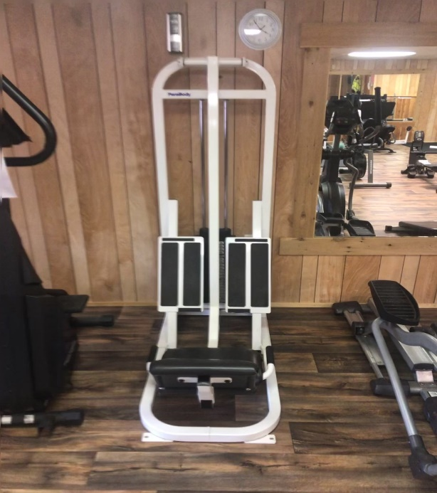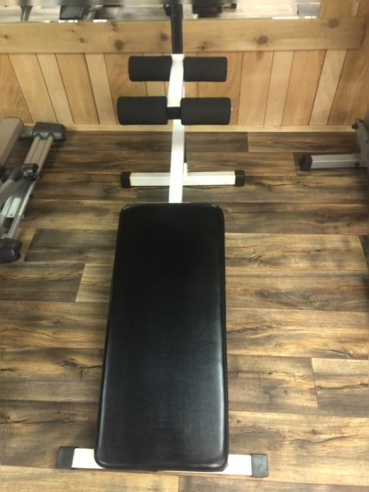
Parabody Leg Press $100 or best offer Sit up bench $25 or best offer
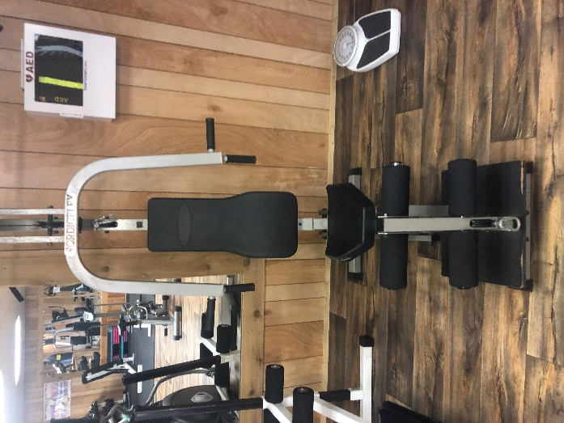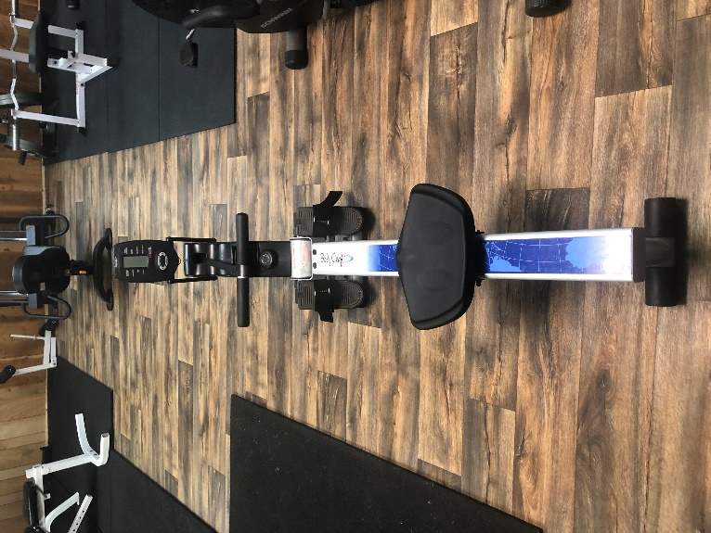
NordaFlex $25 or best offer Body Craft Rowing Machine $25 or best offer
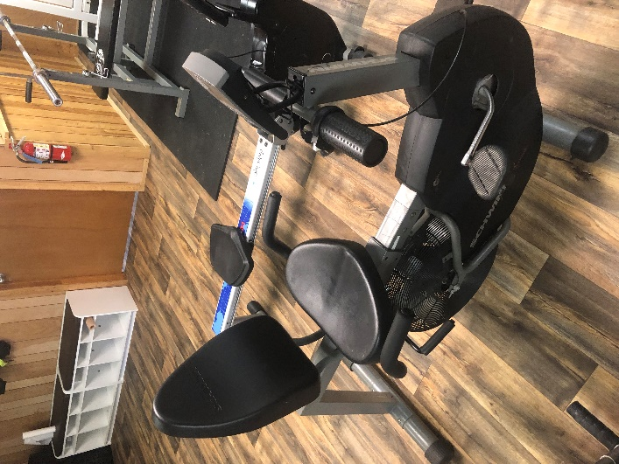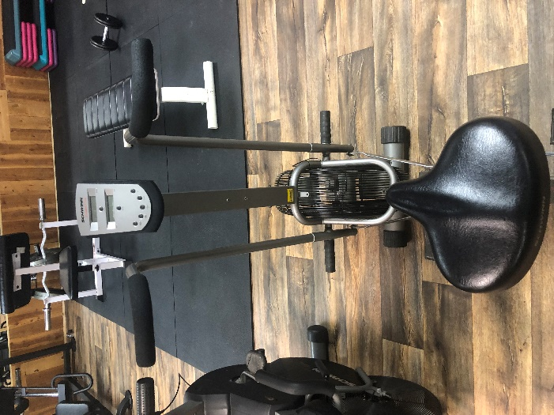
Schwinn backdraft $75 or best offer Schwinn Evolution Comp $75 or best offer
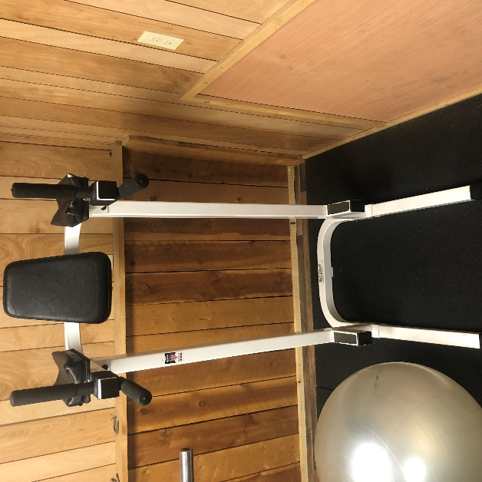
Tough Stuff Ab Machine $50 or best offer

We are upgrading equipment in the gym, these items are for sale. Email or contact the office with your bids, directoroms@ccmepoa.com

