TAURANGA COMMUNITY HOUSING TRUST
  - ANNUAL REPORT
2017

“Enhancing community wellbeing through the provision of quality, appropriate and affordable housing”
Section ONE
Overview 1
TCHT Statement of Strategic Intent 2014 – 2017 2
Chairperson’s Report 3
Managers’ Report 5
Achievements 7
Report –Eastern Bay of Plenty 10
Operational Activity 12
Support Acknowledgment TCHT Trustees and management formally thank TCHT landlords and many supports including: 13
Company Overview 1
Statement of Strategic Intent 2
Chairpersons Report 3
Managers Report 5
Achievements 7
Operation Activity
Healthy Homes 10
Friendly Landlord Programme 11
TCHT Staff 12
Supporters Acknowledgments 13

Section TWO
Non Financial Information:
Auditors Report 1
Entity Information 3
Statement of Service Performance Year Ended 31 December 2016 4
Statement of Service Performance Year Ended 31 December 2015 6
Financial Information:
Statement of Financial Performance 7
Statement of Financial Position 8
Statement of Cash Flow 9
Statement of Accounting Policies 10
Statement of the Performance Report 11

Overview
Tauranga Community Housing Trust (TCHT) was established in December 2003 following a growing concern around the lack of affordable, appropriate housing for disabled people and their families. The issues at the time are still relevant today. TCHT services are targeted at responding to identified housing needs and gaps in the community.
TCHT’s services include the provision of
- Transitional housing
- Affordable rental housing
- Specialist housing services for people with disabilities and chronic health conditions
- Housing Facilitation Service linking people to appropriate housing
- Healthy Homes Scheme
- Friendly Landlord Programme

In its first five years of operation TCHT focused solely on housing single people with a disability and/or and families with a disabled person within the household. In late-2009, the Trust has broadened its criteria to include others in the community who are on low incomes and have a serious housing need.
Issues such as population growth, an undersupply of housing, property and rental price increases and a lack of accessible properties contribute to the demand for more and new affordable housing solutions.
TCHT is and will continue to work creatively with a range of stakeholders to increase its portfolio and develop new models of housing in order to address unmet housing need in the community.

TCHT support and endorse – Community Housing Aotearoa’s - ‘Vison for the Future’

We have a vision of all New Zealanders well-housed, where choices are available across the range of housing that meet the varied needs of any household, at a price they can truly afford, today and tomorrow.
We see a future where mixed-income, mixed tenure communities are the norm, with high quality homes that are warm, dry, easy to take care of, and inexpensive to run and maintain. These are homes that enhance health and well-being, homes we can be proud of, in communities that people feel part of, and where every person can have a stake in their future, whether they rent or own their home

TCHT Statement of Strategic Intent 2014 – 2017
Vision
Mission

To be a recognised provider of quality housing and related services
Enhancing community wellbeing through the provision of quality, appropriate and affordable housing.
Valuesss
- Integrity
- Respect
- Innovation
- Vision
Appropriate, affordable housing is fundamental to the health and wellbeing of individuals, families and communities
Our Beliefs

Strategic Direction
- To grow a diverse, sustainable housing portfolio that achieves positive community outcomes
- To be a dynamic well governed and managed organisation that achieves business excellence
- To provide quality services and operational excellence aligned to our core values and stakeholder needs
- To build and enhance effective external relationships in order to advance our Vision and Mission

Chairperson’s Report
Kia ora tatou
Nga mihi mahana ki a kotou katoa
Warm greetings to all our supporters,
When looking back on the last calendar year, from the Board's perspective it is difficult to decide what have been the high and low points as they all seem to be so intertwined. It is with immense satisfaction that we report that in the week before Christmas, after many delays, our fourteen new accessible and well insulated single bedroom units in Waihi Road Tauranga had new long term tenants move in. This was accomplished thanks to a grant from TECT, as well as again securing long term social loan finance from BayTrust and having an ongoing good relationship with Kiwibank. The feedback has been very satisfying and the staff are to be congratulated on their efforts to make this project happen so smoothly.
TCHT real challenge is that community housing projects are not commercially viable unless there is significant outside contribution to the capital investment. The demand in Tauranga where the population is rapidly growing, cannot be met by current supply, and there is little incentive for commercial developers to increase the supply of more affordable homes.
TCHT along with other providers has a real challenge in trying to change the local culture so that all sectors of the community come to realise that inadequate and unaffordable housing stock is now affecting everyone. This is in terms of the adverse impacts on the health, schooling and general wellbeing of inadequately housed (i.e. technically defined as homeless) families and individuals. When lower income earners cannot afford to live here it affects the availability of suitable workers in turn affecting local productivity. Is our current growth so great when not all the community are enjoying the benefits and the poverty indicators are increasing especially in our young families? We are nearing the reality of over half of our population being dependent on rental accommodation.
TCHT is proud of its achievements in trying to secure satisfactory housing solutions and working in collaboration with other support services and agencies to get the best outcomes. We believe that if an individual or family can secure a place to live, their other challenges/social impacts can then be addressed.
The focus of our work in the eastern Bay of Plenty has been on integrating our tenants in the 79 units that we purchased last year from the District Council into community supports. We thank everyone who has supported the range of actions TCHT has undertaken to manage this change of ownership in the best way possible over our first full financial year.
A recent review found that the Board believed that all their volunteer input and continuing policy and financial reviews were being effective, and they were getting satisfaction from the various successes that we have. Therefore a big thank you to our committed and positive Trustees who contribute such a diverse and practical range of experience.
We benefit from the ongoing active support from our Patron Adrienne von Tunzelmann. She is a great advocate for our work and generously offers her advice on our continual governance improvement efforts. It is an ongoing challenge for Trustees to ensure that they are correctly performing their duties. The Manager in partnership with various working groups and advisers, has reviewed our key documents. We believe that our risk management and health and safety processes in particular, now provides a good base for future best practice operations and monitoring in our organisation.
We could not continue without the support of our local philanthropic funders, various grants, our service contracts and especially the security of the NZ Lotteries grant for operational support. Your trust in TCHT is appreciated. Thank you.
Thank you to all our Trustees, Dylan Barrett Deputy Chair, Russell Hunter Treasurer, Kate Cosgriff, Graham Mallett and Alan Tate. You make the Chair's role at the rudder so much easier when we are all paddling our waka together and know where we are going.
In particular, sincere thanks to our Manager Chris Johnstone for the way in which she leads her team and the practical manner in which they find a way together through the daily challenges that come their way. The Board respects the work that each staff member does and I believe that there is also public appreciation of your efforts in the community.
TCHT have made a lot of progress this year due to internal innovation, determination and capability. However, we operate in a housing sector political and economic environment that has many hurdles and few incentives to strive for our goals. Therefore the score card suggests that with the right environment we could have far more impact.
I repeat my continuing belief that: “It takes a whole community to rear a child and therefore it takes a whole community to find a secure home for them”
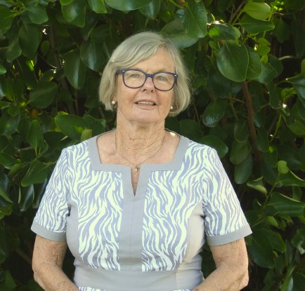
Thank you everyone,

_________________
Jo Gravit
TCHT Chairperson

Managers’ Report
Warm Greetings,
TCHT’s experience throughout 2016 was consistent with other growth regions throughout New Zealand. Poor quality housing stock, an inability of people on low/middle incomes to access decent housing, escalating rents and house prices and an insufficient supply of affordable rentals contributed to unprecedented demand for TCHT’s housing and services. Despite the above and considerable media attention on the housing issues the sale of the HNZC housing stock in Tauranga appeared to dominate much of the governments focus and resources. Unfortunately the announcement of the HNZC portfolio sale marked the cessation of HNZC’s development programme in Tauranga thereby stalling new social housing supply at a time that it was needed the most. This put further pressure on, and competition for, the limited social and affordable housing that was available.
For the first time we noted a marked increase in requests for housing through the winter months. The demand for rentals, emergency and transitional housing elevated as local residents and seasonal workers competed for rental housing.
Two other noteworthy points. We received enquiries from people who have never before required social and or community housing. Historically their house needs have been adequately meet by the private rental sector; however this is no longer an option for many. We noted also a marked increase in the number of people in the 65-85 age range seeking housing. Accordingly much of TCHT’s focus is now on developing new affordable housing solutions for older persons. As the pressure increased so too did the demand for housing related assistance and social services, our own services as well as those in the wider community.
Despite multiple challenges TCHT managed to increase its housing portfolio and met all its major strategic and business targets – please see TCHT Achievements on page 8.
These achievements were only possible because of TCHT’s committed governance and staff team members, some who have been with the organisation of some years now. To meet the increase in service work three new housing services staff were recruited. Coyla Weeber and Trieste Ngawhika joined the Tauranga office and Bryce Sheedy was recruited to lead the developing team in Whakatane.
For the most part TCHT does not receive government funding for its community development, the housing facilitation work or for capital works projects. We only achieve the outcomes and made traction due to the support and ongoing commitment from the generous funders and supporters who backed our work and projects this year. In particular we want to acknowledge the local funder holders, Bay Trust and TECT who provided us with the resources to complete the Waihi Road project. A special mention to Lotteries. The multiyear provides surety for planning and enables us to focus on delivering services and achieving housing outcomes rather than fund raising.
With no sign of the housing shortage abating and further increases projected, much of the focus was and will continue to be on the sourcing new and/or the development of more affordable housing options for those in the community experiencing with serious housing need.
Lastly, a huge thanks to dedicated staff and volunteer team whose focus, energy and ongoing commitment to the organisation enables us to continue to steadily track forward and achieve very positive outcomes for the people we work alongside.

________________
Chris Johnstone
Manager

Achievements
In 2016 TCHT staff housed 184 people. This is a significant achievement in an environment where supply is scarce and the competition for suitable rentals is very high.
A high percentage of those assisted were housed with external housing providers. This was only possible because TCHT staff proactively built sound working relationships with a range of housing providers in the social and private sectors. Working relationships with these landlords involves leasing and or management arrangements, brokerage, and advocacy. These relationships broaden the scope (number, type of location) of housing options available to the people TCHT supports beyond TCHT’s own portfolio. Without TCHT involvement these solutions would not otherwise be available to the people TCHT supports

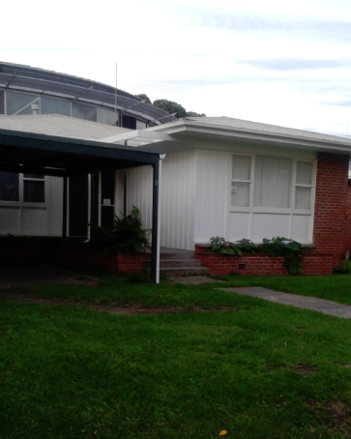
Kakariki and Tara Lodges (TGa)
The Lodges provide medium term accommodation for over fifty single men, women and children thought the year. The Lodges provide a friendly, stable and secure environment for residents to prepare for independent housing. When people move on from the Lodges it is into long term independent tenancies.

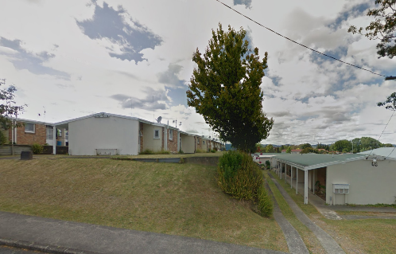
RSA Flats – Management (Tga)
In mid-2016 TCHT took over the management of 31 one bedroom properties in central Tauranga. By the end of the year urgent repairs and maintenance were underway or had been tackled and longer term plans were being developed.

162 Waihi Road (Tauranga)
In late 2015 TCHT signed an agreement to purchase 14 one bedroom fully accessible units in a special housing accord development. The purpose built units were completed in early December, enabling the tenants to move and settle into their new warm rental homes prior to the Xmas holiday break. The development has communal seating situated outside the units, giving residents a place to gather. The tenant’s feedback is that the complex has a ‘real community feel’. They report that their neighbors, all home owners within in the development, are very friendly, and cooperative at times pitching in and helping the TCHT tenants out.
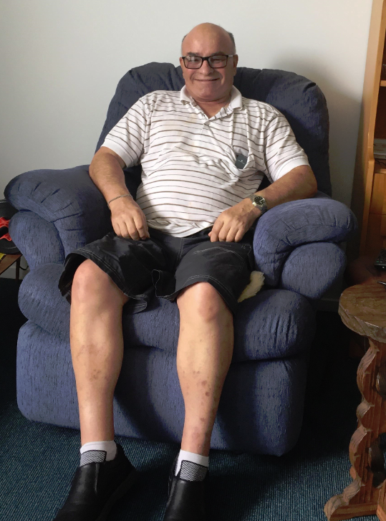
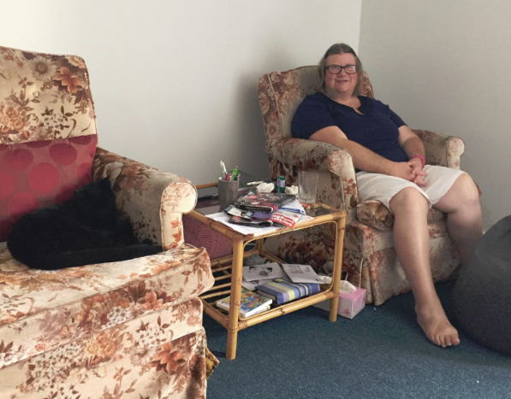
Steve Garett “Very happy, lots of room, easy to walk around.
No problem everything is good!
Thumbs up!

Anne and Silky (cat) “Good, love it, easy to get around and great location as it is not far away for mum to travel and see me”.

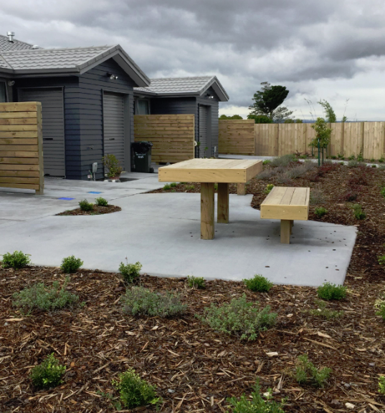
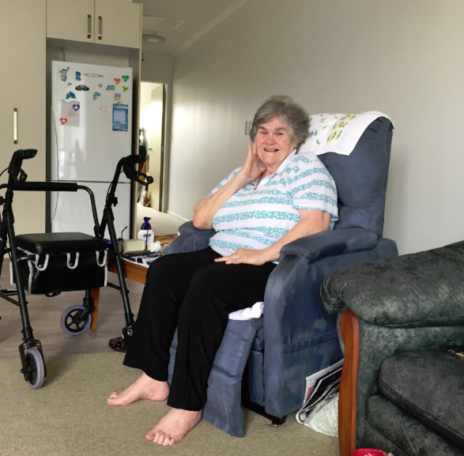
Maureen Thompson “Love it, love it, LOVE IT!! Bedroom and shower lots of room to take my walker in and out. Everyone in the complex and surrounding is so nice and welcoming, sharing produce, it has a good community feel”.

Pensioner Housing Portfolio (EBOP)
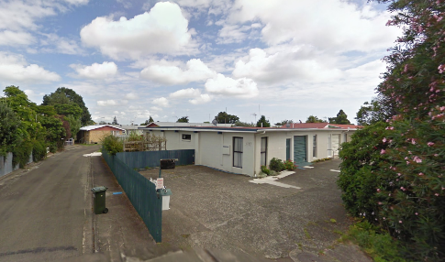
The acquisition of 79 units from Whakatane District Council (WDC) ‘Pensioner Housing Portfolio’ in late 2015 was a major undertaking. Accordingly much of the focus for 2016 was addressing urgent repairs, getting to know the tenants and finding out what their goals for the villages are. Staff also focused on building strong working relationships with key stakeholders in the Whakatane and Murupara communities.
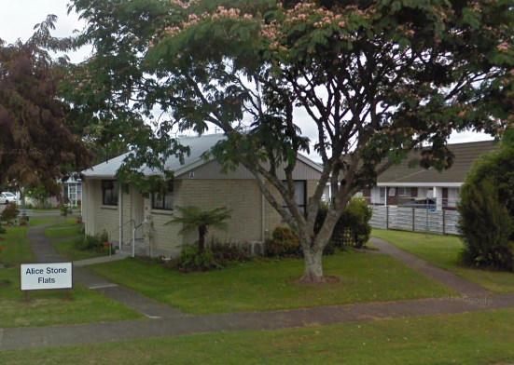
TCHT will continue to strive to achieve better outcomes in the eastern Bay of Plenty by upgrading, and where possible, redeveloping and intensifying the villages to better meet the community’s long term housing needs.
Our thanks to our team of advisors and supporters who continued to back and assist us through the transition process.

Up & Coming

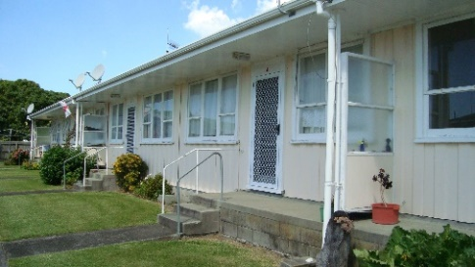
WDC village Redevelopment (Whakatane)
Plans to redevelop one of TCHT former WDC villages in Whakatane were progressed and concept plans completed. This work is part of a long term aim is to redevelop and intensify the site and to add a communal shared facility for older persons seeking company.

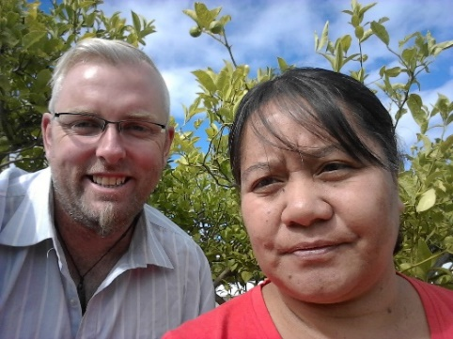
Extending the friendly landlord prodramme to eastern bay of Plenty
The programme will begin in early 2017 and begin by gaining feedback from key stakeholders about the gaps, barriers and the types of housing they believe is required for people experiencing serious mental illness. TCHT will then work with local housing providers and people in the mental health arena develop new housing options to meet some of these needs.
The Team from Eastern BOP
Left: Bryce Sheedy & Yvonne Rua

Report –Eastern Bay of Plenty
There was notable changes across the housing market in 2016. Increase in rents, house prices and insufficient supply of housing at the lower end of the market has resulted in overall undersupply of affordable. This is impacting on people on low incomes, particularly those on low fixed incomes. Property agencies are reporting extensive waiting lists and a growing trend of working people unable to secure suitable rental properties. Within our target group, there has been a noticeable increase in elderly people vacating their private sector tenancies due to unaffordable rents. Like Tauranga, rents have increased particular after the properties were sold. In some instances, rents were increased by 20 percent after rental properties were re-let by property investors. The number of rooms advertised to rent on social media e.g. buy swap sell, trade me, etc. is greater than ever, not only letting bedrooms within homes but also letting sleep outs and lined garages. Along with this, there are many posts asking for private rent as the stock with agents are very limited.
As the year progressed so did the amount of enquires staff received at the Whakatane office. This included enquires from young people and families who don’t meet the criteria for the council flats. In total 69 direct inquiries were currently logged with additional enquires from support services and agencies enquiring on behalf of people requiring housing.
TCHT housed 102 people throughout the year in Whakatane and Murupara; of those 15 were new tenants.
There was an increase in people coming from outside the area, primarily moving back to the area to be closer to whanau. Others came from higher demand areas (Auckland or Tauranga) because Whakatane is perceived as more affordable. Consistent with previous years, there are also a number of older people moving from rural to urban areas to be closer to medical and community services as they age and require higher levels of support.
In October 2016 TCHT extended the Healthy Homes Programme to Whakatane. By years end, staff had systems established and had started undertaking housing needs assessment in the area. They also delivered a number of presentations to key stakeholders. While referrals got off to a slow start, it is anticipated there will be a steady climb as winter approaches and the benefits of the programme becomes more widely known.
There has been much effort into addressing the immediate maintenance needs of the housing portfolio. Many of the properties are over 20 years old so maintenance upkeep and new legislative requirements need to be assessed. Rather than ‘fix and patch’ approach TCHT’s focus is to develop long term plans for the portfolio that includes an outline of the overall strategy to improve and/or where applicable redevelopment to better meet the long term needs of the tenants and community.
In 2016, considerable work was put into engagement with local community agencies and generally lifting the TCHT profile in Whakatane.
As we ended first year of operations in the eastern Bay of Plenty, we look forward to the challenges ahead and to actively work alongside the communities in the eastern Bay of Plenty to develop new affordable housing solutions for those in the local community who are in need of housing.
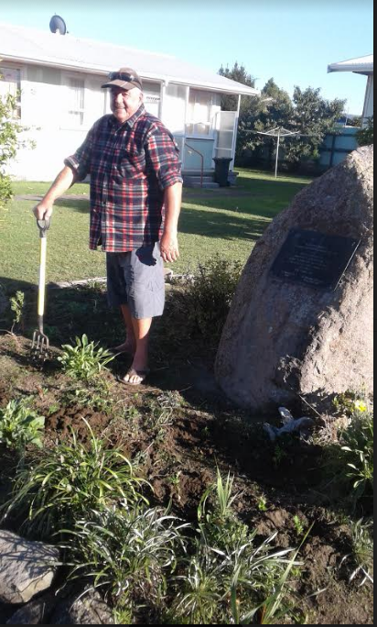
Tenant Profile: Stan
How long have you lived in Whakatane?
1959 to 1962 in Whakatane
1962 to 1967 army
1967 to 1990 drove coach liners
1990 2009 trucks and buses
How long have you lived in lovelock court units?
Going on 3 years, and hope to be around for a long time yet
What’s the best thing about living here?
The climate, peace and quiet.
Walking distance to shops and hospital and doctors
What do you like to do in your spare time?
Keep the surrounding area neat and tidy. Gardening water blasting and helping the other tenants. I like to drive and keep my car clean.
Favorite food?
Japanese food, Malaysian, white bait, pork chicken and salads.
What excites you about the future?
I hope to travel to japan and ride the bullet train, the shikkan sen, and travels at 300knms per hour. Might have to sell my car to do this.
If you could meet anyone from the past who would it be and why?
I would like to meet up with my army mates and my wife who passed away in 2006 of cancer.

Operational Activity

Healthy Homes Rheumatic Fever Prevention Programme
TCHT has been involved in the Healthy Homes rheumatic fever prevention programme (HHP) since in March 2015. The focus of the HHP is to reduce rheumatic fever rates in this region which predominantly affect Māori and Pacific children living in poor housing and crowded conditions.
The HHP initiatives systematically identify families with children at risk of getting rheumatic fever who are living in crowded households and facilitate access to a range of interventions to reduce that crowding and make the homes warmer, drier and healthier.
There were are broad range of interventions completed in 2016. They included homes insulated, curtains, beds and bedding provided, minor repairs to homes made and ventilation installed in kitchen/bathrooms. Heating sources such as firewood and/or oil heaters were delivered and heat pumps installed. Some families/whanau were supported to access alternative healthy housing in the private and/or social housing sectors.
Friendly Landlord Programme (FLP)
The Friendly Landlord Programme (FLP) as it is known, supports people experiencing serious mental illness to access and maintain independent housing.
The FLP programme has seen some positive movement throughout 2016. Community Mental Health NASC referrals lulled in the middle two quarters of 2016; however increased in the last quarter, with 9 referrals received in the last quarter of the year. Kakariki and Tara lodges (operated by TCHT) continued to play an important role in preparing FLP clients to transition into independent community living. The one and two bedroom accommodation provided at Cameron Road and Clarke Street units have proved invaluable for housing FLP clients that required affordable independent housing. The shortage and unaffordability of one and two bedroom housing in Tauranga has made it very difficult for FLP clients to find private rental accommodation. This was a continuing theme throughout 2016. As the demand for housing has grown, so has the importance of having the appropriate supports in place for FLP clients to sustain their tenancies. Supporting people to maintain their tenancies absorbed much of TCHT staff time, energy and focus throughout the year.
With no sign of the housing shortage abating we envisage further increases in referrals and more demand on FLP services to try and source suitable affordable housing for those that need it.

Support Acknowledgment
TCHT Trustees and management formally thank TCHT landlords and many supports including:
- ABC All Business Computers Ltd
- Acorn Foundation
- Beca
- Carpet Court Tauranga
- Community Organisation Grants Scheme (COGS)
- CCS Disability Action
- Crowther Company
- Department of Internal Affairs
- Expressions by Design
- First Sovereign Trust
- Gerrand Floorings
- HNZC
- HOBEC
- KiwiBank
- NZ Lotto Grants Board
- New World Brookfield
- North and South Trust
- PAR Trust
- Police Charity Luncheon
- Pub Charities
- Rotary Club of Tauranga
- Sir John Logan Campbell Residuary Estate
- Southern Trust
- Tauranga City Council
- Tauranga Energy Consumer Trust (TECT)
- Techsoup New Zealand
- The Flooring Room
- The Lion Foundation
- Tindall Foundation
- Western Bay of Plenty Disability Support Trust
- Window Gleam
- Zonta International
TCHT would not have been able to make the traction it has with the resources, support and grants it has received. A huge thank you to all those above for their continued support.

