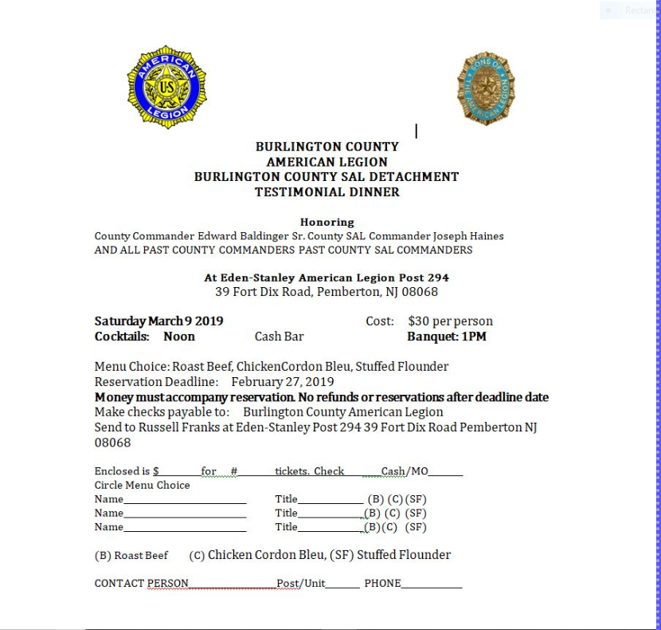

**PHILIP WIEN 120 N STILES AVE MAPLE SHADE NJ 08052**

**February 14, 2019**