**ASSOCIATION OF TEACHERS IN BIOLOGICAL SCIENCES**

**National Standard Examination in Biology – 2024**

# Date of Examination: November 24, 2024

**Time: 2:30 PM to 4:30 PM Question Paper Code: 21**

|  |  |  |  |  |  |  |  |  |  |  |
| --- | --- | --- | --- | --- | --- | --- | --- | --- | --- | --- |
| Student’s Roll No: |  |  |  |  |  |  |  |  |  |  |

***Write the Question Paper code (mentioned above) on YOUR OMR Answer Sheet (in the space provided), otherwise your Answer Sheet will NOT be evaluated. Note that the same Question Paper Code appears on each page of the Question Paper.***

**Instructions to Candidates:**

1. Use of mobile phone, smart watch, and iPad during examination is STRICTLY PROHIBITED.
2. In addition to this Question Paper, you are given OMR Answer Sheet along with candidate’s copy.
3. On the OMR sheet, make all the entries carefully in the space provided **ONLY** in **BLOCK CAPITALS** as well as by properly darkening the appropriate bubbles.

**Incomplete/ incorrect/ carelessly filled information may disqualify your candidature.**

1. On the OMR Answer Sheet, use only **BLUE or BLACK BALL POINT PEN** for making entries and filling the bubbles.
2. Your **Ten-digit roll number and date of birth** entered on the OMR Answer Sheet shall remain your login credentials means login id and password respectively for accessing your performance / result in National Standard Examination in Biology - 2024.
3. Question Paper has two parts. In part A-1 (Q. No.1 to 48) each question has four alternatives, out of which **only one** is correct. Choose the correct alternative and fill the appropriate bubble, as shown.

# Q.No.12 c



a



c



~~d~~

In part A-2 (Q. No. 49 to 60) each question has four alternatives out of which any number of alternative (s) (1, 2, 3, or 4) may be correct. You have to choose **all** correct alternative(s) and fill the appropriate bubble(s), as shown

# Q.No.52



a



c



1. For **Part A-1,** each correct answer carries 3 marks whereas 1 mark will be deducted for each wrong answer. In **Part A-2,** you get 6 marks if all the correct alternatives are marked and no incorrect. No negative marks in this part.
2. Rough work may be done in the space provided. There are **19** printed pages in this paper
3. Use of **Non-programmable scientific** calculator is allowed.
4. No candidate should leave the examination hall before the completion of the examination.
5. After submitting Answer Paper, take away the Question Paper & Candidate’s copy of OMR sheet for your future reference.

**Please DO NOT make any mark other than filling the appropriate bubbles properly in the space provided on the OMR Answer Sheet.**

**OMR Answer Sheets are evaluated using machine, hence CHANGE OF ENTRY IS NOT ALLOWED. Scratching or overwriting may result in a wrong score.**

**DO NOT WRITE ON THE BACK SIDE OF THE OMR ANSWER SHEET.**

**Instructions to Candidates (Continued) :**

***You may read the following instructions after submitting the Answer Sheet.***

1. **Comments/ Inquiries/ Grievances regarding this Question Paper, if any, can be shared on the Inquiry/ Grievance column on** [www.iapt.org.in](http://www.iapt.org.in/)**on the specified format till Dec 3, 2024.**

1. **The Answers/ Solutions to this Question Paper will be available on the website:**

[www.iapt.org.in](http://www.iapt.org.in/)  **by Dec 2, 2024.** The score card may be downloaded after Dec 24, 2024.

1. **CERTIFICATES and AWARDS:**

Following certificates are awarded by IAPT/ATBS to students, successful in the

National Standard Examination in Biology – 2024

* 1. “CENTRE TOP 10 %” To be downloaded from iapt.org.in after 30.01.24
  2. “STATE TOP 1 %” Will be dispatched to the examinee (iii) “NATIONAL TOP 1 %” Will be dispatched to the examinee

(iv) “GOLD MEDAL & MERIT CERTIFICATE” to all students who attend OCSC – 2025 at HBCSE Mumbai

Certificate for centre toppers shall be uploaded on iapt.org.in

1. List of students (with centre number and roll number only) having score above **Minimum Admissible Score (**MAS) will be displayed on the website: [**www.iapt.org.in**](http://www.iapt.org.in/) by **Dec 25, 2024. See the MAS clause** on the student’s brochure on the web.

1. List of students eligible to appear for Indian National Biology Olympiad (INBO – 2025) shall be displayed on [**www.iapt.org.in**](http://www.iapt.org.in/) by Dec 30, 2024.

# ASSOCIATION OF TEACHERS IN BIOLOGICAL SCIENCES

**NATIONAL STANDARD EXAMINATION IN BIOLOGY**

**(NSEB - 2024)**

**Time: 120 minute Max. Marks: 216**

***Attempt All Sixty Questions***

**A – 1**

**ONLY ONE OUT OF FOUR OPTIONS IS CORRECT. BUBBLE THE CORRECT OPTION.**

1. A realized niche is the space occupied by a species under real-world conditions. Identify the factors that influence the establishment of realised niche of a species.

(i) interspecific competition. (ii) predation.

(iii) availability of resources. (iv) intraspecific competition.

Choose the correct option:

* 1. (i) and (iii) only (b) (ii), (iii), and (iv) only
  2. (c) (i), (iii) and (iv) only (d) (i), (ii), and (iii) only

The interspecific competition is a more significant factor for realisation of niche in real world conditions as compared to intraspecific competition.

1. A study conducted to analyse the foraging strategies of house sparrow compared observations on sparrow

populations in rural and urban surroundings. The image below depicts the findings.

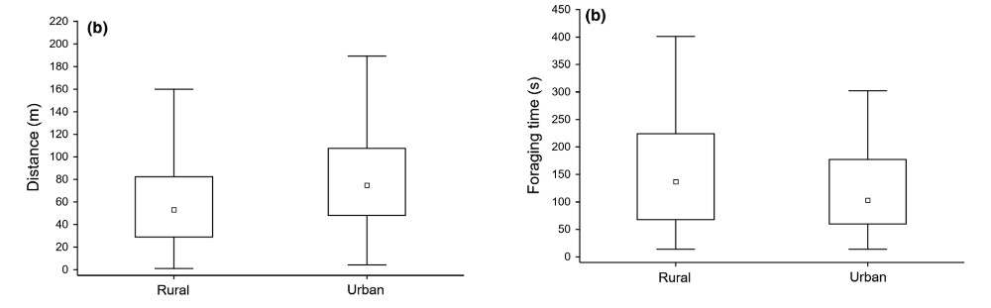

**(**

**a**

**)**

The Marginal Value Theorem says that animals must forage by using most economic and efficient strategy that will balance energy gain and consumption. Which of the following interpretations of the study results, support the theorem?

* 1. The foraging distances in urban environs are shorter while those of rural environs are longer.
  2. The sparrows spent more time in foraging in urban environs due to more “artificial habitats” in urban environs.
  3. The sparrows spent less time foraging in urban areas where resources are at larger distances.
  4. Rural environs with “more natural” habitats offer lesser resources at shorter distances.

The answer is very evident in graph b.

1. Which of the following **cannot** be considered an advantage of the efficient photosynthetic pathway for the fixation of atmospheric carbon dioxide in C4 plants?
   1. It facilitates adaptation to arid conditions. (b) It facilitates adaptation to high temperatures.
   2. It facilitates lower energy cost per CO2 fixed. (d) It facilitates survival in marginal environments.

The cost per CO2 fixed is not facilitated

1. Like the bony skeletons in vertebrates, haemolymph hydraulics enables some invertebrates in locomotion. Which of the following animals use haemolymph hydraulics for locomotion?
   1. Grasshopper (b) Spider (c) Crab (d) Octopus

Many invertebrates use hydraulics but in the above, spider with a softer exoskeleton is the right answer.

1. Which of the following has a turnover time equal to lifetime of humans?

(a) Lens of the eye (b) Sperm cells (c) Muscle cells of ribs (d) Hepatocytes

Lens has higher turnover considering a **healthy** life long sustenance of the tissue.

1. The population of Medium Ground Finch (*Geospiza fortis*) on Santa Cruz Island of Galapagos, features mainly large and small beak size morphs, with relatively few intermediates. The Figures (a) and (b) below depict the pairing patterns in two different breeding seasons. Male and female ‘beak PC1’ values are Principal Component - 1, indices derived based on beak length, depth and width.

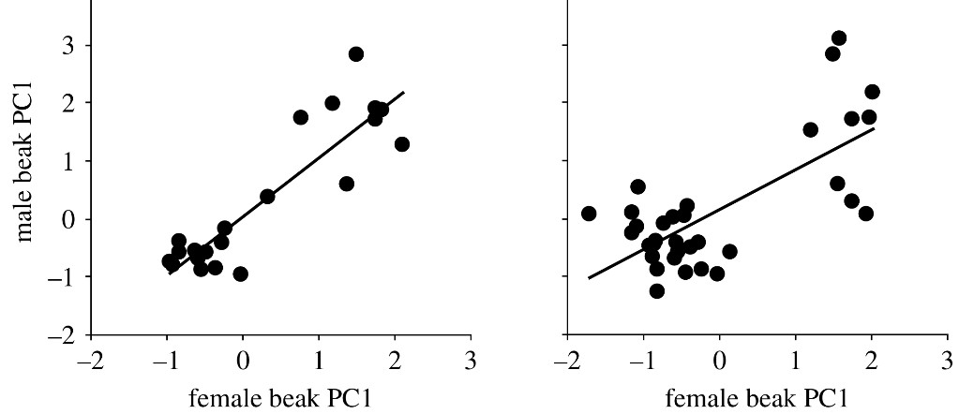

(

a

)



(

b

)

Which of the following interpretation is correct?

* 1. This type of breeding indicates a reproductive isolation purely of allopatric origin.
  2. There is disruptive selection in sympatry against birds with intermediate beak sizes.
  3. The pairing pattern indicates a selection pressure for intermediate beak sizes.
  4. The trend in the pairing patterns seen in two seasons indicates an efficient reproductive isolation between the morphs.

Here the regression curve clearly show that the reproductive isolation is inefficient and selection is working against intermediate beak length.

1. If one starts with 10,000 (104) bacterial cells in a culture that has a generation time of 2 hours, what would be the magnitude (ten-fold) of increase in cell number at 4 hours, 24 hours and 48 hours respectively?
   1. less than 1, 4, and 7 (b) 1, 3, and 7
   2. (c) Less than 1, 5, and 9 (d) 4, 16 and 49

The calculation is made with the formula g=t3.32(logN2−logN1)

1. If atmospheric pO2 is 130 mm of Hg and alveolar pO2 of a person is 85 mm of Hg, which of the following is most likely correct?
   1. The person is suffering from lung dysfunction.
   2. The person is respiring at high altitude.
   3. The partial pressure of oxygen in pulmonary arteries for the person must be between 60-130 mmHg.
   4. The partial pressure of oxygen in pulmonary veins for the person must be between 40-60 mmHg.

Since the ambient pO2 is given, the person is at an altitude with no disease.

1. Consider the following pathway involving glycolysis that further leads to citric acid (TCA) cycle. (PFK = Phosphofructokinase).



Which of the following molecules are likely to act as activators and inhibitors respectively of the enzyme PFK?

* 1. Citrate and ATP (b) AMP and ADP (c) ATP and citrate (d) AMP and citrate

10.

The Gastrointestinal tract with

some associated organs are shown in the

diagrams below.

The names of

the organs marked I, II and III respectively

are

;

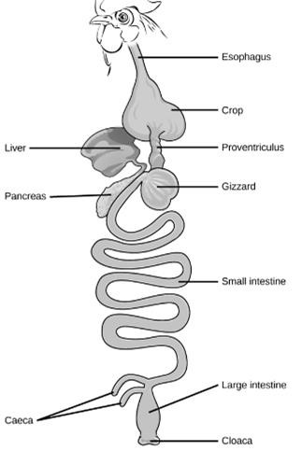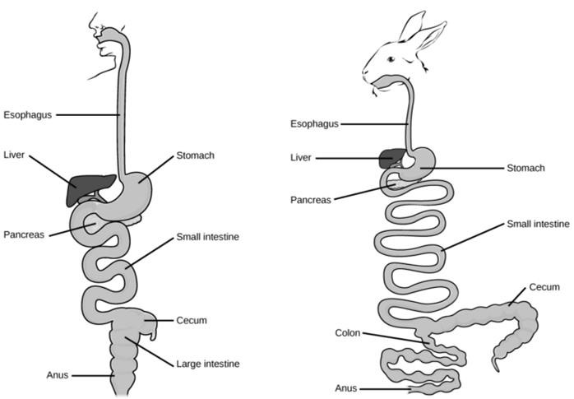



III



I

II

* 1. Duodenum, gall bladder and cardiac stomach
  2. Gall bladder, Intestinal diverticulum and pyloric stomach
  3. Pancreas, caecum and gizzard
  4. Pancreas, Intestinal diverticulum and stomach

Crop is shown so III is from a bird; gizzard

1. Coelom is the fluid filled space between the body wall and the digestive system. Its absence or presence significantly influences classification of animals. The schematic diagrams (i), (ii), and (iii) below depict three different variations in the coelomic condition. Select the correct sequence of animal group to respectively match the coelomic types (i), (ii) and (iii).

**(i)**

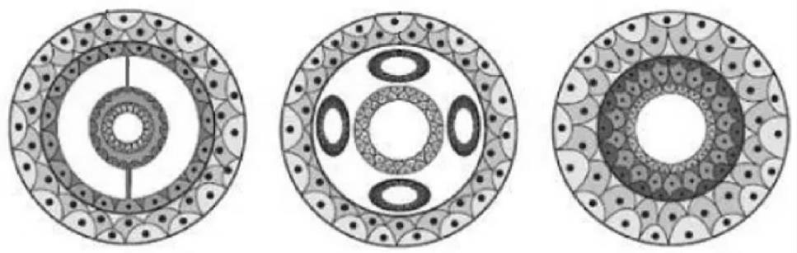

**(**

**ii**

**)**

**(**

**iii**

**)**

(a) Annelids, Roundworms and Flatworms (b) Roundworms, Flatworms and Annelids

(c) Flatworms, Roundworms and Annelids (d) Annelids, Flatworms and Roundworms

1. One of the portal systems evolved in lower vertebrates, to help drain the muscular hind legs. The image below depicts that portal system in the red-eared terrapin (*Trachemys scripta elegans*), a fresh water turtle and the most commonly kept pet reptile. The organ marked “☒” is ___________________.

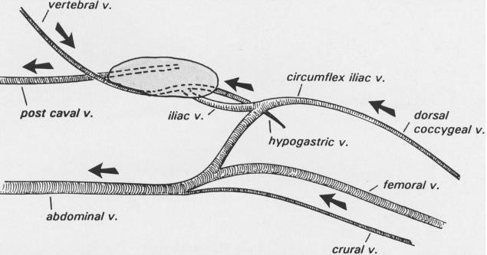

☒

(a) Lymph node (b) Kidney (c) Testis (d) Liver

Renal portal system is depicted so, the organ is kidney.

1. pH difference across inner mitochondrial membrane over time in an actively respiring cell is shown in the graph. The likely effects of addition of P and Q to the cell at the time indicated by arrow are also shown. Which of the following statements is correct?



**pH**

**difference**



**Q**



**P**



**Time**

* + 1. P is likely to be ATP synthase inhibitor.
    2. Q is likely to be cytochrome inhibitor.
    3. P is likely to be metabolic activator.
    4. Q is likely to be activator of anaerobic respiration.

Answer is (a) since metabolic activation cannot change pH as shown while “c” is a very general statement with no specifics.

1. Siamese cats show a mutated enzyme tyrosinase (required for the synthesis of melanin) that is active only below a temperature of 330C. Based on this information, which of the following is likely to be correct?
   * 1. Newly born Siamese kittens are likely to be creamy or white in colour.
     2. As the young grow to adulthood, mainly their belly portions are likely to turn dark.
     3. Newly born Siamese kittens are likely to show darker nose, paws, and ears than the rest of the body as compared to adults.
     4. The body of the Siamese cat is likely to be darker in summer as compared to winter season.

Uterus temperature is higher than 33 so kitten are born without pigments.

1. Phylogenetic classification of five animal phyla is shown below.



1



4



3



**Mollusca**

**Nematoda**

**Arthropoda**



**Platyhelminthes**

**Annelida**

Which of the following option correctly identifies the characteristics associated with labels 1 to 4?

(a) 1 is Bilateral symmetry and 3 is Protostomy

(b) 3 is Diploblasty and 4 is Triploblasty

(c) 1 is Bilateral symmetry and 2 is Deuterostomy

(d) 2 is Protostomy and 3 is Spiral cleavage

Point 3 can only be spiral cleavage and so the other is Protostomy. The number 2 was inadvertently not printed but it is deducible.

1. Among several excretory products of animals, P, Q and R are tabulated along with their properties.

|  |  |  |  |
| --- | --- | --- | --- |
| Properties | P | Q | R |
| Toxicity | +++ | ++ | + |
| Energy cost | + | ++ | +++ |
| Water loss during excretion | +++ | ++ | + |

Waste product P most likely is:

(a) Urea (b) Carbon dioxide (c) Uric acid (d) Ammonia

Ammonia is most water soluble and energy cost is lowest.

1. Weight specific oxygen consumption and body surface area to volume (S/V) ratio of three animals (X, Y and Z) is depicted in the graph.



Weight specific

oxygen

consumption

mL O

2

/gm.h



0



4



Z



Y



X



High

low

S/V

X, Y and Z respectively indicate:

* + 1. Elephant, human, dog
    2. Shrew, sheep, cat
    3. Mouse, sheep, elephant
    4. Horse, dog, cat

Surface area to volume is maximum is for mouse.

1. In the event of a bat attack, tiger moths show three different types of responses. Some tiger moths show warning colouration indicating their toxic chemical defence while some moths produce clicking sounds to jam bat’s sonar. Some moths show acoustic startling responses to deter the attacking bats. Scientists experimented with a bat colony that was not exposed to these moths. When they studied the moth capture rate against each of these moth responses, the following data was obtained.



Time (night) 7 hrs



Moth capture

rate %



100



**R**



**Q**



**P**



0

Which of the following can be deduced from these results?

* + 1. P indicates response to jamming behaviour.
    2. Q indicates response to acoustic startle behaviour.
    3. R indicates bat’s response to warning colouration for chemical toxicity.
    4. R indicates control behavior of bats in absence of all the three types of moth behaviour.

Bats are nocturnal so warning colours are less effective, and so sound waves are best. P is warning colours, R is jamming.

1. Zebra finch are monogamous birds mainly found in Australia and Indonesia. These birds (both male and female) lack any crest feather (ornamentation) on their head. To study the mate choice behaviour of zebra finches, the following experimental groups of modified individuals were made.

|  |  |  |
| --- | --- | --- |
| Group | Modification | Mate preference of female offspring |
| I | Both male and female ornamented and mated. | Ornamented male |
| II | Only males ornamented and mated with females. | Ornamented male |
| III | Only females ornamented and mated with males. | Both preferred equally |
| IV | Neither sex was ornamented and mated. | Both preferred equally |

The results indicate that:

* + 1. Ornamentation of crest on either parent influences mate choice.
    2. Mate choice behavior is genetically determined and cannot be changed.
    3. Mate choice is influenced by imprinting.
    4. Mate choice behavior is dictated by presence or absence of ornamentation of female parent.

1. How many times does megaspore mother cell nucleus divide till the formation of female gametophyte in angiosperms?

(a) 5 (b) 11 (c) 4 (d) 8

Megaspore mother cell nucleus divide twice during meiotic division to form 4 haploid cells. Three degenerate and surviving cell undergoes 3 mitotic divisions to form 8 nuclei.

1. Consider a germ cell having 3 pairs of homologous chromosomes. After meiotic division, how many possible combinations of chromosomes will be found in egg cells?

(a) 8 (b) 16 (c) 6 (d) 9

3 pairs can possibly shuffle in 8 ways (23=8)

1. On a rocky intertidal habitat, a sea star (*Pisaster ochraceus)* and mussel (*Mytilus* *californianus)* are commonly found along with several other smaller sized species of various animals and algae. When all sea stars were removed from the habitat, the results obtained are depicted in the following graph.



No. of

species



20



Before removal



After

removal



Time in years



0

What can be deduced from this data plotted in the graph?

* 1. Sea star was a likely predator of mussels that overgrew in the habitat in the absence of Sea star.
  2. Mussels are the keystone species of the habitat.
  3. In absence of sea star, severe competition between the remaining species led to their extinction. (d) Sea star is the dominant competitor for space to all other species thriving in the intertidal zone.

Sea stars are most voracious feeders of bivalves. On removing them, the gradual fall of curve is due to predation.

1. Primary spermatocytes undergo meiotic division to give rise to sperm cells. Non-disjunction of sex chromosomes during this division can lead to male gamete formation with abnormal number of chromosomes. If such a sperm cell fuses with a normal egg cell, which one of the following genotypes will not be found in the offsprings?

(a) XXY (b) XXX (c) XYY (d) YO

Because Non-disjunction in spermatogenesis will give XY, XX, YY and O types of sperms and normal egg cell definitely has X chromosome. Hence YO combination is not possible.

1. Australian Bush fly lays its eggs in the fresh dung of herbivores. As the dung hardens, no more eggs can be laid. When the eggs hatch, larvae feed on the dung until they pupate in the nearby soil. In an experiment, fixed volume of cow dung cakes (2 dm3) was populated with different number of eggs ranging from 1400 – 4250. Figure 1 shows percentage of eggs emerged as adults from each dung cake. Each dot represents a 2 dm3 dung cake. Figure 2 represents percentage survival for any original egg number which will give exactly 915 adults. What conclusion can be drawn?

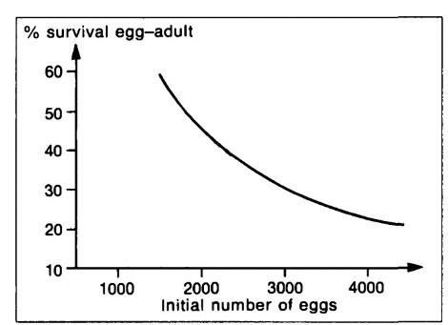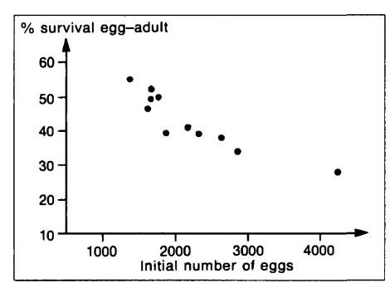

Figure

1

Figure 2

* 1. The number of adults emerging from the dung cake of any size is always fixed.
  2. Dung cake populated with lesser number of eggs would have given higher number of adults emergence.
  3. Number of adults emerging is fixed if dung cake size is nearly constant.
  4. All the eggs laid by bush fly are not viable if the number is above 1400.

Second graph is matching with the pattern found in the first one. So as long as dung cake size is fixed, the number of adults emerging remains same.

1. The amount of dead organic matter accumulated on the forest floor at any given point of time differs as one goes from equator to higher altitude. The table given below represents 4 forest types with the amount of dead organic matter measured per hectare.

|  |  |
| --- | --- |
| Forest type | Mass of dead organic matter (tons/ha) |
| M | 10 |
| N | 2 |
| O | 85 |
| P | 30-45 |

Which one represents a tropical rain forest?

(a) M (b) N (c) O (d) P

Tropical forest produces significant organic matter but has the faster rate of decomposition, so very less dead organic matter. Biomass per unit area is greatest at the equator but its present in living organisms.

1. IUCN has listed several criteria in order to protect the area under the biological diversity hotspots. Some of these criteria are 1) the area must support 0.5 percent of the global total plant species (≈ 3,00,000) and 2) the region must have lost more than 70 percent of its original habitat. Based on this IUCN has already protected 25 hot spots all over the world.

A researcher comes up with four areas (i, ii, iii and iv) that support several endemic plants and face substantial loss of their natural habitat over a period. Which of these area/s can be protected under the global biodiversity hotspots?

|  |  |  |  |
| --- | --- | --- | --- |
| Name of area | Number of endemic plant species in the area | Total area of  Habitat (in sq km) | Loss of habitat (sq. km) |
| i | 1250 | 15000 | 7500 |
| ii | 1512 | 80000 | 64000 |
| iii | 1525 | 90000 | 62000 |
| iv | 1275 | 36000 | 6000 |

(a) i and ii only (b) iii and iv only (c) ii only (d) iii only

1. ‘Reproductive isolating mechanisms play an important role in speciation. One such interesting example is of two closely related species of cicadas of the genus *Magicicada*. Both *Magicicada tredecim* and *Magicicada septendecim* spend almost 99% of their lifetime underground in immature nymph state. They feed on xylem fluids from the roots. Individuals of both the populations are developmentally synchronized and in both the species, emergence occurs in large numbers. The mature nymph of *Magicicada tredecim* emerges out after 13 years and moults into adult form whereas *Magicicada septendecim* emerges out after 17 years. Therefore, even though being closely related and belonging to the same habitat, interspecific mating is avoided. This type of reproductive isolation is;

(a) Spatial isolation (b) Temporal isolation

(c) Mechanical isolation (d) Behavioural isolation

The difference in time of emergence is the most effective factor for reproductive isolation.

1. Under normal circumstances, lipid bilayer of cell membrane allows certain molecules to readily pass through it. Which one is the correct order of molecules with respect to increasing permeability across the membrane?

|  |  |  |
| --- | --- | --- |
| (a) Vit. A < Ca2+ < Glycerol < Glucose |  | (b) Ca2+< Glucose < Glycerol < Vit. A |
| (c) Glucose < Glycerol < Vit. A < Ca2+ |  | (d) Glycerol < Vit. A < Ca2+ < Glucose |

A,D,E vitamins are small nonpolar molecules, Glycerol is small polar molecule, Glucose is large polar and calcium ion is charged entity therefore membrane permeability differs.

1. An experiment was carried out with a purified extract of a functional protein ribonuclease (R). The following steps were followed:
   1. Extract and purify R from tissue.
   2. Add urea (disrupts the H2 and ionic bonds) and mercaptoethanol (disrupts disulphide bridges).
   3. Slowly remove the chemical agents used in the previous step and then check for enzyme activity.
   4. Functional protein detected.

The type of structure/s of R affected at step (ii) is/are:

(a) 1º and 2º structures (b) 2º and 3ºstructures (c) 3ºstructure only (d) 1º structure only

Urea and mercaptoethanol disrupts the 2o and 3o structures and since the functional protein is detected in step (iv), primary structure is not affected.

1. A few statements regarding C3, C4 and CAM plants are given. Mark the correct statement. (a) In C4 plants, the C4 and C3 pathways are separated temporally.
   1. CAM plants utilize the C4 pathway during the day and the C3 pathway at night.
   2. The C3 pathway takes place in the bundle sheath cells of the C4 plants.
   3. Both C4 and CAM plants keep their stomata open at night.

The C3 and C4 pathways in C4 plants are separated spatially. In CAM plants the C4 pathway takes place at night while C3 occurs during the day. Also stomata of only the CAM plants are open at night.

1. A pedigree for a rare congenital cataract condition is given below.

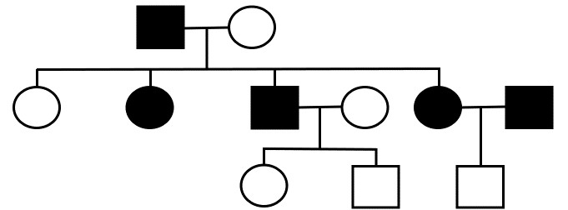

The most likely mode of transmission of the trait is:

(a) X-linked dominant (b) X-linked recessive

(c) Autosomal dominant (d) Autosomal recessive

The condition cannot be X-linked recessive since affected mother would give rise to affected son. The condition cannot be autosomal recessive since son of both affected parents would have to affected. It also cannot be X-linked dominant since then affected father would have an affected daughter.

1. Restriction fragment length polymorphisms (RFLPs) are differences in DNA sequences due to mutations in restriction sites. These can serve as genetic markers. The RFLP gel patterns for members of a family can be obtained by restriction digestion of the sample containing the alleles for a particular trait and then carrying out electrophoresis, probing and blotting.

Consider the following alleles – *P* (dominant allele) and *p* (recessive allele) responsible for an autosomal recessive trait. Note: Arrows indicate restriction sites.

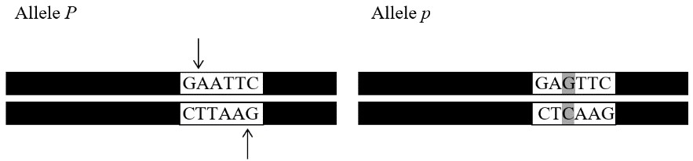

The number of bands that the RFLP profiles of an unaffected, affected and carrier individual for this trait would respectively show is:

(a) 2, 1 and 2 (b) 2, 1 and 3 (c) 1, 2 and 3 (d) 1, 1 and 2

Unaffected, affected and carrier individuals in this condition will have genotypes PP, pp and Pp respectively and the RFLP profiles will show 2, 1 and 3 bands respectively.

1. The presence or absence of certain structures in three types of cells is tabulated below.

|  |  |  |  |
| --- | --- | --- | --- |
|  | Plant | Animal | Bacteria |
| M | Present | Present | Present |
| N | Present | Present | Absent |
| O | Present | Absent | Present |

Structures M, N and O could respectively be:

* + 1. Nucleus, Golgi apparatus and cell membrane
    2. Cell wall, endoplasmic reticulum and chloroplast
    3. Centrioles, ribosomes and cell wall
    4. Ribosomes, endoplasmic reticulum and cell wall

Ribosomes are present in plant, animal and bacterial cells; ER is absent in bacteria while cell wall is absent in animal cells.

1. 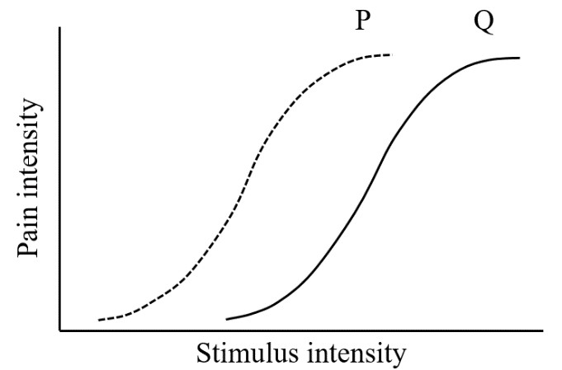The sensation of pain and its intensity begins with the peripheral receptors (nociceptors) that are activated by thermal, mechanical, and chemical stimuli. Nociceptors are found in the skin, muscle and viscera. Hyperalgesia refers to an abnormally increased sensitivity to pain, which may be caused by damage to nociceptors or peripheral nerves and can cause hypersensitivity to stimulus. The following graph represents pain intensity as measured against stimulus intensity in two individuals represented by curves P and Q.

Mark the correct statement from the following statements.

* 1. Curve P shows early habituation to pain as compared to Q.
  2. Curve Q could be the response in a normal healthy person while curve P could be a victim of platypus venom which is known to cause increased sensitivity to pain.
  3. Curve Q shows increased sensitization to stimulus of the same intensity as compared to that in curve P.
  4. It has been observed that long-term opioid usage for treatment of chronic pain leads to hyperalgesia. This can be observed in curve Q.

P feels pain at a lower stimulus intensity than Q which means P is more sensitive to pain than Q.

1. The type of parental care for a particular species of fish, bird and mammal is given below;

|  |  |  |
| --- | --- | --- |
| **Species of** | **Parental care** | **Mating Type** |
| Fish | Male only | X |
| Bird | Both male and female | Y |
| Mammal | Female only | Z |

Mating systems X, Y and Z respectively, in these species would most likely be:

(a) Polygyny; promiscuous and polyandry (b) Monogamy; Polygyny and monogamy

(c) Polyandry; monogamy and polygyny (d) Polyandry; monogamy and polyandry

Both parents in case of monogamy exhibit parental care. In polyandry and polygyny, one of the parent i.e. male or female respectively give parental care.

1. Pulse-chase analysis is a commonly used technique to study proteins in the cell. Cultured cells expressing the protein of interest are allowed to take up radioactively labelled amino acids for a brief interval (pulse) during which all the newly synthesized proteins incorporate the label. In an experiment 3H-leucine was added to a cell culture to label secretory proteins in the cell and radioactivity at different locations in the cell was recorded at 5, 10 and 45 minutes after addition. Which organelles respectively will show maximum radioactivity at these time points respectively?
   * 1. Golgi apparatus; endoplasmic reticulum and secretory granules
     2. Secretory granules; endoplasmic reticulum and Golgi apparatus
     3. Endoplasmic reticulum; secretory granules and Golgi apparatus
     4. Endoplasmic reticulum; Golgi apparatus and secretory granules

The pathway followed by secretory granules is endoplasmic reticulum 🡪 Golgi apparatus 🡪 secretory granules and hence radioactivity would be observed accordingly.

1. Treatment with which type of the following enzymes will be the most effective in digesting the basic framework of the myelin sheath around the axons?

(a) Glycosidase (b) Protease (c) Nuclease (d) Lipase

1. Modern vascular plants have evolved organs like the roots, stems and leaves to support terrestrial life. In evolutionary history, structural modifications are products of natural selection, that enable specialized adaptations. Pair the following plants with the plant organs that support an adaptation:

|  |  |  |  |  |  |  |  |  |  |
| --- | --- | --- | --- | --- | --- | --- | --- | --- | --- |
| |  |  | | --- | --- | | I. | *Solanum tuberosum* | | II. | *Beta vulgaris* | | III. | *Allium cepa* | | |  | | --- | | i. Root | | ii. Shoot | |

(a) I –ii, II – i, III – ii (b) I – i, II – ii, III – ii (c) I – ii, II – ii, III – I (d) I – i, II – i, III – ii

1. The following image shows a sequence of processes involved in the classical solid – liquid extraction of peptides from a cell culture.

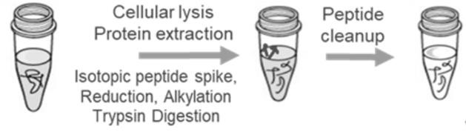

**1**



**2**



purification

Which of the following enzymes is generally used in this process during the step marked 1?

(a) Lipase (b) Trypsin (c) Pepsin (d) Papain

Trypsin in specific concentration is used to break protein into peptides and then   
lipase is used in clean up.

1. Which among the following statements about chloroplast is **false**?
   1. Proteins found in chloroplast are either encoded by the chloroplast DNA or the nuclear DNA.
   2. Chloroplast genes exhibit Mendelian pattern of inheritance.
   3. PhotosystemsI and II are spatially separated in the thylakoid membrane of the chloroplast.
   4. Chemiosmotic mechanism converts the energy stored in chemical and electric potential to ATP

similar to mitochondria.

1. Which of the following is true for a competitive inhibitor of an enzyme?
   1. The inhibitor increases the stability of enzyme-substrate complex formed.
   2. Maximum reaction velocity cannot be reached even at very high concentration of substrate.
   3. Very high concentration of substrate can relieve inhibition completely.
   4. The inhibitor only binds to the enzyme-substrate complex.

For a competitive inhibitor, increasing substrate can relieve the inhibition and may help reach maximum velocity. This is due to faster saturation of reaction sites provided the competitor concentration is low.

1. P and Q are the two nuclear proteins that are required for activating transcription of gene Y. Individually neither of the two is sufficient to activate the transcription of the gene Y. The upstream DNA sequence of gene Y was used to study the DNA binding properties of purified P and Q proteins separately as well as in combination. The bound fractions were eluted and confirmed by Western blotting (shown below) using antibodies against P and Q.

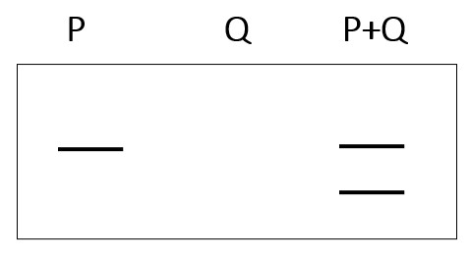

From the above which of the following statements are true? (i) Only P can bind to upstream DNA of gene Y

* 1. P and Q both can bind to upstream DNA of gene Y
  2. Q activates transcription once it is recruited to upstream DNA of gene Y by P
  3. P is likely to activate the transcription of gene Y

(a) (i) and (iv) (b) (ii) and (iv) (c) (i) and (iii) (d) (ii) and (iii)

1. Following table depicts the carbon transport and decarboxylation in C4 plant species. Fill in the blanks with the correct options for P, Q and R.

|  |  |  |
| --- | --- | --- |
| C4 acid transported to bundle sheath cells | C3 acid transported to mesophyll cells | Decarboxylase |
| Malate | ------P------- | NADP + malic enzyme |
| ------Q------- | Alanine | NAD + malic enzyme |
| Aspartate | ------R------- | PEP carboxykinase |

(a) P: Pyruvate Q: Aspartate R: Pyruvate

(b) P: Pyruvate Q: Malate R: Alanine

* + 1. P: Aspartate Q: Pyruvate R: Malate
    2. P: Aspartate Q: Aspartate R: Phosphoenol pyruvate

1. When two species of Monkey Flower plant (X and Y) were studied, following data was obtained:

|  |  |  |  |
| --- | --- | --- | --- |
| Species | Nectar volume (µl) | Seeds per flower | Weight of horizontal shoots (stolons) that develop into roots |
| X: *Mimulus eastwoodiae* | 4.94 | 25 | 0.49 |
| Y: *Mimulus cardinalis* | 50 | 280 | 0.07 |

Which of the following statements about plant X and / or Y is correct?

* + 1. Plant X allocates more resources towards shoot growth as compared to plant Y.
    2. Plant X allocates its resources to asexual reproduction more than plant Y.
    3. Species X is likely to be native in habitat with abundant water availability.
    4. Root to shoot growth ratio of both plants show inverse relationship.

More stolons will lead to more asexual reproduction

1. Few characteristics of a particular animal behaviour are listed below:
   * + Performed without learning
     + Are stereotypic
     + Cannot be modified by learning

Which type of behaviour from the following do these indicate?

(a) Operant conditioning (b) Habituation

(c) Classical Conditioning (d) Fixed action pattern

Conditioning and habituation all involve learning while fixed action pattern does not.

1. Read the following observations made in the experiments done to investigate whether DNA or protein is the genetic material:
   1. 35S labelled T2 phages were adsorbed onto bacterial host cells. Upon thorough mixing bacterial cells and phage ghosts were separated. The radioactivity was recorded only in phage-ghosts and not in bacterial host cells.
   2. 32P labelled T2 phages were adsorbed onto bacterial host. Upon thorough mixing bacterial cells and phage ghosts were separated. The bacterial host cells exhibited radioactivity.
   3. Purified DNA of 174 bacteriophage can successfully infect bacterial protoplasts and produce parental phage progeny.

Which of the observations confirm that DNA and not protein propagates genetic information?

(a) Only (i) (b) Only (i) and (ii) (c) Only (ii) and (iii) (d) (i), (ii), and (iii)

1. The changes in membrane potential of ventricular muscle cell are depicted in graph I. These changes result from the activity of the various ion channels involved in nerve conduction as represented in a corresponding graph II.

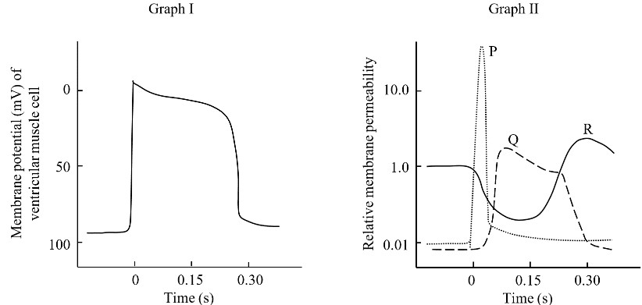

**P**



**R**



**Q**

P, Q and R in graph II respectively correspond to:

* + 1. K+ channels; Na+ channels and Ca2+ channels
    2. K+ channels; Ca2+ channels and Na+ channels
    3. Na+ channels; K+ channels and Ca2+ channels
    4. Na+ channels; Ca+ channels and K+ channels

If graph I is overlapped with II, then P, Q and R respectively represent the relative membrane permeability of Na+, Ca2+ and K+ channels respectively. Answer is “d”

1. An enzyme “M” has a low Km value relative to the physiological concentration of its substrate. Another enzyme “N” has a high Km value relative to the physiological concentration of its substrate. In the normal physiological condition, and substrate concentrations within the physiological range, which of the following statement is correct?
   1. The activity of “M” will vary as the concentration of substrate varies, and the rate of formation of product will depend on the availability of substrate.
   2. Enzyme “M” will act at a more or less constant rate, regardless of variations in the concentration of substrate.
   3. Enzyme “M” will not be normally saturated with the substrate.
   4. Enzyme “N” will act at a more or less constant rate, regardless of variations in the concentration of substrate.

**A – 2**

**ANY NUMBER OF OPTIONS (4, 3, 2 or 1) MAY BE CORRECT**

**MARKS WILL BE AWARDED ONLY IF ALL THE CORRECT OPTIONS ARE BUBBLED AND NO INCORRECT.**

1. In Bioinformatics, transcriptome is identified as the complete set of mRNA transcripts produced by the genome at any one time. Which of the following statements are correct?
   1. Transcriptomes are made up of the complementary regions of both intron and exon portions of the transcribed DNA
   2. Transcriptomes reflect the genes that are being actively expressed at any given time in the cell.
   3. Transcriptome shows the conserved regulatory sequences of genes in active physiological state of a secretory cell.
   4. Transcriptome varies considerably in different cells due to different patterns of gene expression.

Transcriptome is a collection of RNA molecules; m, r, t RNAs and also other noncoding RNAs.

1. Octopuses and Horseshoe crabs have blue blood because the protein transporting oxygen in their blood, hemocyanin, contains copper, instead of iron, making their blood appear blue rather than red. It is also seen in invertebrates living in habitats with very low temperature. Select the correct statement from the following.

(a) Hemocyanin binds more oxygen molecules than haemoglobin and is found freely floating in blood. (b) Hemocyanin binds less oxygen molecules than haemoglobin and is found in the haemocytes.

(c) Hemocyanin is more thermostable than haemoglobin and is bigger in size than haemoglobin

(d) Hemocyanin is less thermostable than haemoglobin and is smaller in size than haemoglobin

At lower temperatures hemocyanin is more efficient than haemoglobin in freely floating conditions.

1. Fragile X Syndrome (FXS) is a X-linked genetic disorder in which CGG base triplet number is abnormal as compared to normal healthy individual. The carriers have intermediate copy number of CGG repeats. The presence of CGG region is responsible for inactivation of protein required in brain and neural development.

Gel pattern of CGG repeats along with the family pedigree is shown below.

* indicates persons affected with FXS.



Mo Fa S1* S2 W GD H

GGS*



CGG

repeat

s

Which of the following statements are correct?

* 1. CGG repeat number is found highest in diseased person.
  2. CGG repeat number remains stable when passed through sperm.
  3. The FXS trait is X-linked recessive.
  4. Individual S2 is a carrier for the disease and will transmit the disease to next generation.

GD is a carrier female whose mother is not a carrier and not affected. So the CGG repeat remains stable when passed through sperms.

1. An organism’s evolutionary history is documented in its genome. Evolution of ancestral gene A is shown in the figure below. Genes A1 and A2 are called orthologues while genes A1 and B1 are called paralogues.



gene A2



gene A1



gene B1



gene B2



gene B



gene A



A

ncestral gene A



Species 1



Species

2



P



Q

Which of the following statements are true?

* 1. P and Q respectively indicate speciation and duplication events.
  2. Hemoglobin and myoglobin are examples of paralogous genes.
  3. Paralogous genes are likely to provide chance to evolve novel functions in an organism.
  4. Polypoidy observed in plants is an example of event P.

1. Study the following reaction:



CO

2

+

H

2

O

→

H

2

CO

3

→

H

+

+

HCO

3



CO

3

—



HCO

3

-

The reaction indicates:

(a) Alveolar hyperventilation

(b) Oceanic acidification

(c) Calcium depletion of coral reefs.

(d) Increased photosynthesis of oceanic algae.

1. A scientist found a brown cat with ears having an unusual curl. In order to find if this trait is dominant or recessive, she mated the cat with a random cat of the same species with uncurled ears. The mating resulted in all offsprings with non-curled ears. Which of the following can be deduced from this?
   1. The assumption for curled ear trait to be dominant is justified by the results.
   2. The assumption that the curled ear trait is recessive would have got justified only if the offspring showed 1:1 ratio of both phenotypes.
   3. The assumption for curled ear trait to be recessive is justified by the results.
   4. The results confirm that the randomly chosen cat is true breeding.

1. Considering Meiosis II as an independent event, which one of the following phenomena makes Meiosis II different from Mitotic division?
   1. Sister chromatids are held together by protein complex called cohesins in metaphase-II only.
   2. Daughter cells may have sister chromatids with different genetic composition. iii. In meiosis II, chromosome number of daughter cells remains unchanged.

iv. DNA replication does not take place before prophase II.

(a) Only ii (b) Only i (c) ii and iv (d) i and iii

Due to cross over events in prophase I, genetic composition of sister chromatids may vary and DNA replication doesn’t occur in-between meiosis I and II.

1. A few processes that occur in a cell are listed below.
   * 1. Cholesterol uptake
     2. Chemiosmotic generation of ATP
     3. Movement of oxygen into cells
     4. Movement of glucose into cells
     5. Secretion of mucous

Which of the following statements regarding these processes are true?

* + 1. (i) and (ii) are active processes while (iii), (iv) and (v) are passive processes.
    2. (i) occurs by carrier-mediated endocytosis while (v) occurs by exocytosis.
    3. (iii) and (v) occur by direct passage through the membrane.
    4. A membrane protein is involved in the processes (ii) and (iv).

Cholesterol uptake is carrier-mediated endocytosis while secretion of mucous occurs by exocytosis and not through simple diffusion. Generation of ATP and transport of glucose both involve protein carriers.

1. Approximately 97% of the total oxygen is transported as haemoglobin-bound O2. Our body tries to maintain pO2 in the blood and therefore oxygen delivery to tissues differs based on different physiological situations. The picture shows a O2-dissociation curve (solid line). The curve shifts to right or left at different physiological conditions.



0

20

40

60

80

**pO**

**2**

**(**

**)**

**mmHg**



**% O**

**2**

**Saturation**



100

80

60

40

20



Based on the graph, indicate which of the following statements are true.

* 1. At high altitude O2 dissociation curve will exhibit a left shift.
  2. In Methemoglobinemia, where methaemoglobin (Fe3+ in heme) is higher than normal, a right shift of the normal curve is observed.
  3. During exercise, elevated level of CO2 in the muscles needs to be removed. In this case, the normal graph will shift to the right.
  4. In foetus, higher O2 affinity of haemoglobin will cause a left shift of the curve.

Elevated CO2 causes acidification.

1. Cortisol is a glucocorticoid hormone secreted in the blood whenever there is any kind of stress or ‘fight or flight’ situation. Which of the following is/are correct about this hormone?
   * + 1. It is likely to follow circadian rhythm.
       2. It is likely to stimulate body carbohydrate and fat metabolism.
       3. It is likely to reduce the blood pressure.
       4. It is likely to induce immune system to mount greater response.

Answer a. and b. are correct. d. is not correct.

1. Lettuce seeds are known to germinate if exposed to a brief period of light. Plant physiologists carried out experiments to study the effects of repeated alternating flashes of red light (R) for 01 minute and far-red light (FR) for 4 minutes on the germination of lettuce seeds. The results of four experiments (1 – 4) are tabulated below.

|  |  |  |
| --- | --- | --- |
| Experiment | Treatment | Observations |
| 1 | R | Most germinate |
| 2 | R – FR | Few germinate |
| 3 | R – FR – R – FR – R – FR - R | Most germinate |
| 4 | R – FR – R – FR – R – FR – R – FR | Few germinate |

Based on the results obtained, mark the correct statement(s) from the following:

* 1. Red light and far-red light reverse each other’s effects.
  2. Dormancy in experiment 4 could be overcome if the sequence had 4 periods of red light preceding the last far-red period.
  3. The ratio of 1:4 minutes of R:FR is required to ensure germination.
  4. The final exposure determines the germination response.

Red light is effective in promoting germination but far-red light reverses the effect as seen from the results of experiment 1 and 2. In experiments with repeated alternating flashes, the final exposure determines the germination response.

1. An experiment was carried out to understand animal interactions and community structure in an intertidal habitat. Four experimental plots were created: (A) Both Sea urchin and Limpets are removed, (B)

Only Sea urchins are removed, (C) Only Limpets are removed and

(D) None is removed (Control). The % seaweed cover recorded over the experimental period lasting several months is depicted below;

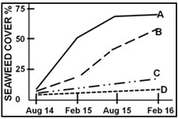

Which of the following observations are correct?

* + 1. Seaweed growth was equally regulated by grazing of limpets and sea urchin.
    2. Limpets had least impact on the seaweed growth.
    3. Sea urchins have higher grazing potential as compared to limpets.
    4. In this community, sea urchins are regulators of the seaweed growth.

# Rough Work