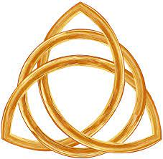

June 12, 2022

Trinity Sunday

Carson City United Methodist Church

10:30 am

Greeting/Announcements

Call to Worship

L: We praise you Lord maker of heaven and earth.

P: We acclaim you as Lord; with all creation we worship you.

L: To you all the angels, cherubim, and seraphim, sing in endless praise.

P: Holy, holy, holy Lord, God of power and might, heaven and earth are full of your glory.

L: The glorious company of the Apostles praise you.

P: The Noble company of all the prophets praise you.

L: The white robed multitude around your throne praise you.

P: Throughout the world your holy church praises you, God in three the Blessed Trinity.

*Hymn: Holy, Holy, Holy UMH 064

Opening Prayer: (unison)
We bind unto ourselves today the name, the strong name of the Trinity, by invocation of the same, the Three in One, the One in Three, of whom all nature has creation, eternal Father, Spirit, Word. Praise to the Lord of my salvation, salvation is of Christ the Lord. AMEN

Contemporary Song: I am (Mark Schultz)

Offering

Doxology UMH 95

Offertory Prayer

Sharing of our Joys and Concerns

Call to Prayer: Surely the Presence of the Lord
UMH 328

Pastoral Prayer

Gospel Reading: JOHN 17:20-23

Old Testament: GENESIS 1:2
Epistle Lesson: 2 PETER 1:19-21
Contemporary Song: Don’t Tread on Me
(We the Kingdom)

MESSAGE

*Hymn: When We All Get to Heaven UMH 701

Benediction

CCUMC – Announcements & Upcoming Events:

As a courtesy to others please silence or shut off cellphones

==================================================
IMPORTANT NOTICE: The church office will be closed Wed, Jun 15th and Thur, Jun 16th. Pastor Ian will be up North starting Tue, Jun 14th and will return Mon, Jun 20th. Pastoral duties will be handled by Pastor Larry Nalett. Should you need to contact Ian please call his cell @ 906-322-5318. Bonnie has carpal tunnel surgery on Jun 15th and will return Mon, Jun 20th. Bonnie will be checking email & voice mails from home during this time or call her cell @ 989-763-1674.
==================================================
Hall rentals for June: Sat, June 18th Sat, June 25th 10:00 am to ?
==================================================
Sun, June 12th is Peace with Justice Sunday. Peace With Justice Sunday is one of the special Sundays of The United Methodist Church. Each year on this special Sunday, United Methodists across the globe give offerings to promote peace all over the world. There are pamphlets located on the church Welcome Center or to give online go to
https://www.umc.org/en/content/peace-with-justice-sunday-ministry-article
==================================================
Vacation Bible School for 2022: July 17th to July 21st, 6:00-8:30 pm. We need crew leaders and helpers. Please contact Roberta Kile if you are willing to help. Register via email here: vbs.register@gmail.com Or call the office 989-584-3797.
==================================================
VBS Supplies needed: white flat sheets, cylindrical oatmeal boxes, tissue paper, pool noodles, boxes, brown packing paper. Please place in tub under the Monumental table.
==================================================
Church Picnic: Sun, Aug 7, 2022, following 10:30 am Worship Service. See the flyer located throughout the Church for more information.
==================================================
Christmas 2022 Service: With Christmas Day falling on Sunday for 2022 we would like to go with the following schedule so people can spend Christmas Day with family and friends. Please let us know your thoughts.
- Christmas Candlelight Service: 12/24/22 @ 7 pm
- Christmas Day Service: No Sunday Worship Svc

Serving & Supporting Sunday Worship
Audio/Video: Lauren Monroe

Joys, Concerns & Prayer Request
For those battling cancers:
Jim Dunlap, Carolyn Nykerk, Ray Seaman, Dillan Abell, Andrew Hogan, Amorena Newman-Wojciakowski

For those who need support, guidance or have health concerns: Mike Decker

Monthly Giving
5/29 $3479.35 6/5 $3298.84

Nursery Schedule
Open for the summer but no supervision

Lighting of Candles

Passing of Collections Plate

Our Church in Ministry This Week
Mon: PT Class 6:30-8 pm
Tue & Thu: COA Meal @ Noon

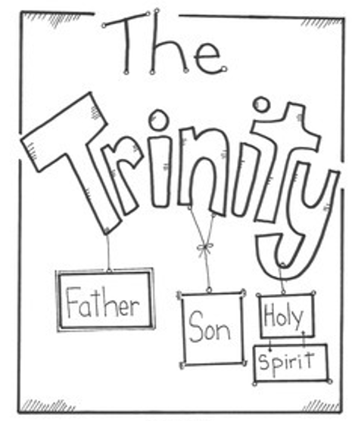
Coloring Page

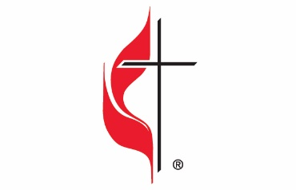

Carson City United Methodist Church
Location: 119 East Elm St., Carson City, MI
Mail: PO Box 298, Carson City, MI 48811
Phone: 989-584-3797 Email: carsoncityumc@gmail.com
Website: carsoncityumc.com
Sunday Worship Service: 10:30 am
Office Hours: Monday-Thursday, 9:00 am-12:00 pm
After hours by appointment
Pastor: Ian McDonald 906-322-5318
Secretary: Bonnie Seaman 989-763-1674

Weekly Sunday Bulletin now available on our website
@ www.carsoncityumc.com

“You are my calm in every rush, Father. Thank You for giving me Your peace as I continue to trust You”

