PUBLIC HEARING/REGULAR MEETING
FEBRUARY 19, 2014

A Public Hearing and the Regular Meeting of the Town Board of the Town of Hampton, County of Washington and the State of New York was held at the Town Hall, 2629 State Route 22A, Hampton, New York on the 19th day of February, 2014.

PRESENT: David K. O’Brien----------Supervisor
Tamme Taran--------------Councilwoman
David Jensen---------------Councilman
Donald Sady----------------Councilman
Andrea Sweeney-----------Councilwoman-came at 7:31pm
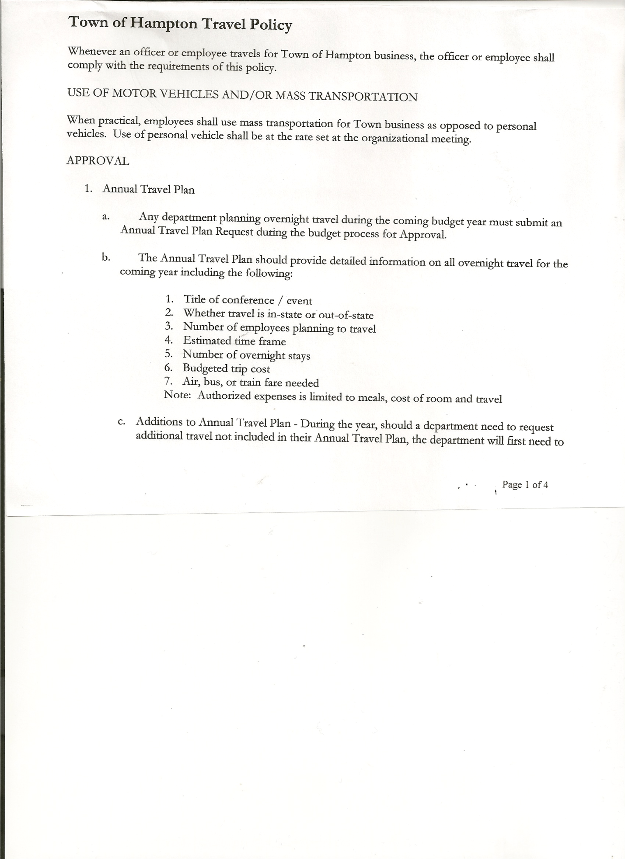
Rebecca Jones--------------Town Clerk
Herbert Sady, Jr.-----------Highway Superintendent

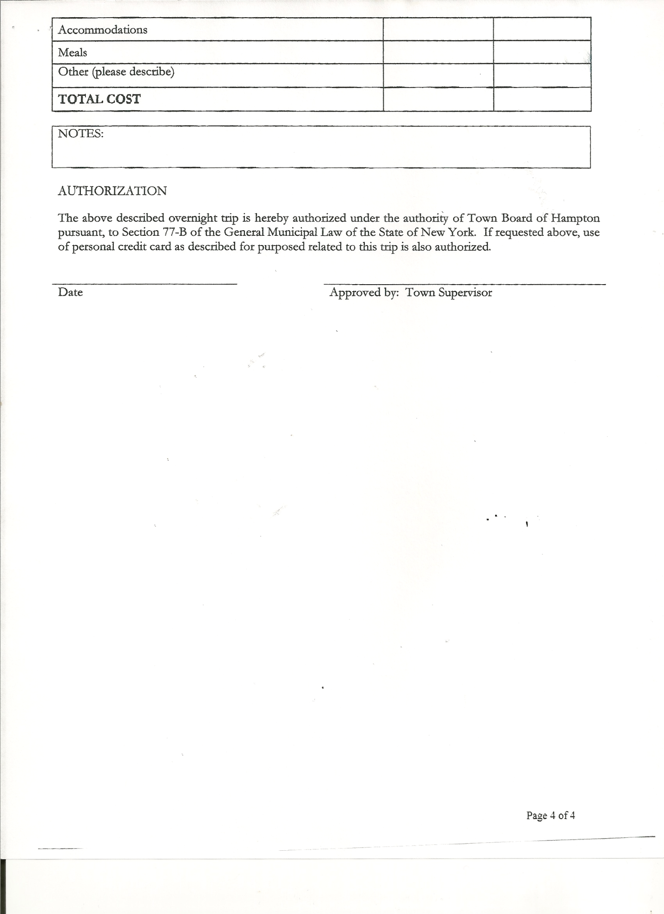
Planning Board Member(s): Bonnie Hawley, Chair

Also present: Frank Baker, Artie Pratt, Matthew Pratt and Nathan Saxton came at 8:14pm

The Public Hearing was called to order by Supervisor O’Brien at 7:29pm followed by the Pledge of Allegiance. Locations of Fire Exits were given. Legal Notice of hearing was read (copy is attached). Supervisor O’Brien asked for comments on proposed Local Law 1 of 2014. With no one desiring to speak, Supervisor O’Brien closed the hearing at 7:31pm.

Prior to the start of the regular meeting, Supervisor O’Brien presented Francis Baker with a slate plaque for his years of service to the Town of Hampton in various jobs.

REGULAR MEETING
The Regular Meeting was called to order by Supervisor O’Brien at 7:32pm.

Supervisor O’Brien asked for a moment of silence in memory of Arnold Mercier, a Hampton resident and former Highway Superintendent.

RESOLUTION NO. 19-2014
APPROVAL OF THE MINUTES
On a motion of Councilwoman Taran, seconded by Councilman Jensen, the following resolution was
ADOPTED: Ayes 5 O’Brien, Taran, Jensen, Sady, Sweeney
Nays 0
RESOLVED that the Regular Town Board Minutes for January 15th, 2014 and the Special Town Board Minutes for January 24th, 2014 be accepted.

Planning Board Report…Bonnie Hawley, Chair gave report
- Mobile Home Law.... reviewing comments and suggestions from Attorney with the Planning Board at their next meeting, which will be Tuesday, January 25th, 2014 at 7:00pm at the Town Hall

TOWN BOARD MEETING
FEBRUARY 19, 2014 PAGE 2

Larry Carman, Dog Control Officer submitted his report, which was read by Supervisor O’Brien…a copy is attached. Larry also submitted info on the “5th Annual DCO/ACO Conference 2014” that he would like to attend May 6th and 7th. Following a discussion of his estimated expenses, the board will consider paying the following:
- Conference fee of $50.00
- Mileage, total of 324 miles @.40cents a mile and
- 7 hours of lost wages @$14.00/hr…..for a total of $277.60. Supervisor O’Brien will discuss with Larry and advise Town Board of his decision.

Herbert Sady, Jr., Highway Superintendent gave his report: (a copy is attached)
- plowing and sanding roads
- Door was closed on the Loader and the glass was shattered… it is currently at Winmill Equipment being repaired
- Received 10 loads of sand from the County
- Received another load of salt
- Lowering snowbanks on the sides of the road and at the intersections.
- Continuing to do maintenance on equipment to keep it in good running order.

Discussed closing Staso Road in the wintertime, Supervisor O’Brien will speak with Town Attorney about the same and advise board. Also started discussing looking at new Highway Truck.

RESOLUTION NO. 20-2014
BUDGET AMENDMENT
On a motion of Councilman Sady, seconded by Councilwoman Sweeney, the following resolution was
ADOPTED by Roll Call Vote: Supervisor O’Brien AYE
Councilwoman Sweeney AYE
Councilman Sady AYE
Councilwoman Taran AYE
Councilman Jensen AYE
RESOLVED the following Budget Amendment to the General Fund is approved:
Increase Unexpended Balance in the amount of $10083.90
Increase Contingent Fund A1990.4 in the same amount of $10083.90

RESOLUTION NO. 21-2014
BUDGET AMENDMENT
On a motion of Councilwoman Taran, seconded by Councilman Jensen, the following resolution was
ADOPTED by Roll Call Vote: Supervisor O’Brien AYE
Councilwoman Sweeney AYE
Councilman Sady AYE
Councilwoman Taran AYE
Councilman Jensen AYE
RESOLVED the following Budget Amendment to the Highway Fund is approved:
Increase Appropriated Balance in the amount of $20909.42
Transfer to Equipment Reserve Fund DA9901.9 the amount of $20909.42

TOWN BOARD MEETING
FEBRUARY 19, 2014 PAGE 3

RESOLUTION NO. 22-2014
BUDGET AMENDMENT
On a motion of Councilman Sady, seconded by Councilwoman Sweeney, the following resolution was
ADOPTED by Roll Call Vote: Supervisor O’Brien AYE
Councilwoman Sweeney AYE
Councilman Sady AYE
Councilwoman Taran AYE
Councilman Jensen AYE
RESOLVED to move money left in Building Fund to the Garage Contractual Expense.

RESOLUTION NO. 23-2014
APPROVAL OF SUPERVISOR’S MONTHLY REPORT
On a motion of Councilman Sady, seconded by Councilman Jensen, the following resolution was ADOPTED Ayes 5 O’Brien, Taran, Jensen, Sady, Sweeney
Nays 0
RESOLVED the Supervisor’s Monthly report be accepted as submitted for JANUARY 2014
12/31/13 01/31/14
ACCOUNT BALANCE RECEIPTS DISBURSEMENTS BALANCE
General Fund $ 41083.90 $ 91246.42 $ 8200.21 $ 124130.11
Highway Fund $ 22909.42 $100004.59 $ 18455.63 $ 104458.38
Equipment Reserve $ 64161.28 $ 5.45 $ 0.00 $ 64166.73
Building Fund $ 1349.10 $ .11 $ 0.00 $ 1349.21
Fire #1 $ 0.00 $ 0.00 $ 0.00 $ 0.00
Fire #2 $ 0.00 $ 0.00 $ 0.00 $ 0.00
Totals $129503.70 $191256.57 $ 26655.84 $ 294104.43
All Board Members present signed Supervisor’s Report.

Pleasant Valley Infirmary has been sold, it is now Washington Center for Rehab and Health Care.

Town of Hampton’s 2013 Annual Financial Report has been filed with the Comptroller’s Office.

RESOLUTION NO. 24-2014

MOTION BY: Councilman Donald Sady
SECONDED BY: Councilwoman Tamme Taran

TITLE: RESOLUTION ADOPTING LOCAL LAW TO RESCHEDULE THE DATE FOR HEARING COMPLAINTS BY THE BOARD OF ASSESSMENT REVIEW

WHEREAS, pursuant to Section 512 of the Real Property Tax Law of the State of New York, the Town Board (the “Board”) of the Town of Hampton (the “Town”) has the authority to

TOWN BOARD MEETING
JANUARY 15, 2014 PAGE 4

adopt a local law rescheduling the date of hearing of complaints by the Board of Assessment Review pursuant to Real Property Tax Law Section 512; and

WHEREAS, the Board finds that this law is necessary to coordinate the hearing date with the schedule of the Town’s assessor who also works with neighboring municipalities in Washington County; and

WHEREAS, a local law has been drafted to reschedule such date of hearing of complaints; and

WHEREAS, notice of said public hearing was duly posted and then published in The Granville Sentinel and The Whitehall Times, the official newspapers of the Town of Hampton pursuant to and in conformance with Section 20 of the Municipal Home Rule Law; and

WHEREAS, said public hearing was duly held and all parties in attendance were permitted an opportunity to speak on behalf of or in opposition to the proposed Local Law.

NOW, THEREFORE BE IT RESOLVED by the Town Board of the Town of Hampton as follows:

Section 1. The Town Board finds that the proposed Local Law rescheduling the date for hearing of complaints by the Board of Assessment Review is in the best interests of the residents, inhabitants and guests of the people of the Town of Hampton.

Section 2. The proposed Local Law, copies of which are attached hereto and made a part hereof, is hereby adopted.

Section 3. The Law shall take effect immediately upon its filing in the Office of the Secretary of State.

Section 4. This resolution shall take effect immediately.

DATED: February 19, 2014 Supervisor O’Brien AYE
Councilwoman Sweeney AYE
Councilman Sady AYE
Councilwoman Taran AYE
Councilman Jensen AYE

TOWN BOARD MEETING
JANUARY 15, 2014 PAGE 5

Health Insurance….is all set, Town is saving between $4000 and $5000.

RESOLUTION NO. 25-2014
TOWN JUSTICE ANNUAL AUDIT
On a motion of Councilman Jensen, seconded by Councilwoman Sweeney, the following resolution was ADOPTED Ayes 4 O’Brien, Taran, Jensen, Sweeney
Nays 0
Abstain 1 Sady
RESOLVED that the Town Justice audit that was reviewed and completed on January 15th, 2014 be accepted.

RESOLUTION NO. 26-2014
TAX COLLECTOR, TOWN CLERK & SUPERVISOR’S ANNUAL AUDIT
On a motion of Councilwoman Taran, seconded by Councilman Sady, the following resolution was
ADOPTED Ayes 5 O’Brien, Taran, Jensen, Sady, Sweeney
Nays 0
RESOLVED that the Tax Collector, Town Clerk and Supervisor’s Annual Audits that were reviewed and completed in January 2014 be accepted.

RESOLUTION NO. 27-2014
TOWN OF HAMPTON INVESTMENT POLICY
On a motion of Councilwoman Taran, seconded by Councilman Jensen, the following resolution was ADOPTED Ayes 5 O’Brien, Taran, Jensen, Sady, Sweeney
Nays 0
RESOLVED that upon review by the Town Board, the above policy is approved for 2014.

The Town Clerk’s report for January 2014 was submitted to the Board. The Town Clerk had Board Members review and sign bank reconciliation statements for Town Clerk Account and Special Town Clerk Account dated January 31, 2014.

Deputy Tax Collector Jones submitted Tax Collector Report for January 2014.
She also had Board Members review and sign bank reconciliation statement dated Janauary 31, 2014.

RESOLUTION NO. 28-2014

AUDIT OF CLAIMS
On a motion of Councilman Sady, seconded by Councilwoman Taran, the following resolution was ADOPTED Ayes 5 O’Brien, Taran, Jensen, Sady, Sweeney
Nays 0
RESOLVED that the bills have been reviewed by the Town Board and are authorized for payment in the following amounts.
General Fund No. 23 through No. 43 $ 12046.94
Highway Fund No. 15 through No. 25 $ 5436.79
Total both funds $ 17483.73

TOWN BOARD MEETING
JANUARY 15, 2014 PAGE 6

RESOLUTION NO. 28-2014

AUDIT OF CLAIMS
On a motion of Councilman Sady, seconded by Councilwoman Taran, the following resolution was ADOPTED Ayes 5 O’Brien, Taran, Jensen, Sady, Sweeney
Nays 0
RESOLVED that the bills have been reviewed by the Town Board and are authorized for payment in the following amounts.
General Fund No. 23 through No. 43 $ 12046.94
Highway Fund No. 15 through No. 25 $ 5436.79
Total both funds $ 17483.73

RESOLUTION NO. 29-2014
VOUCHER CORRECTION
On a motion of Councilman Jensen, seconded by Councilwoman Taran, the following resolution was ADOPTED Ayes 5 O’Brien, Taran, Jensen, Sady, Sweeney
Nays 0
RESOLVED that a previous amount of $86.66 deducted from Personnel Contractual Expense A1430.4 now be deducted from Garage Contractual Expense A5132.4.

On a motion of Councilman Sady, seconded by Councilwoman Sweeney, the meeting adjourned at 9:08pm. All in favor Aye.

Respectfully submitted,

Rebecca S. Jones, RMC
Town Clerk

