SPECIAL MEETING
SEPTEMBER 26, 2023

A Special Meeting of the Town Board of the Town of Hampton, County of Washington and the State of New York was held at the Town Hall, 2629 State Route 22A, Hampton, New York on the 26th day of September, 2023.

PRESENT: David K. O’Brien-----------Supervisor
Donald Sady-----------------Councilman
Tamme Taran----------------Councilwoman
Andrea Kugler---------------Councilwoman
Michael Pietryka------------Councilman
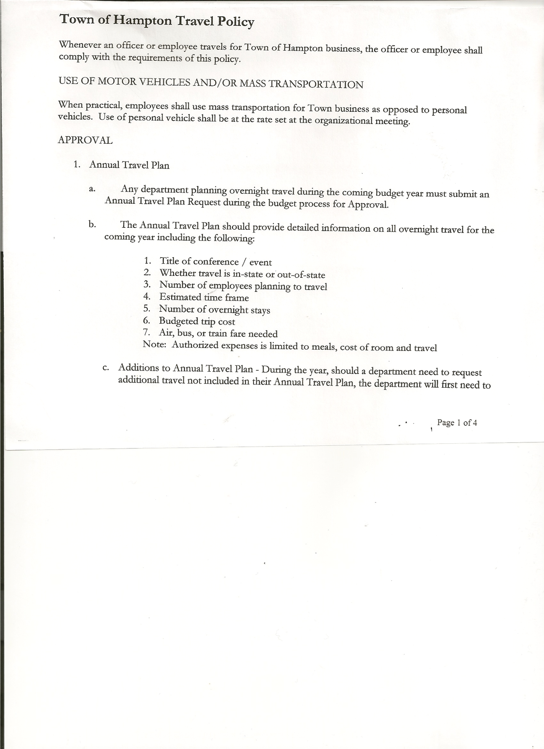
Rebecca Jones---------------Town Clerk
Camilla Shaw----------------Deputy Town Clerk
Tyler McClure---------------Highway Superintendent

Planning Board Member(s):…. Richard Cole and Matthew Pratt

Also present: see attached sheet

The Special Meeting was called to order by Supervisor O’Brien at 7:18pm, followed by the Pledge of Allegiance. Location of Fire Exits were given. Quorum of board members present.

Town Clerk Jones read the Legal Notice of the Special Meeting (copy attached), which was published in Manchester Newspapers on 09/21/23.

Supervisor O’Brien went over the Budget process.

Highway Superintendent Tyler McClure explained his need for an additional Highway Employee.

Fire Department budget and request submitted. Discussion of expenses and revenues.

The Town Board then discussed, reviewed and modified Tentative Budget.

RESOLUTION NO. 82-2023
ADOPTION OF TENTATIVE BUDGET
On a motion of Councilman Sady, seconded by Councilman Pietryka, the following resolution was ADOPTED: : AYES 5 O’Brien, Sady, Taran, Pietryka, Kugler
NAYS 0
RESOLVED, that the 2024 Tentative Budget be adopted and becomes the 2024 Preliminary
Budget for the Town of Hampton.

TOWN BOARD MEETING
SEPTEMBER 26, 2023 PAGE 2

RESOLUTION NO. 83-2023

MOTION BY: Councilman Donald Sady
SECONDED BY: Councilwoman Tamme Tarn

RESOLUTION INTRODUCING PROPOSED LOCAL LAW
TO OVERRIDE THE TAX LEVY LIMIT ESTABLISHED IN GENERAL MUNICIPAL LAW SECTION 3-c

WHEREAS, pursuant to Section 10 of Municipal Home Rule Law, the Town Board of the Town of Hampton (the “Town”) has the authority to adopt local laws; and

WHEREAS, pursuant to General Municipal Law Section 3-c, the Town Board of the Town of Hampton has the authority to adopt a budget that requires a tax levy that is greater than the tax levy limit for the coming fiscal year by adopting a local law by a vote of sixty percent (60%) of the total voting power of the Town Board of the Town to override such limit for such coming fiscal year only; and

WHEREAS, a proposed Local Law has been prepared by the Town Attorney, a copy of which is attached hereto; and

WHEREAS, the Town Board is desirous of proceeding with the review and consideration of this proposed Local Law.

NOW, THEREFORE BE IT RESOLVED that the proposed Local Law is hereby accepted for introduction to the Town Board. A public hearing shall be scheduled for the consideration of the proposed Local Law to be held by the Town Board on October 19, 2023 at 7:25p.m. at the Town Hall located at 2629 State Route 22A, Hampton, New York. Copies of the Local Law shall be available at the Town Clerk’s office for review; and be it further

RESOLVED, that the Town Clerk is directed to post and publish a notice of said public hearing in the Manchester Newspapers at least five (5) days before the hearing; and be it further

RESOLVED, that the consideration and proposed adoption of this Local Law is an action under the New York State Environmental Quality Review Act (SEQRA). The Town Board hereby declares that this action is a Type II action pursuant to 6 NYCRR 617.5(20) and (27) and declares that the action does not have a significant impact on the environment and the action is hereby precluded from further environmental review; and be it further

RESOLVED, that this resolution shall take effect immediately.

DATED: September 26, 2023 Supervisor O’Brien AYE
Councilman Sady AYE
Councilwoman Taran AYE
Councilwoman Sweeney AYE
Councilman Pietryka AYE

TOWN BOARD MEETING
SEPTEMBER 26, 2023 PAGE 3

RESOLUTION NO. 84-2023
PUBLIC HEARING ON HAMPTON FIRE DISTRICT NUMBER 1
On a motion of Councilwoman Kugler, seconded by Councilman Pietryka, the following resolution was ADOPTED: AYES 5 O’Brien, Sady, Taran, Pietryka, Kugler
NAYS 0
RESOLVED, to set the Public Hearing to discuss the proposed contract between the Town on behalf of the Town of Hampton Fire Protection District Number 1 and the Hampton Volunteer Fire Company for October 19th, 2023 at 7:00pm.

RESOLUTION NO. 85-2023
PUBLIC HEARING ON HAMPTON FIRE DISTRICT NUMBER 2
On a motion of Councilwoman Kugler, seconded by Councilman Pietryka, the following resolution was ADOPTED: AYES 5 O’Brien, Sady, Taran, Pietryka, Kugler
NAYS 0
RESOLVED, to set the Public Hearing to discuss the proposed contract between the Town on behalf of the Town of Hampton Fire Protection District Number 2 and the Hampton Volunteer Fire Company for October 19th, 2023 at 7:05pm.

RESOLUTION NO. 86-2023
PUBLIC HEARING ON PRELIMINARY BUDGET FOR 2024
On a motion of Councilwoman Kugler, seconded by Councilwoman Taran, the following resolution was ADOPTED: AYES 5 O’Brien, Sady, Taran, Pietryka, Kugler
NAYS 0
RESOLVED, to set the Public Hearing on the Preliminary Budget for 2024 for October 19th, 2023 at 7:10pm.

RESOLUTION NO. 87-2023
PUBLIC HEARING-PROPOSED LOCAL LAW TO OVERRIDE TAX CAP
On a motion of Councilwoman Kugler, seconded by Councilman Sady, the following resolution was ADOPTED: AYES 5 O’Brien, Sady, Taran, Pietryka, Kugler
NAYS 0
RESOLVED, to set a Public Hearing for October 19th, 2023 at 7:25pm on the proposed Local Law regarding overriding the Tax Cap.

RESOLUTION NO. 88-2023
MEETING ADJOURNED
On a motion of Councilman Sady, seconded by Councilwoman Kugler, the following resolution was ADOPTED: : AYES 5 O’Brien, Sady, Taran, Pietryka, Kugler
NAYS 0
RESOLVED, that the meeting adjourned at 9:30pm

Respectfully submitted,

Rebecca S. Jones, RMC
Town Clerk

