RSAI 2021 Legislative Priority:
Opportunity Equity for High-Poverty Students:
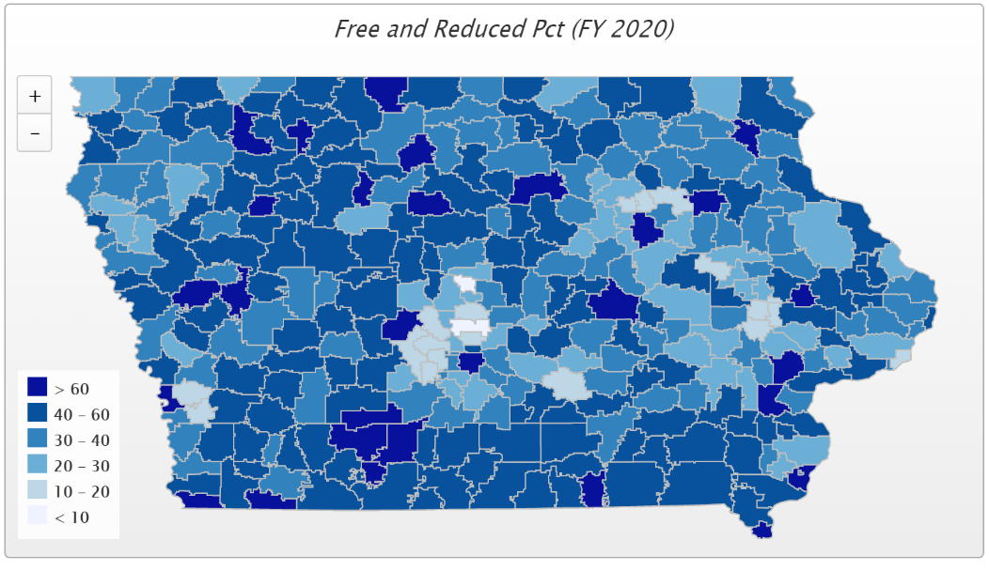
Background: Iowa’s funding formula does not sufficiently recognize poverty as a driver of at-risk student programing. In 2001, about 27% of students were eligible for Free/Reduced Price Lunch (FRPL), with the lowest district percentage of eligibility at 4.2%. That rate has increased significantly. Dropout Prevention funding is based on total enrollment, not the percentage of students at-risk. Although flexibility for the use of DoP funds has been expanded, DoP capacity is still limited to 2.5% of the total regular program district cost or up to 5% of regular program district cost based on historical practice.
The December 2019 School Finance Interim Committee passed a unanimous and bipartisan recommendation to study the impact of poverty on educational outcomes. The study was directed to review other states’ formulas that provide resources for students from low-income families which are showing successful student achievement outcomes for at-risk students. HF 2490 Poverty Weighting Study was approved with strong bipartisan support in the House Education Committee in the 2020 Session but received no further action. This bill serves as a good starting point for continued conversation.
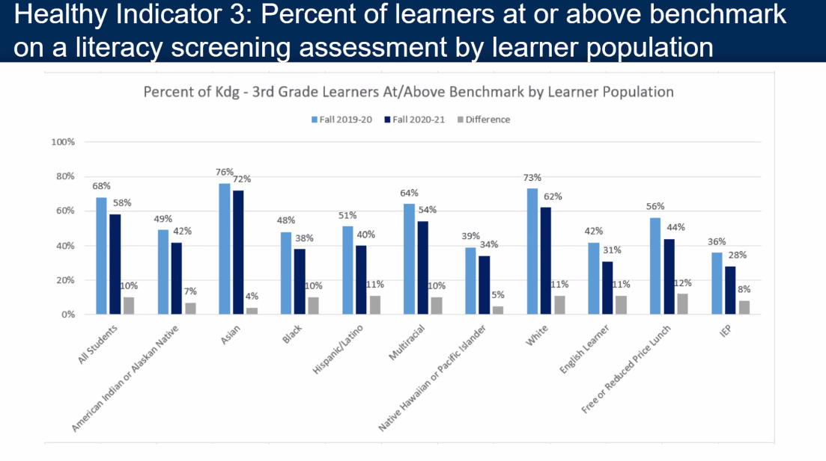
COVID-19 Impact: The Iowa State Board of Education received evidence of significant regression, or slide, in fall early literacy FAST testing in Iowa schools, due to school closure last March, including this chart by subgroup. It is no surprise that the low-income demographic group experienced the most significant learning loss, testing 12% below low-income early literacy performance in the Fall of 2019.

Additionally, quality preschool is proven to improve student learning and deliver a cost-benefit economic return down the road for taxpayers. Nationally, PK and Kindergarten enrollments dropped around 16-20% in Fall 2020, as parents just kept four-year-olds and five-year-olds at home for the year. Iowa’s funding formula does not protect districts from enrollment changes in preschool, meaning the fall of 2021 budgets will drop commensurate with the 2020 enrollment drop. Since school districts are prohibited from using general fund to pay for PK, there will be fewer PK slots available for students in the Fall of 2021 as a result. We do not know if parents of next year’s five-year-olds will want to enroll them in kindergarten or try to recover a year of PK experience, which is currently not funded for five-year-olds.
Current Reality: In FY 2020, 42.4% of students, or 205,947 children, were FRPL eligible, according to the Iowa Department of Education’s reporting.
- Poverty is now found throughout the state. It is indeed a rural challenge. The previous page’s map’s darkest color shows districts with 60% or more of enrolled students eligible for FRPL. Of the 77 school districts with more than 50% of students eligible, 68 are rural. In districts below 300 students enrolled, 49.9% of enrolled students are eligible.
- Iowa’s funding for at-risk and dropout prevention translates into less than 10% funding commitment for students in poverty, well short of the national average 29% beyond the base for low-income students. (AIR, Study of a new Method of Funding for Public Schools in Nevada, Sept. 2012)
- Students from low-income families are more likely to begin school academically behind, exhibit nonproficient literacy skills, especially in early elementary, and fall further behind over summer breaks, unless schools have the resources, staff and programs to meet their needs.
- Districts must waive student fees for FRPL-eligible families, meaning those districts with concentrated poverty have fewer resources for textbooks and drivers’ education, further stressing the general fund.
- High-poverty School Investments boosts achievement. Education Week, Student Outcomes: Does More Money Really Matter? Fresh research bolsters the case for K-12 cash—and a rough road without it, Daarel Burnette II, June 4, 2019 reports: "More money does, in fact, make a difference, they (researchers) say—provided that you spend enough, and in the right manner. They point to research in the past five years that provides examples of instances where politicians and taxpayers invested more money in teacher salaries, school construction, and schools with high populations of low-income students and saw students’ test scores jump.”
- The McCourt School of Public Policy, Georgetown, FutureEd, State Education Funding; The Poverty Equation, March 2020, states, “What’s more, when poverty is concentrated in a school—that is, when a significant portion of students in a school come from low-income households—the impact on performance is compounded. A body of research suggests that there is a ‘tipping point,’ somewhere between 50 to 60 percent of a school’s students living in poverty, where performance for all students there drastically declines.”
- Low-income rural students are an important piece of Iowa’s workforce puzzle, will stay in Iowa, and will either be the backbone of our rural communities’ potential or a drain on future resources.

Opportunity Equity: RSAI supports resources for at-risk students. Resources should be based on need, such as the percentage of students eligible for Free and Reduced Price Lunch (FRPL), in addition to enrollment of the district. The current disparity in dropout prevention capacity, (some districts held to 2.5% and others allowed to access up to 5% of regular program district cost) is arbitrary, based on history no longer relevant to supporting student needs. All school boards should be able to realize the full 5% dropout prevention funding. The formula must further recognize the disproportionate cost of providing equal educational opportunities to low-income students. School districts should be granted spending authority for FRPL eligible students’ fees mandated to be waived by state and federal law.
The COVID-19 experience has also shown us glaring differences among student home support. This includes both the ability to engage in learning based on lack of internet connectivity, as well as parents not being able to stay home to support required continuous learning because of work requirements to support their families. Experts anticipate a COVID-19 ripple effect which will increase achievement gaps.
RSAI supports full attention to and implementation of the December 2019 School Finance Interim Committee recommendation to study the impact of poverty on educational outcomes, including other states’ formulas that provide resources for students from low-income families which are showing successful student achievement outcomes for at-risk students. HF 2490 Poverty Weighting Study was approved with strong bi-partisan support in the House Education Committee in the 2020 Session serves as a good starting point for continued conversation.

