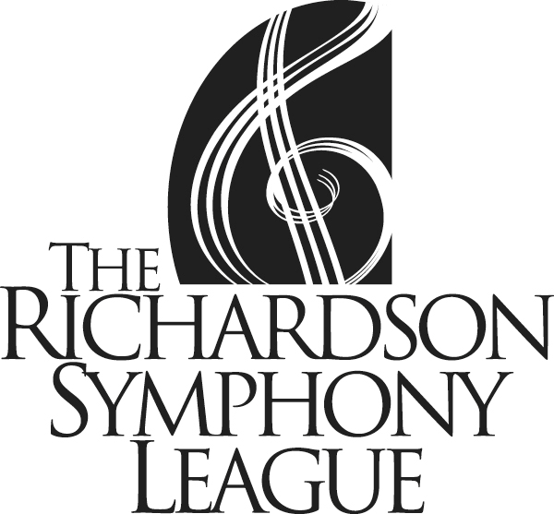

General
Debutante/Honor Guard General Information and Requirements

- Membership is limited to those in 9th through 12th grade
- Must have a league sponsor
- Debutantes/Honor Guards serve as ambassadors of the Richardson Symphony Orchestra and fine arts in Richardson

Requirements
- Must attend/work:
  - Three Deb/Honor Guard meetings
  - Two concerts
  - Two service events
  - Two Ball shifts

Expenses
- Membership dues (includes season concert tickets $125
- Fundraising obligation (due January 1st) $150
- Membership nametag (one time, unless replacing) $10
- Debutantes – Black concert dress attire Your personal budget
- Honor Guard – Black tux & shoes Your personal budget

