THE MOST HOLY TRINITY
JUNE 15 & 16, 2019
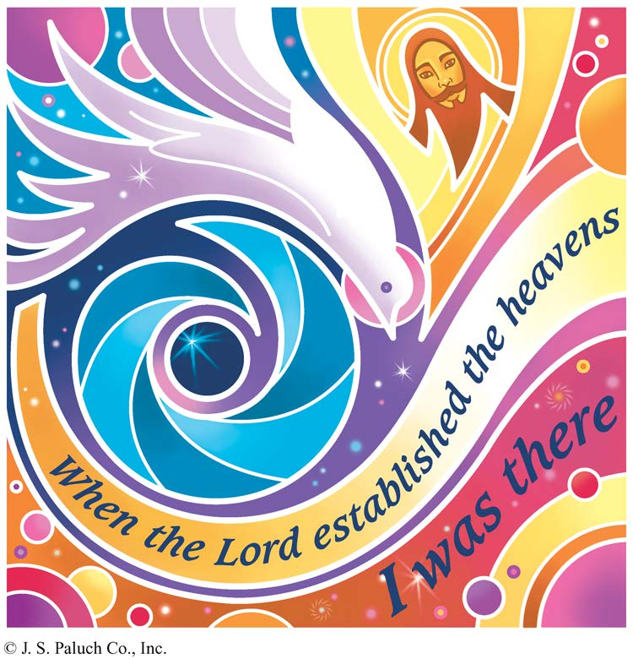
THIS IS THE HOLY TRINITY

Today, we celebrate the Solemnity of the Holy Trinity, one of the most confounding mysteries of our faith. Through this mystery, we experience our relationship to God: Creator, Savior, and Holy Spirit. This relationship is not easy to understand or to describe. It does not become clearer through analysis. Its complexity mirrors the complexity of all our relationships. We understand our relationships with our spouses, our children, our parents, and our friends only through daily give-and-take, annual rituals, and the life-changing moments we share. We understand our relationships only as we live them. The relationships we have with those we love, and who love us, sustain us through an uncertain and difficult life. This is the Holy Trinity.
What is striking about today’s readings is that each is incomplete. What they do offer is a description of a moment in our relationship, a memory of a time and an event when our relationship made sense even though that sense may be beyond our ability to describe fully. Often that is all that our faith offers, that is, a memory of what is possible, what is promised, what has been given. A memory of eternity, of love beyond understanding is to be cherished and nurtured even if not fully understood. This is the Holy Trinity.

FIRST DEATH
By Dennis Tavares

Hundreds of years after God removed them from their idyllic garden called Eden because of their disobedience, the first humans - Adam and Eve – finally experienced the death God told them they would encounter as a consequence of their sin. Abel, their son who took care of the sheep flock, didn’t come home from afield as usual. They searched and found him with blood on him from a wound. They thought he was asleep since they did not know of death. They tried to wake him and make him talk, but nothing worked. Finally they realized what God had meant, when He told them of death, and they were troubled and sad. They learned the terrible lesson that the consequences of sin fall both on the sinner and also on others. But merciful God told them to hope for a redeemer who would correct their mess.

PASTORAL RUMMINATIONS
By Father Andre

Finding fault and criticizing others is easier than discovering their good traits and praising them. Improving our relationship with people who cross our path is primordial if we are to survive a dog-eat-dog society rife with division and competition. More so for Christian disciples like us who are tasked with loving and caring for the welfare of our neighbor.
This Sunday, Father’s Day, is Fr. Lou Nichol’s 87th birthday. Would it not be more appropriate for the OLGC Parish to honor Father Lou, a just and righteous man, who enters a new life phase as he retires from active priestly ministry on June 24th?
Many times he has supported our Parish by making himself available to celebrate Mass in my absence and hear confessions on different liturgical seasons.
Once Father Lou even offered to purchase our church and rectory cleaning supplies without charging us anything. Known for his generosity to a fault, he has accommodated at least two persons to live with him in the rectory gratis. I also noticed that whenever Father Lou and I dined at the Mendocino Hotel, he always stopped to exchange pleasantries with the less fortunate. Likewise he showed his respect for a younger colleague like me, as he never failed to amiably introduce me to his numerous friends and acquaintances. Thus, through the years, our brotherhood has evolved into a personal friendship.
Sometimes driving him to various Diocesan events gave me a better insight into Father Lou’s person. Although he still belongs to the Diocese of Syracuse, New York, he never missed any of the presbyteral workshops and gatherings. That for me is an amazing feat!
In reality, a priest never retires; he just creatively reinvents himself. One way or the other, this faithful servant of God would always be in demand given the current situation of priest supply shortage in our Diocese. I only wish the best for Father Lou Nichols, a friend and a brother priest. Tu es sacerdos in aeternum! A Priest forever!
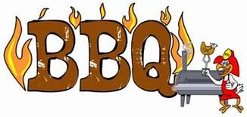
Our Lady of Good Counsel’s 65th Annual Church BBQ and Parish Carnival is Sunday, August 4th.
By OLGC BBQ Fundraiser Team

Please join us for a great day of community and family fun.
Dinner is served from 11am until 5pm or until chicken is sold out.
Unable to join us that day? Worry not. You may still support the Parish by purchasing dinner tickets, or kids bracelets for unlimited rides. Father Andre will see to it that deserving families in our Parish receive a free meal and/or all-day ride bracelets on August 4th.
All proceeds from this event will be used to finance our Parish year long up keep and various ministries.
Your generous donations are much appreciated!
Likewise the helping hands of volunteers create the miracle of fun, camaraderie and community.
No one has to do a lot, if everyone does a little.
Thank you and God bless you and your family.

SUMMER CAMP

July 10-12 from 9:00am-2:00pm.
For children in grades 1-8.

Come join us for fun activities and crafts, games, prayer and Mass with the OLGC Youth Group as we learn how to worship God with our
Mind, Body, and Spirit.
Lunch and snacks will be provided.
Register Now!
Cost: $20/student or $30/family.
Forms will be available in the vestibule. Please return them to the office or contact
Yesenia Huerta at (707) 357-6512.

A CALL TO ACTION
WE ARE UPDATING OUR PARISH REGISTRATION LIST.
PLEASE TAKE A FORM AND GIVE US YOUR CURRENT INFORMATION.
YOU CAN PUT IT IN THE COLLECTION BASKET, RETURN IT TO THE OFFICE, CALL US AT 707-964-0229 OR E-MAIL US AT olgcinfb@gmail.com.

OUR SILENT AUCTION NEEDS HELP

WE ARE ASKING EACH FAMILY TO CONSIDER MAKING A BASKET OR DONATING AN ITEM FOR THE AUCTION.
SOME SUGGESTIONS ARE: A SPA BASKET, MOVIE NIGHT BASKET, TOURIST BASKET, OR; ARTWORK, JEWELRY, AND VARIOUS TYPES OF WOODWORK, ETC.

ATTENTION: WE NEED DONATIONS OF EGG SHELLS FOR OUR CHICKEN BBQ CARNIVAL.
YOU CAN BRING THEM TO THE OFFICE FROM
MONDAY – FRIDAY AND 10AM – 2PM.

DIOCESAN SUMMER WORKSHOP
LAST WEEKEND, THE WRONG DATES FOR THE DIOCESAN PRIESTS SUMMER WORKSHOP WERE INADVERTENTLY ANNOUNCED. THE CORRECT DATES ARE FROM MONDAY TO THURSDAY, JUNE 17 – 19, 2019. NO MASSES WILL BE CELEBRATED ON WEDNESDAY & THURSDAY, JUNE 19TH AND 20TH.
ALL MASS INTENTIONS FOR THOSE DAYS WILL BE MOVED TO FRIDAY, JUNE 21ST AT 12:05PM.
WE APOLOGIZE FOR ANY INCONVENIENCE.
PRAY FOR OUR FAMILY AND FRIENDS THAT ARE
IN THE MILITARY SERVICE
Rebecca Sánchez, José Araiza Jr., Edgar Toscano, Marina González, Alondra Jara, Sonia Jara, Jason Lorenz,
Matt Mill & Jared Schroeder.

MASS INTENTIONS
JUNE 19 - 23, 2019
Wednesday (19)  Thursday (20)  Friday (21)  Saturday (22)  Sunday (23) | 12:05pm  12:05pm  12:05pm  5:00pm  6:30pm  8:00am  10:00am | NO MASS  NO MASS  Ruby Burns †  Lois & Antonietta Filosi †  Robert “Bob” Bartalini †  Fred & Clara White †  Deceased Memebers of the Wooden Family  María Ramírez †  Pacita Tan †  Maria Madalena De Freitas †

READINGS OF THE WEEK
Monday: 2 Cor 6:1-10;Ps 98:1,2b, 3-4; Mt 5:38-42
Tuesday: 2 Cor 8:1-9;Ps 146:2,5-9a; Mt 5:43-48
Wednesday: 2 Cor 9:6-11;Ps 112:bc-4, 9; Mt 6:1-6,16-18
Thursday: 2 Cor 11:1-11; Ps 111:1b-4, 7-8; Mt6: 7-15
Friday: 2 Cor 11:18,21-30;Ps 34:2-7;Mt6: 19-23
Saturday: 2 Cor 12:1-10; Ps34: 8-13;Mt6: 24-34
Sunday: Gn 14:18-20;Ps 110:1-4; 1 Cor 11:23-26;
Lk 9:11b-17

WEEKLY COLLECTION
JUNE 8 & 9, 2019…..$1,898.50
MAINTENANCE FUND….$728.00
THIS WEEKEND’S SECOND COLLECTION:
PRIESTS BENEFITS AND WELFARE
NEXT WEEKEND’S SECOND COLLECTION:
YOUTH MINISTRY
THANK YOU
FOR YOUR SUPPORT & CHRISTIAN GENEROSITY.

PLEASE PRAY FOR OUR SICK PARISHIONERS
Karma Mendez, Juan Hernández, Frank Richards, Richard Braga, Lisa Wright, Ricardo Contreras, Florencia Chávez, Refugio Yáñez, Tarcicio García, Sofía García, María de Jesús Mendoza, Antonio Cazares, Ana García, Ryan Moore, Jane Vartanian, Marianne Brannan, Lilia Parrish, Nancy Smith, Julián Palomar, Luisa Martínez, Jennifer Vera, John Braet, Kim Koskinen, Margaret Valencia, Matthew Marcoulier, Dennis Tavares, Jose Freitas, Alfredo Sousa, Juana Ar reguín, Aron Yasskin, Victoria Walzer, Fidela Yáñez Jara, Erika Ramos, Bill Gibson, Carla Tomas, Erasmo Yáñez, Memo Soria, Patricia Vargas, Fidela Yáñez, Elvia Flores, Yonel Ruíz, Angie Freitas, Russel Bryant, Derrick Heater, Luis Angel, Juan Barrera-Terán, Gabriel Hurtado, Gerald Butler, Helen Reynolds, Toni Clark, Ann Gallagher, Brianna Lopez, Margaret Milliken, Gina Pivirotto, Nick Quin, Mary Servis, Denis Sousa, Victor Venegas, Matty Walker, Charles Lorenz, Rebecca Lorenz, Ofelia Ibarra, Leonardo Naal, Gina Leal.

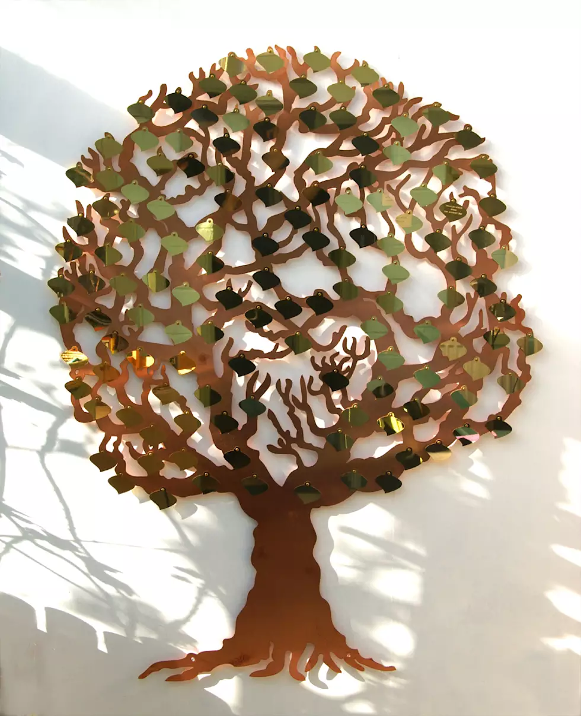
OLGC’S MEMORIAL TREE
In the vestibule of the Church, on the southern wall, is a beautiful Memorial Tree.
Its bright leaves represent permanent memorials to the departed of our Parish.
For the sum of $200.00, you can give to the Parish Secretary, the correct spelling and dates of the departed and in due time the leaf is printed and attached to the tree: a permanent reminder of a loved one who is gone.
For more information, call the Parish Office at
964-0229.

