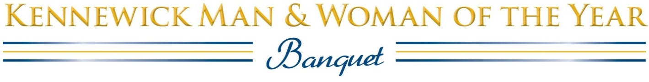
Three Rivers Convention Center • Monday, February 24, 2020
Social 6:00 P.M. (No host bar) • Dinner 6:30 P.M • Awards Ceremony to Follow

 | I would like to reserve _____ Banquet tickets at $40 each
 | I would like to reserve _____ Sponsored Tables of 8 at $400 each (Up to 2 added guests @ $40 each)
This sponsorship includes a table for eight, best-possible placement. You will also be recognized from the podium and in the keepsake program.

 | I would like _____ Special Table Recognition(s) at $75 each (Tickets must be purchased separately.)
 | You or your organization will be recognized in the program and with a table sign as the sponsor of a table of friends or colleagues who have purchased individual tickets. Perfect for service clubs or groups of friends. Please give us a list of those who wish to be seated at your table.
 | My check for $ __________ is enclosed |  | Please charge my credit card $__________
MC/VISA/DISCOVER CARD NUMBER: __________________________________________________
Verification Code (three numbers on back of card) ___________ EXP DATE: ___________________
Name on card:____________________________ Signature: ________________________________
Billing address: ______________________________________________________________________
City: _______________________________________ State: ________ Zip: __________________
Daytime phone: ______________________________ e-mail: _______________________________
Table of 8 or 10 sponsored by: ___________________________________________________________
Reservations must be paid no later than Thursday, February 20,2020
Attendees:
This meal is NOT gluten-free, to request dietary restrictions, note here:
1. | MENU  Chicken Cordon Bleu  with Mornay sauce  Garlic Mash Potatoes  Seasonal Vegetables  Assorted desserts  Coffee, Iced tea, Water  no-host bar
2.
3.
4.
5.
6.
7.
8.
9.
10.
Please return completed form to:
Kennewick Man & Woman of the Year FAX: 509-491-1291
PO Box 3905 e-mail: kennewickmen_women@charter.net
Pasco, WA 99302 Questions: 509-987-5822

