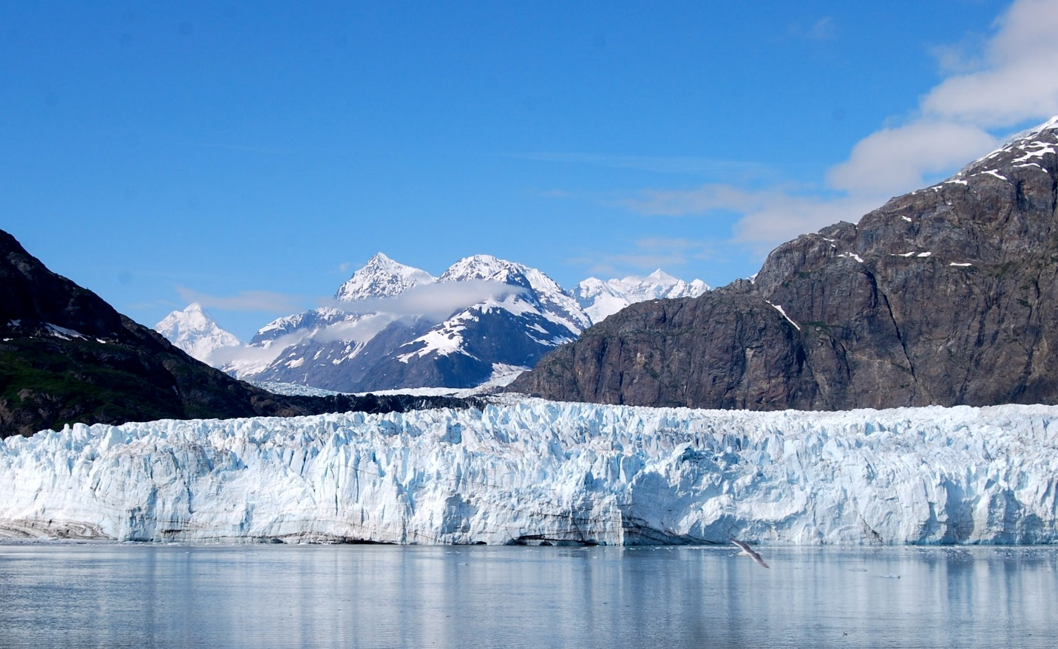
This Photo by Unknown Author is licensed under CC BY-SA

Day 7: Pray for Our Ancestors the Glaciers and Act on Their Behalf
In The Future of Ice: A Journey into Cold, Gretel Ehrlich, a skilled nature writer, laments the loss of glaciers thanks to global warming:
“A glacier is an archivist and historian. It saves everything no matter how small or big, including pollen, dust, heavy metals, bugs, bones, and minerals. It registers every fluctuation of weather. A glacier is time incarnate, a moving image of time. When we lose a glacier – and we are losing most of them – we lose history, an eye into the past; we lose stories of how living beings evolved, how weather vacillated, why plants and animals died. The retreat and disappearance of glaciers – there are only 160,000 left – means we’re burning libraries and damaging the planet, possibly beyond repair. Bit by bit, glacier by glacier, rib by rib, we’re living the Fall.”
Say a prayer for humanity and the nations of the world to wake up and see the havoc being created by our pollution. For 20,000 years we have lived in “an interglacial paradise” and now we face the loss of these glaciers and the wildlife in the Artic regions. Continue your prayers by actively lending your support to groups working to halt the pernicious forces behind global warming.

