WINDLESTONE PARISH COUNCIL

7 Front Street, Bishop Middleham, County Durham. DL17 9AJ
Tel: 07808062525 Email: karenyoung311@yahoo.com

ORDINARY MEETING

Time: 6.00pm Date: Thursday, 7th December 2023 Venue: Hutton House, Chilton

Dear Councillor, you are hereby summoned to attend the above meeting at which the following business will be transacted.
AGENDA

- Welcome by the Chair
The Chair to open the meeting and make any necessary announcements.

- Apologies for Absence
To receive apologies for absence

- Declarations of Interest
To notify of items that appear on the agenda in which Members may have an interest

- Minutes
To Approve the Minutes of the Ordinary Meeting of Windlestone Parish Council held on 31st August 2023 as an accurate record (attached).

- Matters Arising from the Minutes
To clarify or provide an update regarding any matter recorded in the Minutes of the Meetings held on 31st August 2023.

- Public Participation
To invite representation from Members of the Public.

- Finance
- To approve and make payment for Expenditure incurred.
- To consider the Parish Precept for 2024-2025.

- Planning
To consider any matters in relation to Planning Applications submitted to the Local Authority in the Parish.

- Correspondence
To consider and report any correspondence received.

- Update RE: Eden Arms
To receive an update regarding the Eden Arms

- Update RE: Rushyford Roundabout
To receive an update regarding Rushyford Roundabout

- Definitive Map/Public Footpaths
Update from Members RE: Lapsed footpaths in the Parish

- Date & Time of Next Meeting
To agree the date and time of the next Meeting
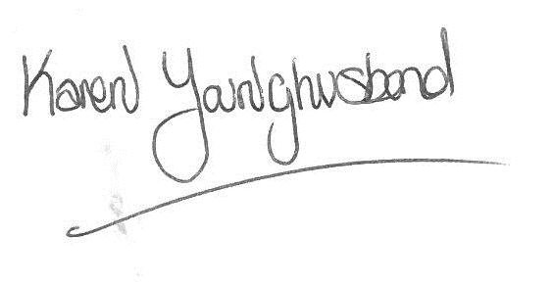
Karen Younghusband
Clerk Windlestone Parish Council

