  - 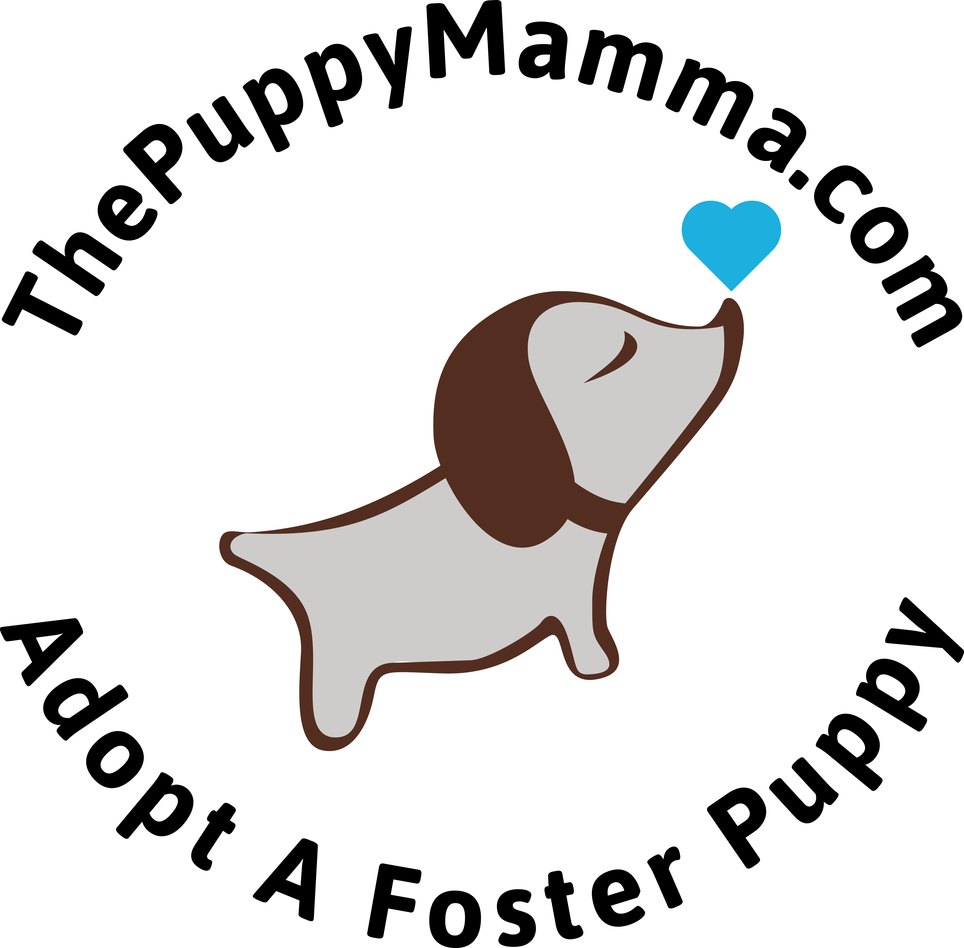
The Puppy Mamma is a Non-Profit, 501(c)3 organization that rescues and fosters pregnant dogs and puppies. We provide nurturing, compassion and care to puppies and their mammas until they find their fur-ever homes.
Pregnant dogs often come to us from County Animal Care and Control and we provide them with a foster home setting in which to have their puppies where they can feel safe and calm, and be pampered and loved. We rescue at-risk puppy litters to ensure spay and neuter practices are continued to prevent future abandoned puppy litters. Mamma dogs and puppies do not leave our safekeeping until they are spayed/neutered, vaccinated and micro-chipped.
We are an all volunteer run organization and we rely solely on the kindness and generosity of animal lovers who open their hearts and homes to help us take care of animal orphans that desperately need help. We are 100% donation funded and your support is necessary for our continued success.

Tap here to add a caption

A MESSAGE FROM OUR FOUNDER
When I decided to start The Puppy Mamma I had no idea what I was getting myself into. I did, however, know one thing. . . I needed to surround myself with the best of the best to help me. I have the most wonderful volunteers, fosters, donors and affiliated organizations there are. Because of them we are able to attract the best adopters. That was the beginning of our success.
The Puppy Mamma received its 501(c)(3) status on April 7. In the 9 short months we have been operating there have been ups and downs. In July we took in a litter of 5 puppies who all, unknown to us at the time, had parvo. Through the generosity and hard work of one of our fosters, 3 of them survived and have been placed in loving forever homes. In July we got a call from Gila County Animal Care and Control asking us to take in 11 puppies. As a new rescue we were financially broke at the time but I said I would come and get them anyway. I knew I had the best donors and affiliated organizations and would be supported in order to feed, spay/neuter, vaccinate and microchip them. Not only did our donors step up to help but so did our fosters. All 11 were successfully adopted and are now with their new loving families.
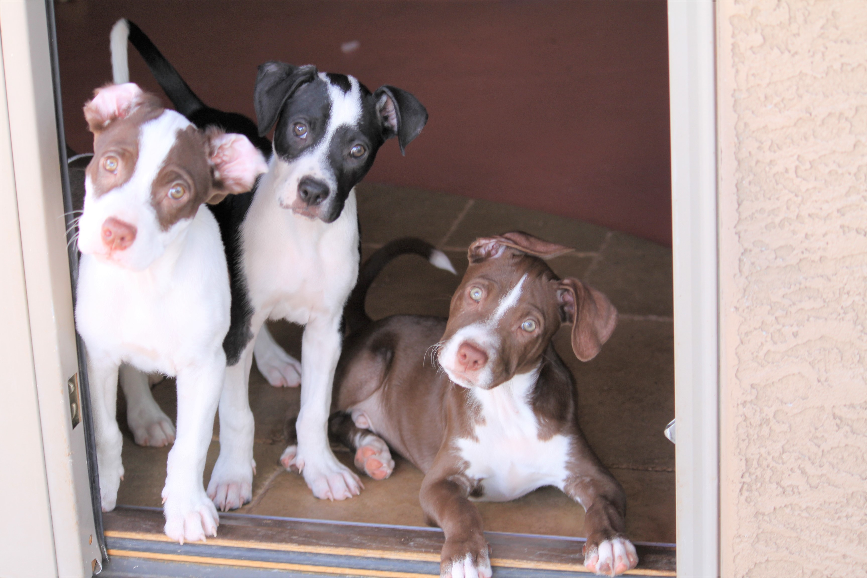
The Parvo Survivors – Bagel, Jelly & Toaster
In August we encountered our first challenging situation with an adopter. Her puppy got very sick immediately after she took him home. I was able to pick up the puppy from her and place him with one of our most nurturing fosters until he was fully recovered. At that time we reunited him with his very grateful adopter. She now keeps our foster updated with pictures of him thriving and growing into adulthood.
In August we picked up a very pregnant Eleanor from Pinal County Animal Care and Control and she had her puppies 2 days later. She was full of ticks, had severe infections in both ears, an upper respiratory infection, a yeast infection and an entropian eye that required surgery. We were constantly picking ticks out of the whelping box when she had her puppies and the yeast and respiratory infections were spread to the puppies as they nursed. Mom and puppies went on antibiotics immediately. Because she was so malnourished her puppies had to be supplemented with bottle feedings twice a day. Once again, we had the best volunteers to help throughout this recovery process, and all 9 of Eleanor’s puppies were placed in their forever homes.
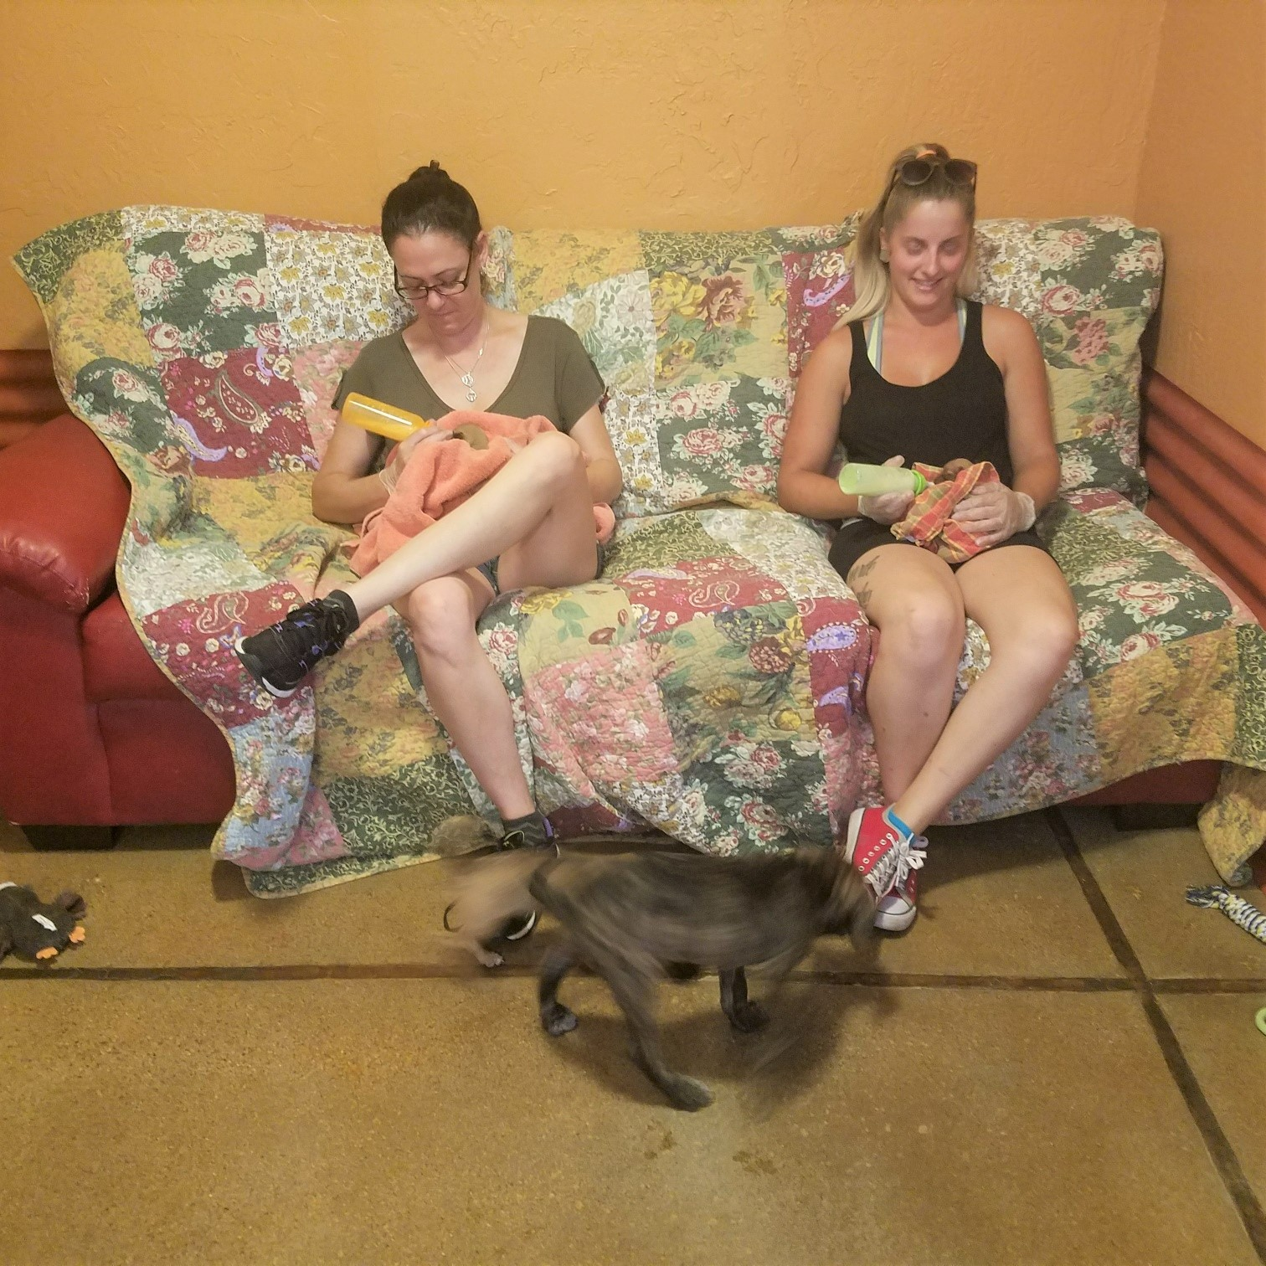
Volunteers Bottle Feeding and Supervising Puppy Play

In between all of this, we were rescuing, nurturing and adopting into great homes a myriad of other puppies that come to us through various avenues. Some of them were healthy and some were not. Many of the older ones we took in needed much socialization and all of them needed lots of love. Our volunteers and fosters work hard to ensure that when the puppies leave our care for their forever homes they are healthy and happy.

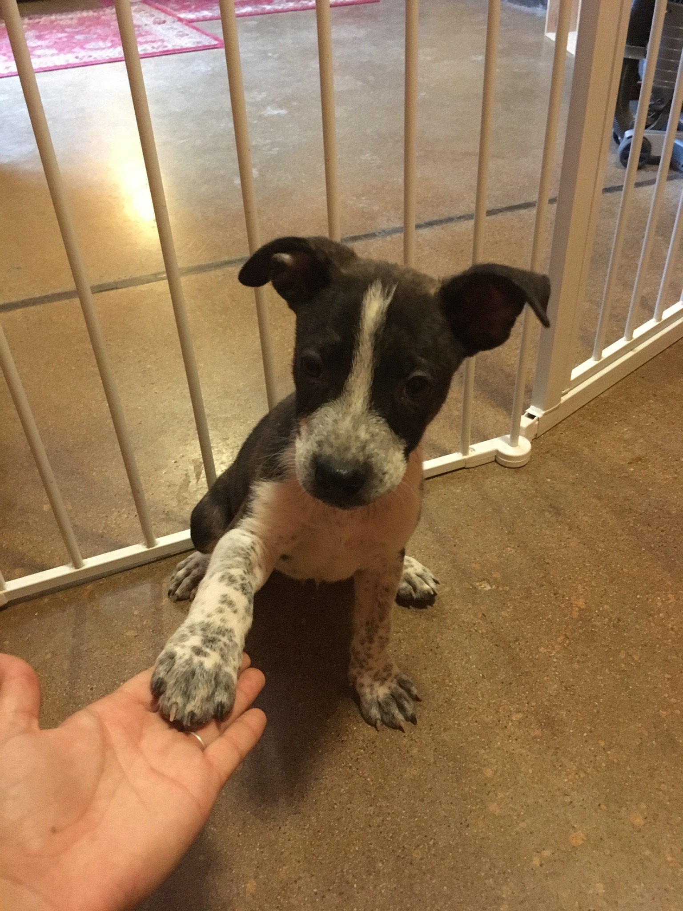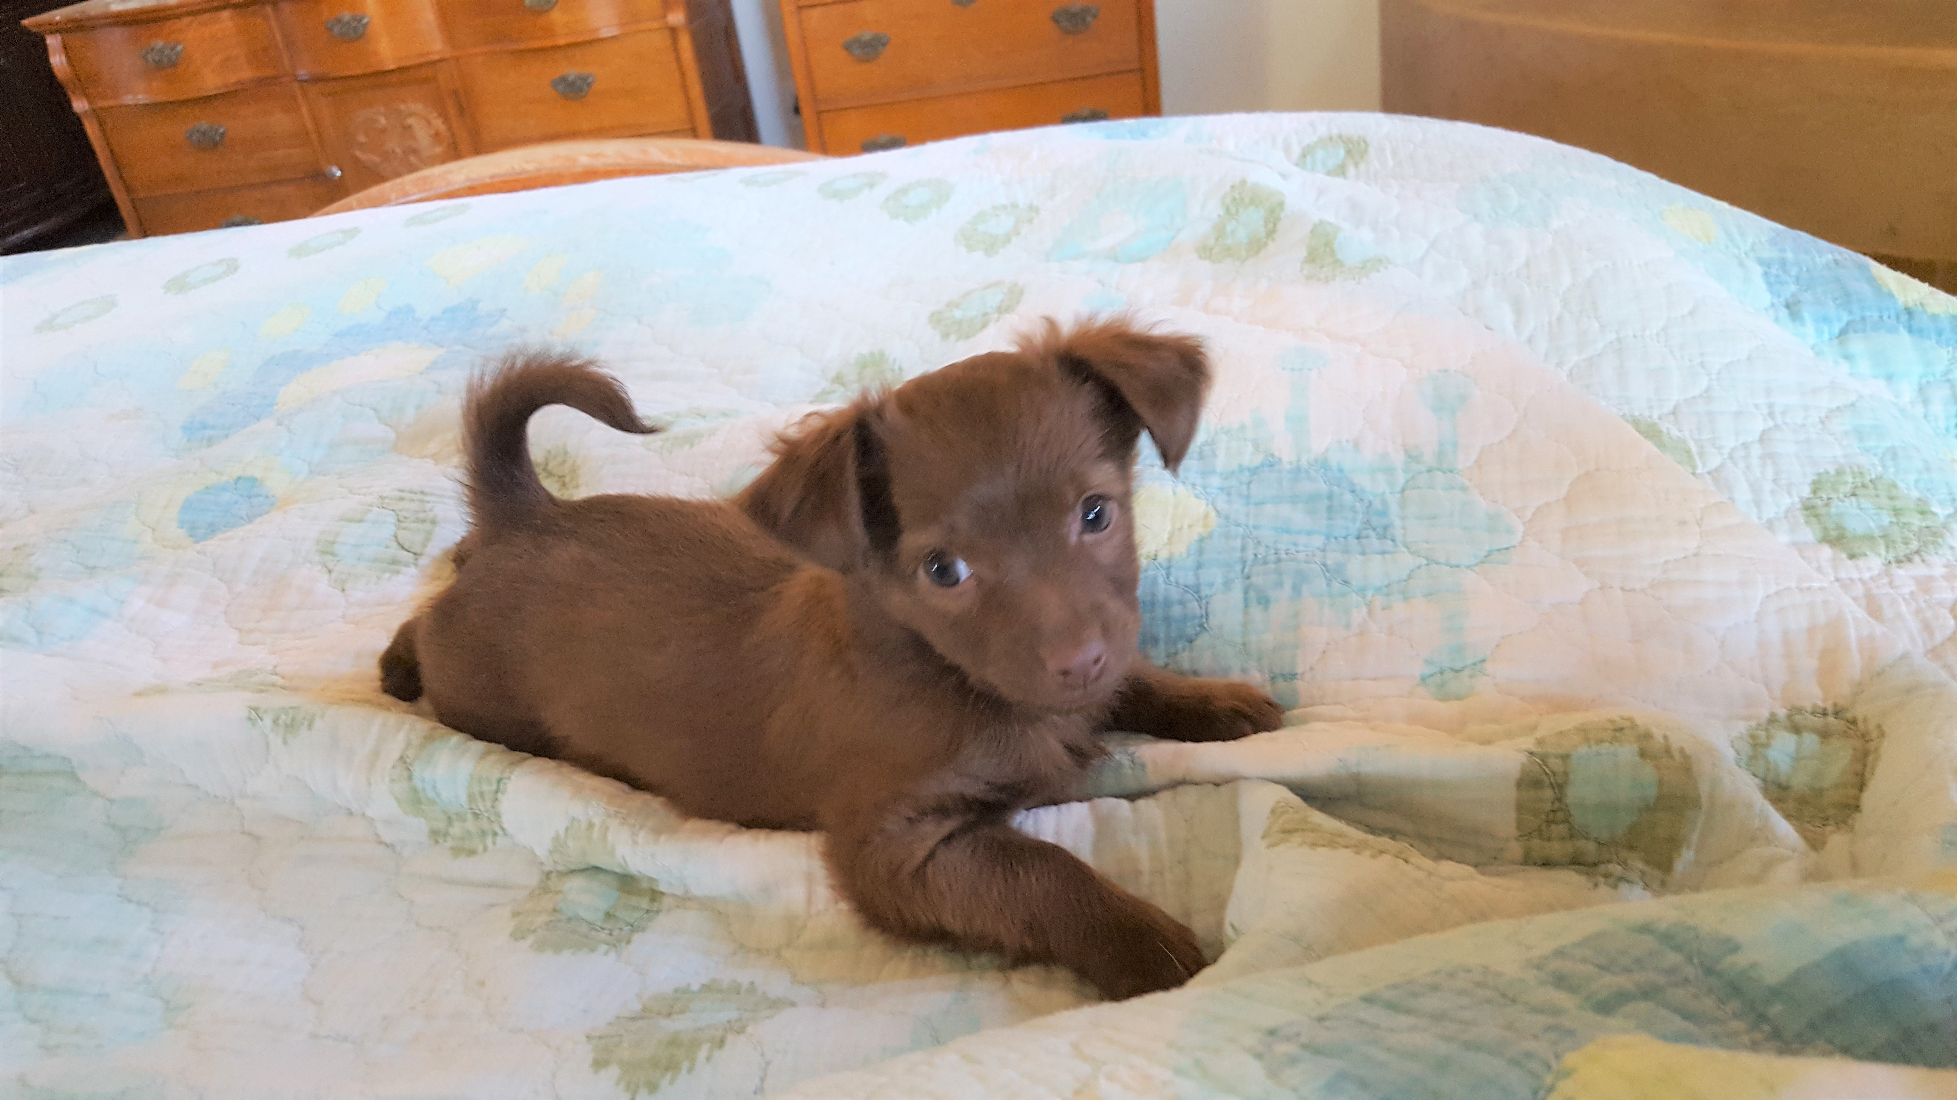
Buck now Tequila Autumn

Through all the tears, laughter and 54 successful adoptions in the span of 9 months, this has been the most rewarding thing I have done in my life. Dogs have always been a part of my life, but never more so than they are now. Each day I wake up feeling grateful and blessed to have the opportunity to help so many dogs. I have met so many wonderful people who have adopted puppies and adult dogs from us. My fosters and volunteers have become cherished friends, if they weren’t already. Many of the people from other organizations that help The Puppy Mamma have also become friends and confidants in the fight to spay and neuter all puppies and dogs to stop unwanted litters.
Thank you to each and every one of you that helped to make our first year a success and there is no doubt in my mind that we will be even more successful in 2018.

Sandy Webb
Founder
The Puppy Mamma
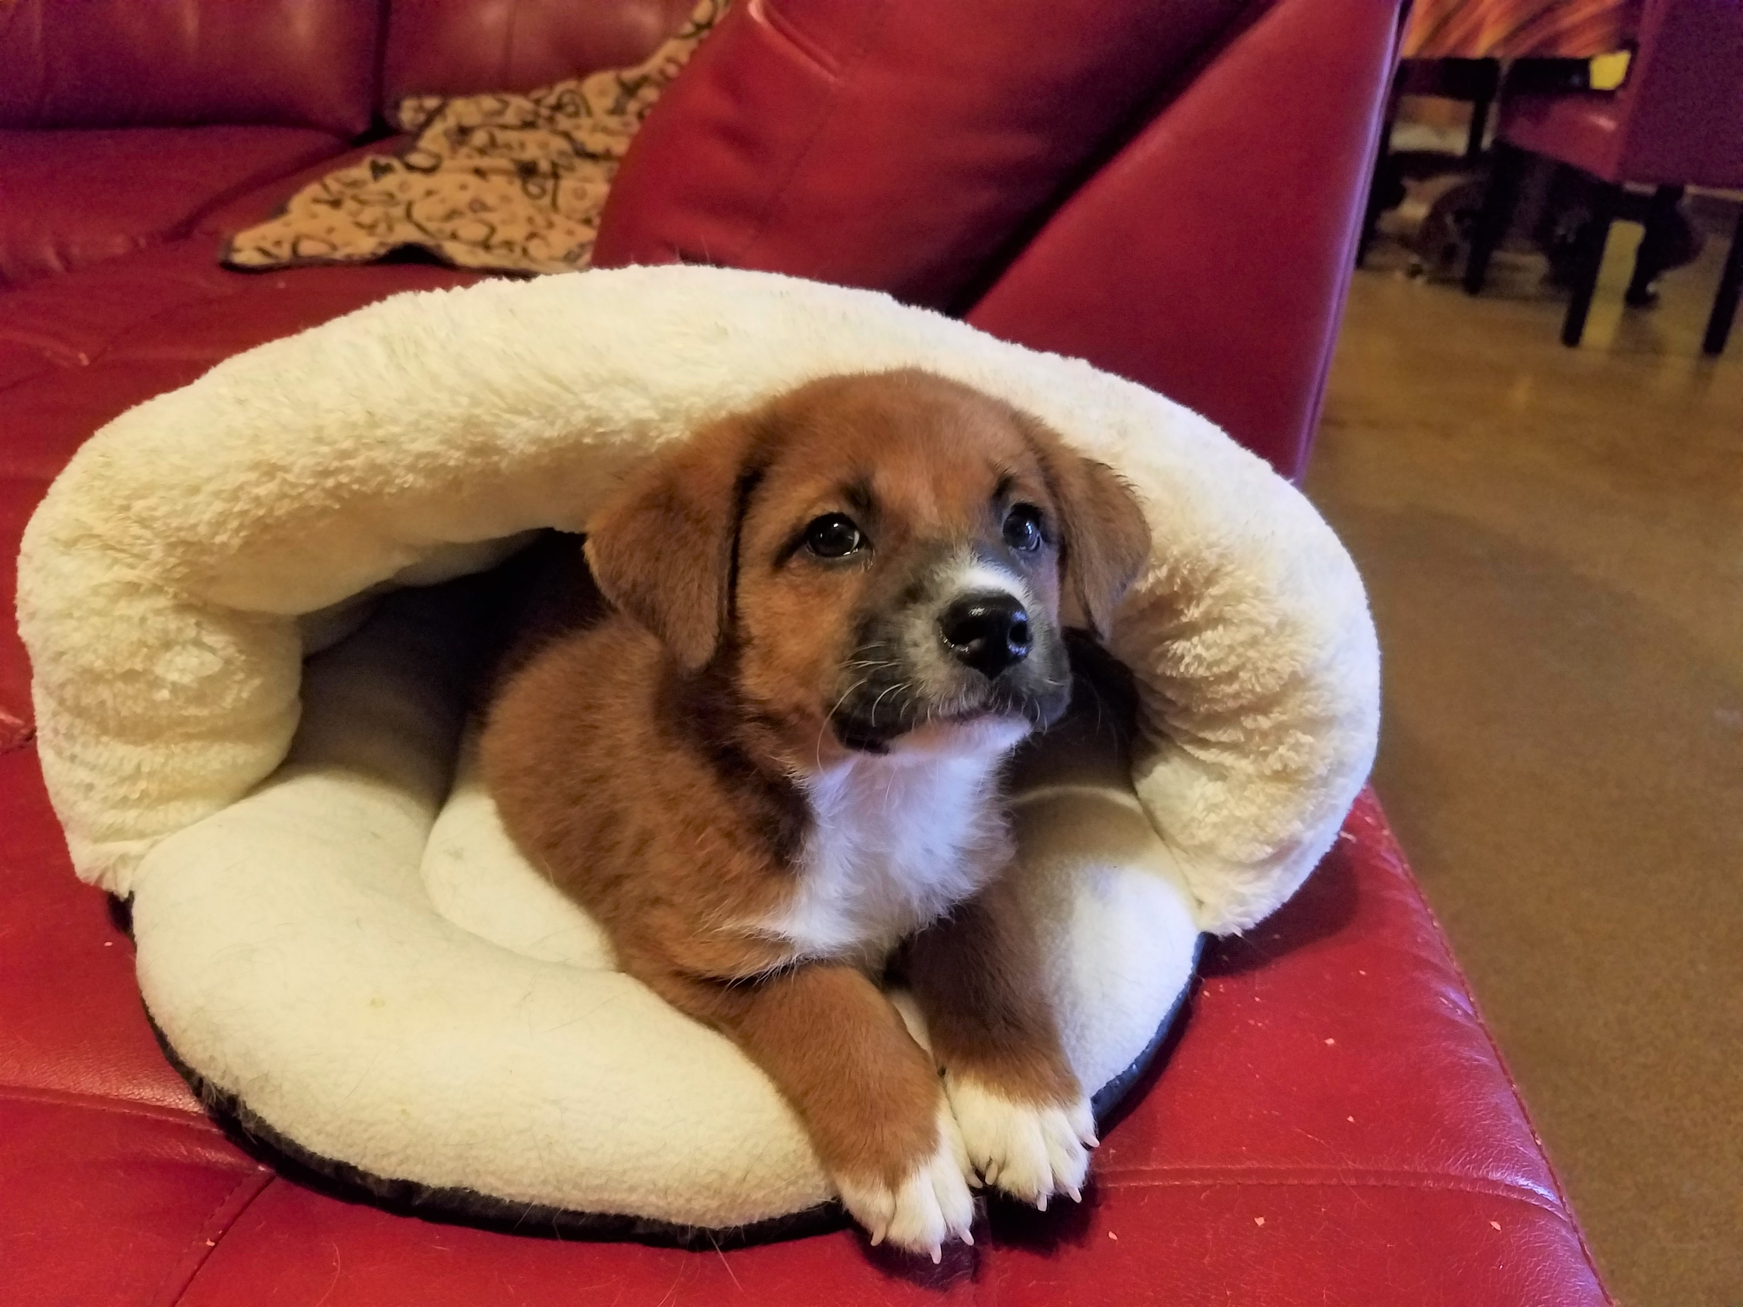

Pickles – One of The 11 From Gila County

From An Adopter
My husband Gary and I lost the last of our family dogs, in September. Buddy, was our chocolate lab and was 16 and a half years old, and Max, 10, our Terrier mix, had to be put down 2 weeks to the day after we lost our Buddy. We were devastated.
Towards the end of October we decided to start our search for our new 4 legged family members. This decision was not easy, but we also knew we were missing something in our family. We are part of the CVMA, Combat Vets Motorcycle Association, and a lot of our members have service dogs that they found at rescues. We had been looking at a breeder in Northern AZ at silver labs when we decided to look for a rescue dog instead.
We came across Sandy and The Puppy Mamma, and found our Harley and Groot. When we went to see them for the first time, we were so impressed with her home, the cleanliness of the kennels, and her obvious devotion to helping abandoned dogs and their puppies. We adopted 2 puppies of a 7 puppy liter. Sandy kept me posted everyday and sent pictures, until they were ready to come home. It was so nice to see how they were growing each day.
We are so grateful to have found Sandy and our newest family additions. Thank you Sandy for your devotion and giving us a fantastic Christmas gift for our family, as well as our grandson’s first puppies!
Gary and Heather Smith

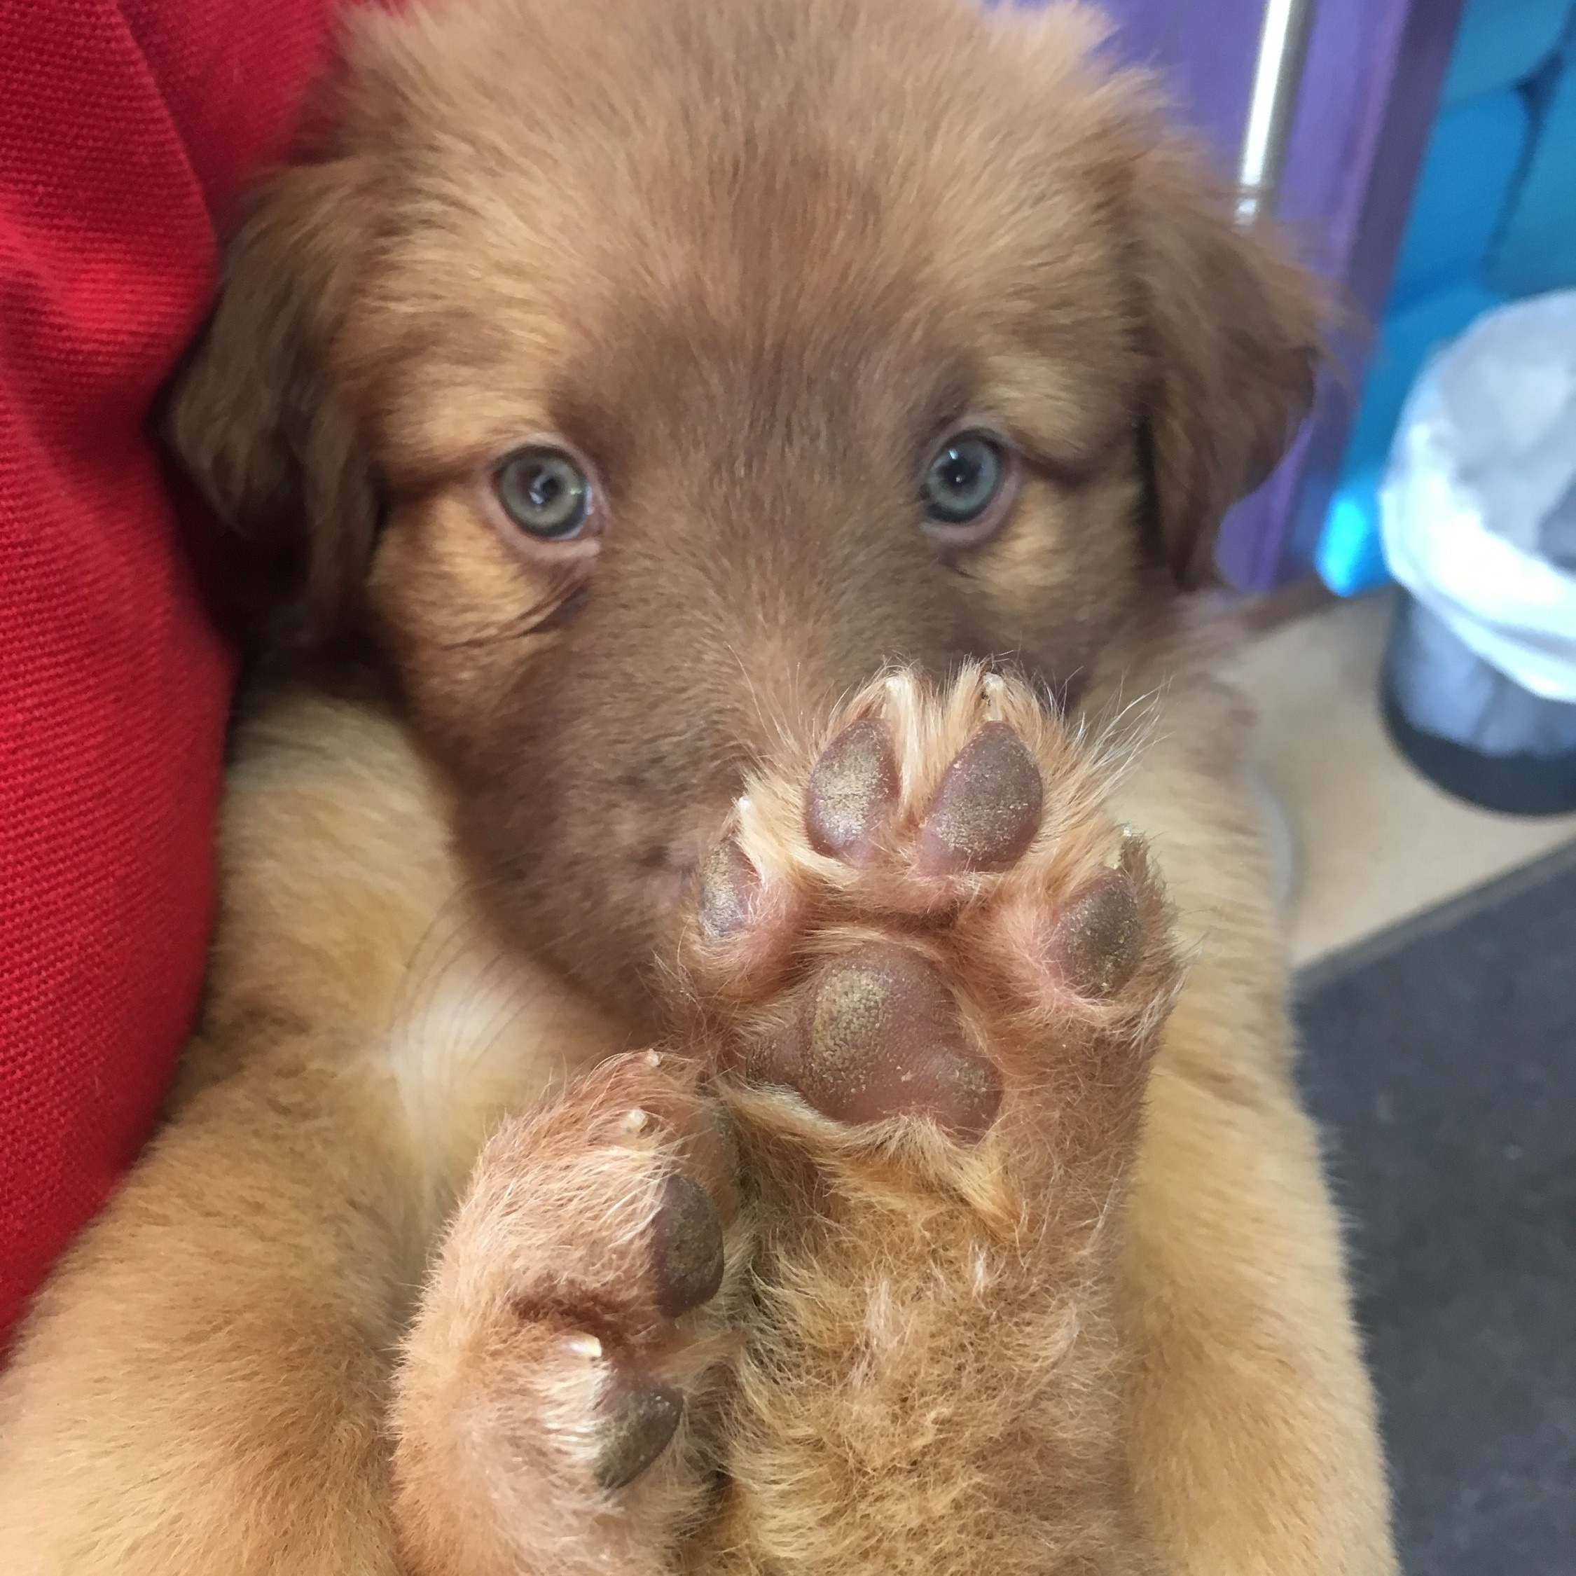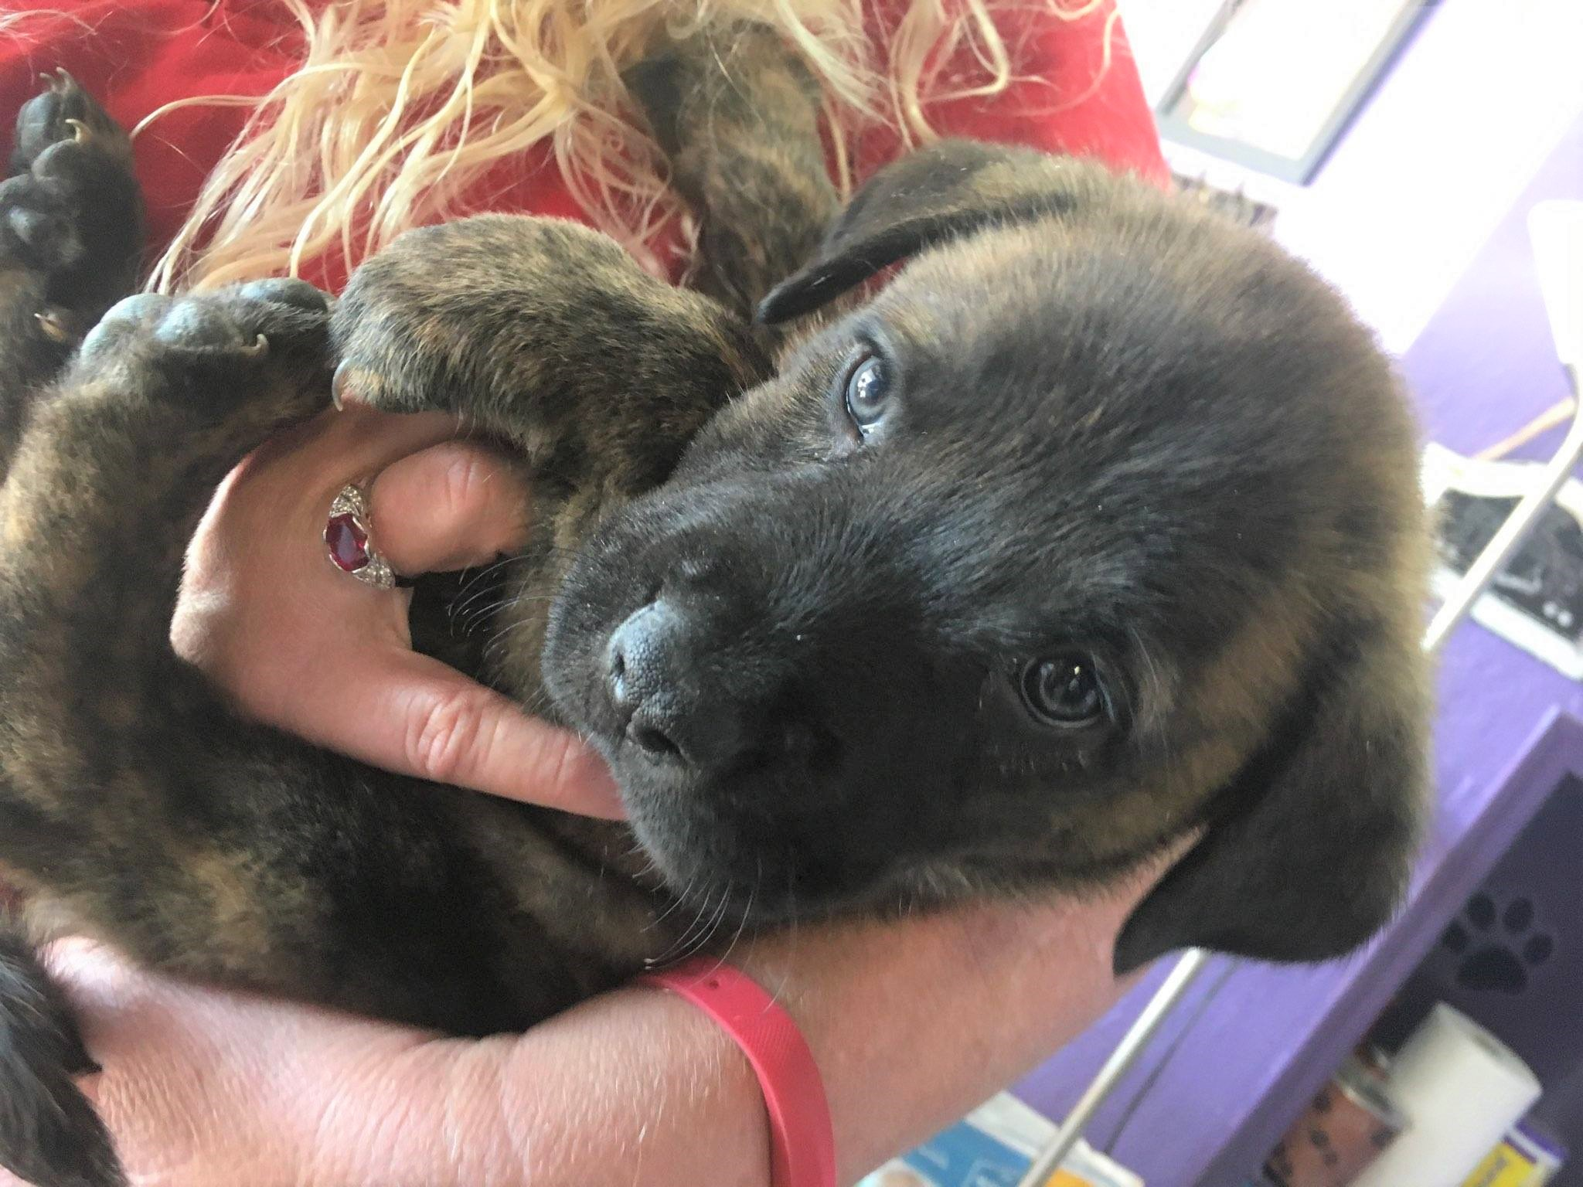
Harley Groot

From A Foster
Our time fostering puppies for The Puppy Mamma has been amazing. Sandy is incredibly easy to work with. She is easy to get ahold of for anything that is needed. The dogs' food and supplies always get delivered on time and we never run out of items that the puppies need. Sandy always ensures that the dogs' medical needs are on track and are all taken care of when needed. We have fostered for another rescue previously, however wanted to come foster for The Puppy Mamma due to our fantastic experience in the past when we adopted our dog through them. We know that all dogs that are with The Puppy Mamma are well cared for due to Sandy.
Christine & Maddie Bell

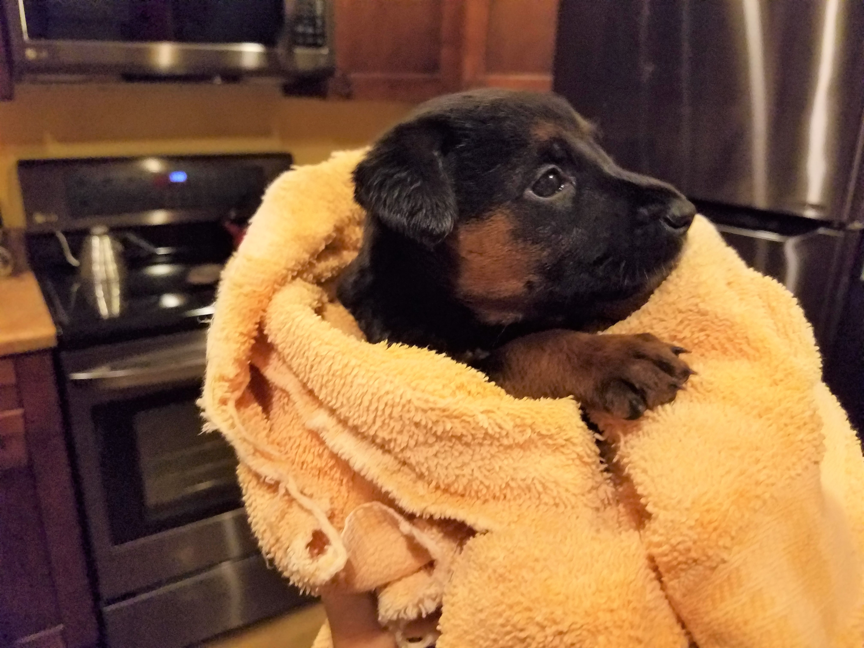
Thor – A Foster Failure

From A Volunteer
"I have been a volunteer for The Puppy Mamma for 4 months and it has been such a special and rewarding experience. The amazing people involved in this rescue organization are truly one of a kind. They open their homes and their hearts to foster momma dogs and their babies with a deep compassion and commitment to providing a nurturing and stable environment for healing and care. Each dog becomes a part of the family until they move on to their forever homes. I am truly grateful to be a part of such a wonderful organization." – Tamra Piland

FUTURE Newletters

Contact Us
The Puppy Mamma
PO Box 4
Apache Junction, AZ 85117
480-688-6969
Sandy@ThePuppyMamma.com
ThePuppyMamma.com
If you would like to receive any future newletters that we may put out please go to our website www.thepuppymamma.com and sign up to have them delivered electronically.

54 ADOPTIONS IN 9 MONTHS
THANK YOU TO ALL OF YOU!!!
