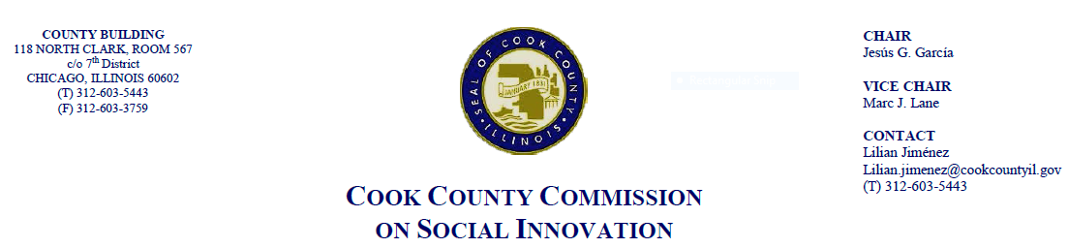August 16th, 2018, 4 P.M.
69 W. Washington, 22nd Fl.
Chicago, IL 60602

MINUTES

- Call to Order

The Cook County Commission on Social Innovation convened via an in-person meeting to discuss committee updates and hear from a guest speaker. The meeting was chaired by Chairman Garcia. The meeting was open to the public and took place from 4:10 p.m. to 5:14 p.m.

Commission Members Present:
- Chair García
- Vice Chair Marc Lane
- Carrie Thomas
- Wendy Raymer
- Jay Stewart
- Christyn Henson
- Marc Loveless
- Ana Guajardo
- Matt Erickson
- John Yonan
- Xochitl Espinosa
- Howard Males (via call-in)
- Ismael Cuevas (proxy for Ald. Sadlwoski-Garza)
- Victor Dickson

Commission Staff Present:
- Victoria Moreno
- Alma Anaya
- Aneesa Patwary

Public Speakers:
- Kimball Ladien - about after school job programs to help cut violence in the city through his Safe Haven program.
- Alec Hudson - intern at Austin Coming Together. Student at UIC. Supports worker co-ops movements in Illinois.
- Mark Armstrong - Chicago Urban Fine Arts Fund. Filmmakers looking for opportunities to promote civic engagement for the County and promoting the South Side.
- Theodore - worker co-ops can help support constituents in Cook County
- Brenda Rodriguez - representing Chicago Food Policy Action supporting for the Chicago Worker Cooperative Ecosystem.
- Sarah Faulkner - CPS teacher and filmmaker. Vocational training through film is a way to keep kids out of crime.

- Approval of the Minutes
- Wendy Raymer moved the motion, seconded by John Yonan for the minutes from June 21st and July 19th.

- Committee Updates
- Pamela Rodriguez and Maria Kim have resigned. Putting out notices for people interested in position of committee updates.
- Victor Dickson, Chair of Social Capital Committee, has submitted a progress report about his committee.
- No new business.

- Guest Speaker: “Chicagoland Cooperative Ecosystem Coalition”
- Eric Rodriguez from the Illinois Worker Cooperative Alliance
  - Presentation of the White Paper on worker cooperatives in Chicago.
  - What is a worker coop? A business that is cooperative owned and controlled by its workers.
  - Worker coop with following characteristics: revenue generating business, workers are owners
  - 60% of worker coops in operation were formed since 2000. Worker coops in the Chicago area are based in or led by working class communities of color. They provide access to capital, legal and accounting complexity, employment issues.
  - Recommend worker coop members, coop incubators, tech assistance providers etc to develop a collective vision and worker coop coalition structure
  - City of Chicago and Cook County should pass a resolution in support of worker cooperative businesses and development. State of IL should pass a statute as well.
- Renee Hatcher from the John Marshall Law School
  - Necessity of worker coop in the Chicagoland area. Recognize manufacturing renaissance. The ecosystem includes advocates and champions, technical assistance providers, incubators and developers, and worker cooperatives.
  - NYC has invested millions of dollars into worker coops. Happening in Berkeley, California and Madison, Wisconsin.
  - Proposing a process to implement the recommendations that came out of the Illinois Worker Cooperatives Alliances
  - Hope that the resolution drafted by the Financial Capital Committee will be discussed
- Xochitl Espinosa, Commissioner and Co-op Ed Center
  - Working proposal to pitch the idea. Primary goal is to establish a cooperative ecosystem in Cook County that fosters an environment for developing and sustaining worker owned enterprises.
  - Establish a coalition and a network through a few different steps. 1) Plan to convene all the stakeholders in a meeting. 2) raising awareness about the worker cooperative model to gain support (capital, resources, skills) for the model. 3) strengthen the capacity of the incubators and technical assistance providers. 4) sustaining worker cooperatives such as developing business coaching and developing ordinances/policies that foster worker cooperatives.

- Post Presentation Discussion
- Commissioner Raymer, Chair of the Financial Committee, talks about the resolution. Result is fantastic. Expresses the need for a worker cooperative ecosystem. Want to resolve that CC BED develop recommendations for using block grants as a source of funding for local worker cooperatives. Have resources in CC available for those worker cooperatives as well as other resources.
- Commissioner Stewart, want some more time to look at the recommendations because CDBG money does have some restrictions.
- VC Lane, going to discuss this more. All like the principles, will work on it more so that it can potentially be up for a vote next month.
- Chair Garcia, thank you to everyone that came out today as part of the public for speaking out or worker cooperatives.
- Commissioner Guajardo - if there’s anything that Jay and BED needs, reach out.
- Comm. Garcia, Victor Dickson and Marc Loveless have joined us.

- Adjourn
  - Commissioner Loveless moved to adjourn, seconded by Commissioner Erickson. Meeting was adjourned at 5:14pm.

