Market vs. Mandate:
Why the United States Government Cannot Hold the Individual Consumer Responsible for Mitigating Anthropogenic Environmental Degradation

Skot Rogers
Roosevelt University
December 2014
Abstract
The environment is at a critical tipping point; this is due to mankind’s activities in it. Luckily, one remarkable thing about humanity is its ability to develop solutions for the problems it creates. There’s no doubt that free-market capitalism is a powerful tool to build and fix things; as a structure to invest, take risks, and hope for returns, capitalism can grow the wealth of an individual, company, or entire nation by incredible proportions. However, what the market cannot be counted on is a solution to every problem. This paper examines the extent of anthropogenic (human-caused) environmental degradation and shows where the United States is lagging behind other nations in implementing meaningful solutions. The US applies a weak and passive approach of letting the consumer handle the phasing out of mankind’s harmful habits with little more than a hope that all Americans will buy the most fuel-efficient cars and appliances, choose organic food, and recycle all of their trash. However, successful international strategies towards mitigating environmental degradation have not come from those kinds of consumer choices alone. They have come from strong environmental investments and regulations that have made environmental sustainability in contemporary lifestyles accessible and/or invisible to all citizens of those countries.

Introduction
There is a common saying here in the early twenty-first century, “The stone age didn’t end because they ran out of stones.” Taken into today’s context, an examination of the extent of anthropogenic environmental degradation caused by contemporary lifestyles is of value. Billions of cubic tons of fossil fuels have been dug up and burned leading to global climate change. Biodiversity on earth has been, and continues to be, irreversibly destroyed with an ongoing expansion of conventional agriculture. Today’s world is one where countries and oceans are being filled up with non-biodegradable trash that will last thousands of years. The hope is that this age of anthropogenic degradation of the biosphere will not end only because humans run out of fossil fuels, usable resources to grow food, and natural spaces to discard all of this waste. The hope is that the new age of environmental sustainability will be marked with a choice—a choice to move humanity forward because there is enough concern to do so. It sounds easy enough to choose, but choice is actually a tricky thing to bet on. In the United States, reducing greenhouse gas (GHG) emissions, increasing access to organic and sustainably produced food, and decreasing non-biodegradable waste streams has been mostly left in the hands of the market where American consumers are seen as the driving source of change through product demand and individual consumer responsibility. However, meaningful advances historically cannot be driven by consumer choice alone. They come from strong environmental law. Unfortunately, environmental law has, pun very much intended, began to run out of gas. Environmental advances in the mid-to-late twentieth century such as The Clean Air Act (1963), The Water Quality Act (1965), Motor Vehicle Air Pollution Control Act (1965), and the creation of the Environmental Protection Agency (1970) show that big changes, enormous and sweeping changes, don’t come when people are forced to vote with their dollar alone; they come when the government takes that burden of choice off of the shoulders of the consumer by turning environmental responsibility into Federal law. Following the last substantial US environmental boom with sweeping protections in air, water, and the creation of the Environmental Protection Agency (EPA) itself, consumer demand for 'green living' has been strategized as the primary driver for lessening humanity’s impact on the environment. However, simply hoping that the individual consumer will purchase only the most energy efficient products available, use less fossil fuel energy, shop only for organic food, and recycle all of their waste, is not a strategy that will work. A market-driven environmental protection strategy is simply not feasible, economic, or a priority for most consumers. Furthermore, numerous studies show that it has not been proven to be a tool as effective as the sweeping environmental laws currently operating in other countries; many of which far outperform the United States in a number of various measures of environmental sustainability. Considering a market-driven approach as the predominant solution to environmental degradation will not alone proliferate the meaningful changes that must occur. It is time to dig even deeper, not for more natural resources to exploit, rather for a modern era of groundbreaking environmental legislation that dwarfs the last major push in the mid-twentieth century and leads the rest of the world into a more sustainable future.
How the Movement Lost Momentum
On July 9th 1970 President Nixon sent a letter to US Congress titled: “Reorganization Plan No. 3 of 1970.” A section of the letter below found on the Environmental Protection Agency’s website shows how contemporary concerns about the environment had grown to such a level that correcting them would require an enormous governmental overhaul:
To the Congress of the United States:
As concern with the condition of our physical environment has intensified, it has become increasingly clear that we need to know more about the total environment—land, water, and air. It also has become increasingly clear that only by reorganizing our Federal efforts can we develop that knowledge, and effectively ensure the protection, development and enhancement of the total environment itself.
The Government's environmentally-related activities have grown up piecemeal over the years. The time has come to organize them rationally and systematically. As a major step in this direction, I am transmitting today two reorganization plans: one to establish an Environmental Protection Agency [EPA], and one to establish, with the Department of Commerce, a National Oceanic and Atmospheric Administration [NOAA] (“Reorganization Plan No. 3 of 1970,” n.d., para. 1).
The detailed notice went on to outline all of the many responsibilities, roles, components, and functions the new EPA and NOAA would hold including, “The conduct of research on the adverse effects of pollution and on methods and equipment for controlling it, the gathering of information on pollution, and the use of this information in strengthening environmental protection programs and recommending policy changes” as well as “Assisting others, through grants, technical assistance and other means in arresting pollution of the environment“ (Roles and Functions of the EPA section, n.d., para. 1). It was huge. It demanded a brand new agency to hold a lot of federal power over states. As bold, brave, and sweeping as this federal proposal was, it was not something that just simply came to the President without a call for it. There were events—measureable abnormalities that led to a public outcry for something to be done.
Concern around the safety of nuclear testing, radiation fallout, environmental consequences of the use of the pesticide dichlorodiphenyltrichloroethane (DDT), widespread food and waterborne illness all built in the fifties and sixties. Finally a 1969 a massive oil spill in Santa Barbara, California was considered by many to be a breaking point for public patience with the US government’s inaction on environmental protection. Organization of a new event to spearhead a demand for environmental action underwent planning. What became of it on April 22, 1970 was “…20 million Americans [who] took to the streets, parks, and auditoriums to demonstrate for a healthy, sustainable environment in massive coast-to-coast rallies” in what perhaps remains the largest US protest for environmental protection: Earth Day (“Earth Day: The History of a Movement,” n.d., para. 6).
What the United States has on its hands today is a bit of a dull roar at the point when the noise should be the loudest. That is because the shift has been handed to the individual consumer. President Obama has built up a notable list of environmental pursuits as presented in a July 2013 science journal Nature editorial. However, that list is predominantly related to greenhouse gas reduction alone. This leaves the rest of the cleanup to the consumer and doesn’t handle all areas of sustainability at all. The Nature editorial explained how the President’s proposal for restrictions on construction of new power plants, “…would essentially ban the construction of new power plants unless they are equipped to capture and sequester carbon.” Additionally, “Obama’s ‘climate action plan’ contained a variety of other initiatives, including calls for a new round of appliance standards, fuel-economy regulations on heavy-duty vehicles and various efforts intended to prepare the country for a warmer climate” (“More than hot air,” 2013, para. 3). Those are all elements that do place focus in the right place as they take the responsibility off of the shoulders of the consumer by mandating through regulations. However, in comparison to the scale of the creation of the EPA itself in 1970, where are the groundbreaking changes and attention to all environmental challenges, not just climate?
Non-biodegradable trash will not stop creating itself. Pollution and threats to biodiversity with the use of genetically modified organisms (GMO), pesticides, and conventional agriculture will not simply disappear because they should. Moreover, while greenhouse gas emissions are on the US environmental concerns list, to a point where they may be gaining some meaningful traction, there is still China and India—two countries that are creating an impact on carbon pollution so large that it could potentially dwarf the impact of the US and Europe’s last 200 years combined. How could the United States begin to lead the world if it is not first setting an example? It is time for the United States to exact a laser sharp focus on utilizing all current technology available in all realms of environmental sustainability. This is an opportunity to make an example of what can and must be done so that all legal mechanisms for contemporary environmental protection can be pursued. That focus won’t come from shopping alone, and the US consumer is not the one who should be responsible.
Fossil Fuels and Greenhouse Gasses; Is This Even a Man-Made Issue?
According to the 2013 Intergovernmental Panel on Climate Control (IPCC) Assessment Report Five (AR5), the most all-encompassing, thoroughly substantiated climate change analysis to date, the debate on whether the globe is warming is over. In the summary for policymakers, Stocker et. al. (2013) explained in no uncertain certain terms, “Warming of the climate system is unequivocal, and since the 1950s, many of the observed changes are unprecedented over decades to millennia” (Stocker et al., 2013, p. 4). The same section explained how scientific measurements have proven that the levels of recorded snow and ice have lessened. The sea level has risen. And the amount of greenhouse gasses in the atmosphere has increased without question. This report, produced by an international coalition of hundreds of highly specialized scientists, arguably the top in the entire field, is the very same report under the purview of all world leaders including US President Obama and US Congress. Similar to the confirmation of the warming of the atmosphere itself, the initial debate about human involvement in the matter has been settled with an extremely high degree of certainty. As confirmed in the same report:
Human influence has been detected in warming of the atmosphere and the ocean, in changes in the global water cycle, in reductions in snow and ice, in global mean sea level rise, and in changes in some climate extremes…This evidence for human influence has grown since AR4. It is extremely likely that human influence has been the dominant cause of the observed warming since the mid-20th century. (Stocker et al., 2013, p. 17)
Those report figures represented visually below (Figure 1) clearly show that land surface temperatures, ocean surface temperatures, and ocean heat content have risen as a result of anthropogenic forcings (man-made factors). The models using only natural forcings contrast how these temperatures would show no such increase were it not for humans burning fossil fuels for energy which creates unnatural levels of GHGs in the atmosphere.
(Figure 1)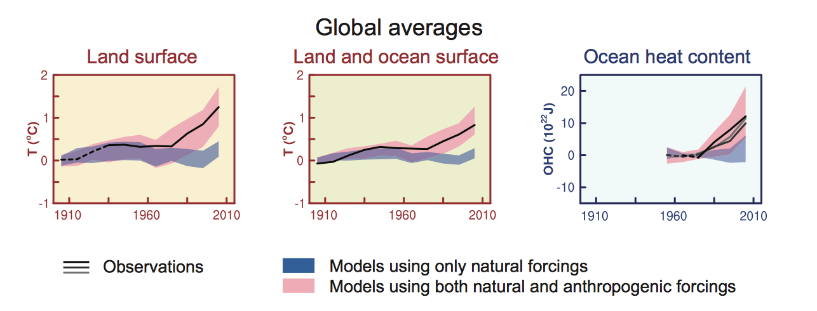
Just like knowing that there is a problem doesn’t solve that problem, placing the solution on the shoulders of the consumer won’t solve an enormous consumption problem. First, a look at what alternative energy sources are even available is in order.
What Renewable Resources Can Create Usable Energy?
For thousands of years mankind has used the power of wind to sail ships, pump water, mill grains, and perform other mechanical tasks. There is an argument in some contemporary conversations that if renewable energy technologies were going to be the source of power, mankind would have already figured it out by now. As charming as that thought it, it is akin to saying that mankind should have had a car as soon as he invented the wheel—obviously technology moves in great strides but they are often quite slow. The fact is, sources for renewable energy do exist and the technology is there to extract it.
In 2009 the South East Europe Transnational Cooperation Programme, co-financed through the European Union (EU), began a project that resulted in the creation of a detailed technical overview on all of the knowledge currently available in the realm of renewable energy production. The result was the Handbook on Renewable Energy Sources, published in 2012 by authors De Carolis et. al. It serves as a training handbook developed by experts and is translated into many languages. As explained in the introduction to the handbook itself, its main objective is to provide an all-encompassing, consolidated detail of the technology that allows for creation of Renewable Energy Sources (De Carolis et. al., 2012, p. 6). The very technical guide predominantly focused on four of the major interests for the south eastern European region: Biomass—technology that creates usable fuels in the form of gas or heat energy from decomposing organic material, Geothermal—the process of digging below earth’s surface to tap into the molten fuel there for heating and electricity generation, Hydropower—wielding the natural flow of freshwater towards the oceans to spin electricity-generating turbines, and Wind—creating electricity by capturing the energy in blowing wind. Similarly, a 2011 special report produced by the IPCC, called the Special Report on Renewable Energy Sources and Climate Change Mitigation (SRREN) is similar in function and technical detail. It adds more sections on additional technologies written by hundreds of collaborating international authors. Additional sections include the promise of Solar—capturing the sun’s energy to create, transport, and store electricity, and Ocean Energy—using the force of tides and currents along with chemical and temperature potentials in ocean water (Edenhofer et. al, 2011, pp. 333-497). The scientific consensus in both publications is that technological understanding is no longer the limitation in the worldwide proliferation of the use of renewable energy. As the SRREN technical details supported, “…studies have consistently found that the total global technical potential for RE [Renewable Energy] is substantially higher than global energy demand” (Edenhofer et. al, 2011, p. 10). In other words, any debate on whether or not creating the energy that civilization needs with renewable sources is over; it is indeed possible. Humanity could switch to 100% renewable energy and even have some to spare if the right investment and priority is put in place.
The reason that these very extensive reports are considered successes lies in their purpose, what they are and what they are not. These are not catalogues for interested homeowners to shop from; no single homeowner is expected to distill these data for use in their own lives. No homeowner is expected to use the technical principles contained within to drill into the earth below their home looking for 2,000 ºF lava to warm their house and create electricity. Instead, these international reports are extensively peer-reviewed, highly detailed, all-encompassing guides designed for policymakers in charge of entire countries, arguably the entire world, to use. They are intended to explain how science has now found the means to plan, build, and maintain high tech energy infrastructures that can sustainably fuel all of the energy needs of contemporary mankind with sources that do not require the burning of fossil fuels.

Isn’t the Prius Supposed to Fix Global Warming?
One ‘green-catalogue’ that is effectively available to the consumer, a choice that the average consumer can make, is what car to buy if any. The idea here is that individual consumer choice may mitigate carbon pollution when enough people buy hybrid cars or electric cars. Unfortunately, the data show that it really won’t make the kind of difference that is required. Research by Holzman (2011) through the National Center for Biotechnology Information (NCBI) found that, “…only 13 of 34 hybrid vehicles assessed achieve better than a 25% reduction in greenhouse gas (GHG) emissions, and just 3 exceed a 40% reduction…” (Holzman, 2011, p. A384). While a possible reduction in GHGs in a small amount of hybrid cars sought after by a tiny section of an ecocentric driving public still adds a little bit of value, the overall generation of GHGs from all of the contemporary consumption outside of transportation still creates an enormous amount of pollution that has very little to do with cars at all. Looking at the EPA data from 2012 below (figure 2) (Overview of Greenhouse Gases and Sources of Emissions section, 2012, para. 1), transportation only makes up 28% of total GHG emissions. In short, the hybrid car isn’t going to do anything to curb wastes coming from electricity, commercial/residential, agriculture, and industry. Similarly, carbon reducing cars that consumers may opt to purchase don’t decrease the other main GHGs Nitrous Oxide, Methane, and Fluorinated Gases making up the other 18% of GHGs. (Figure 3)

(Figure 2) (Figure 3)
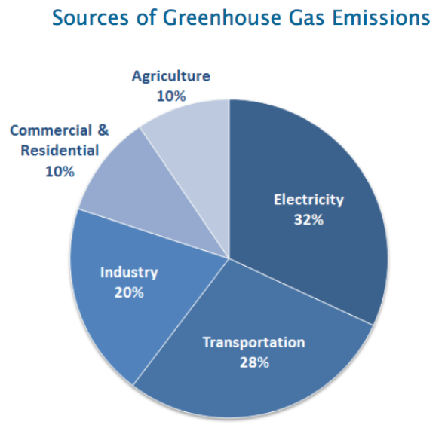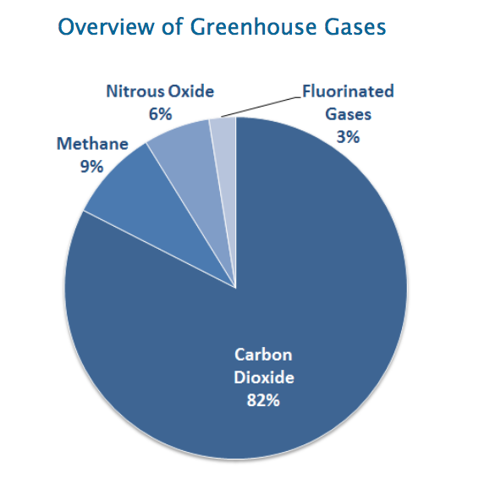
US greenhouse gas emissions are on a very slight decline, and that is worth noting, but that is largely accounted to technological advances in the drilling for natural gas in the controversial new method of hydraulic fracturing (fracking) for electricity fuel. That method is controversial (a) because it creates potential for entirely different types of pollution and (b) it is still not renewable energy. What remains is a global crisis, one that the individual consumer is not equipped or empowered to solve alone by buying the right car.
What is Everyone Else Doing Then?
International researcher Stuart Bruce (2012) explained how scientific consensus has forecasted that the possibility of averting catastrophic climate change is already dwindling. To maintain even a 50% chance of aversion, global temperature must not increase by more than 2 ºC by 2050. Unfortunately, as of that writing, the world is, ”…‘nowhere near’ a ‘realistic path’ to globally decarbonise [sic] all energy generation by 2050. So significant are these challenges that an urgent ‘energy revolution’ is required, ‘before the door to 2 °C is closed’” (Bruce, 2012, p. 20). Urgency and revolutions go hand-in-hand, and there is no better time than now to take enormous leaps forward. Surprising to many, a lot of other countries are taking a much more robust leadership role in the matter, leaving the US well behind in relative innovation and implementation.
There are millions of metric tons of fossil fuels burned to create electricity that is then lost in the transmission, storage, and off-peak wastage in a very antiquated system of inefficient electricity distribution over the US. However, modernization of energy distribution networks like that of the US, commonly referred to as ‘the grid’, has already begun to decrease overall energy consumption. However, contrary to what many would guess, those innovations are not coming from the United States. The study performed by Kothari and Vijayapriya (2011) explained how the first, and as of that publishing the largest, ‘smart grid’ was built in Italy. The system was “…considered highly unusual in the utility world because the company designed and manufactured their own meters, acted as their own system integrator, and developed their own system software” (Kothari & Vijayapriya, 2011, pp. 306-307).
In addition to being behind in an antiquated energy grid, the US does not lead the world in the consumption or production of its own renewable energy. The most recent report created by the US Energy Information Administration (EIA) Monthly Energy Review October 2014, contains monthly totals for this year all the way through July 2014 (Renewable Energy section, 2014, p. 136). What is shown (Figure 4) is the huge gap that remains between US consumption of energy from fossil fuel compared to US consumption of energy from renewable sources, represented in quadrillions of British Thermal Units (BTu).
(Figure 4)
Sources of United States Energy Consumption in BTu 1949 - 2013
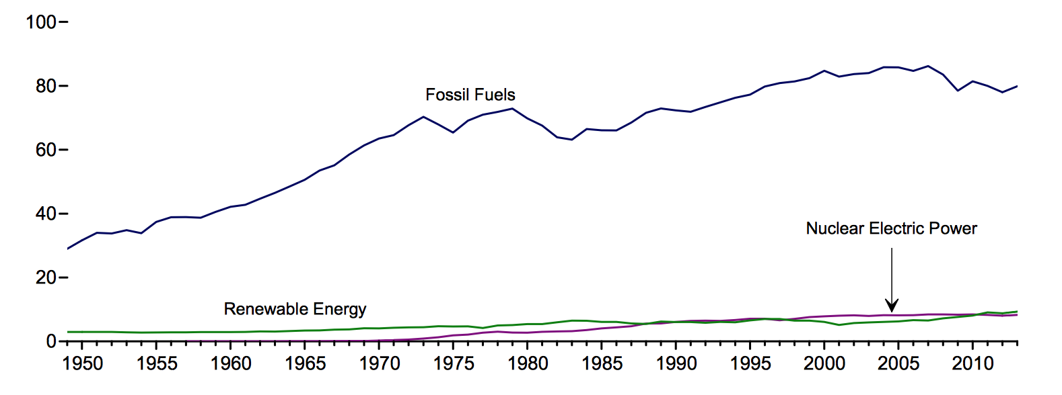
Looking next at the production of renewables in the US, for the months of January to July 2014 (Energy Overview section, 2014, p. 3), the total production of US energy was 49.82 quadrillion BTu. Of that, 4.79 quadrillion BTu were nuclear, only 5.76 quadrillion BTu were renewable, leaving the remaining 39.27 quadrillion BTu coming from fossil fuels. That makes renewables only 12% of the total energy produced in the US so far this year (Figure 5). When that is compared to the 2012 percentages of the energy mix of the EU’s production provided by the European Commission’s latest report (Figure 6), which shows renewables coming in at over 22% of total (Energy Production and Imports section, 2012, para. 1), it is clear the US is not at all leading by example in terms of renewable energy consumption or production.

(Figure 5)
Sources of Total US Energy Production by Percentage January - July 2014
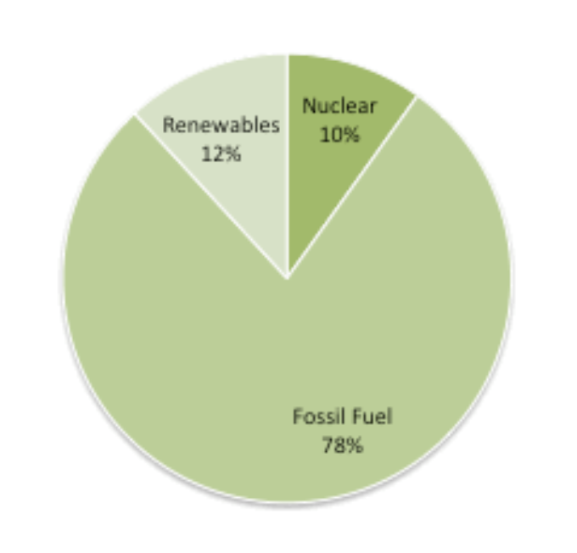
(Figure 6)
Sources of Total EU Energy Production by Percentage 2012 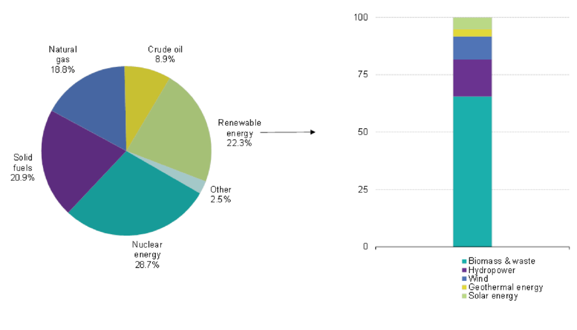
What Should Be Done Then?
Therein lies the necessity for a ramping up. There has been a huge boom in natural gas production in the US. However, while it is much cleaner than coal, it is not free of pollution, and it is not a renewable energy source. Furthermore, digging it up with whatever new technology the US finds is not the best thing this country has to offer. The space, technology, resources, wealth, and opportunity for investment that this country has should put the United States well in the front of the pack in renewable energy production. Sitting behind, counting on US consumers to make the dents in fossil fuel consumption by using less electricity, buying hybrid cars and appliances is not going to turn any trends around. What will, is what IPCC (2011) called for in section seven of the SRREN titled Policy, Implementation, and Financing. In it is no mention of individual consumer demand as a target strategy for the fulfillment of Renewable Energy’s potential for success. Rather, success in global GHG mitigation through use of renewables will come with, “Government policies [that] play a crucial role in accelerating the deployment of RE technologies.” As explained in more detail in the same section:
RE-specific policies for research, development, demonstration and deployment help to level the playing field for RE. Policies include regulations such as feed-in-tariffs, quotas, priority grid access, building mandates, biofuel blending requirements, and bioenergy sustainability criteria…Other policy categories are fiscal incentives such as tax policies and direct government payments such as rebates and grants; and public finance mechanisms such as loans and guarantees. Wider policies aimed at reducing GHG emissions such as carbon pricing mechanisms may also support RE. (Edenhofer et. al, 2011, p. 24)
Once again, the US is undoubtedly one of the biggest players in the global energy demand, but as shown in this section, the role of the innovator in production and consumption of renewable energy sources is being immensely outpaced by other countries that are proportionally creating and using much more of their own than the US does. It is time to resume a leadership role in this and expand the focus to all areas of environmental degradation.
Organics: Where the Green Ball is Being Dropped
The individual consumer’s role in the lessening of anthropogenic environmental degradation may have no greater misapplication than the grocery store dollar—what is purchased there and what becomes of the waste. The bad idea here is that if a person has a concern with the environmental effects of conventional agriculture, then they may shop for only organic. If a person has a concern with the environmental effects of their waste stream, then they may recycle 100% of it instead of sending it to the landfill or the ocean. Unfortunately, these systems of environmental protection are simply not feasible for everyone. Often they are not only infeasible for some, they are impossible.
In the book Living Green A Practical Guide to Simple Sustainability, Horn (2006) made a very admirable attempt to explore the choices that a consumer can make to help perpetuate the kind of changes that are needed to avert environmental disaster. Unfortunately, while Horn’s book is incredibly well intentioned, well written, and fairly inexpensive, it is simply not going to solve the problem. In the section, “Getting Started: The Top Ten”, the author instructed readers to “…pick something worthwhile from the top ten sustainable steps below. Notice the tremendous impact that even small changes in our choices can have” (p. 27). In step one, the author insisted that readers should commit to Eating Organic. The detail that follows in that seemingly simple step is, unfortunately, not very simple at all. Horn (2006) explained:
For each 1 percent increase in organic food consumption in the U.S. alone, pesticide and herbicide use is reduced by over 10 million pounds per year. Organic food also tastes better and is far healthier than conventional food. And it is probably available at the same store you are shopping in today. (p. 27)
The simplicity in this step, further outlined in the subsequently dedicated section of the book, unfortunately doesn’t account for the fact that many people are not at all able to feed their family organic food. The statement above that organic food is “…probably available at the same store you are shopping in today” sadly fails to account for the fact that a huge number of American families don’t even have access to grocery store shopping at all, let alone organics. Researchers Bania, Leete, and Sparks-Ibanga (2012) reviewed the concept of a “Food Desert” and defined the phenomenon as “…socioeconomically disadvantaged urban neighborhoods that lack easy access to retail outlets selling healthy and competitively priced food.” This phenomenon, “…alter[s] the range of choices facing disadvantaged populations, potentially leading to poor health, social, and economic outcomes” (Bania et al., p. 214). As explained further in that study as well as in many other studies on the topic, there are entire stretches of American cities where residents have little to no access to any fresh produce, non-processed foods, or foods with any substantial nutritional content at all. Horn’s (2006) insistence that these residents can take environmental matters into their own hands by shopping for organics is, unfortunately, terribly shortsighted. The ‘food’ options that so many Americans are left with are the boxes of processed chemicals from convenience stores or the hideously non-nutritional offerings of fast-food chains, set up purposefully in such areas with the sole intention of exploiting the vulnerability of those residents’ limited food options.
If the answer does not involve providing a copy of Living Green to every American, a look at what the answer is should then be examined. That answer lies in the enacting of structural regulatory systems within the United States that effectively take the cost, access limitation, and burden of choice off of the shoulders of the consumer. It is probably not a surprise, but other countries have already pioneered this strategy. The research Thøgerson (2010) conducted looked at how worldwide consumption of organic food varied and why. What it boils down to is not how many people care about saving the world and choosing organic, but rather how much government involvement there is in the process of making access to affordably priced organic food possible. Within the research it is explained in detail how:
…Some countries have supported organic agriculture, and the development of an organic market, earlier, more persistently, and with a broader range of means than others. This has led to a range of impediments to consumer organic choices being removed or substantially reduced, especially those related to availability, price, and consumer uncertainty. (p. 181)
More specifically in the analysis, the country of Denmark is examined. Various research has continually concluded that it is, “…the country which has gained the earliest, strongest, and most substantial governmental involvement…” and it is therefore explained how Denmark has consequently become one of the, “…countries in the world with the highest organic food market share” (p. 181). The root of the matter is that European Union countries have been subsidizing organic farmers for a long while. Thøgerson (2010) explained that in fact, “…since 1994 all EU member states have been obliged to support the conversion to organic farming financially” (p. 176). That priority shows huge returns in the data. Research conducted by Daugbjerg and Sønderskov (2012) found even more evidence of what is possible when government aims its focus where it belongs. Their review concluded that the US governmental strategy for promoting green markets is not at all strong. As stated, “The US is an example of a country applying a weak version of the passive market development policy type. US organic food policy provides neither organic conversion nor permanent producer subsidies…” (Daugbjerg & Sønderskovp, 2012, p. 406). Alternately, that policy was compared to that of Denmark’s where, “The Danish organic food policy is a clear-cut case of the active market development policy. The Act on Organic Farming, adopted in 1987, introduced organic subsidies” (p. 407). Denmark went on to cement the needed changes with permanent organic subsidies introduced in 1994. Denmark took even broader control of where the organics would come from, thus ensuring growth in its own economy and less environmental damage in the importing of goods. Daugbjerg & Mannemar Sønderskov (2012) explained the structure of that law:
The state label is the sole national organic label and can only be applied by enterprises producing, processing or packaging organic produce in Denmark. The introduction of the state label meant that only state-certified farms would be allowed to sell organically labelled [sic] products and receive state support. The state has provided considerable subsidies for market research, product innovation and marketing of organic produce. (p. 407)
What contrast has this distinct difference in policy left the US and Denmark with? The same study shows an enormous difference in the average consumption of organic goods over time; simply put, people buy more local and organics when the government makes it cheaper and more abundant for them. Measured as a percentage of organics in total market share (Figure 7) between 1997 and 2008 (p. 408), Denmark maintained a clear leadership, averaging 54% greater returns.
(Figure 7)
Comparison of Percentages of Total Average Organic Share in the Food Market From 1997 - 2008
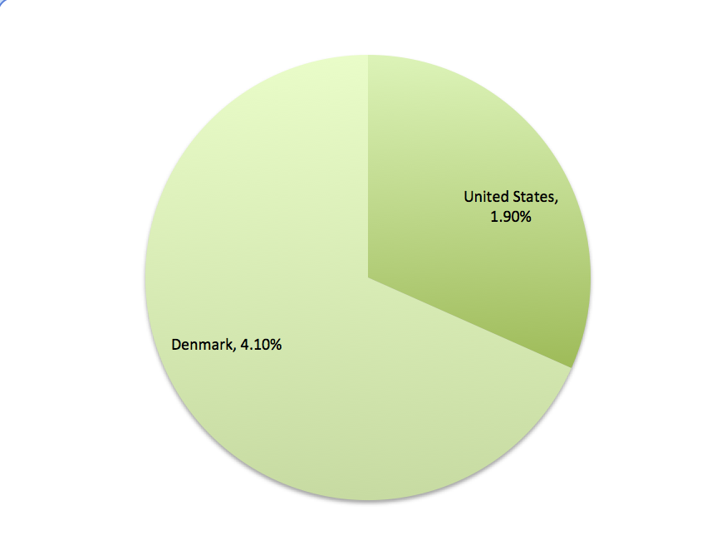
Combining these data and extrapolating Horn’s (2006) analysis in Living Green, that each 1% increase in US organic consumption results in ten million less pounds of herbicide and pesticides in the environment per year, the US could reduce toxic and destructive herbicide and pesticide pollution by over twenty-two million pounds per year by simply following the steps Denmark has already taken—funding, permanent subsidies, ongoing research, conversion investments, and meaningful localization with labeling of the country’s organic operations. None of the success stories in Denmark’s organic food boom were about placing an expectation on its citizens to simply eat the costs of their organic consumption, to magically find means to locate and afford organic food; rather, that successful strategy has been configured as an essential government function.
Consumer Interest in Waste: Put it in the trash
Last in the chain of consumption that leads to environmental degradation is a look at what happens after Americans buy and use things. Leonard (2011) analyzed contemporary disposable items in American culture—where all of the things in the typical American life come from, go to, and for what reason. The conclusion is a very long story, one that has more problems, participants, and puzzles than pieces of plastic in any pile of trash. In short though, the conclusion is that a lot of those details, perhaps most of those details about where all of the consumer’s ‘stuff’ comes from and goes to, are simply not details anywhere close to the average person’s radar. Because of that, it should not be the average person’s worry.
Recycling is pointed out as something that is supposed to be the remedy, again the individual consumer’s responsibility. But that is inherently problematic in the way that recycling is considered a meaningful solution. Leonard (2011) quoted Dr. Paul Connett’s idea on the matter who stated that, “Recycling is an admission of defeat; an admission that we were not clever enough or didn’t care enough to design it to be more durable, to repair it, or to avoid using it in the first place” (p. 232). This sentiment is echoed with Leonard’s (2011) own assertion that recycling is, in and of itself, not bad. Rather that it is, “…our overemphasis on it [that] is a problem. There is a reason recycling comes third in the eco mantra ‘Reduce, reuse, recycle.’ Recycling is the last thing we should do with our stuff, not the first” (p. 232). Moreover, in more practical analysis, she looked at the problems with the US single-use culture itself and explained how little is realistically under the control of the average individual consumer:
Then there’s all the other stuff in the garbage: the stuff that is the product of intentional choices in design and manufacturing, choices that were outside our reach of immediate influence. This stuff falls under someone’s responsibility—the people who designed, produced, and profited from it. If you, Mr. Ketchup Producer, switch from a recyclable glass bottle to a squeezable one made of multiple plastic resins bonded together that can never be separated for recycling, you need to figure out how to deal with that at the end of its life. If you, Ms. Printer Producer, decide to make toner cartridges that are impossible to open and refill and so must be thrown out while still perfectly functional, then you deal with it. That is your choice, not mine. (p. 233)
What Leonard has captured here is the concept of Extended Producer Responsibility (EPR), sometimes thought of as a “you made it, you deal with it” approach (p. 233). Simply explained, when producers are legally bound to be responsible for the entire lifecycle of goods, not just to the point of sale, they are then inclined to design, produce, and distribute in a way that is not burdensome and expensive for them at the end of the use. If an ink cartridge is not recyclable or refillable, under an EPR system, that manufacturer is then legally responsible to pay for the shipping of that cartridge back to themselves to figure out what to do with it.
Of course, as the trend goes, the implementation of these kinds of successful systems are already in place in other countries where the government has taken a responsibility in the matter instead of putting that on the individual consumer. Leonard (2011) explained how already there are “…strong government mandated models of EPR in place, notable Germany’s Green Dot system and the European Union’s WEEE (waste electrical and electronic equipment) directive, that illustrate how entirely feasible this approach is” (p. 234). As easy as these solutions may be, the fact is that the US government is not taking control on the matter like other countries do. Surprisingly, the few examples of progress in the US are standards that US companies adopted around other parts of the world. McDonald’s has been criticized for trying to capitalize on the environmental movement, ‘green washing’ as it is commonly called, by eliminating Styrofoam packaging, using biodegradable containers, and increasing post-consumer recycled material to tout its commitment to the environment. Surprisingly, those changes came back to the US largely because of McDonald’s operations in other countries that required compliance in order to even operate there.
In another example of lax regulatory control of contemporary waste issues, Leonard (2011) outlined an additional step that is needed for sustainable waste management when she stated the US should, “Develop a national composting infrastructure to ensure that organic waste is kept out of landfills and that composing biomaterials moves from ideal to reality” (p. 257). Surprisingly, this very law is actually already on the books in Illinois state legislature. But sadly, because there is no real enforcement, this law is being completely ignored by the City of Chicago who currently offers no organized collection of landscape waste. If a Chicago resident wanted to follow this Illinois state law, they would be hard-pressed to even find resources with which to go about doing that.
It is worth mentioning that there are some small examples of progress here in the United States; as far as banning plastic bags at grocery store checkout, some US cities and states have successfully removed them with overwhelming citizen support meeting very little objection. Because of the rule that meats, grains, and fresh produce may still be bagged in plastic, and the fact that technological advances in biodegradable plastics creates another positive factor, the conversion to less plastics is essentially invisible to the consumer—not another option in a list of choices they are expected to be concerned with. Leonard (2011) is certainly a proponent of individual action too. The very last section, Appendix 3: Sample Letter to PC Retailers, Manufactures, and Lobbyists, contained a letter which the reader may wish to copy, tailor and send to applicable recipients (p. 265). All things considered though, what Leonard (2011) has most effectively substantiated is the argument that the real change, the big change that is actually needed, is not something the US consumer can do alone. Companies won’t do what is best for the planet before they will do what is best for their profit. Thus, the only solution for the sake of the planet is government legislation in this matter as well.
Conclusion
The list of humanity’s technological advances grows exponentially bigger every year, decade, and century. Technological advancement comes at such a proliferating rate that progression can no longer be quantified in papers, books, or studies alone, but rather in whole libraries, entire colleges, and whole countries. The single thread that ties all of this advancement together is that these great strides are rarely the kinds of things that are done without a strong governmental impetus to support them. Countries that have installed meaningful carbon reduction strategies did not put a priority on doing so in order to make things fun. They mandated those kinds of mechanisms in order to save the planet and affect meaningful change that will allow those countries to prosper for generations to come. Countries that have succeeded in expanding the reach of organics, greatly reducing environmental degradation through the decreasing of pesticide use, GMO use, and all kinds of other impacts, have not done it by putting it squarely on the shoulders of its citizens to figure out where to get organic food and how to afford it. They have done it by means of prioritization that makes it cheaper and simpler for the consumer to gain access to those goods. In the same vein, countries that have began to cut back the total amount of non-biodegradable waste they are spewing into the environment haven’t done it by hoping that consumers will start making it a personal priority. They have done it through the tried and tested structure of law.
In hundreds of years, when humanity looks back at twenty-first century American priorities, there will be lessons taught about the collective focus on solving the environmental issues that had built up from the technologically explosive century prior. When it comes to averting total environmental disaster, it will not be a history lesson about “What they started buying and recycling in the early twenty-first century to save the planet.” Rather, it will be a lesson about “How twenty-first century Americans went about pushing their own government to create the grandest and most impactful environmental legislation and investment the entire planet had ever seen.”
While the dollar bill can be a very powerful means with which to vote in the capitalistic sense, to push things in the right direction, good old-fashioned ballots are currently the only legal form of voting in the democratic sense. Similar in contrast, the free-market is effectively a permanent protest stage; people can opt out of the systems they find unjust, unsustainable, or underserving of their support. But the fallacy in relying on that kind of setup is that it does not support the kind of diversity of passions that exist in all of the hundreds of millions of Americans interested in all kinds of different things. Is the corporate tax lawyer realistically able to remain 100% percent focused on her daily challenge of keeping her company operating justly while she somehow applies an additional 100% focus on every aspect of her life’s environmental impact? The answer is no. Environmental regulations are matters that she should expect to be handled by the government on her behalf. As interesting as she may find corporate tax law, not everyone is expected to be equally as passionate about it. Thus, as interesting as environmental sustainability solutions are to a great many, the government should not expect that everyone shares that same level of focus in order to address the threats that are unquestionably here right now. The things that the US government does take responsibility for, ensuring that roads are drivable, planes are flyable, and public water is not poisonous to name a few, are handled without burdening those details on every single person who drives, flies, and takes a shower. It is time now for the US government to match and then lead other nations in a massive restructuring of federal responsibility which ensures that all Americans, with their myriad of diverse passions, live in a country where they may focus on those passions while the investment, installation, and permanent progression of environmental sustainability is configured as an essential government responsibility.

References
Bania, N., Leete, L., & Sparks-Ibanga, A. (2012). Congruence and Coverage: Alternative Approaches to Identifying Urban Food Deserts and Food Hinterlands. Journal of Planning Education and Research, 204-218. doi:10.1177/0739456
X11427145. Retrieved from http://jpe.sagepub.com.ezproxy.roosevelt.edu:2048/
content/32/2/204.full.pdf+html
Bruce, S. (2013). International Law and Renewable Energy: Facilitating Sustainable Energy for All?. Melbourne Journal of International Law, 14(1), 18-53. Retrieved from http://ezproxy.roosevelt.edu:2048/login?url=http://search.ebscohost.com/
login.aspx?direct=true&db=a9h&AN=91682751&site=ehost-live&scope=site
Daugbjerg, C., & Sønderskov, K. M. (2012). Environmental Policy Performance Revisited: Designing Effective Policies for Green Markets. Political Studies, 60(2), 399-418. doi: 10.1111/j.1467-9248.2011.00910.x. Retrieved from http://ezproxy.roosevelt.edu:2048/login?url=http://search.ebscohost.com/login.aspx?direct=true&db=a9h&AN=74690773&site=ehost-live&scope=site
De Carolis, C., Di Fazio, M., Foppapedretti, E. C., Gajdoš, J., Giakoumelos, E., Giancarlo…Ručinský, R. (2012). Handbook on Renewable Energy Resources. Transnational Cooperation Programme. ENERSUPPLY. Retrieved from http://www.ener-supply.eu/downloads/ENER_handbook_en.pdf
Earth Day: The History of a Movement. (n.d.) The Idea. Retrieved from http://www.earth
day.org/earth-day-history-movement
Edenhofer, O., Pichs-Madruga, R., Sokona, Y., Seyboth, K., Matschoss, P., Kadner, S.,...von Stechow, C. (2011). IPCC, 2011: IPCC Special Report on Renewable Energy Sources and Climate Change Mitigation. Prepared by Working Group III of the Intergovernmental Panel on Climate Change. Cambridge University Press, Cambridge, United Kingdom and New York, NY, USA, 1075 pp. Retrieved from http://srren.ipcc-wg3.de/report/IPCC_SRREN_Full_Report.pdf
Eurostat. (2014, January, 12). European Commission: Statistics Explained. Energy Production and Imports. Retrieved from http://epp.eurostat.ec.europa.eu/
statistics_explained/extensions/EurostatPDFGenerator/getfile.php?file=159.63
.165.175_1417473173_70.pdf
Holtzman, D. C., (2011). Scorecard Rates Emission Reductions of Hybrid Vehicles. Environmental Health Perspectives, doi: 10.1289/ehp.119-a384a. Retrieved from http://www.ncbi.nlm.nih.gov/pmc/articles/PMC3230416/
Horn, G. (2006). Living Green: A Practical Guide to Simple Sustainability. Topanga, CA: Freedom Press.
Leonard, A. (2011). The Story of Stuff: The Impact of Overconsumption on the Planet, Our Communities, and Our Health--And How We Can Make It Better. New York, NY: Simon & Schuster, Inc.
More Than Hot Air: US President Barack Obama gave a fine speech on global warming, but now he must deliver on regulations for coal power and greater fuel economy. (2014, July 3). Nature International Weekly Journal of Science. Volume 499. Issue 7456. doi:10.1038/499005a. Retrieved from http://www.nature.com/news/
more-than-hot-air-1.13314
Stocker, T.F., Qin, D., Plattner, G.K., Tignor, M., Allen, S.K., Boschung, J.,…Midgley, P.M. (2013). Climate Change 2013: The Physical Science Basis. Contribution of Working Group I to the Fifth Assessment Report of the Intergovernmental Panel on Climate Change. Cambridge University Press, Cambridge, United Kingdom and New York, NY, USA, 1535 pp. Retrieved from http://www.climatechange
2013.org/images/report/WG1AR5_ALL_FINAL.pdf
Thøgersen, J. (2010). Country Differences in Sustainable Consumption: The Case of Organic Food. Journal of Macromarketing, 171-185. doi: 10.1177/02761467
10361926 Retrieved from http://jmk.sagepub.com.ezproxy.roosevelt.edu:2048
/content/30/2/171.full.pdf
United States Energy Information Administration. (2014, October). October 2014: Monthly Energy Review. DOE/EIA-0035(2014/10). Retrieved from http://www.
eia.gov/totalenergy/data/monthly/archive/00351410.pdf
United States Environmental Protection Agency. (2014). About EPA. Reorganization Plan No. 3 of 1970. Retrieved from http://www2.epa.gov/aboutepa/reorganiza
tion-plan-no-3-1970
United States Environmental Protection Agency. (2014) National Greenhouse Gas Emissions Data. Retrieved from http://www.epa.gov/climatechange/ghgemi ssions/usinventoryreport.html
Vijayapriya, T., & Kothari, D. (2011). Smart Grid: An Overview. Smart Grid and Renewable Energy, Vol. 2 No. 4, 2011, pp. 305-311. doi: 10.4236/sgre.2011.240
35. Retrieved from http://www.scirp.org/journal/PaperDownload.aspx?
paperID=8269

