Texas History with Mr. Brown
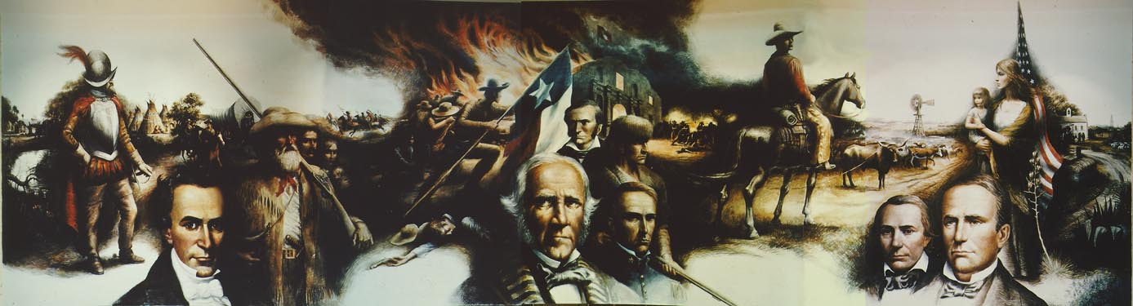“Texas Moves Toward Statehood"
Facts about the Mural in the Lobby of the Lorenzo de Zavala State Archives and Library Building
The Lorenzo de Zavala State Library and Archives Building was completed in the summer of 1961. The formal dedication of the structure took place in April 1962. Early on, officials decided that the building deserved a special piece of commemorative art reflecting the history of the Lone Star State. The Texas Library and Historical Commission and the State Building Commission envisioned a large-scale painting to depict the story of Texas. The commissioners contacted the well-known southwestern artist Peter Hurd of New Mexico to paint the mural. When it became evident that the project required rigorous physical activities, the 65 year old artist requested that the commission be passed on to his son-in-law, Peter Rogers, to do the final painting. This request was granted.
The mural was completed in three months during the summer of 1964. Rogers and Hurd spent several months studying Texas history before Rogers actually began painting the mural, which conveys 400 years in Texas, from conquistadors to cowboys.
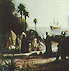
Rogers begins in the left corner with the small ship coming in from the sea, bringing some of the first settlers and missionaries, shown trying to "civilize" the Indians. The figure of the conquistador symbolizes the large part the French and Spanish explorers had in our history. Behind him, a group of Indians are sitting in front of their tipis. The blue design around the front tipi indicates the chief's residence and what appear to be tassels on top of the poles extending from the top are actually scalps. Buffalo jerky is hanging up to dry above the woman to the right.
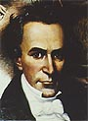
Stephen F. Austin is shown for his participation in the settlement of Texas, bringing over 300 families to this area. The characters behind him represent the different types of people that came to Texas with their various means of travel.
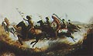
The small group of Indians on the warpath -- traveling in the opposite direction of the flow of the painting –
represent the Indians' opposition to the White man's settlement of the land.
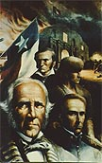
The center portion of the mural depicts Texas fighting for independence from Mexico and eventual statehood (symbolized by the man carrying the flag of the Republic, which became the state flag). In this scene, Sam Houston takes center stage because of his victory at the Battle of San Jacinto. Behind him are the heroes of the Alamo: Travis in the blue uniform, David Crockett and Jim Bowie. The sky over the Alamo is shown the way it looked at the actual time of the battle; Santa Anna attacked at 4 a.m. and that is the reason for the pre-dawn darkness. Mr. Rogers even did research to determine the phase of the moon at the time of the battle. The flames behind the Alamo represent the fires of revolution.
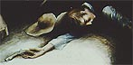
The young man lying face down to the left of Houston not only symbolizes all the fallen fighters, but it is also a self-portrait. By painting his own image into the mural, Peters Rogers was following a long-standing tradition of artists to include their own images in large works, usually in unflattering situations.
The next scene shows Texas developing her resources and becoming a state. The cowboy takes us into the trail-driving days. The rope around the longhorn represents our beginning to control the land and the windmill became a trademark for developing it. The small steam engine in the background indicates more people and new industry coming to Texas.
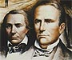
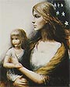
The man on the left in the last scene is Mirabeau B. Lamar, the second president of the Republic of Texas (Sam Houston was the first). It is said that no matter you stand in the lobby of the building, the eyes of Lamar will appear to be staring directly at you. On his right is Anson Jones, the last president of the Republic. Jones was a noted politician and physician who played a key role in bringing Texas into the Union in 1845.
The woman with the child represents the United States bringing Texas into the Union as a young state. (Peter Rogers used his wife Carol as a model for this woman.) Originally, Mr. Rogers was going to depict Texas as a baby, but then he decided that Texas had been getting along on its own for nearly 10 years as an independent republic, so he changed it to a child to show more growth and development. Behind her is the United States flag, on which Texas is the 28th star.
In the corner is the state flower, the bluebonnet. The other plants are those typically found in Texas: the yucca and century plant. The bales of cotton represent the cotton industry introduced to Texas and the two men in front of the white building are confederate soldiers symbolizing Texas' contribution to the Civil War.
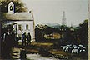
The sheep and oil wells on the far right show new growth and development that launched Texas into a greater industrial era.
The artistry of Peter Rogers and Peter Hurd compresses 400 years of Texas history into a compelling and comprehensive panorama. Their colorful vision of Texas' past will continue to impress visitors to the state's Archives and Library building for generations to come.

Directions: Now that you understand more about the mural you can create a song that tells the story of the mural on a separate sheet of paper. Work with your group to come up with lyrics that will explain each part of the mural. Keep in mind that the lines of your song need to rhyme. You may write about the pictures in any order just make sure you include them all. You could be asked to perform your song so be sure you have decided on a tune for singing it.

