#class of the month C:\Users\Stephanie\Pictures\Microsoft Clip Organizer\j0416014.wmf

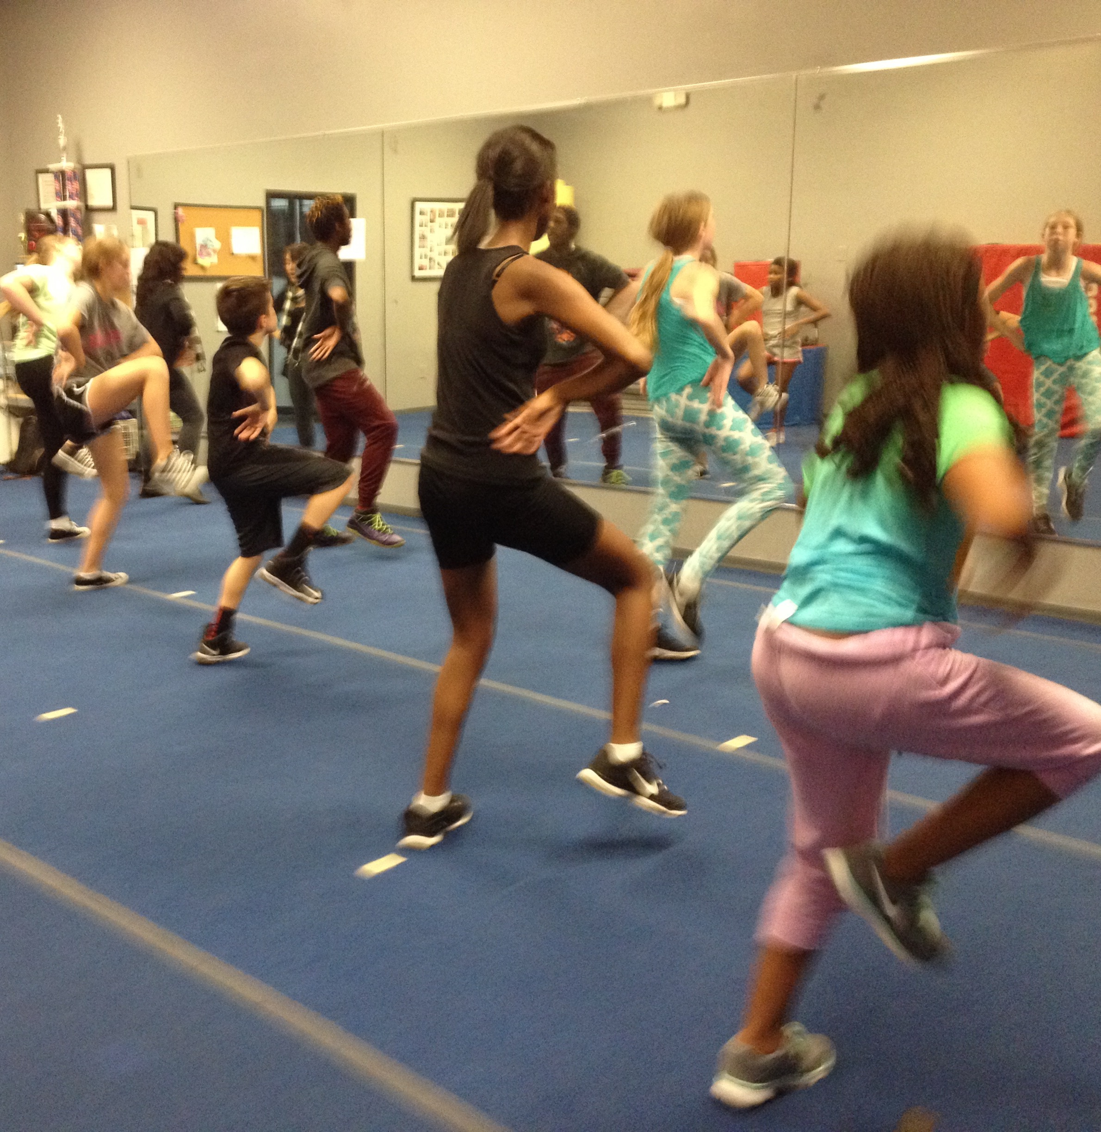

***HIP HOP CLASSES***

Some of the most fun and exciting classes at NSD! Whether you are 2 or 18 years old, we have the class for you. Guys and girls bring your Converse and get ready to sweat it up.

CONTINUING

EDUCATION

You never finish learning. That goes for teachers as well as students. Next Step Dance offers several conventions each year that can give your dancer a leg up while having fun at the same time.

DANCE MASTERS OF AMERICA

November 4th-6th, 2016

Greensboro, NC

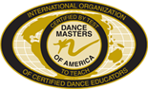

SHOWSTOPPERS

January 13th-15th, 2017

Myrtle Beach, SC

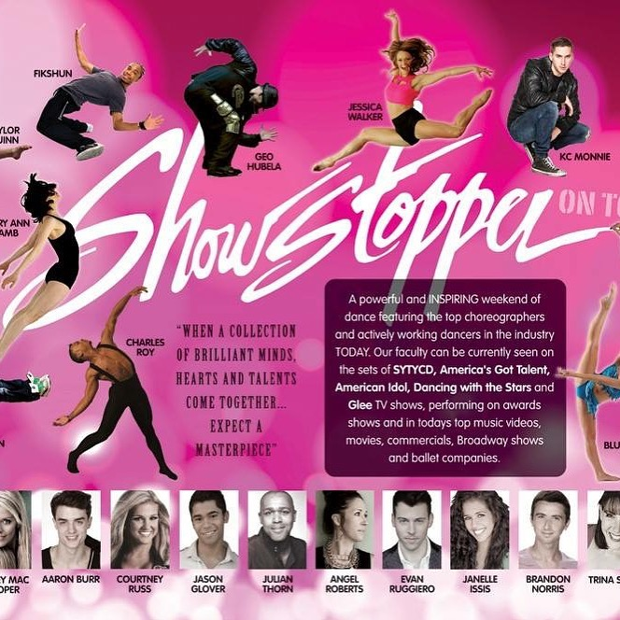

For more information on either learning experience stop by the desk!

C:\Users\Stephanie\Pictures\Microsoft Clip Organizer\j0416014.wmfC:\Users\Stephanie\Pictures\Microsoft Clip Organizer\j0416014.wmfC:\Users\Stephanie\Pictures\Microsoft Clip Organizer\j0416014.wmf

INSPIRATION C:\Users\Stephanie\Pictures\Microsoft Clip Organizer\j0416014.wmf

Never stop dreaming #motivation

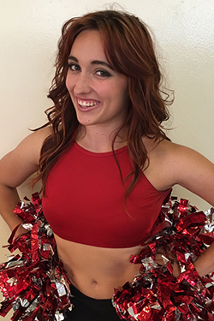 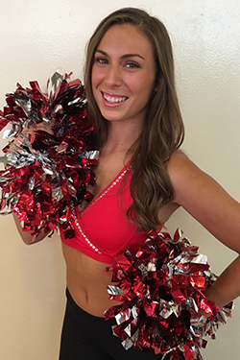

**HIP HOP FRIDAY NIGHT**

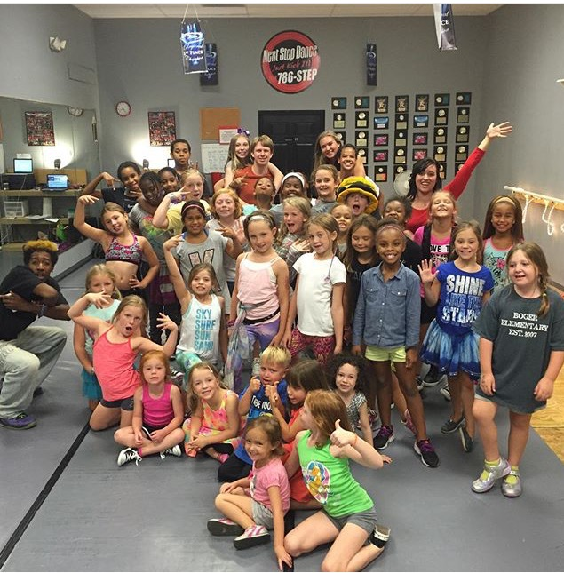

**Each month we pick the second Friday night to celebrate!**

**From 6:30-8:30pm, we dance, play games, and eat! Bring your friends with you because you don’t have to be a student at NSD to attend. There are prizes to be won and dancing to be done. Don’t miss your next opportunity on Friday night, October 14, 2016. The cost is $10.00 per person for 2 hours of action with Mary Beth and Thomas. Mark your calendar now.**

C:\Users\Stephanie\Pictures\Microsoft Clip Organizer\j0416014.wmf C:\Users\Stephanie\Pictures\Microsoft Clip Organizer\j0416014.wmf

Steppin’ into OCTOBER 2016 with Next Step Dance

[**www.thenextstepnc.com**](http://www.thenextstepnc.com)

**7712 Sossamon Lane, NW Concord, NC 28027 (704) 786-7837 nsdcalendar@gmail.com**

NSD ENRICHMENT PROGRAMS

Each week our teachers exit the studio and go to non-traditional setting to share the love of dance. This is our 6th year at Kids R Kids, Concord and 2nd year at Kings Keep Learning Center and our 1st year at Harrisburg Presbyterian CDC! We also added a dance class at Bradford Prep and at Kannapolis Preschool for the Performing Arts. #joinourdancefamily

C:\Users\Stephanie\Pictures\Microsoft Clip Organizer\j0416014.wmf

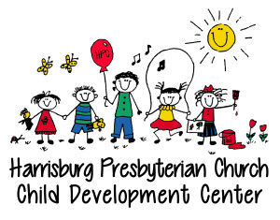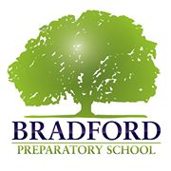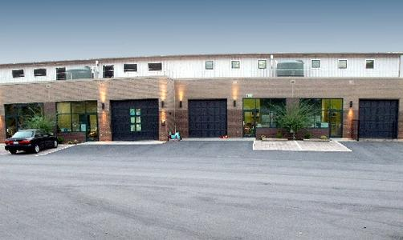 

SAVE THE DATE C:\Users\Stephanie\Pictures\Microsoft Clip Organizer\j0416014.wmf

Hip Hop Friday Night- 10/14/15

Yankee Candle Fundraiser-

10/17/15-11/07/16

Mrs. Pumpkin’s Pies Fundraiser-

10/24/16-11/03/16

Studio Closed 10/31/16

Jump on FB to see what we are doing daily. Monday we talk about the week, Tuesday we give a ”Shout-Out” to a group, Wednesday we answer a question parents have asked, Thursday we talk about people that have motivated us, and then it is the weekend and who knows!

**https://www.facebook.com/next.s.dance**