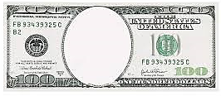
Whaling
greenbacks
Panic
Of
1837
Trade &
Navigation
Acts
Lincoln’s
Financial
Plan
Specie
Circular

