Texas History with Mr. Brown Name ____________________________ Period _____

Chapter 18: King Cotton, Picture Search p. 380-394, 3 pts each
Directions: Use the pictures, maps, graphs, Info boxes, and their captions in your textbook to find the following information.
1) Who was the artist of “Chicken for Dinner”?
2) Who painted “Cotton Picking”?
3) What did some Texans have to do to make their own clothing after the Civil War?
4) Taking out a loan was risky for poor tenant farmers. Often, lenders would charge an interest rate of up to _________________ percent.
5) One thing that kept many families trapped in a cycle of poverty was _______________________.
6) The ________________ Bureau, which operated in Texas for a few years following the Civil War, recognized the need for literacy.
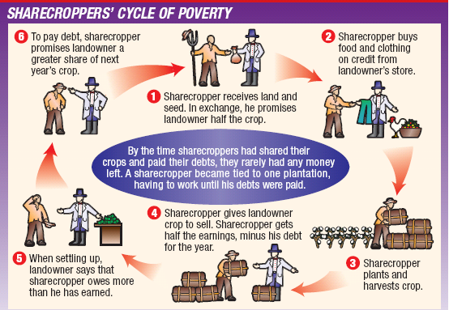
7) What are the six steps of the Sharecroppers Cycle of Poverty?
1:

2:

3:

4:

5:

6:
8) Although Texas’s agricultural future looked bright, many Texans remained poor because of a
cycle of _________________.
9) At the end of the Civil War, an estimated ____________________________ African Americans lived in Texas.
10) What percentage of the population in Texas was African American, after the civil war?
11) What is the Ox cart hauling on p.386?
12) Who was the first Texas governor that was born in Texas?
13) Hogg and the legislature established the Texas Railroad Commission in what year?
14) Which rail road line goes through Denison?
15) Which rail road line connects Dallas and Fort Worth?
16) How many daily passenger trains run from Galveston to Houston?
17) The railroad bridge over the ________________ River, built in 1892.
18) That bridge was the highest railroad bridge in North America and the ___________ highest in the world.
How does a Windmill work? Questions 19-23
19)First a well is drilled to an __________________________ water source.
20) Next, a _____________________________ is driven through the well.
21) Then a _____________________ is attached to the pipe.
22) The pump is activated by a large ____________________________.
23) Water is sucked through the pipe and into a ______________________________.
24) Technology such as the ______________________ and the steel plow made cotton production more efficient.
25) Who made Lummus cotton gins?
26) What was the final form of cotton when it finished it’s journey through a cotton gin?
27) Who did Alf Muckle write a letter to in 1868?
28) Where are the cotton pickers pictured on p.291 from?
29) When was the King Cotton photo from p.392 taken?
30) Cotton Towns grew to supply cotton _____________________ with needed supplies.
31) The success of cotton as a __________________________ crop made farmers more dependent on the land.
32) Discovered in Mexico, the _____________________________________ is about one-fourth of an inch long.
33) What did Boll Weevils eat?
34) Who were the first people to grow cotton in Texas?

