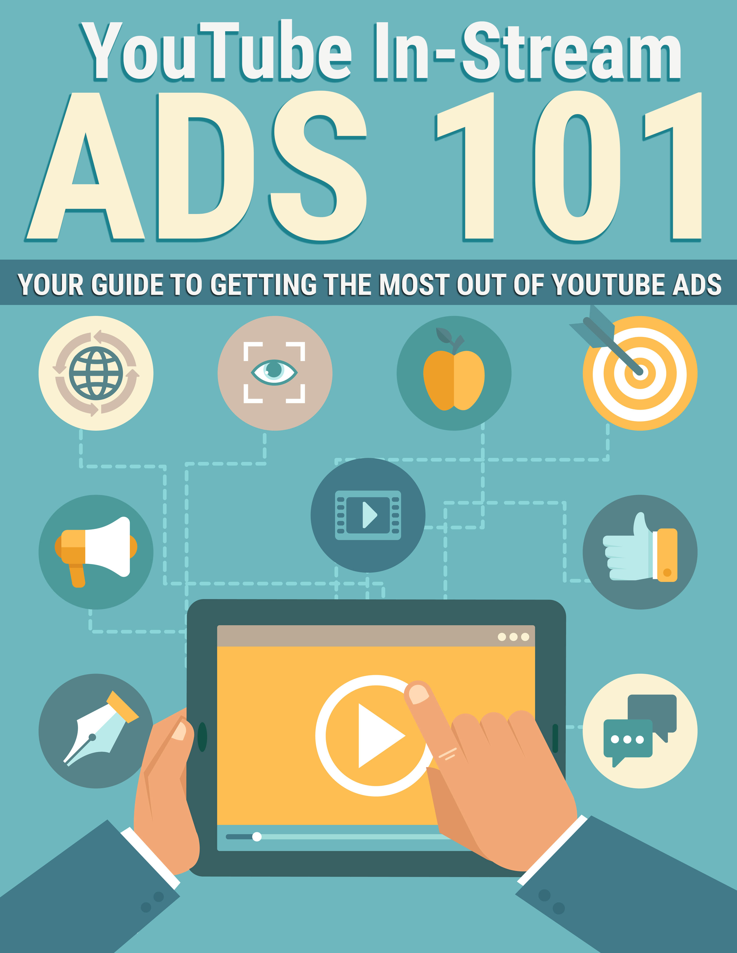

Legal

No part of this publication may be, including but not limited to, reproduced, in any form or medium, stored in a data retrieval system or transmitted by or through any means, without prior written permission from the publisher. The information contained herein has been obtained from sources believed to be reliable at the time of publication. The opinions expressed herein are subject to change without notice.
The publisher disclaims all warranties as to the accuracy, completeness, or adequacy of such information. The publisher assumes no liability for errors, omissions, or inadequacies in the information contained herein or from the interpretations thereof. The publisher specifically disclaims any liability from the use or application of the information contained herein or from the interpretations thereof.

Table of Contents

Legal 2
Table of Contents 3
Introduction 5
Types of YouTube Ads 6
In-Stream Ads 6
In-Display Ads 6
In-Search Ads 7
Prerequisites 8
Creating Your Landing Page 9
Creating Videos 10
Campaign Creation 11
Conclusion 12
Resources 13

Introduction

YouTube is consistently among the highest traffic websites in the world, with over one billion users (almost 1/3 of all the people on the internet) and it reaches more people between 18 and 49 than any U.S. cable network!

Here are some interesting statistics about YouTube:

>> https://www.youtube.com/yt/press/en-GB/statistics.html

As you can see, there’s very little reason to avoid advertising on YouTube, especially if you’re trying to reach that all-important 18-49 age range that YouTube has such a large number of.

Not only does the site have a massive amount of traffic – they claim that people watch hundreds of millions of hours of videos every single day – but it has a great potential to convert, too. Video is one of the most effective ad formats available! There’s really no better way to convey a lot of information quickly while keeping the user’s interest.

In this guide, you’re going to learn how to take advantage of YouTube ads in order to generate leads, get sales, or whatever other conversion goals you have in mind.

Let’s begin.

Types of YouTube Ads

There are actually three different types of YouTube ads that are available to advertisers. In this guide, we’ll be focusing on one in particular – in-streams ads, but there are two other types you could also try. In-stream ads just happen to be the most effective for the majority of advertisers.

In-Stream Ads

The most effective type of ad on YouTube for general purposes is the in-stream ad. This is the type of ad that works like a television commercial, forcing users to view the ad before they can continue to the video they want to watch. Most in-streams ads have the ability for the user to skip the ad by clicking a link after the first five seconds of the ad has been viewed.

If a user clicks the ad, they can be taken to the advertiser’s landing page. This is ideal for getting inexpensive exposure to highly-targeted prospects.

The in-stream ads are perfect if you’re looking for a lot of impressions quickly for branding or promotional purposes. In-stream ads tend to get a lot more views than the other ad types.

In-Display Ads

In-display ads are those you might see in the sidebar when you are viewing a video on YouTube. The ad is shown at the top of the related videos, and the ads blend in quite nicely, but not so much so that they don’t get clicks. They do have a yellow tag that alerts users to the fact that the post is an ad.

This type of ad is best for building your YouTube channel or just getting more views to specific videos. Because the ads lead to YouTube videos and NOT to a landing page, they aren’t as effective for actual promotional purposes.

Of course, you can still build calls-to-action within your video to get users to your website, but the ad won’t link directly to your page.

In-Search Ads

In-search ads are similar to in-display ads, except they appear when a user searches for specific keywords rather than when someone is searching for a video. The ads appear above the content.

These ads work in much the same way as in-display ads. Traffic is sent to a video rather than a landing page, so again, you would need to be certain your video has a strong call-to-action if you want to get traffic to a landing page.

Prerequisites

In order to create YouTube ads, you will need a Google account and an AdWords account. Then you will need to link your YouTube account to Google AdWords to purchase ads.

You can find out more about the basics of advertising on YouTube here:

>> https://www.youtube.com/yt/advertise/

And you can find out how to link your AdWords account to Youtube here:

>> https://support.google.com/youtube/answer/3063482?hl=en

Once your accounts are linked, you can start creating ads right away. Just click the “GET STARTED” button here:

>> https://www.youtube.com/yt/advertise/launch-ad.html

Once you have these things in place, you’re ready to get started.

Creating Your Landing Page

Although it’s not necessary to create a separate landing page specifically for YouTube traffic, it’s a good idea to do so for a few reasons.

First, you’ll be able to easily tell how much traffic the site is sending you. This can be accomplished with a conversion pixel, as well, but this method gives you more control.

Additionally, creating a specific landing page would allow you to target YouTube viewers specifically with your ad. For example, your headline might reference something like “Welcome YouTube Viewers”. Or you could have a video landing page that might be more effective than a traditional landing page since that traffic is coming from a video website.

You’ll definitely want to add a conversion pixel to your landing page even if you create a dedicated landing page for your YouTube traffic. The conversion pixel will send information to YouTube that will let them know how well your ad and landing page are performing, and the system may adjust your ad based on the information it receives from the conversion pixel.

Here’s how you can implement a conversion pixel:

>> https://support.google.com/adwords/answer/1722054?hl=en

Creating Videos

It seems obvious, but too many people seem to think that the quality of their video ad doesn’t matter much. The truth is, it matters a whole lot. And it’s not just the quality of the audio and video itself, but of the way your ad is presented and the type of ad you create.

You can definitely outsource the creation of your video if you don’t feel comfortable making it yourself, but there are myriad tools available these days that make it easy for beginners to create professional videos on their own.

Here are a few examples:

- http://www.PowToon.com
- http://www.VeeRoll.com
- http://www.telestream.net/screenflow/overview.htm (MAC)
- http://www.techsmith.com/camtasia.html (PC/Windows)

Once you have created your ad, just upload the ad to YouTube like you would any video. This will let you get some traditional (FREE) views to your ad from the site itself in addition to making the video available for the ad system.

Campaign Creation

There are a number of different ways to target your in-stream ad on YouTube. Each method has its own strengths and weaknesses, so you may want to try out more than one to see which one gets you the best results.

Keyword

Keyword campaigns allow you to target based on specific keywords. This is helpful if you have a good idea of the types of words and phrases people might search for to find information related to your topic.

Let’s say you have an ad that has to do with digital painting. You might not want to target the word “painting” on its own, because a lot of people might be searching for that word to learn how to paint with oils or acrylics, or they might be looking to paint the walls in their basement. Instead, you’d want to target very specific keywords such as “digital painting” and “painting on a computer”.

Interest/Topic

Another type of targeting is by interest or topic. YouTube keeps track of what logged-in users watch, developing a profile of the type of content each individual likes over time. This helps them deliver accurate suggestions of things the user might like to watch, and also helps them deliver the most relevant ads.

You are likely to get a lot more views if you target by topic, but keep in mind that this type of traffic probably won’t be as well-targeted as keyword traffic, because it isn’t targeted to what that user wants to view at any particular moment. They may view your ad out of curiosity, but the ad might not be as effective as it would be if they had deliberately searched for a related term during this session.

Placement

Placement campaigns are probably the best type of campaign if you’re just getting started, because you can target very specific videos or channels to display your ad. This means you can find videos that fit exceptionally well and show your ads on those specific videos.

If you target by keyword or by topic, you have to hope that Google is correct when it decides the best places to advertise your content. The system will have to interpret both your keywords and the context of the videos before it displays ads. It could end up showing your ad on irrelevant content, costing you money with little to no return.

Using placement campaigns, you can choose relevant content yourself and ensure your ad is making it to your target market.

Keep in mind that you may not see as much traffic with this method as you would with a keyword campaign, but the traffic is much more likely to be profitable for you.

Another cool thing about using placement campaigns is the fact that you can place ads on videos that your competitors have uploaded. This lets you legally “steal” your competitors’ viewers! Best of all, your competitors have already done the work of getting views to the content!

Retargeting

Retargeting campaigns allow you to target people who have already visited your website or landing page at least once.

You might wonder what the point is in targeting people who have already been to your site and failed to convert, but keep in mind that people have many different reasons for failing to convert. A lack of interest is not always the reason!

Remember, someone may be too busy to fill out your email form when they first visit, or they might not have enough money to buy your product at the moment, or maybe they just wanted to shop around first. By targeting those people who have been to your site and not converted, you have another chance to get them back and get that conversion! Best of all, they’ve already proven they were at least somewhat interested in what you have to offer, because they’ve already been to your site!

Campaign Creation

Creating a YouTube ad campaign on AdWords is very simple. Creating the video and uploading it is the hardest part of the process. Once that is done, it’s actually incredibly easy to create a campaign.

First, log into your AdWords account. Click on the Campaigns tab and then click +Campaign to add a new campaign. Click Video.

Enter a name for your campaign and then enter your budget, select YouTube, choose which locations you’d like to target or exclude, and choose the target language for your customers.

Click Save and continue.

Next, enter a name for the ad group within your campaign. Next to “Your video” choose the video you’ve uploaded to YouTube as your ad. Beside “Video ad type”, choose what type of conversion you’d like (views, awareness, conversions, or mobile app installations). Beside video ad formats”, choose in-stream ad. (You can also choose in-display if you want, but we’re focusing on in-stream ads.)

Set your bid amount and select your targeting methods. Click Save ad group.

It’s that simple!

Conclusion

As you’ve learned, creating ads on YouTube via AdWords is actually remarkably simple. It’s also very cost effective, bringing you leads at an affordable price without a lot of time or upfront investment.

Of course, you can’t just slap up any old video and send traffic to a landing page that is poorly designed and expect results. But, like anything, if you’re willing to test and tweak, you should be able to come up with a system that is very profitable in no time.

Don’t forget to add the conversion pixel to your landing page if you have access to do this. (If you’re sending traffic straight to an affiliate offer, you may not be able to.) The conversion pixel will help you see not only how much traffic you’re getting from your in-stream ads, but also how much traffic is making it to your thank you page, which will let you know how well it is converting.

There are also retargeting options you should consider so you can get the people who didn’t convert the first time to come back so you have a second chance to convert them. You could also send those retargeted folks to a different landing page that might have a better conversion rate!

Best of luck with your in-stream ads!

Resources

Here are quick links to the resources mentioned in the guide:

YouTube Ad Basics:

>> https://www.youtube.com/yt/advertise/

Linking AdWords & YouTube:

>> https://support.google.com/youtube/answer/3063482?hl=en

Launch an Ad:

>> https://www.youtube.com/yt/advertise/launch-ad.html

Video Creation Tools:

>> http://www.PowToon.com

>> http://www.VeeRoll.com

>> http://www.telestream.net/screenflow/overview.htm (MAC)

>> http://www.techsmith.com/camtasia.html (PC/Windows)

