THIS IS AN OPTIONAL ENRICHMENT ASSIGNMENT. PRINT AND COMPLETE IN INK.

Name:_______________________________________ Class Period:____ Due Date:___/____/____
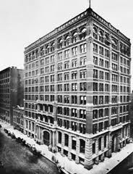
Guided Reading & Analysis: The Growth of Cities and American Culture, 1865-1900

Chapter 18- Urbanization pp 360-373

Reading Assignment:
Ch. 18 AMSCO; If you do not have the AMSCO text, use chapter 25 of American Pageant and/or online resources such as the website, podcast, crash course video, chapter outlines, Hippocampus, etc.

Purpose:
This guide is not only a place to record notes as you read, but also to provide a place and structure for reflections and analysis using your noggin (thinking skills) with new knowledge gained from the reading. This guide, if THOUGHFULLY completed in its entirety BOP (Beginning of Period) by the due date, can be used on the corresponding quiz as well as earn bonus points.

Mastery of the course and AP exam await all who choose to process the information as they read/receive.
This is an optional assignment. So… young Jedi… what is your choice? Do? Or do not? There is no try.

William Le Baron Jenny built the ten story Home Insurance Company building in
Chicago (pictured above) which was the first true American skyscraper. Public Domain.

Directions:
- Pre-Read: Read the prompts/questions within this guide before you read the chapter.
- Skim: Flip through the chapter and note titles and subtitles. Look at images and read captions. Get a feel for the content you are about to read.
- Read/Analyze: Read the chapter. If you have your own copy of AMSCO, Highlight key events and people as you read. Remember, the goal is not
to “fish” for a specific answer(s) to reading guide questions, but to consider questions in order to critically understand what you read!
- Write Write (do not type) your notes and analysis in the spaces provided. Complete it in INK!

Key Concepts FOR PERIOD 6:
Key Concept 6.1: Technological advances, large-scale production methods, and the opening of new markets encouraged the rise of industrial capitalism in the United States.
Key Concept 6.2: The migrations that accompanied industrialization transformed both urban and rural areas of the United States and caused dramatic social and cultural change.
Key Concept 6.3: The Gilded Age produced new cultural and intellectual movements, public reform efforts, and political debates over economic and social policies.

Section 1 Background and Introduction, page 360
Read page 360 and additional information below, Highlight main events, and address the question that follows.
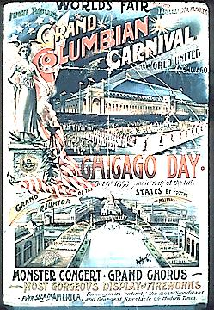
In 1800, the then sixteen United States were still largely agricultural. Just four cities, New York, Philadelphia, Baltimore, and Boston had populations over 20,000, while the nationwide population was 5.3 million. By 1893, after the industrial and transportation revolutions, the growth of slavery, westward expansion, the Civil War, Emancipation, and Reconstruction, the forty-five United States had drastically transformed to become a diverse population of nearly 76 million people. Over 100 cities had populations over 20,000, and three, New York, Chicago, and Philadelphia had over one million people each. Chicago’s meteoric rise to become the second largest American city by 1890 made it the nation’s industrial nerve center, drawing hundreds of thousands of foreign immigrants and rural dwellers to the city. In the twenty years between 1870 and 1890, Chicago's population more than tripled, while over 40% of Chicago dwellers were born outside of the U.S. The city’s central location made it a major railroad hub, connecting the East with the West, and farmers and ranchers with consumers. (Source: ucla.edu)

The World’s Columbian Exposition in Chicago, 1893, millions of people traveled to the “White City” to see new technology and entertainment such as inventions by Thomas Edison and the first Ferris wheel. In the Electricity Building, visitors saw the introduction of the telephone, the phonograph, the typewriter, the elevator, electric lamps, sewing machines, laundry machines, and irons. These exhibits demonstrated how electricity could revolutionize both industry and the home. Technological innovation became and has remained a cornerstone of American identity. Outside the park’s 600+ acres (more than 7 times the size of Disney Land), visitors could attend Buffalo Bill’s Wild West Show. This was all a celebration of the 400th anniversary of Christopher Columbus’s “discovery” of the New World (fair was delayed one year… was planned for 92) and to be the greatest “among monuments marking the progress of civilization throughout the ages.” [Hubert Hugh Bancroft, The Book of the Fair, Preface, 1893]

Compare the gleaming, innovative “White City” in Chicago with the reality of “gray” city life in the 1890s. How do the similarities and differences illustrate the impact of urbanization and industrialization?

Section 2 Guided Reading, pp361-373

- A Nation of Immigrants, pp 361-362

Key Concepts &  Main Ideas | Notes | Analysis
The emergence of an industrial culture in the United States led to both greater opportunities for, and restrictions on,  immigrants, minorities, and women.  International and internal migrations increased both urban and rural populations, but gender, racial, ethnic, religious, and socioeconomic inequalities abounded, inspiring some reformers to attempt to address these inequities.  Immigrants sought both to “Americanize” and to maintain their unique identities; along with others, such as some  African Americans and women, they were able to take advantage of new career opportunities even in the face of  widespread social prejudices.  Increasingly prominent racist and nativist theories, along with Supreme Court decisions such as Plessy v. Ferguson,  were used to justify violence, as well as local and national policies of discrimination and segregation. | A Nation of Immigrants…  Growth of Immigration…  Negative forces driving Europeans to emigrate:  1)  2)  3)  Positive forces for emigrating:  1)  2)  3)  4)  5)  “Old” Immigrants and “New” Immigrants…  New Immigrants…  Restricting Immigration……  Chinese Exclusion Act…  Groups supporting immigration restrictions:  1)  2)  3) | Compare and contrast the waves of immigration before and after the Civil War.  Similarities:  Differences:  What is the difference between an immigrant and an emigrant?  What is the difference between an immigrant and a “bird of passage?”  Was nativism fueled more by economic or cultural forces? Explain your answer.
REMEMBER…As you read the chapter, jot down your notes in the middle column. Consider your notes to be elaborations on the Objectives and Main Ideas presented in the left column and in the subtitles of the text. INCLUDE IN YOUR NOTES ALL SIGNIFICANT VOCABULARY AND PEOPLE. After read and take notes, thoughtfully, analyze what you read by answering the questions in the right column. Remember this step is essential to your processing of information. Completing this guide thoughtfully will increase your retention as well as your comprehension!

- Urbanization, pp 362-364

Key Concepts and Main Ideas | Notes | Analysis
The emergence of an industrial culture in the United States led to both greater opportunities for, and restrictions on,  immigrants, minorities, and women.  Cities dramatically reflected divided social conditions among classes, races, ethnicities, and cultures, but  presented economic opportunities as factories and new businesses proliferated.  Immigrants sought both to “Americanize” and to maintain their unique identities; along with others, such as some  African Americans and women, they were able to take advantage of new career opportunities even in the face of  widespread social prejudices.  In a urban atmosphere where the access to power was unequally distributed, political machines provided social  services in exchange for political support, settlement houses helped immigrants adapt to the new language and  customs, and women’s clubs and self-help groups targeted intellectual development and social and political reform. | Urbanization…  Changes in the Nature of Cities…  Streetcar Cities…  Skyscrapers…  Ethnic Neighborhoods…  Residential Suburbs…  Moving to the suburbs required:  Private City Versus Public City…  Boss and Machine Politics… | What caused migration from rural to urban areas?  Did this internal migration have more in common with foreign immigration or westward migration during this era? Explain your answer and cite specific evidence in your answer.  Explain the historical significance of Americanization.  To what extent were political machines immoral? Defend your answer with specific evidence and acknowledge the opposing view.

- Awakening Reform, pp365-367

Key Concepts and Main Ideas | Notes | Analysis
The emergence of an industrial culture in the United States led to both greater opportunities for, and restrictions on,  immigrants, minorities, and women.  International and internal migrations increased both urban and rural populations, but gender, racial, ethnic, religious, and socioeconomic inequalities abounded, inspiring some reformers to attempt to address these inequities.  Cities dramatically reflected divided social conditions among classes, races, ethnicities, and cultures, but  presented economic opportunities as factories and new businesses proliferated.  In a urban atmosphere where the access to power was unequally distributed, political machines provided social  services in exchange for political support, settlement houses helped immigrants adapt to the new language and  customs, and women’s clubs and self-help groups targeted intellectual development and social and political reform.  A number of critics challenged the dominant corporate ethic in the United States and sometimes  capitalism itself, offering alternate visions of the good society through utopianism and the Social Gospel. | Awakening Reform…  Books of Social Criticism…  Progress and Poverty…  Looking Backward…  Jane Addams & Settlement Houses…  Social Gospel…  Religion and Society…  Families in Urban Society…  Voting Rights for Women…  Temperance Movement…  Urban Reforms… | What did the Gilded Age reformers have in common with Jackson Era reformers?  1.  2.  3.  4.  5.  How were they different?  Explain how and to what extent industrialization created the problems facing cities during the Gilded Age. ATFP and defend your answer with specific evidence.  To what extent did women’s rights improve during the Gilded Age? Defend your answer with specific evidence.
- Intellectual and Cultural Movements, pp 367-372

Key Concepts and Main Ideas | Notes | Analysis
The “Gilded Age” witnessed new cultural and intellectual movements in tandem with political debates over economic and social policies.  New cultural and intellectual movements both buttressed and challenged the social order of the Gilded Age. | Intellectual and Cultural Movements…  Changes in Education…  Public Schools…  Compulsory education…  Kindergarten…  Higher Education…  Morrill Acts of 1862 and 1890…  Philanthropic efforts of Carnegie, Rockefeller and others…  Women’s Universities…  Changing curriculums…  Social Sciences…  Psychology…  Sociology…  Political science…  Economics…  Anthropology…  (define each of the social sciences above as well as recording notes from reading)  The Professions… | Explain how the scientific method impacted American culture during the Gilded Age.  Explain the link to Gilded Age educational reform from the Jackson Era.  Which Jackson Era reformers began the movement we see continuing in the Gilded Age?  1.  2.  3.

Intellectual and Cultural Movements Continued…

Key Concepts and Main Ideas | Notes | Analysis
The “Gilded Age” witnessed new cultural and intellectual movements in tandem with political debates over economic and social policies.  New cultural and intellectual movements both buttressed and challenged the social order of the Gilded Age. | Literature and the Arts…  Realism and Naturalism…  Painting…  Architecture…  Music…  Popular Culture…  Popular Press…  Amusements…  Spectator Sports…  Amateur sports… | Compare urban culture in the Gilded Age to Puritan culture in the Colonial Era.  Similarities:  Differences:  Explain how urbanization and industrialization enabled the dramatic change in American culture.  How did cultural change create social conflict?  How did cultural change illustrate class and gender structure?

- Historical Perspectives, Melting Pot or Cultural Diversity? page 373

To what extent did immigrants give up their heritage to become Americanized, or fully assimilated into the existing culture?  Evidence for Melting Pot: | To what extent did immigrants retain their heritage to become unique, new thread in the American fabric?  Evidence for Salad Bowl:

How did African Americans differ from immigrant groups?

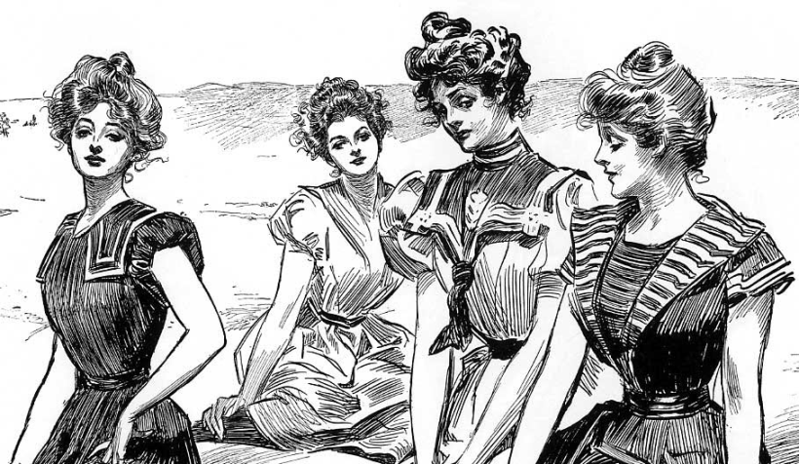
Food For Thought:
How did urban culture create social conflict regarding women’s roles, women’s rights, and social norms?
Made in America! Here’s something you don’t see every decade: in the last quarter of the 19th century, American women embraced a homegrown fashion trend! That’s right. Instead of copying styles from Paris or London, the new feminine ideal was personified by the Gibson Girl, depicted by the pen-and-ink illustrator Charles Gibson. Like other fashion movements, the Gibson Girl style had a definite look, but also reflected an attitude and a unique approach to the world. Gibson Girls were beautiful and glamorous, but they were also fun-loving and even a bit cheeky.
How could the drawings of one illustrator become the iconic images of an age? One word: print. With literacy levels steadily increasing and production and distribution costs simultaneously decreasing, newspapers became a daily habit for most educated people. Readers could choose from morning and evening editions, and news junkies often picked up both. The total circulation of daily newspapers increased from 3,566,395 in 1880 to 24,211,977 in 1909 (from 7% to 26% of the U.S. population). Meanwhile, the total number of monthly magazines increased from 1,167 in 1880 to 2,767 in 1910. Some big titles even boasted circulations over 1 million. These print publications, along with the advertisements within, helped create a mass culture – both shaping and reflecting the standards and expectations of all parts of life.
Part of the increase in magazine readership from 1880-1910 was the result of the Postal Act of 1879, which reduced the mailing cost by establishing a lower second-class rate for magazines.
It was in this context that Charles Gibson drew his satirical cartoons, with his “Girls” sometimes enchantingly ethereal, sometimes comical, but always beautiful. The stereotypical Gibson Girl was tall and trim, with a narrow waist. She had curves, a distinctive S-shaped profile with the help of a corset, and delicate facial features. Popular hairstyles, like the pompadour and bouffant, resembled more relaxed, free-flowing versions of Romantic hairdos; a few locks of a Gibson Girls hair might trail carelessly for artistic effect.
Running errands during the day, the Gibson Girl was likely to wear a “traveling suit,” including an embroidered blouse with a dark bowtie, a seersucker “outing” skirt, elbow-length satin gloves, and straw “boater” hat decorated with flowers or ribbons. When she wanted to stand out in the evening, the Gibson Girl got a bit friskier, wearing elegant, low-cut gowns that revealed her shoulders, arms, and more than a hint of cleavage. Of course, she always had spectacular gem-encrusted earrings and necklaces to call attention to the aforementioned cleavage. Other elegant, must-have accessories included fancy silk fans, jeweled hatpins, and tiny silk handbags.
The women Gibson idolized were a new breed, and much of their behavior – smoking, drinking, maintaining an active, sporty lifestyle – was viewed as unladylike. Some worked as shopgirls, priding themselves on financial independence. Others even traveled on their own, unaccompanied by men. Overall, guys were clearly nervous about the blurring of gender boundaries, fearing female invasion of traditionally male domains. As a satirist, Gibson was an equally keen observer of men, and he loved playing of their anxieties and befuddlement. (Eric Sass, A Mental Floss History of the United States, 2010)

Reading Guide written by Rebecca Richardson, Allen High School
Sources include but are not limited to: 2015 edition of AMSCO’s United States History Preparing for the Advanced Placement Examination,
2012 and Revised 2015 College Board Advanced Placement United States History Framework, and other sources as cited in document and collected/adapted over 20 years of teaching and collaborating..

