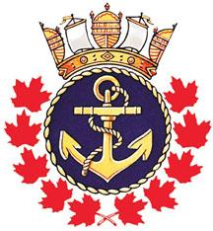 | ROYAL CANADIAN SEA CADET CORPS “REPULSE”  P.O. BOX 2071  SARNIA, ON N7T 7L3  SPONSORED BY  THE NAVY LEAGUE OF CANADA | 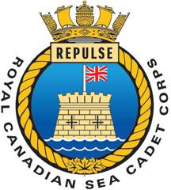

25 January 2017

Dear Parents/ Guardians

RE: Drill Team, Seamanship Team and Sport Teams

The Drill Team will be starting February 4th and running every Saturday between 1000 hr till 1130 hrs. This team is comprised of cadets that wish to perform rifle drill using precision based movements. Cadets build confidence in themselves, agility, and drive, while improving their dress and deportment. This is a great opportunity for cadets to come out and become part of an excellent team. All cadets are welcome regardless of previous drill experience. The dress of the day will be civilian attire with cadet black parade boots. The Drill team will be competing against other Corps in the Band and Drill Competition on the Mothers Day weekend. This team will be meeting at different times as it gets closer to the Competition.

The Seamanship Team will commence on February 4th and run every Saturday between 1130 hr and 1300 hrs. The Seamanship team learn a variety of nautical skills that they use in a competitive way. Nautical and common knowledge learnt on this team are excellent skills they can apply to everyday life. Again all cadets are welcome regardless of previous seamanship experience. The dress will be civilian attire with cadet boots.

On Saturday February 4th from 1400 (2:00 pm) to 1500 (3:00pm) the cadets are invited to participate in a floor hockey tournament. Everyone is welcome.

For Cadets participating in more than one activity they are encouraged to pack a lunch.

Yours Aye,

D. Anderson CD2
Lieutenant (N)
Commanding Officer

