Ladies in Training: Session 6 – December 19, 2014
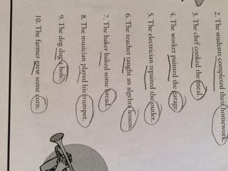
Today’s lesson was about grammar. Scary? Not really!
The kids first learned about direct and indirect objects, which seemed to be a new topic for most kids. However, the kids picked it up very quickly, and were not hesitant to ask questions. Good spirit!
Then, we watched a fun video/rap by Flocabulary, called “Something that Doesn’t Exist” which included many vocab words. Half of the girls were singing along and cheering, while the other half claimed that “their ears were bleeding”.
After that, the girls played a fun game called Silent Artwork. They looked at a drawing, and tried to replicate/trace it on someone else’s back. That person would have to try and guess what the drawing was, and it was very tough (I think we went from a peace sign to a house).
The last game was called Coke and Pepsi, which basically consisted of lots of running and high-fiving between partners. Great teamwork!
