

USAF Lieutenant Colonel (Ret) Terence (TJ) Spann is an AF Civil Servant who has unselfishly volunteered his leadership services in on and off-duty capacities for over 35-year now. He served in the USAF for 21+ years and as the Tidewater Chapter Tuskegee Airmen Inc. (TC-TAI) President for 6-consecutive years. Currently, he serves as their Immediate Past Chapter President, a National TAI’s Membership Committee Chair, Eastern Region TAI Board Representative (6th year) and 1st Vice President (4th year) of the Eastern Region TAI organization.

Prior to retiring from the USAF in June 2003, Col Spann served as a Logistician/Supply Officer. He was a Squadron Commander twice...first over Air Combat Command’s AF Contingency/Centralized Supply Squadron…its first Commander responsible for successfully testing the first 5-ACC bases of the AF’s Supply accounts—now regionally comprised at Scott AFB, MO and at USAFE and PACAF bases. Immediately afterwards, he was handpicked to serve as the 1st Fighter Wing’s 1st Supply Squadron Commander (now known as the 733rd Logistics Readiness Squadron). His fini active duty USAF tour

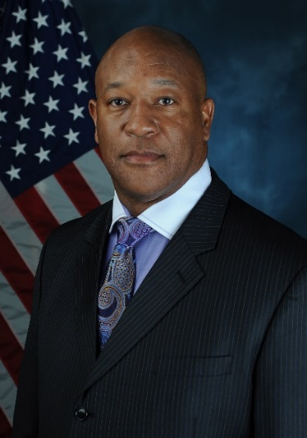

BIOGRAPHY

**Tidewater Chapter ~ Tuskegee Airmen, Inc.**



was with the North Atlantic Treaty Organization (NATO), Headquarters’ Supreme Allied Command Transformation (ACT) in Norfolk, VA. Among his duties was responsibility for ensuring the NATO Pipeline was secured following the 9/11 attacks. After his military retirement, Mr. Spann worked for Northrop Grumman’s Mission Defense Sector for 10.5 years and is now back at Joint Base Langley-Eustis as a Civilian Program Manager and Branch Chief over 17-Acquisition Programs valued at a $650M. He, his wife (Alice) and Hampton University graduate daughters (Camille & Dominique) have resided in the Hampton Roads area since 1994. TJ is an HBCU graduate as well hailing from Tennessee State University (TSU), Nashville, TN.

As TC-TAI President, Mr. Spann led the famed Tuskegee Airmen Chapter, where three Documented Original Tuskegee Airmen continue as members, and meet monthly with other Chapter Members, who are committed to continuing the Tuskegee Airmen heritage and legacy. Mr. Spann was responsible for helping (a) perpetuate the activities and achievements of those pioneering Americans who shared in the aspirations/frustrations of the Tuskegee Experiment in the United States Army Air Corps, (b) motivating today’s youths to attend college and pursue aviation, science, technology, engineering and mathematics (STEM) studies/careers and other non-technical study/career areas as well, and (c) gained the City of Hampton’s siting/funding approval to build a $1M Tuskegee Airmen Memorial at its Air Power Park. Fundraising is still on-going for the Memorial.

As 1st Vice President for the Eastern Region TAI organization, Mr. Spann has double duty as a National TAI Board of Director. He’s responsible for keeping 5 of 21 TAI Region Chapters, with 800+ Members in his zone, informed of National and Regional TAI activities, fundraisers, etc. that are planned and/or afoot. For the Eastern Region, he has taken on the herculean task of acquiring 100-DOTA Biographies by 31 May 2021 in the Region which would more than quadruple the number of DOTA Biographies on-hand and ready for promulgating on TAI’s Website.

Before his 1994 relocation to Virginia, and after completing his Supply/Fuels Officer training at Lowry AFB, CO in 1981, Lieutenant Spann began his military career at Sheppard AFB where he was selected for numerous military/volunteer service awards…including Base Company Grade Officer of the Year for 2-consecutive years. After Squadron Officer School, Captain Spann relocated to Wright-Patterson AFB, OH, where he continued to excel and volunteer his leadership services as President of the Nightingale House; a military compassionate care program that served as the template and precursor to today’s Fisher Houses. He and his family are recognized as one of its several Co-Founders on a plaque outside the Fisher House facility. After a remote assignment to Galena, AK and several TDYs around the world, Major Spann was relocated to Langley AFB where he continued to excel professionally and volunteer his leadership services to include Co-Founder and President of Langley’s Air Force Cadet Officer Mentor Action Program (AFCOMAP). He helped mentor young officers to prepare them for greater responsibility in today’s very challenging U.S. Air Force. Today, one of his protégé’s/mentees is a Brigadier General and former Wing Commander at Sheppard AFB, TX and he recently mentored 2-Enlisted personnel to become USAF Officers and now 2nd Lieutenants in Germany and California.

Mr. Spann earned his Master’s degree in Public Administration at Central Michigan University, Mt. Pleasant, MI. He has received National TAI’s Top 2 Awards, the Brigadier General Noel F. Parrish and Captain Lemuel Custis awards. Also, the HQ ACC has recognized him as their 2019 Volunteer of the Year, 2020 Blacks In Government and the Zachary & Elizabeth Fisher award winner. To learn more about the programs Mr. Spann has impacted in the Tidewater Chapter – TAI organization over the decades, you can contact him directly, the Eastern Region TAI President or visit the Chapter’s Website for more information at [www.TAI-TidewaterChapter.Com](http://www.TAI-TidewaterChapter.Com).