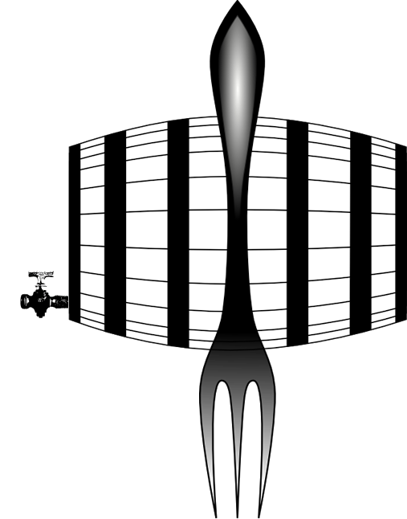
Fork
&
Kids
Barrel

Restaurant

COMPLETE KIDS MEAL FOR $6.00
The menu is designed for children 7 years old and under, to customize their meals with choices to satisfy every appetite. Choose 1 selection from each category.
MAIN
GRILLED CHEESE
American cheese on texas toast

BEEF & CHEESE
Shaved beef and american cheese on texas toast

CHICKEN TENDERS
Breaded chicken tenders deep-fried

CHICKEN BREAST
SIDES
TATER TOTS
SHOESTRING FRIES
SIDE SALAD
APPLESAUCE
COTTAGE CHEESE
VEGETABLE OF THE DAY
BEVERAGES
MILK
ORANGE JUICE
CRANBERRY JUICE
LEMONADE
ICED TEA
SODA
Grilled chicken breast seasoned with salt and pepper

SPIRAL PASTA
Spiral Pasta with your choice of cheese sauce or butter

* Consuming raw or undercooked meats, poultry, seafood, shellfish or eggs may increase your risk of foodborne illness; especially if you have certain medical conditions.
