Kennedy High School
Advisor: Barry Wilson
Location: 4545 Wenig Rd. NE, Cedar Rapids, IA, 52402
Phone Number: 319-784-7697
bwilson@cr.k12.ia.us
Dennis Davis, Grade 10, Documentation writer
Derek Severson, Grade 12, Crew Chief
Kaleigh Martin, Grade 10, Driver

40 car, class 1
Derek Severson has been forced to make a brand-new car for the new racing year. He has been making progress with the beginning designs of his car he also has a new driver he must train and fit into the car. Derek had a tree year old car and had to replace it. Derek has made good progress creating the three starter rims of the car and will continue with making the chassis. Derek is in a difficult position, he must train a new driver and create the car equal to the new drivers’ conditions. He has also been training his replacement for a new crew chief. Derek is graduating this year making the next year a new crew chief needed.

Kennedy High School
Advisor: Barry Wilson
Location: 4545 Wenig Rd. NE, Cedar Rapids, IA, 52402
Phone Number: 319-784-7697
bwilson@cr.k12.ia.us
Dennis Davis, Grade 10, Documentation writer
Brian Becker, Grade 11, Crew Chief
Rodrigo Sagastume, Grade 11, Crew Chief/Driver
50 car class 2
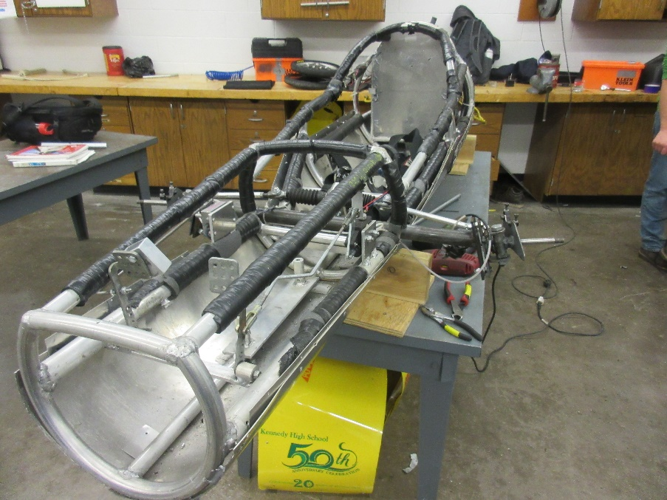
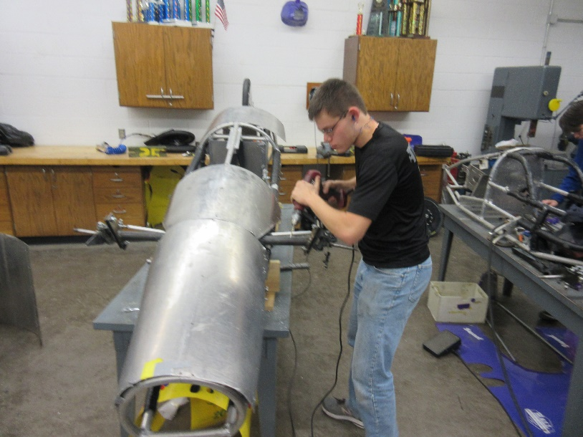
Throughout the month of January Brian has been working very hard repairing his car from the powerful last year of cougar electric car. Brian has been repairing the frame of his car making it legal for the change in the rule books he is also replacing his old axel and making an air plane strut his replacement axel. Brian’s new improvements should show great growth in the cars maneuvering, braking and endurance. They have begun attaching the wheels and then they will be deciding what color to make the outside of his car. Brains car was also an inch off the six inches between the framing box. Brian has been forcing to remake parts of the frame to meet the rules conditions.
Kennedy High School
Advisor: Barry Wilson
Location: 4545 Wenig Rd. NE, Cedar Rapids, IA, 52402
Phone Number: 319-784-7697
bwilson@cr.k12.ia.us
Dennis Davis, Grade 10, Documentation writer
John Tedesco/ Colin Flannigan, Grade 11 and grade 9, Crew Chiefs/Driver
John Tedesco, Grade 11, Crew Chief/Driver
30 car, class 2
Through the month of February John Tedesco has been working hard on his improved 50 car from last year. In an unfortunate turn of events john driver from the previous year has graduated there for in ineligible to compete so John hast to take control and drive his own car but this year a new freshman has decided that he wants to become a crew chief but because john his already the designated crew chief they have made Colin a crew chief in training. He has been working hard training Colin and fitting his car with a similar color as last year he plans on making the color purple. He has also changed the cars safety functions and protection design.


