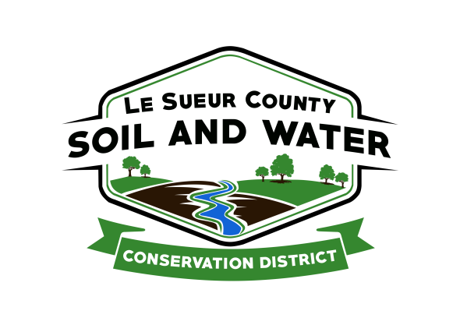

Le Sueur County Soil & Water Conservation District

Le Sueur County SWCD Tel. (507) 419-0365
181 W Minnesota St Website: www.lesueurswcd.org
Le Center, MN 56057

Minutes from November 17, 2020 regular meeting of the Le Sueur County SWCD Board of Supervisors. Le sueur County EOC room, Justice Center, Le Center, MN.

Meeting was called to order by Chairman Struck at 9:05 am.

Members present: Chairman, Jim Struck
Vice-Chairman, Greg Entinger
Secretary, Earle Traxler
Treasurer, Cletus Gregor
PR&I, Glendon Braun

Others present: District Manager, Mike Schultz
District Technician, Joe Jirik
Resource Technician, Karl Schmidtke
District Conservationist, Steve Breaker
Program Specialist, Sue Prchal

The Pledge of Allegiance was recited.

Secretary’s report was read and approved.

Treasurer’s report was read. Le Sueur County appropriation, food plot seed discussed. Motion by Braun, second by Entinger to approve as read and to pay bills.
Affirmative: All
Opposed: None
Motion carried

Schultz discussed the rising number of Covid cases in Le Sueur County. With that being said, the SWCD scaled back to 50% staff in office at one time as of yesterday. Staff will also be working at home when not in the office. Wifi is assessable in the SWCD storage building, if a staff member would prefer to be there. USDA will begin working at 50% in office next week and the front door will be locked with no customers allowed in the building until further notice.

Schultz informed the board that the front office door was vandalized on October 30/31. The Le Center police department got in contact with Schultz.

The MASWCD will hold its annual convention virtually on December 8, 2020 from 8:00 – noon.

Schultz updated the board on the Cannon River 1W1P.

Kadel will be working on the buffer compliance notifications. Approximately 30 landowners in Le Sueur County are not in compliance with the State of MN buffer law. Landowners will have 11 months to comply before they would start to see fines.

Motion by Entinger, second by Traxler to approve the payment for the GBERBA multipurpose drainage management storage and treatment wetland project to the Le Sueur County Drainage Authority, cost-share contract #CWF-MDM-17-40-01 in the amount of $50,000.00.
Affirmative: All
Opposed: None
Motion carried

Motion by Gregor, second by Entinger to approve payment to Connie Brastad cost-share contract #CAP-2019-5A in the amount of $3710.89.
Affirmative: All
Opposed: None
Motion carried

The board was handed out an update from Southcentral Area 6 Director, Mark Schnobrich.

Steve gave the NRCS report. He is currently certifying practices, fall construction work and working with landowners on future construction projects.

The board received a copy of the 2019 annual audit which was recently completed.

Schultz discussed the possibility of Holly Kalbus, County Water Planner, coming into the SWCD office.

Resolutions were read and voted upon.

Struck gave an update to the board on the personnel committee meeting he and Entinger had with Schultz. Motion by Entinger, second by Gregor to approve the SWCD employee’s 2021 salaries that begin with pay period #1 of 2021. Salaries are as follows: Mike Schultz $43.48/hour; Joe Jirik $29.98/hour; Sue Prchal $39.57/hour; Nik Kadel $23.77/hour; Karl Schmidtke $23.02/hour.
Affirmative: All
Opposed: None
Motion carried

There being no further business, meeting adjourned at 11:35 am.

__________________________ _____________________________________
Date District Secretary

