Texas History with Mr. Brown Name ____________________ Period _____

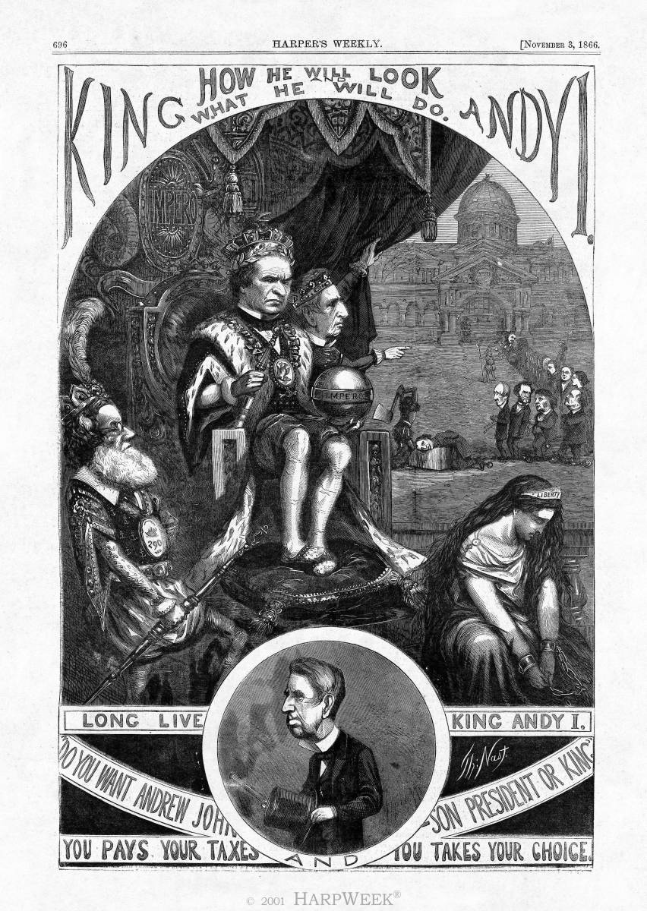
“King Andy"
Originally Published:  November 3, 1866 | Arist:  Thomas Nast

This cartoon appeared shortly before the 1866 congressional elections, and illustrates the fierce conflict between President Andrew Johnson and radical Republicans over Reconstruction policy. Cartoonist Thomas Nast portrays President Johnson as King Andy, with Secretary of State William Henry Seward as his prime minister, pointing to the president’s radical Republican critics in line for the chopping block. On the left is Navy Secretary Gideon Welles as King Neptune; on the right sits Lady Liberty in chains.

In the struggle over Reconstruction, rumors spread among Republicans that the Democratic president had monarchical desires. The notion was reinforced by Secretary Seward’s speech in St. Louis in which he compared his relationship with the president to that between a king and his prime minister. The circular inset depicts Seward in profile, revealing scars from the attempt on his life the night President Abraham Lincoln was assassinated. The pose may seem insensitive, but it was a potent reminder that one should not talk loosely about the serious business of execution and assassination. The line underneath the image—“Do you want Andrew Johnson president or king?”—was falsely attributed to Seward after Democratic victories in Ohio’s October elections.

Here, the man with his head on the chopping block is Congressman Thaddeus Stevens of Massachusetts, the radical Republican who was the president’s chief adversary in the House of Representatives. Behind Stevens are: abolitionist and civil rights advocate Wendell Phillips; publisher John W. Forney; Senator Charles Sumner of Massachusetts, Johnson’s main foe in the Senate; Congressman Benjamin Butler of Massachusetts; renowned public speaker Anna Elizabeth Dickinson; New York Tribune editor Horace Greeley; Congressman John Logan of Illinois; and, at the very end, Harper’s Weekly cartoonist Thomas Nast himself, with a sketchbook under his arm.

1) Does this cartoon support the feelings of Southern Democrats or Northern Republicans?
2) Based on what you already know about President Andrew Johnson does this cartoon influence your opinion of him? Why or Why not?

3) If you did not know anything about President Andrew Johnson would this cartoon be able to convince you that he had unscrupulous (bad or evil) intentions? Why or Why not?

