REGULAR MEETING
AUGUST 18, 2022

A Public Hearing and the Regular Meeting of the Town Board of the Town of Hampton, County of Washington and the State of New York was held at the Town Hall, 2629 State Route 22A, Hampton, New York, also via Zoom on the 18th day of August 2022.

PRESENT: David K. O’Brien------------Supervisor
Donald Sady-----------------Councilman
Tamme Taran----------------Councilwoman - absent
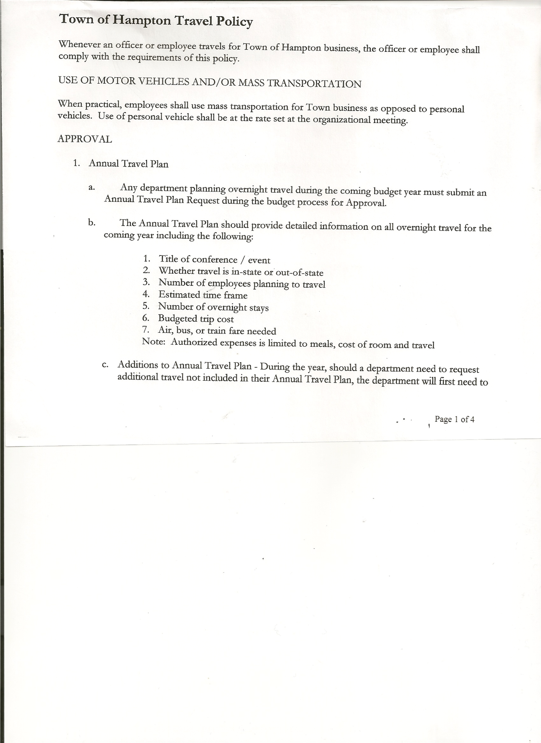
Michael Pietryka------------Councilman - absent
Andrea Sweeney------------Councilwoman – via Zoom
Rebecca Jones---------------Town Clerk
Camilla Shaw----------------Tax Collector/Deputy Town Clerk
Tyler McClure---------------Highway Superintendent

Planning Board Member (s):…Bonnie Hawley, Chair; Matthew Pratt and Richard Cole
Others present at the Town Hall: Deborah Weiss

The Public Hearing was called to order by Supervisor O’Brien at 7:06pm

Town Clerk Jones read the Legal Notice of Public Hearing (copy attached), which was published in Manchester Newspapers on 8/4/22 regarding the adoption of a Local Law amending the existing dog control local law in Hampton.

Supervisor O’Brien went over the recommended changes to the current Dog Control Law.
Councilman Sady felt the violation cost was slightly high.

All persons desiring to be heard, having been heard, the Public Hearing was closed at 7:34pm

REGULAR MEETING
The Regular Meeting was called to order by Supervisor O’Brien at 7:34pm, followed by the Pledge of Allegiance. Location of Fire Exits were given. Quorum of board members present.

RESOLUTION NO. 58-2022
APPROVAL OF THE MINUTES
On a motion of Councilman Sady, seconded by Councilwoman Sweeney, the following resolution was ADOPTED: AYES 3 O’Brien, Sady, Sweeney
NAYS 0
ABSENT 2 Taran, Pietryka
RESOLVED, that the Regular Town Board Meeting Minutes for July 21st, 2022 are approved.

Richard Cole, Dog Control Officer gave his report….
- Ongoing situation on Carver Falls Lane
- Report of abandoned dogs on Wicked Hollow Way, Sheriff’s office was called. Owner disputed that dogs were being attended to.

Camilla Shaw, Tax Collector….. no activity. Submitted Bank Statement to the Board for review and signatures.

TOWN BOARD MEETING
AUGUST 18, 2022 PAGE 2

Bonnie Hawley, Chair Planning Board…copy of the minutes of their meeting held August 10th, 2022 are attached. Next meeting is planned for September 14th, 2022.

Tyler McClure, Highway Superintendent submitted his report, copy of which, is attached.
Tyler also wanted to say Thanks to the Town of Whitehall, Town of Granville, Town of Salem and Washington County DPW for all their help with the project on the South Road.
Following the discussion of where to spend Highway Funds received,(CHIPS, EWR,PAVE NY, POP and ARPA funds) the following resolution was introduced:
RESOLUTION NO. 59-2022
AGREEMENT TO SPEND TOWN HIGHWAY FUNDS
On a motion of Councilman Sady, seconded by Councilwoman Sweeney, the following resolution was ADOPTED:
By Roll Call Vote: Supervisor O’Brien AYE
Councilman Sady AYE
Councilwoman Sweeney AYE
Councilwoman Taran ABSENT
Councilman Pietryka ABSENT
RESOLVED, to accept the Agreement to Spend Town Highway Funds as submitted by the Highway Superintendent.

Winter Sand discussion….
- Stan Martelle, $12.00/yd. Town needs to pick up
- Chuck Friedman, $7.40/per ton if Town picks up
$14.70/per ton if delivered
After discussing pros and cons, the board members present and Highway Superintendent decided to have Friedman’s deliver the winter sand.

John Deere tractor is back, no charge, clutch was a manufacturer fail.

SUPERVISOR’S REPORT/ COUNTY UPDATES/ COMMUNICATIONS

RESOLUTION NO. 60-2022
APPROVAL OF SUPERVISOR’S MONTHLY REPORT
On a motion of Councilman Sady, seconded by Councilwoman Sweeney, the following resolution was ADOPTED: AYES 3 O’Brien, Sady, Sweeney
NAYS 0
ABSENT 2 Taran, Pietryka
RESOLVED that, the Supervisor’s Monthly report be accepted as submitted for JULY
06/30/22 07/31/22
ACCOUNT BALANCE RECEIPTS DISBURSEMENTS BALANCE
General Fund $ 59,668.08 $ 46,640.98 $ 5,061.61 $ 101,247.45
Highway Fund $314,207.19 $ 12,927.93 $ 29,683.18 $ 297,451.94
Equipment Reserve $114,938.20 $ 2.93 $ 0.00 $ 114,941.13
Fire #1 $ 22,081.50 $ 0.00 $ 0.00 $ 22,081.50
Fire #2 $ 5,202.00 $ 0.00 $ 0.00 $ 5,202.00
Cemetery $ 1,761.67 $ .74 $ 0.00 $ 1,762.41
Totals $517,858.64 $ 59,572.58 $ 34,744.79 $ 542,686.43
All Board Members present signed Supervisor’s Report.

TOWN BOARD MEETING
AUGUST 18, 2022 PAGE 3

OLD BUSINESS
Dog Control Law. The following amounts for fines/licensing fees was changed.
- Section 5 Licensing Requirements:
(C) Fees.
i. The licensing fee for a spayed or neutered dog shall be $12.00, which fee includes the assessment of a surcharge of $1.00 for the purpose of carrying out a program of animal population control.
ii. The licensing fee for an unspayed or unneutered dog shall be $20.00, which fee includes the assessment of a surcharge of $3.00 for the purpose of carrying out a program of animal population control.
iv. When the Town Board determines the need for a dog enumeration, a fee of $50.00 will be assessed to the owner of any dog found unlicensed or for which the license has not yet been renewed at the time the enumeration is conducted.

- Section 10 Penalties
(A) Any person convicted of a violation of this local law shall be liable to a civil penalty no less than $40.00 and no more than $100.00 for a first violation, not less than $100.00 and no more than $200.00 for a second violation and no less than $200.00 and no more than $400.00 for a third and each subsequent violation.
The following resolution was introduced:
RESOLUTION NO. 61-2022
Introduced by Councilman Donald Sady
who moved its adoption.
Seconded by Councilwoman Andrea Sweeney

RESOLUTION AUTHORIZING THE ADOPTION OF LOCAL LAW AMENDING THE DOG CONTROL LOCAL LAW OF THE TOWN OF HAMPTON

WHEREAS, pursuant to Section 64 of the Town Law of the State of New York and the Municipal Home Rule Law, the Town Board of the Town of Hampton has the authority to adopt a local law protecting the health, safety and welfare of the residents of the Town of Hampton; and
WHEREAS, the Town Board has reviewed proposed amendments to the Town’s Local Laws concerning dog control in the Town of Hampton titled the Dog Control Local Law of the Town of Hampton; and

WHEREAS, by resolution of the Town Board duly adopted the 21st day of July, 2022, the Town Board set a public hearing on the proposed Local Law; ; and

WHEREAS, the Town Board has held a public hearing for the consideration of the proposed Local Law; and

WHEREAS, this action is a Type II action pursuant to the State Environmental Quality Review Act (SEQRA); and

WHEREAS, the Town Board wishes to adopt the proposed Local Law.
NOW, THEREFORE BE IT:

RESOLVED, that upon due deliberation of the proposed Local Law, the Town Board finds that the adoption of the same is in the best interests of the Town; and be it further

TOWN BOARD MEETING
AUGUST 18, 2022 PAGE 4

RESOLVED, that the Local Law entitled “A Local Law Setting Forth Dog Control Regulations in the Town of Hampton” is hereby adopted as Local Law 1 of 2022, a copy of which is attached to this resolution and made a part hereof; and be it further

RESOLVED, that pursuant to and in accordance with the Municipal Home Rule Law, the Town Clerk is hereby directed to enter Local Law No. 1 of 2022 into the minutes of this meeting and file the same with the Office of the Secretary of State of the State of New York; and be it further

RESOLVED, that this resolution shall take effect immediately.
DATED: August 18, 2022 Supervisor David O’Brien AYE
Councilman Donald Sady AYE
Councilwoman Andrea Sweeney AYE
Councilwoman Tamme Taran ABSENT
Councilman Michael Pietryka ABSENT

NEW BUSINESS
Video Cam Security….Four (4) camera system, wireless for Town Hall/Garage area… cost between $225.00 and $250.00. At the sand pit a couple of Game Cameras…cost $50.00 each.
RESOLUTION NO. 62-2022
PURCHASE OF SECURITY EQUIPMENT
On a motion of Councilman Sady, seconded by Councilwoman Sweeney, the following resolution was ADOPTED: AYES 3 O’Brien, Sady, Sweeney
NAYS 0
ABSENT 2 Taran, Pietryka
RESOLVED, to authorize Supervisor O’Brien to purchase the above security equipment.

2023 Budget Sheets handed out…back to Supervisor by August 31st

Fire Company handed out to Board members their 2023 Proposed Budget. Planning a Golf Tournament/Pig Roast on October 9th at Milestone Golf Course, County Route 18.

Fire Company is in the process of filing a Certificate of Amendment of the Certificate of the Incorporation of the Hampton Volunteer Fire Co, Inc., . The current tax-exempt status cannot accept tax deductible donations, only gifts. Trying to switch from a 501(c)4 to a
501(c)3. Following a discussion of the above action, the following resolution was introduced:
RESOLUTION NO. 63-2022
TOWN OF HAMPTON CONSENT
On a motion of Councilman Sady, seconded by Councilwoman Sweeney, the following resolution was ADOPTED: AYES 3 O’Brien, Sady, Sweeney
NAYS 0
ABSENT 2 Taran, Pietryka
RESOLVED, The Town of Hampton, Washington County, hereby approves and consents to the filing of this certificate of amendment of the certificate of the incorporation of the Hampton Volunteer Fire Company, Inc.

TOWN BOARD MEETING
AUGUST 18, 2022 PAGE 5

PUBLIC COMMENTS/COUNCIL COMMENTS
Richard Cole…filling open position on board, should have announced opening beforehand. Thought it was improper the way it was handled at the July meeting.

RESOLUTION NO. 64 -2022
AUDIT OF CLAIMS
On a motion of Councilman Sady, seconded by Councilwoman Sweeney, the following resolution was ADOPTED: AYES 3 O’Brien, Sady, Sweeney
NAYS 0
ABSENT 2 Taran, Pietryka
RESOLVED that the bills have been reviewed by the Town Board and are authorized for payment in the following amounts.
General Fund No. 107 through No. 117 $ 9,070.43
Highway Fund No. 76 through No. 85 $ 8,145.03
Total both funds $ 17,215.46

The Town Clerk’s report for July 2022 was submitted to the Board. The Town Clerk had Board Members review and sign bank reconciliation statements for the Town Clerk Account and Special Clerk Account dated July 31, 2022.

RESOLUTION NO. 65-2022
MEETING ADJOURNED
On a motion of Councilman Sady, seconded by Supervisor O’Brien, the following resolution was ADOPTED: AYES 3 O’Brien, Sady, Sweeney
NAYS 0
ABSENT 2 Taran, Pietryka
RESOLVED that the meeting adjourned at 9:19pm.

Respectfully submitted,

Rebecca S. Jones, RMC
Town Clerk

