BOULDER TRAP CLUB

Contact Information

Mail Trap Club Global Coordinates

Joe Israel 2700 Utah.st 35*57’16.49”North

1207 Arapaho way known as Crown Point rd. 114*47’56.34”West

Boulder city NV. 89005 Hours 8AM to Noon on Saturday GPS

(702)280-1550 7PM to 9PM on Tuesday 35.952867,-114.797355.

Joeisrael57@yahoo.com Traps 4 Skeet 2

Directions
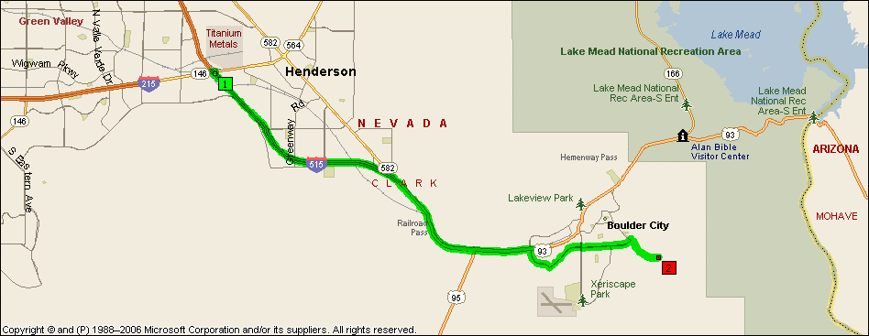

From I-215/I-515 proceed south 4.3 miles on I-515 (93/95) to Veterans Memorial Blvd. This is the first stop light coming into Boulder City. Turn right and go south for 0.8 miles to Adams Blvd. This is the first stop light on Veterans Memorial Blvd. Turn left and go 2.3 miles to Utah Street. This is the third stop sign on Adams Blvd. Turn right and go 0.9 miles to Gun range turn off (known as Crown Point Rd). Turn right just before the landfill. Follow the pave road 1.1 miles to the Gun Club.

