NEW YORK STATE / CONNECTICUT DIVISION
2018 EDUCATIONAL CONFERENCE

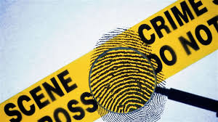

MONDAY, OCTOBER 1, 2018

7:00-1:00 REGISTRATION

7:30-8:00- CONTINENTAL BREAKFAST

8:00-12:00 Workshop
The Recovery of Latent Fingerprints From Notoriously Troublesome Surfaces
Maximum Class Size-25
Jason Cole-Technical Sales Specialist for Foster + Freeman
This hands-on workshop is designed to give experience to the student by using various powder applications and lifting techniques. The best way to become proficient is by doing it! After attending this class students will be able to lift latent prints off almost any surface; such as tape, feathers, wet, textured, multi-contoured and unusual surfaces that a print has been developed on. Students will also be introduced to IR Fluorescent finger print powders and quick, efficient ways to digitally capture them. We will also discuss the proper way to fill out a latent lift card.

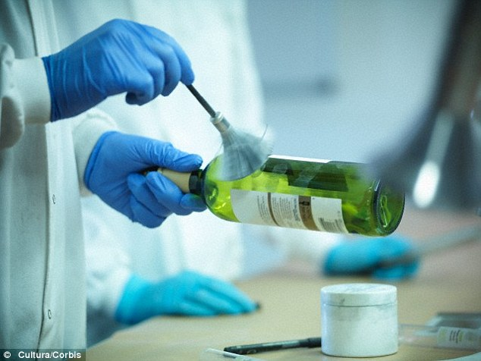

8:00-12:00 Workshop
Latent Print Testimony-How to be transparent without feeling naked
Heidi Eldridge-Research Forensic Scientist, RTI International
Since the 2009 NAS report, changes to the expectations of latent print testimony have multiplied. A trend away from dogmatic statements of fact toward transparent statements of data-supported opinion has left many latent print examiners struggling with the transition. This workshop considers some of the tough concepts they come up in court including error rate, discriminability, certainty, variability, bias, uniqueness, and the identification decision. It will demonstrate one way to present findings without feeling exposed.

8:00-11:00 Workshop
Sufficiency for Exclusions
Eric Ray-Forensic Scientist, Owner Ray Forensics
In 2011 the Noblis black box study on the accuracy of latent fingerprint comparisons was published. While the latent print community was relieved to see a large-scale accuracy study demonstrate the high accuracy of the identification decision, we were somewhat shocked to see a relatively high rate of erroneous exclusions. ENFSI and other professional organizations have defined the exclusion decision as "sufficient features in disagreement". Although no specifics have been provided on how to define sufficiency, many agencies have defined their own standard for the exclusion decision. This workshop reviews recent research and proposes how accuracy study results can be applied to establish an exclusion sufficiency threshold and adjust comparison practices to reduce errors. Participants will also compare fingerprints in practical exercises to further the discussion on an exclusion sufficiency threshold.

11:00-12:00-Lecture
Latent Print Analysis and Comparison in Photoshop
Eric Ray-Forensic Scientist, Owner Ray Forensics
Latent print examiners conducting comparisons onscreen often utilize Adobe Photoshop as both an enhancement tool and a method to mark the features in the images. However, documentation of the analysis or the results may be hand-written or entered into a Word document. Third-party software options are available, but do not offer the full enhancement capabilities of Photoshop. These other software options can also be incredibly expensive. This lecture demonstrates how examiners, while remaining in Photoshop and Bridge, can use properties, actions, shortcuts, and metadata to document analysis and results, easily produce reports for individual comparisons and complete cases, and increase productivity and efficiency by adapting Photoshop to fit the specific needs of the latent print examiner.

12:00-1:00 Lunch, Welcoming Remarks
Bill Rathjen-NYIAI President & Lisa Ragaza-CTIAI President

1:00-2:30- Meet the vendors
Police Department and Crime Lab Supervisors are encouraged to attend, meet with vendors and check out the latest technology. Attendees should meet with vendors and bring this valuable information back to there Employers.

2:30-3:30-Introduction to Forensic Spherical Photography
Andrew McNeill, MFS
In a data-driven society, increasingly influenced and directed by technological advances in digital media, studies show people retain more information when it is presented in visual formats. From crime scene to courtroom, spherical photography is an accepted and frequently expected forensic tool. This presentation will provide an introduction to spherical photography and how 360-degree photos may supplement and support your DLSR photographs. The session will incorporate a homicide case study that explains how the images were used for scene documentation as well as “containers” for other digital evidence, including reports. The presentation will conclude with recommended scene procedures, takeaways from using spherical photography in actual casework, and an assessment of spherical photography’s track record in court.
2:30-4:00 Lecture
Crime Scene Processing on a Shoestring Budget
Jason Cole- Foster & Freeman
Is your department cutting back on supplies due to the economy? Is your department unable to afford expensive equipment and supplies needed for investigating crime scenes? This class is designed to help crime scene investigators find cost-effective ways to process crime scenes. This class will also show you trick of the trade and showcase some of the latest technology in the field of crime scene investigation.
2:30-3:00 Lecture
Inconclusive with Similarities
Admissibility Challenge and Testimony
Eric Ray-Forensic Scientist, Owner Ray Forensics
How do you report results when the latent and exemplar prints have only corresponding features, but insufficient features to identify? While some labs report these results as inconclusive and other labs never compare these latent prints at all, a growing number of labs report the correspondence without reporting an identification. “Inconclusive with similarities” or “Cannot Exclude” are beginning to appear in reports, and testimony on these decisions is being offered in court. This lecture presents a case where the “Inconclusive with similarities” decision was key evidence at trial, and defense challenged the admissibility of the result.

3:30-4:00-Lecture
Frequency of Patterns in Palms
Eric Ray-Forensic Scientist, Owner Ray Forensics
How often do you find a palm with five deltas in the interdigital? How common is a vestige on the right hand? This presentation will describe a basic method for classifying palm prints, define an abbreviation scheme for each area of the palm, and present the frequencies at which Level 1 patterns are found in each area of the palm.

TUESDAY OCTOBER 2, 2018
7:00-1:00 REGISTRATION
7:30-8:00- CONTINENTAL BREAKFAST

8:00-5:00-Workshop
Advanced Digital Imaging Workshop (hands-on)
Maximum Class Size-25
David Witzke-Vice President, Program Management, Foray Technologies
After completing this eight-hour workshop, the class participants will have a more comprehensive working knowledge of Adobe® Photoshop® CC. The attendees will have an understanding of the advanced procedures used in forensic digital imaging, such as working with multiple layers, creating overlays and more, as well as how to apply those concepts in the documentation of the analysis, comparison, evaluation and verification processes and comply with ISO guidelines. This is a “hands-on” training program; all students will participate in a “practical application” exercises to ensure that the required learning objectives were achieved.
The following is a brief outline of the topics that will be taught in this eight-hour training program.
- Adobe Photoshop Overview
  - Setting up preferences for forensic imaging
- Understanding image resolution:
image (file) resolution versus display resolution versus output resolution
    - Calibrating images for 1:1 output
    - Creating composites
- Background suppression
  - Using color information to suppress background noise
  - Suppressing color background noise with Calculations
- Image Enhancement Techniques and Processes
  - Selecting an “area of interest” for processing
  - Enhancement Techniques for creating contrast:
    - Black & White
    - Levels
    - Curves
    - Shadows/Highlights
  - Using filters to suppress noise
    - Noise > Dust and Scratches feature
    - Sharpen > Sharpen and Unsharp Mask options
  - Adjusting image orientation (rotation) while mitigating artifacts
- Using Adobe Photoshop’s new Camera RAW filter for image processing non-camera RAW digital images
- Comparing images on-screen
  - Adjusting image resolution for side by side display
  - Moving images simultaneously
- Creating analysis and comparison documentation
  - Marking minutiae
  - Tracing ridges
  - System Requirements:
Attendees must bring a laptop and an external mouse. The minimum acceptable system requirements for Adobe Photoshop CC are:
- Intel® Core 2 or AMD Athlon® 64 processor; 2 GHz or faster processor
- Microsoft Windows 7 with Service Pack 1, Windows 8.1, or Windows 10
- 2 GB or more of RAM (8 GB recommended)
- 2.6 GB or more of available hard-disk space for 32-bit installation; 3.1 GB or more of available hard-disk space for 64-bit installation; additional free space required during installation (cannot install on a volume that uses a case-sensitive file system)
- 1024 x 768 display (1280 x 800 or greater recommended) with 16-bit color and 512 MB or more of dedicated VRAM; 2 GB is recommended
- OpenGL 2.0-capable system
- NOTE: A free trial version of Adobe Photoshop CC can be downloaded from:

www.adobe.com/downloads.html
An internet connection and registration are necessary for required validation of trial subscriptions. Beginning May 9th, 2016, Adobe Systems reduced the length of the trial period for Adobe Photoshop CC to only 7 days. Therefore, I would recommend that participants in the training program not install the trial version until Wednesday or Thursday.
If you load the trial version early, we can reset the trial date. You must, however, have appropriate permissions to write files to the drive where Adobe Photoshop is installed. (Even if it is just temporary, I would encourage you to have administrative permissions for the laptop.

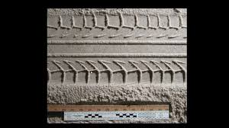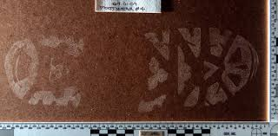

8:00-12:00- Workshop
Documentation and Collection of Footwear/Tire Track Impression Evidence
Lisa Ragaza-Division of Scientific Services, Meriden CT
Maximum Class Size-12
This workshop will discuss the most effective methods of documenting footwear and tire track impression evidence at a crime scene through the use of photography. The collection of crime scene impression evidence through lifts and casts will be discussed along with the most useful materials and practices which can aid the examiner in his/her laboratory analysis. Finally, methods for the making of test impressions of tires will be described along with information on how tire track comparisons are done. Please plan to bring your camera, tripod and off the camera flash and cord.
9:00-10:00- Lecture
How to solve a problem like variability? Development of an analysis tool for latent prints
Heidi Eldridge-Research Forensic Scientist, RTI International
It has been well established that latent print examiners exhibit variability in reaching suitability determinations. While it is possible to eliminate variability by devising an automated process to determine mark suitability, the human examiner brings benefits to the process and a stringent, objective threshold would likely result in the loss of many potentially suitable marks. Which will perform better – a human-algorithm hybrid decision engine, or a lights-out automated decision process? This lecture describes ongoing research to develop a software tool for assigning value to fingermarks that incorporates both human and automated input.
10:30-11:00-Lecture
Improving Methods for Fingerprint Development on Hand-guns
Eliot Springer-Deputy Director NYPD Police Laboratory
Hand-guns are often involved in crimes and submitted to forensic laboratories for fingerprint development. Despite the advance of fingerprint development methods over the years, firearms in general, and hand-guns in particular are still difficult exhibits for fingerprint development. This presentation discusses research into this phenomenon and attempts to develop more successful methods for fingerprint development on hand-guns.

11:00-11:30- Lecture
A Murder by Orangutan – Poe Revisited
Eliot Springer-Deputy Director NYPD Police Laboratory
This presentation re-visits a classic Poe detective story and discusses what might happen today using modern forensic science tools to try and solve the mystery. Light and entertaining, various issues such as cognitive bias will be addressed.

12:00-1:00-Lunch (Meet the vendors)

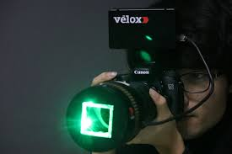

1:00-5:00- Workshop
Full Spectrum (UVIR) Forensic Photography Day 1
Julio Sosa-Professional photographer & forensic consultant for Fujifilm
Maximum Class Size-24
This course covers Full Spectrum Photography, which includes Ultraviolet, Visible Pass, and Infrared applications. Ideal for Crime Scene, Coroner, Medical Examiner, S.A.N.E. or S.A.R.T Nurses, District Attorney Investigators and Photographers. Fujifilm XT-1IR cameras will be supplied for the workshop, class size is limited.
Lectures and Practical’s will include:
• Fundamentals of Full Spectrum photography (wavelengths channels)
• Working with Lights, Visible Spectrum and Nonvisible Spectrum.
• Using Infrared and Ultraviolet Filters with Full Spectrum Camera
• Photographing Latent Fingerprints (Practical) (Orange and Yellow Barrier filters required)
• Photographing Blood Spatter (Practical)
• Photographing Gun Shot Residue (Practical)
• Photographing Tattoos (Live and Post Mortem Discussion) and or (Practical)
• Photographing Footwear Impressions (Practical) (understanding 415nm)
• Photographing Tire Marks (Practical)
• Obliteration Photography (Practical)
• Photographing Bruises and Wounds (Practical)
• Autopsy and Post Mortem discussion
• Scanning a subject Post Mortem on scene or at Medical Examiners prior to Autopsy
• Scanning a Crime Scene using a XT-1IR
• Painting with light using a XT-1IR (Practical)
• Photographing Automobiles UV/IR (Discussion)
• Surveillance applications with XT-1IR (Discussion

1:00-2:00- Lecture
Understanding and Calculating Error Rates in Pattern Evidence
Heidi Eldridge-Research Forensic Scientist, RTI International
Many “error rate studies” now exist in the literature, but what is an error rate? This lecture will explore different types of error rates, what they mean, how to calculate them, and how to appropriately use them in the courtroom.

2:30-3:00- Lecture
Twice Bitten-The Lecture! Latent Print Perspectives on the PCAST report
Heidi Eldridge-Research Forensic Scientist, RTI International
The recent PCAST report reflected somewhat harshly on many forensic disciplines, but were their arguments entirely without merit? In the lecture, we will describe the main findings of the report, including how latent prints got a “pass”, why many other disciplines did not, and whether it is safe to be resting on our laurels. We will also clarify the report’s usage of the term “foundational validity” and “validity” as applied” and what they mean for your laboratory.

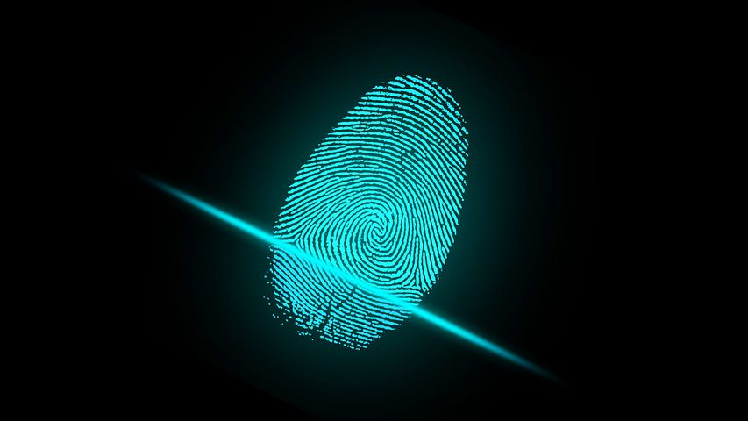

3:30-4:30- Lecture
Visualization of MBD on Light Colored Substrates
Thomas Carboy Jr.- Forensic Scientist, NYPD Police Laboratory
While much work has gone into validating MBD as a contrast enhancing fluorescent dye stain, little to no mention has been made to document the dye’s ability to visibly stain CA, providing enhanced contrast under white light on certain light-colored or metallic substrates. This paper formally documents the increased visibility of latent prints treated with MBD after cyanoacrylate fuming. This was accomplished by photographing CA fumed prints under white light before and after treatment with MBD, and comparing the photographs to determine if any more ridge detail is viewable in the later photos. The results of this comparison showed instances where more ridge detail was apparent after treatment with MBD.

WEDNESDAY OCTOBER 3, 2018

7:00-9:00 REGISTRATION
7:30-8:30- CONTINENTAL BREAKFAST & MEMBERSHIP MEETING
8:30-12:30 –Workshop
Recent trends in fingerprint evidence
Melissa Gische- FBI Physical Scientist (Technical Leader) Latent Print Unit
Michelle Reznicek-FBI Supervisor, Physical Scientist/Forensic Examiner
Latent Print Unit
As the scientific reliability of friction ridge evidence continues to be challenged, latent print examiners must be prepared to defend their science in the courtroom. Reports from the PCAST and NAS have identified perceived weaknesses in the latent print discipline and have generated questions of reliability in the courtroom. As new research becomes available and limitations of the discipline are better understood, latent print testimony has had to evolve. Through presentations and group discussions, participants will discuss how to rely on published research and best practices to support the scientific reliability of friction ridge evidence during testimony.

8:30-12:30- Workshop-Fuji
Full Spectrum (UVIR) Forensic Photography Day 2
Julio Sosa-Professional photographer & forensic consultant for Fujifilm
This course covers Full Spectrum Photography, which includes Ultraviolet, Visible Pass, and Infrared applications. Ideal for Crime Scene, Coroner, Medical Examiner, S.A.N.E. or S.A.R.T Nurses, District Attorney Investigators and Photographers. Fujifilm XT-1IR cameras will be supplied for the workshop, class size is limited.

9:00-10:00 Lecture
The “CSI Effect”: For Crime Scene Investigators
Detective Tim Kelly-Suffolk County Police Identification Section
I. Introduction
A. Background and Experience.
II. “CSI Effect”: Does it Really Exist.
A. What is the CSI Effect?
B. Prior cases (Personal).
C. CSI Effect Theory – The Prosecution (Video).
III. Three ways the “CSI Effect” influence public perception of Forensics:
A. What Crime Scene Investigators and Forensic Scientists do?
B. Depiction of technologies that may not exist.
C. Unrealistic expectations for types of evidence that can be collected
or what can be determined from evidence.
IV. Why is the “CSI Effect” important?
A. Public Expectations.
V. Juror Expectations for Forensic Evidence.
VI. Conclusion.
- Questions and Discussion for Crime Scene Investigators.

12:30- 1:30 -Lecture
Changes in the FBI Latent Print Unit: consensus panels for conflict resolution and change in value definition
Melissa Gische- FBI Physical Scientist (Technical Leader) Latent Print Unit
Michelle Reznicek-FBI Supervisor, Physical Scientist/Forensic Examiner
Latent Print Unit
This presentation will highlight two changes implemented by the FBI’s Latent Print Unit (LPU): consensus panels for conflict resolution and a revised definition for claiming a print. The FBI LPU is testing a conflict resolution process that allows for differences of opinion to be retained while still producing a technically sound decision. The FBI LPU also changed its claiming definition to account for limitations associated with the process as demonstrated by research.

10:00-12:00- Workshop
Evidence Detection across the Spectrum: Using Forensics Light Sources from 254nm to over 1µ (>1000nm)
Walter Hiller- SPEX Forensics Division of Horiba Instruments Inc.
Forensic Light Sources are important tools aiding in evidence detection both at the crime scene and in the laboratory. When utilized to their fullest potential, many different types of evidence can be detected, documented, and collected for further processing or enhancing.
In this lecture, you will have the opportunity to see several different types of light sources covering the Shortwave Ultraviolet, Visible, and Near Infrared portions of the spectrum. The instructor will locate numerous types of evidence, such as: hairs, fibers, inks, biological evidence, latent prints, and many others. This lecture is designed for the examiner with no light source experience to one who might want a refresher.

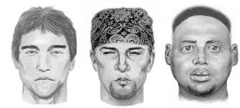
12:00-1:00- Lecture
Forensic Art
Danielle Gruttadaurio-Forensic Artist/Graphic Technician, Suffolk County Police Department
This presentation will explore the role of a Forensic Artist and the techniques one can provide to assist law enforcement with criminal investigations. We are going to discuss interviewing a victim and/or witness for composite imaging, 2D & 3D facial reconstruction/approximation of the human skull, post mortem composites, adult age progression as well as facial recognition software to help identify subjects

