The 11th Annual

South Texas Association of School Maintenance

Officials Summer Conference 2023
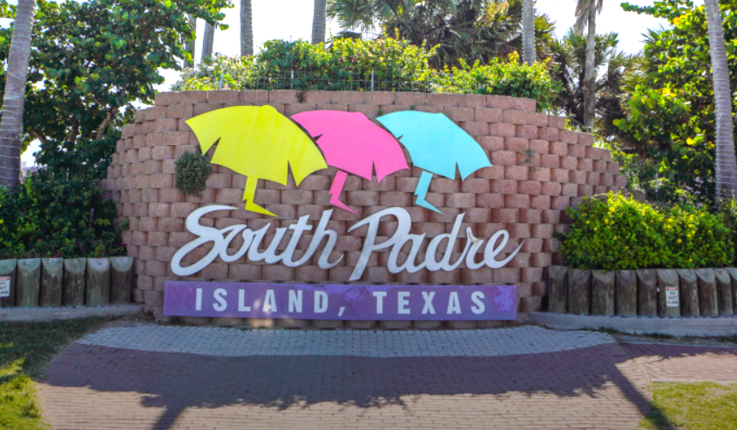

  - July 19-20th, South Padre Island Convention Center, 7355 Padre Blvd, 78597

Why Should I Attend?
This our 11th Annual M&O Summer Conference at South Padre Island on July 19 & 20th! The two-day conference is a mix of school maintenance-related presentations, networking opportunities and a trade show. The conference takes place at the South Padre Island Convention Center. The first day consists of well thought out presentations and a fun evening social event involving a spacious boat. The second day is more presentations that are interesting, delicious lunch and our Trade Show that will include up to 40 vendors. The day ends with incredible door prizes give away.

STASMO or the South Texas Association of School Maintenance Officials hosts the conference. STASMO was established in 2006. Our mission has been to bring together maintenance/facilities related school district officials primarily in the ESC Region One area to provide learning opportunities, share successes & concerns and develop relationships between districts and associated vendors to allow members to better serve their districts. To serve its communities STASMO awards seven $1,000 scholarships annually to eligible students of parents who work in school maintenance as well as donate generously to the RGV Food Bank.

Who Should Attend
If you are involved in school maintenance or construction in any form or fashion this is the conference for you. Visit our site to register today! District folks only pay $100 for both days. We look forward to seeing YOU at our 11th Annual Summer Conference!

For District Employees
These conferences include breakout sessions specifically geared toward maintenance and custodial issues. Registration is only $100 for both days, to allow school districts to send many of their custodial and maintenance leaders. This year in addition to our six presenters, we have added a new “Did You Know” session... Visit our site to register today!

For Service Affiliates (Vendors)
Exhibit space is available to vendors for a limited time on the second day of the conference. All of our school district participants will visit with our trade show participants. The atmosphere gives vendors and district professionals the opportunity to really share and make good contacts. There will be up to 40 trade show spaces available for our vendors. Spaces are available for $499 and include two participants, sitting in on the presentations and lunch on Thursday as well as the Bay Cruise. There is also an option to participate in the conference without signing up for a trade show table. Visit our site to register today!

Sponsorship
Limited conference sponsorship opportunities are available to school maintenance and custodial related vendors. By sponsoring a portion of any of the Conference or contributing to offset the costs, your organization helps to keep registration for District Professionals affordable, while providing outstanding visibility for your products and services. Sponsorship opportunities are available.
Sponsoring Hotel
The sponsoring hotel for this year’s event is the Best Western Beachside Inn located at 4500 Padre Blvd, South Padre Island, TX 78597. The rate is $159.99 a night. Call 956.761.4919 Reservations are limited and can be made up until June 26.

Conference Agenda Summary
Wednesday, 7/19 continental breakfast, sign in/registration begin at 9:00 am. Presentations are from 9:45 am to 4:00 pm. Lunch will be “on your own.” There will be a Bay Cruise social from 5-7 pm.

Thursday, 7/21, continental breakfast, sign in begin at 8:00 am. Presentations are from 8:45 to 11:45 am. Lunch will be provided followed by the Trade Show from 1:00 pm to 3:00 pm. The conference concludes at 3:30 pm with closing remarks and door prizes give away.

Contact us
Rolando Borrayo, President, 956.832.2085, rborrayo15452@lfcisd.net
Martin Castaneda, Vice-President, 956.310.8703, mvcast59@mcisd.org
Dan Cantu, Secretary/Past President, 956.832.2412, dacantu@lfcisd.net

