2016 MGIS Geog564 – Lab 6 Impact Models and Change Models
Assigned date: Feb 4th, 2016
Due date: Feb 15th, 2016

Introduction –
In Lab05, you established your Change model by generating a set of Proposed Levee Setback Projects. You started an impacts analysis by looking at both how much market value each PLSP would protect and their cost in terms of the market value of the infrastructure that would need to be destroyed to create them. You discovered a number of PLSPs that destroy more than they would potentially protect.
In this lab you first eliminate PLSPs that destroy more than twice the market value of what they would potentially protect. You then complete your impacts modelling using three of the criteria you developed in Lab04 Evaluation models. Chose one criterion from each of the three Values categories - economic, environmental and Social. You will assess those criteria on the Unique Flood Zones protected by each PSLP and evaluate any other changes in criterion value that is not flood-protected related (e.g. Chinook habitat quality) if any, based on the characteristics of the PSLPs - all wetlands with forested riparian areas. You will use MCE to combine all impacts, including the market value costs of the PLSPs, into a single MCE decision model to support stakeholders in choosing the best PLSP to implement. You will use your decision model to determine which PSLP to recommend under different perspectives.
Topics
-- Applying evaluation criteria from the Evaluation model in the Decision Model
-- Decision Models contains both cost impacts and designed beneficial impacts
-- Using chart symbology to convey MCE analysis results
Techniques and Tools
Tools
You have experience working with the [Simple MCE Normalization] and[WST_2016.py] from Lab04. But you need to download and use the newest version of the MCE toolset - SMCEN4 from the Lab06 Page.
Techniques
A significant element of this lab is clearly accounting the changes in the value of criteria your research in Lab01 showed were important to the community. Communicating this analysis to the community is important. For small numbers of criteria, the Chart Symbology capability of ArcMap can be useful. The value of bar chart symbology is you can show the relationship among multiple attributes for each feature. The challenge of bar charts are cases where the attributes have incommensurate scales and cannot be shown meaningfully alongside each other. This is a challenge you experience firsthand in this lab. See the ESRI help for detail on how to implement bar chart symbology and the comments in the appendix.
To perform the spatial accounting necessary for the full impacts model, it is important that if a criterion from your evaluation model is affected by the change to the PSLP site itself, that those changes (deltas) are estimated for each PSLP.
- For instance, if Protect People is an objective, and one criterion associated with that objective is the number of residents outside the floodzone, then when calculating the change to that criterion you need to take into account the gain** in that by a PSLP shrinking the flood zone by its UFZ.

- Additionally, you must take into account changes to non-flood related criteria that the implementation of a PSLP would cause. For example, if Restore Wetlands was an objective, and a criterion was “Acres of wetlands within the flood plain”, then, for each PSLP, the entire area of each PLSP site should be added to your wetlands acres total.
[**We ignore losses in a criterion due to a PLSP extending beyond the original floodzone. Gene and I did some preliminary checking, and though there are a few small areas that were never flooded before, but would fall inside a PLSP, and hence be flooded (its wet in a wetlands!), such areas are small and you have already accounted for loss in market value in Lab05. So we will ignore those few areas that were not in flood danger would become wetlands when calculating changes in criteria.]
Once you have calculated the change in all your criteria for each PLSP, you create a Multi-criteria Evaluation of the PLSPs by running the changes in your criteria together with the market values gain in the UFZ less the loss in market value of the land within the PLSP through the MCE and WST tools.
Finally, you’ll look at the ranking of the PLSPs under weights sets that represent three different perspectives.
Environment Prep
A Set geoprocessing to over write
B Set Geoprocessing Environmental Workspace to a new workspace folder
C Create New Lab06 Map
D Import the following Feature classes to start with (this is a minimum, but sufficient set). You will have your own names for the features classes you created in previous labs– but consider exporting features classes from last labs and changing the names to names that better indicate their purpose in this Lab.
Table 1 Input Data Layers (your FCs will likely be named differently)
Feature Class | Description | Google Drive Source | Your Lab path/layer
duwamish_green_LG | Segmented river layer | hydro.gdb
wria9_LG | Lower WRIA9 boundary | hydro.gdb
PLSPmv | PLSP with market values from Lab05 |  | Your Lab05
FZ | Flood Zones from Lab05 |  | Your Lab05
UFZmv | Unique Flood Zone areas from Lab05 with market value densities |  | Your Lab05
Your criteria measure FCs | Feature classes that contain 3 measures you developed in Lab04 (but pre flood zone transforms, if relevant) |  | Your Lab04

Lab06 Workflow Summary
Step | Task | Inputs | Methods/[tools] | Output
Step 0 Setup | Set up environment, assemble input fcs | See Table 1 above | Readsteps 1-3 and import fcs | Table of your Inputs Data layers
Step 1 Eliminate PSLPs that cost twice what they might protect | Create a new PLSP fc that contains only those worth continuing with from Lab05 | PLSPmv fc from Lab05 - PLSPs with mkt val fields for PLSP and UFZs | Create a new field [mv_ratio] and fill it with market value of UFZ/PLSP. Select the PLSPs with [mv_ratio > 0.5]; Export to new PLSPmvps fc | PLSPmvps fc Map of kept PLSPs colored by mkt val ratio of UFZ/PLSP
Step 2 Calculate impacts in your protection-based Criteria for UFZ fc | For each of your criteria that depends on being in/out of the flood zone, calculate the sum of that criterion for the UFZ | UFZ fc, parcel measures fc, any other fc you used for your protection related criteria (see Instructions Appendix) | OAJ with your parcel_measures on the UFZ fc. Criteria summed values should be area weighed, not density. Manage absence situations. | UFZ_criteria
Step 3 Calculate impacts in your non FZ-based Criteria for PLSP | For each of your non-FZ sensitive criteria, calculate the criteria for the PLSP (e.g. wetlands) | PLSP_FC  parcel measures, any other fc you used for your protection criteria | OAJ with your parcel_addres Criteria summed values should be area weighed, not density. Include PLSP cost (Lab05) | PLSP_criteria
Step 4 Combine all impacts | Join UFZ_FC to PLSP_FC | UFZ_criteria  PLSP_criteria | Join/Export to create PLSP fc with all 3 criteria and Costs (make –ve) | PLSP_Impacts; Map of all Impacts per PLSP using chart symbology
Step 5 Create MCE criteria from impacts | Transform your impact criteria to MSE Criteria | PLSP_Impacts | [Simple MCE Normalization]; remember to orientate cost impacts appropriately | PLSP_MCE; map of PLSP with MCE vertical barcharts symbology
Step 6 Create and Run LPSP MCE Decision Model | Calculate the weighted SUM of your impact criteria for equal weights | PLSP_MCE | [WST_2016.py]; | PLSP_WST; Map of PLSPs colored by WST score for equal weights; In Excel create a stacked horz barchart of MSE scores for each PLSP
Step 7 Run LPSP MCE Decision Model with 3 perspectives | Explore rankings of PLSPs under weight sets representing 3 different perspectives | PLSP_MCE, 3 different weight sets | [WST_2016.py]; | Table with top 10 PLSP from each perspective in each column; Discuss the results; Map of PLSPs with bar chart of rank from 3 perspectives

Deliverables
- Step 0 Setup
  - Table of your Inputs Data layers
- Step 1 Eliminate PSLPs you identified in Lab05 as losers
  - Map of Kept PLSPs colored by mkt val ratio UFZ/PLSP
- Step 2 Calculate protection Criteria for UFZ fc
- Step 3 Calculate non-protection Criteria for PLSP
- Step 4 Combine all impacts
  - Map of all Impacts per PLSP using chart symbology
- Step 5 Create MCE criteria from impacts
  - Map of PLSP with MCE vertical barcharts symbology
- Step 6 Create and Run LPSP MCE Decision Model
  - Map of PLSPs colored by WST score for equal weights;
  - In Excel create a stacked horz barchart of MSE scores for each PLSP
- Step 7 Run LPSP MCE Decision Model with 3 perspectives
  - Table with top 10 PLSP from each perspective in each column;
    - Discuss the results;
  - Map of PLSPs with bar chart of rank from 3 perspectives;
    - Discuss results
Rubric
Performance | Credit | Description
No deliverable | 0 points (0%) | No deliverable
Minimal engagement | 15 points (60%) | Less than five of the seven steps attempted.
Incomplete | 20 points (80%) | All seven steps attempted and less than four steps demonstrate misunderstanding of course concepts or lack of effort.
Complete | 25 points (100%) | All steps completed demonstrating complete understanding of course concepts
Beyond complete | 25 points (100%) with up to five future points | Complete with addition of critique, insight or further exploration of course concepts. Bringing more than the minimal 3 criteria through the analysis.

Appendix – Some steps detailed
- Step 0 – See the table above for guidance on how to set up your table. Remember this table is as much for your guidance and organization as it is to help others better interpret your work.
- Step 1 – Comparing PLSP and UFZ values can be done by joining records using ‘fidtxt’ as the join field.
- Step 2 – Before you begin you want to make sure your criteria are all area weighted. Unit per area and percent of total area measures are appropriate here. This is important so you can calculate the quantities of the parcels that are split during the intersect operation. Because the UFZ features do not overlap you can use the standard intersect operation on the UFZ and parcel_address feature classes. The outcome here is all the parcels or portions of parcels inside each UFZ. ‘fidtxt’ is the field that identifies the UFZ / parcel relationship. As noted above, calculating the parcel polygon attributes depends on the area based measures and the areas of the intersect polygons. Recalculate the intersect polygon areas and calculate the quantities of each criteria. Be cognizant of how you name your fields so they are distinct and won’t conflict with the similarly generated fields for the PLSPs in the later steps. These parcel attributes need to be summarized for each UFZ using the summary command on the field ‘fidtxt’ and then joined back onto the UFZ feature class using ‘fidtxt’ as the join field. You will want to export the joined UFZ feature class to a new file so the joined table becomes one and use the field manipulation tools to consolidate and rename the new UFZ attributes as needed.
- Step 3 – This step is almost identical to step 2 using the PLSP features.
- Step 4 - Now that you have the criteria for the UFZs and PLSPs you can bring them together for comparison by joining the UFZ table onto the PLSP and map them using bar chart symbology.
  - Using Chart Symbology to communicate MCE contributions. In Lab05 you calculate the market value lost by creating each PLSP, and the market value protected by each PLSP by the value of the PLSP’s UFZ. A useful way to display this tradeoff is by using the chart/barchart Symbology for the layer:
  - 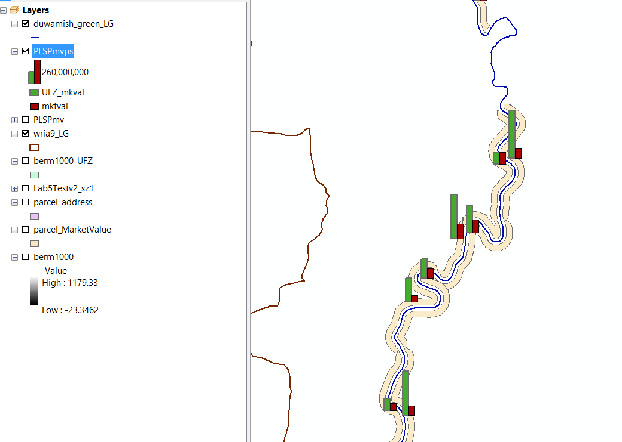
  - Right click your layer in the TOC, open Properties and navigate to the Symbology Tab
  - 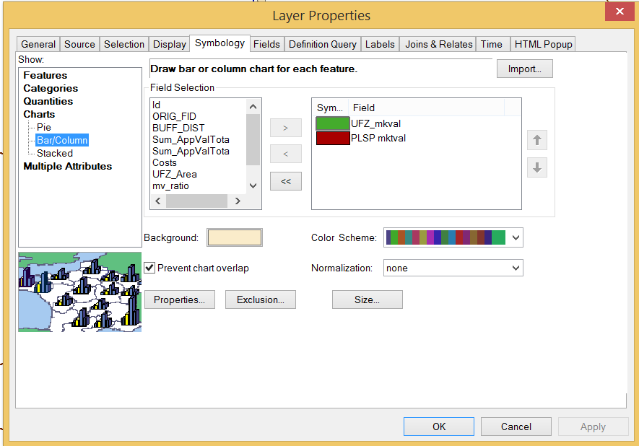
    - In the Show list tree on the left, select Charts and Bar/Column
    - On the right select the fields you want to include – you can change the symbol colors manually to suit your message – e.g. red for costs.
    - Click OK
    - You will likely want to adjust the Size button on the Chart Symbology dialog
- Step 5 – Transform your criteria to MCE criteria. In this case you are calculating MCE criteria for the PLSP/UFZ and ‘fidtxt’ is the id field to use. Use the chart symbology to display the MCE values for each PLSP
  - 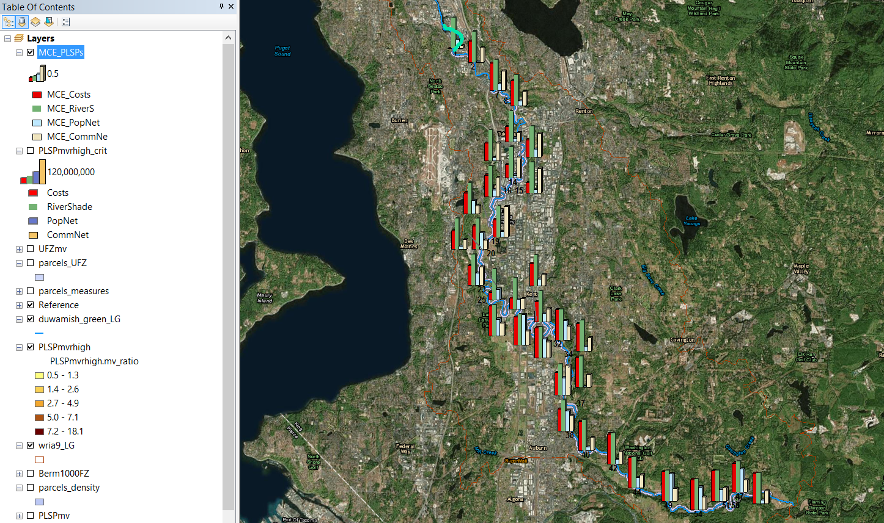
- Step 6 Use WST_2016.py to calculate WST for equal weights
- Step 7 Use WST_2016.py to calculate WST for weights representing 3 perspectives
Create a table of the top 10 PLSPs from each perspective. Color code to more easily see how PLSPs rank from each perspective.
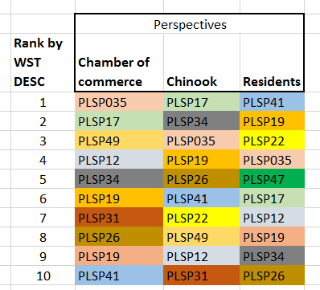
  - Discuss

