WINDLESTONE PARISH COUNCIL

7 Front Street, Bishop Middleham, County Durham. DL17 9AJ
Tel: 07808062525 Email: karenyoung311@yahoo.com

ORDINARY MEETING

Time: 6.00pm Date: Thursday, 8th September 2022 Venue: Chilton Town Hall

Dear Councillor, you are hereby summoned to attend the above meeting at which the following business will be transacted.
AGENDA

- Welcome by the Chair
The Chair to open the meeting and make any necessary announcements

- Apologies for Absence
To receive apologies for absence

- Declarations of Interest
To notify of items that appear on the agenda in which Members may have an interest

- Minutes
To Approve the Minutes of the AGM and Ordinary Meetings of Windlestone Parish Council held on 19th May 2022 as an accurate record (attached).

- Matters Arising from the Minutes
To clarify or provide an update regarding any matter recorded in the Minutes of the Meetings held on 19th May 2022

- Public Participation
To invite representation from Members of the Public.

- Finance
To approve and sign cheques for Expenditure incurred.

- Planning
To consider any matters in relation to Planning Applications submitted to the Local Authority in the Parish

- Correspondence
To consider and report any correspondence received.

- Eden Arms
To consider recent developments at the Eden Arms

- Definitive Map/Public Footpaths
To consider the Definitive Map for the Parish

- Right to Roam Query RE: Public Footpath through Woodland at Windlestone Park
To consider a query received from a member of the public

- Date & Time of Next Meeting
To agree the date and time of the next Meeting
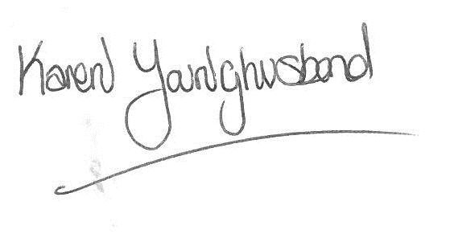
Karen Younghusband
Clerk Windlestone Parish Council

