Section TWO   
TCHT Performance Report for the year ended 31 December 2016

Non Financial Information:

Auditors Report 2

Entity Information 3

Statement of Service Performance Year Ended 31 December 2016 4

Statement of Service Performance Year Ended 31 December 2015 6

Financial Information:

Statement of Financial Performance 7

Statement of Financial Position 8

Statement of Cash Flow 9

Statement of Accounting Policies 10

Statement of the Performance Report 11

# Non-Financial Information

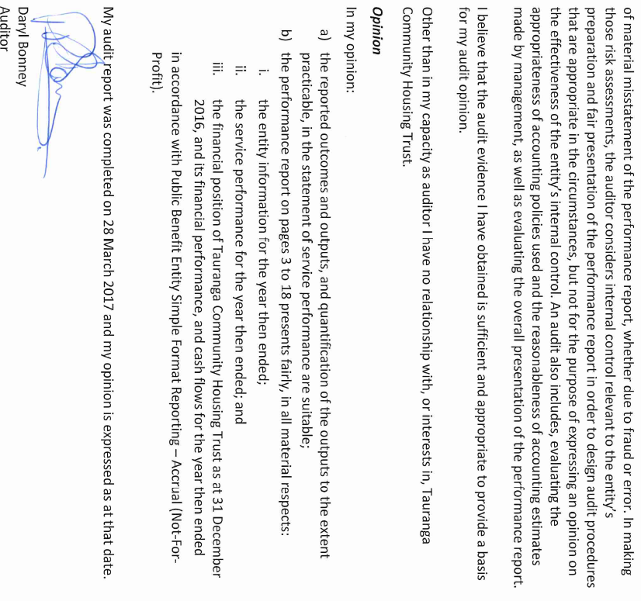

Entity Information

Legal Name of Entity: Tauranga Community Housing Trust, trading as Tawanui Community Housing

Other Name of Entity (if any): TCHT

Type of Entity and Legal Basis (if any): Charitable Trust

Registration Number: CC23971

**Entity's Purpose:**

To be the regional community housing provider of choice by: -

* working with diverse groups and all sectors to improve access to quality, sustainable housing
* providing a Housing Facilitation Service which develops housing solutions for individuals and families
* advocating for and implementing new housing models to meet current and emerging community needs

**Entity's Vision:**

Enhancing community wellbeing through the provision of quality, appropriate and affordable housing.

**Entity Structure:**

TCHT, a charitable trust that was established in 2003 in response to the lack of suitable, affordable housing opt ions in the Western Bay of Plenty. Since establishing, TCHT has broadened the client base and the geographical area in which the organisation operates. In 2015 TCHT became a registered community housing provider with the Community Housing

Regulatory Authority. Formal registration opens up new opportunities for funding and support via central government.

**Main Sources of the Entity's Cash and Resources:**

TCHT receives income from grants, including a multi-year operating grant from Lotteries (that ensures funding over 3 year periods) , from contracts with the Ministry of Health, Bay of Plenty District Health Board, and Ministry of Social Development for service provision, and from rental income. Our capital building projects have been funded by grants and loans from both the commercial and community sectors.

**Main Methods Used by the Entity to Raise Funds:**

Our main fund raising methods are grant applications and contracts for the provision of housing and related services. TCHT built and maintains positive relationships with fund holders in the philanthropic and commercial sectors, as well as the central and local agencies whom we work alongside.

**Entity's Reliance on Volunteers and Donated Goods or Services:**

We have a commit ted volunteer base. We also receive a significant amount of housing related goods from our supporter base and the general public.

**Contact Details: -**

Physical Address: 14a Willow Street, Tauranga

Postal Address: PO Box 13316, Tauranga 3141

Phone / Fax: (07) 571 5390

Email/Website: [www.tcht.org.nz](http://www.tcht.org.nz)

Statement of Service Performance – fOR YEAR ENDED 31 DECEMEBER *2016*

**Description of the Entity's Outcomes:**

People with a serious housing need, in addition to health, social, disability needs, are housed in affordable, suitable, healthy homes.

Despite the unprecedented pressure in the housing market, increased demand for housing services and competition for philanthropic resources, TCHT continued to make traction in terms of service delivery and portfolio growth.

TCHT'S belief is that appropriate, affordable housing is fundamental to the health and well-being of individuals, families and the community.

PORTFOLIO

Across the portfolio it was a year of consolidation and steady growth.

* TCHT completed the first year as owners of 79 units available to low income older persons in the Eastern Bay of Plenty. Ongoing refurbishments are underway and concept plans to redevelop one of the villages (to better meet the needs of the existing and future occupants) were completed.
* A highlight for the year was the completion of 14 fully accessible one bedroom units. This enabled 16 people, all of whom have a disability and/ or serious health issue, to access affordable, safe, warm, dry homes.
* Another significant under taking was to successfully negotiate a contract with the Bay of Plenty District Health Board to manage, and over time upgrade 31 of their one bedroom units.

SERVICES

* The provision of housing services to vulnerable people/ households increased. The Housing Co-ordination programme housed and supported people experiencing serious mental illness. The Healthy Homes initiative improved the housing conditions of families with children at risk of, or experiencing respiratory and/ or infectious diseases. Interventions include installing heating and ventilation, firewood provided, curtains, bedding and blankets provided, extra financial assistance from Work and Income, minor home repairs, educating families.
* The Housing Facilitation Service supported many of our clients to access and sustain a tenancy by providing practical hands on support such as providing referrals and liaising with health services, employers and support providers. Also practical upskilling, household and budgeting support to access long term housing. This provides health and wellbeing benefits to individuals and families, increasing people's ability to engage in education and training and reduces health costs.

**Actual**

**Description and Quantification of the Entity's Outputs: This Year**

***Number of clients assisted into new housing solution during the year*** 184

***Made up of:***

Tenants housed in TCHT owned or leased properties during the year 50

Tenants housed in properties owned by third party 134

Number of clients residing in TCHT's owned or leased housing during the year 233

Number of houses owned by TCHT at financial year end 112

Percentage of rent in arrears (more than 2 1 days) 0%

***Housing Co-ordination Service funded by Bay of Plenty DHB to provide***

***housing support for mental health service users:***

Number of clients supported during the year34

***Healthy Homes Initiative funded by Bay of Plenty DHB to reduce cold,   
damp and unhealthy homes:***

Actively worked with 126 families

Interventions completed (often more than one per home) 222

Geographical area that TCHT's services coverEastern and Western Bay of Plenty

**Additional Information:**

* Non-occupancy rates are less than 1.2% in housing owned and leased by TCHT. This is due to systematic upgrades being carried out, in particular at Cameron Road units and Whakatane housing.
* Proper ty inspections are carried out quarterly.
* Client Satisfaction Surveys are carried out annually.
* TCHT collaborates with a large number of other agencies and organisations to provide new housing solutions and ongoing support to our clients.
* Any benefit gained from TCHT's rental operations is used solely to provide further housing solutions to serve the Community.

**Feedback from Clients:**

"Transit ion into my new home was good and amazing…"

"Love my new unit!"

"TCHT was a pleasure to work with."

"TCHT went out of their way to make it a home to live in."

**TCHT had feedback from funders on the format of the 2015 Statement of Service Performance, and based on that feedback, the report for 2016 has been reformat ted.** **A copy of the 2015 report is attached.**

Statement of Service Performance – fOR YEAR ENDED 31 DECEMEBER *2015*

**Descript ion of the Entity's Outcomes:**

TCHT continued to make traction towards its mission of facilitating and providing housing and related services to people with a serious housing need, as evidenced by the growth in entity outputs, in particular houses owned and tenants housed.

**Actual Actual**

**Description and Quantification of the Entity's Outputs: This Year Last Year**

Tenants currently housed in properties owned or leased by TCHT 136 57

Percentage of tenancies sustained for more than one year   
(does not include Lodge medium term tenancies): 95% 100%

Lodge tenancies, medium term shelter - people housed and 27 Adults 25 Adults  
actively supported: 6 children 6 children

Houses owned by TCHT 98 19

Occupancy rates in houses owned 100% 100%

Percentage of rent in arrears 0.08% 0.10%

Number of tenants accessing IRRS subsidy for rent 17 14

We delivered warmer, safer, drier homes to many families in the Western Bay of Plenty who were at risk of rheumatic fever, through the Healthy Homes Programme.   
48 housing intervention plans were signed off by families as at the end of the year.

Property inspections and necessary maintenance and repairs carried out in target timeframes.

**Additional Information:**

* TCHT achieved registration with the Community Housing Regulatory Authority (CHRA) and became a preferred provider with the Ministry of Social Development (MSD). This enables TCHT to access the IRRS (Income Related Rent Subsidy) for our clients.
* A comprehensive tenancy management IT programme was purchased and implemented during the 2015 year.
* TCHT was also approved for capacity building mentorship programme through the Tindall Foundation. This was accessed through the 2015 year and further support for 2016 was approved in December 2015.

# Financial Information

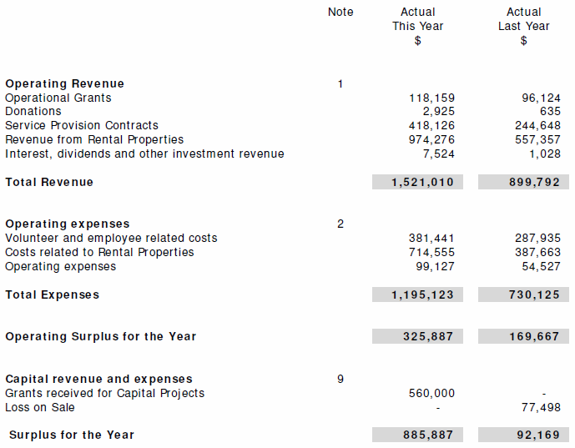Statement of Financial Performance

Statement of Financial Position

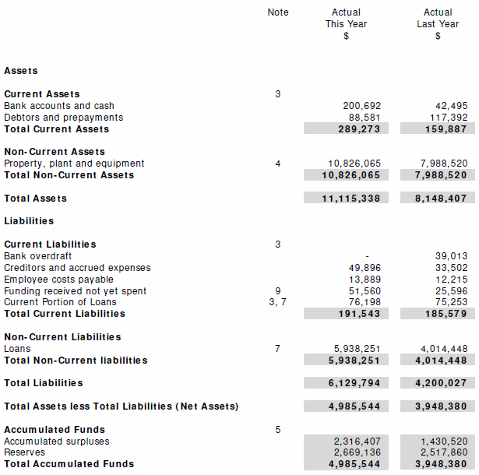

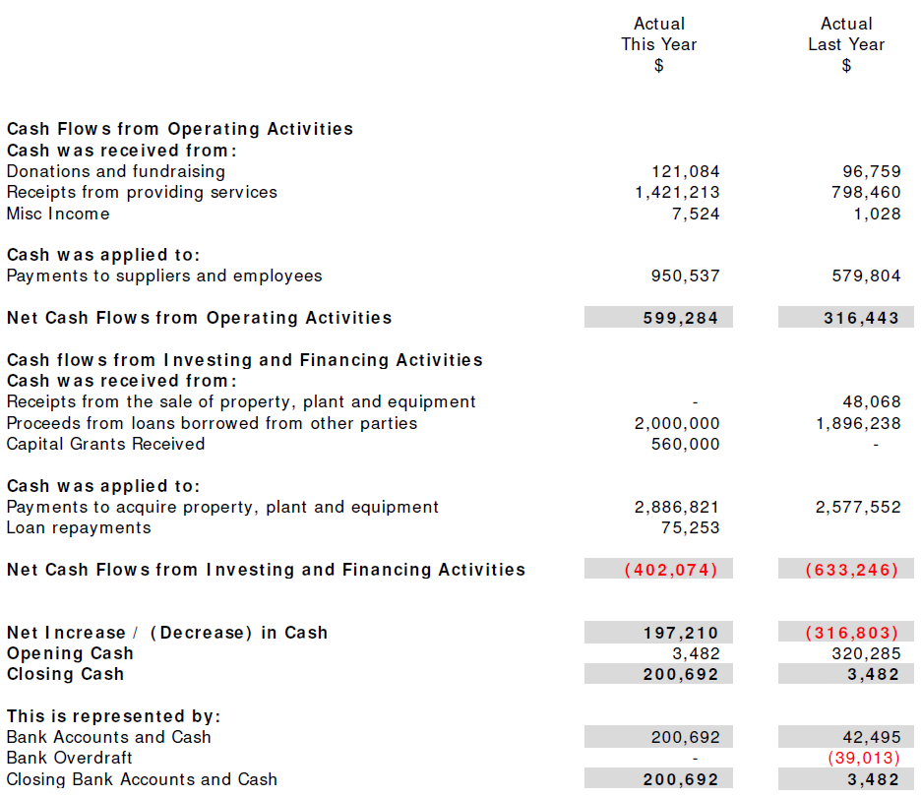Statement of cash flow

Statement of accounting policies

**Basis of Preparation**

Tauranga Community Housing Trust has elected to apply Tier 3 PBE SFR-A (NFP) Public Benefit Entity Simple Format Reporting - Accrual (Not -For -Profit) on the basis that it does not have public accountability and has total annual expenses of equal to or less than $2,000,000. Inclusion of PBE IPSAS 17 from the Tier 2 standard has been adopted for revaluation of properties. All transactions in the Performance Report are reported using the accrual basis of accounting. The Performance Report is prepared under the assumption that the entity will continue to operate in the foreseeable future.

**Goods and Services Tax (GST)**

All amounts are recorded exclusive of GST, except for Debtors and Creditors which are stated inclusive of GST.

**Income Tax**

Tauranga Community Housing Trust is wholly exempt from New Zealand income tax having fully complied with all statutory conditions for these exemptions.

**Bank Accounts and Cash**

Bank accounts and cash in the Statement of Cash Flows comprise cash balances and bank balances (including short term deposits) with original maturities of 90 days or less.

**Fixed Assets Valuation and Depreciation**

Fixed assets (with the exception of revalued properties) are recorded at cost less accumulated depreciation. Depreciation for non-building assets has been provided for at the rates of depreciation allowable for taxation purposes. Building assets have been depreciated at the rate of 3%, according to our asset management plan - further details in Note 9.

**Changes in Accounting Policies**

There have been no changes in accounting policies from the previous year.

notes to the performance report



# 

# 

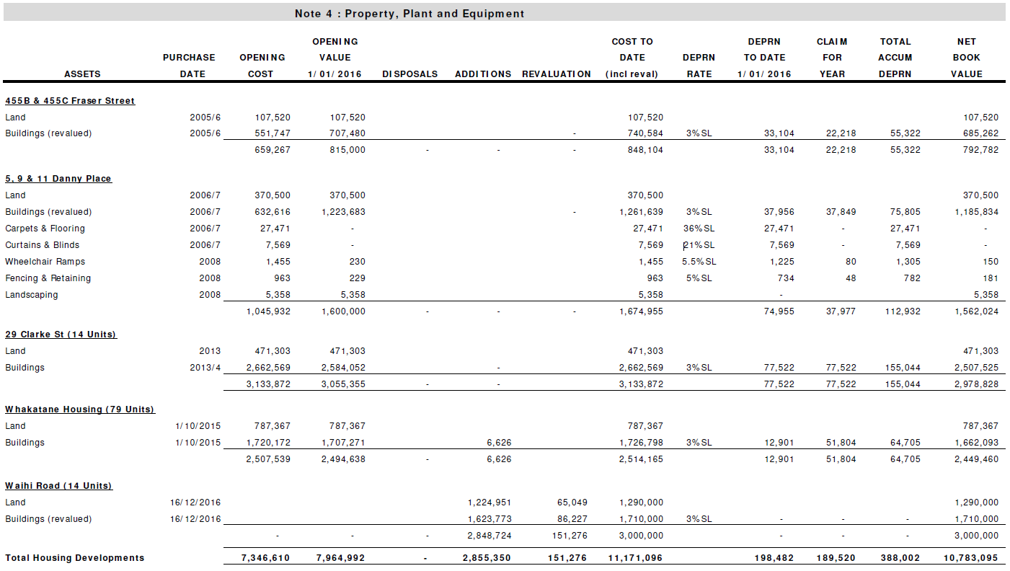

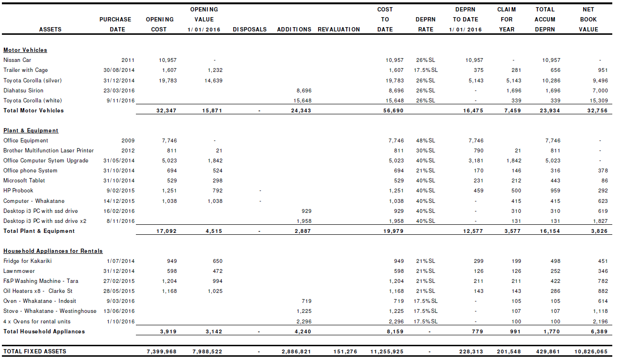

Details of properties pledged as security for liabilities is included in Note 7.

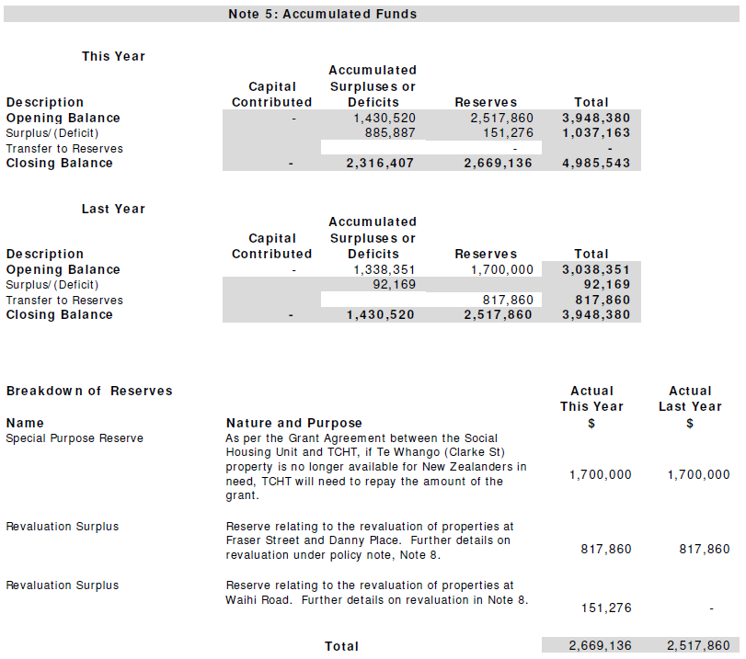



**At Bal. Date At Bal. Date**

**Commitment Explanation and Timing This Year Last Year**

Commitments to lease or TCHT lease two lodges in Fourth Ave

Rent assets for transitional medium term housing.

Both lodges leases expire with right of

Renewals. $9,870 $28,740

Commitments to lease or TCHT leases office space in Willow Str.

Rent assets Lease is for two years, expiring April

2018 with right of renewal. $44,438 -

Commitments to lease or Operating rental agreement with

Rent assets Sharp Corporation for printer – duration

Of operating lease is 3 years $2,367 $3,234

Commitments to purchase TCHT Entered into a conditional

Property agreement units at Waihi Road in 2015.

$20,000 was paid in 2015. The balance

Was paid on completion of build

December 2016. - $20,000

**Contingent Liabilities and Guarantees**

There are no contingent liabilities or guarantees as alt balance date (Last Year – nil)

**Note 7: Assets Used as Security for Liabilities**

**Nature and Amount of Borrowing Nature and Amount of Asset Used as Security**

Kiwibank Overdraft, interest rate is floating. Clarke St Properties value on balance sheet Kiwibank have security over the property at 29 Clarke St = $2,978,828

Account is in credit as at 31/ 12/ 16.

Bay Trust loan drawn down in 2014. Loan is due to expire

in 2019. Repayments are interest only. Bay Trust hold

security over the property at 29 Clarke St , ranking in

priority behind Kiwibank.

Outstanding balance = $760,000

Housing NZ loan drawn down in 2007. Repayments are Danny Place properties value on balance sheet

interest free until 2017. Security held over 5,9,11 = $1,600,000

Danny Place.

Outstanding balance = $548,351

Housing NZ loan drawn down in 2007. Repayments are Fraser St properties value on balance sheet

interest free until 2017. Security held over 455B & 455C = $815,000

Fraser St.

Outstanding balance = $285,388

Kiwibank Loan drawn down in 2015, interest rate is floating. Whakatane properties value on balance sheet

Kiwibank have security over the Whakatane properties = $2,494,638

Outstanding balance = $1,500,000

Bay Trust loan drawn down in 2015. Interest rate is OCR

plus margin of up to 1%. Bay Trust hold security over the

properties in Whakatane, ranking in priority behind Kiwibank

Outstanding balance = $971,191

Kiwibank Loan drawn down in 2016, interest rate is floating. Waihi Road properties value on balance sheet

Kiwibank have security over the Waihi Road properties. = $2,848,724

Outstanding balance = $2,000,000

**Note 8: Revaluation of Properties**

The properties at Waihi Road have been revalued to market value. The valuation was carried out on 2 November 2016 by an independent valuer. The valuation methods used were the Direct Market Comparison, the Value in One Line, which considers the likely gross realisation provided by the sale of individual units, and the Investment Approach, which considers rental income received and capitalising it at an appropriate rate of return.

TCHT intends to revalue properties, to reflect current market value, every three years on a cyclical basis, as per PBE IPSAS 17 adopted from Tier 2 reporting requirements.

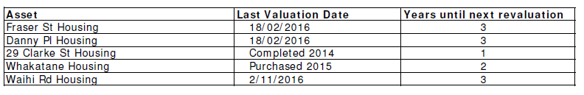

**Note 9: Additional Information**

**Grants Received for Capital Projects**

In 2016 TCHT received grants from Bay Trust and TECT for the development at Waihi Road. Refer to Note 1 for breakdown.

**Funding Received, Not Yet Spent**

Grants and Ministry of Health funding received are tagged for a specific purpose, and often span more than one financial year. Grants are acquit ted within a timeframe set by the provider, and can range from three to twelve months.

**Asset Management Plan**

TCHT has implemented a detailed asset management plan to maintain the value and safety of our property portfolio. This is a long term plan for all capital expenditure and the timing that will be needed for any capital renewal/replacement during the life of the asset. This capital renewal/replacement is being provided for by depreciating our buildings at a straight line rate of 3%.

**Note 10: Related Party Transact ions**

There were no transactions involving related parties during the financial year. (Last Year - Nil)

**Note 11: Events After the Balance Date**

There were no events that have occur red after the balance date that would have a material impact on the Performance Report . (Last Year Nil)