SPECIAL MEETING
JANUARY 3, 2022

A Special Meeting of the Town Board of the Town of Hampton, County of Washington and the State of New York was held at the Town Hall, 2629 State Route 22A, Hampton, New York also via Zoom and live streaming on the You Tube Channel for “Town of Hampton New York” on the 3rd day of January 2022.

PRESENT: David K. O’Brien------------Supervisor
Donald Sady------------------Councilman
Tamme Taran----------------Councilwoman
Michael Pietryka------------ Councilman
Travis Dean------------------Councilman
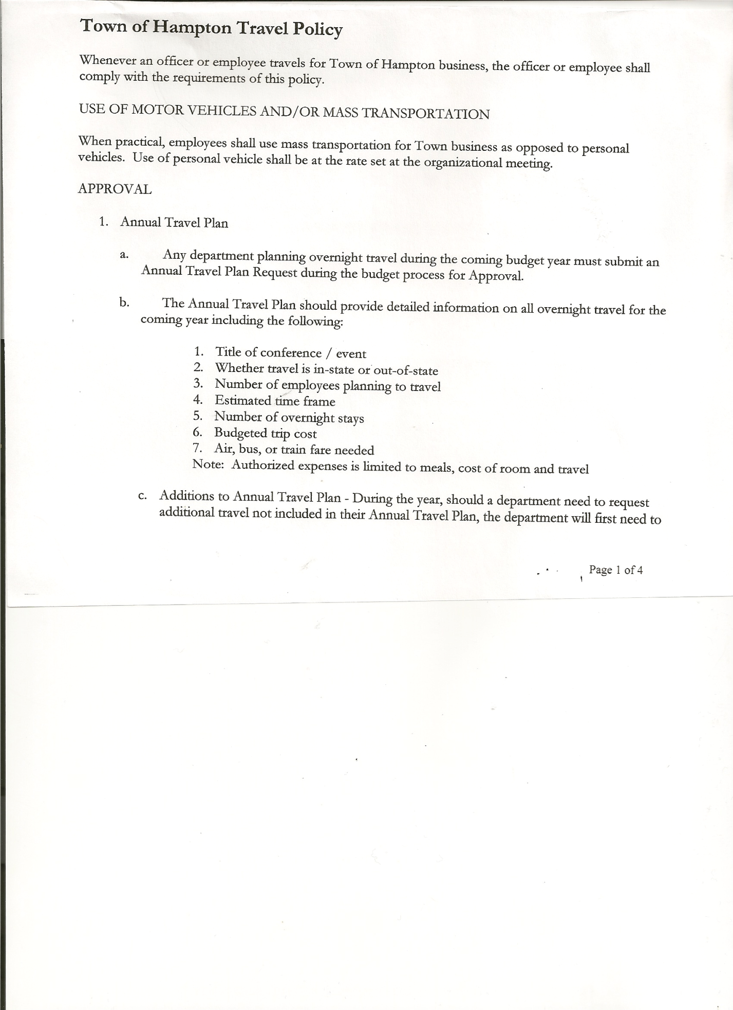
Rebecca Jones---------------Town Clerk
Camilla Shaw----------------Tax Collector/Deputy Town Clerk
Tyler McClure---------------Highway Superintendent

Planning Board Members: Bonnie Hawley, Chair – via Zoom and
Matthew Pratt at the Town Hall

Also present at the Town Hall: Richard Cole and Elijah Dean
Present via zoom: Deb Weiss

The Special Meeting was called to order by Supervisor O’Brien at 7:30pm, followed by the Pledge of Allegiance. Location of Fire Exits were given. Quorum of board members present.

OATH OF OFFICE
The Oath of Office was administered to the Elected Officials present:
- David O’Brien – Town Supervisor
- Donald Sady - Town Councilman
- Travis Dean – Town Councilman
- Camilla Shaw - Tax Collector
The Oath of Office was also administered to the Appointed Officials present:
- David O’Brien-Local Compliance Officer; Point of Contact for NIMS and Association
of Towns Voting Delegate
- Donald Sady-Deputy Town Supervisor
- Tyler McClure – Highway Superintendent
- Tamme Taran-Health Officer
- Camilla Shaw – Deputy Town Clerk
- Travis Dean – Member of the Ethics Board
- Matthew Pratt-Member of Planning Board & Ethics Board
Judge Sady administered the Oath of Office to Rebecca Jones as Town Clerk (Elected) and Registrar of Vital Statistics; Deputy Tax Collector and Association of Towns Alternate Voting Delegate (Appointed) prior to the meeting.
Town Clerk Jones will administer Oath of Office to other Appointed Officials by January 31st, 2022.

TOWN BOARD MEETING
JANUARY 3, 2022 PAGE 2

RESOLUTION NO. 1-2022
HAMPTON ORGANIZATIONAL CHARTER FOR 2022
On a motion of Councilman Sady, seconded by Councilwoman Taran, the following resolution was ADOPTED: Ayes 5 O’Brien, Sady, Taran, Pietryka, Dean
Nays 0
RESOLVED, that upon review the Hampton’s Organizational Charter for 2022 is adopted as proposed.

Planning Board has an opening plus an alternate. If anyone is interested, they can contact Bonnie Hawley, Chair of the Planning Board.

RESOLUTION NO. 2-2022
HAMPTON TOWN POLICIES
On a motion of Councilman Sady, seconded by Councilwoman Taran, the following resolution was ADOPTED: Ayes 5 O’Brien, Sady, Taran, Pietryka, Dean
Nays 0
RESOLVED, that upon review the following Policies:
- Travel Policy
- Investment Policy
- Cell Phone Policy
- Sexual Harassment Policy
- Workplace Violence Policy
- Credit Card Policy
- On-line Banking Policy
- Ethics Policy
- Computer Usage Policy
- Record Storage Policy
- Employee Handbook
- Drug/Alcohol Testing Policy
- Town Hall Use
- Road Side Tree Policy
- Cyber Security Policy
Of the Town of Hampton are approved.

RESOLUTION NO. 3-2022
PROCUREMENT POLICY 2022
On a motion of Councilman Sady, seconded by Councilwoman Taran, the following resolution was ADOPTED: Ayes 5 O’Brien, Sady, Taran, Pietryka, Dean
Nays 0
RESOLVED, to accept the Procurement Policy for 2022 (copy is attached)

TOWN BOARD MEETING
JANUARY 3, 2022 PAGE 3

RESOLUTION NO. 4-2022
STANDARD WORKDAY and REPORTING RESOLUTION
On a motion of Councilman Sady, seconded by Councilwoman Taran, the following resolution was ADOPTED: Ayes 5 O’Brien, Sady, Taran, Pietryka, Dean
Nays 0
RESOLVED, that the Standard Workday and Reporting Resolution for Elected and Appointed Officials (RS 2417-A) be approved. (copy is attached)

RESOLUTION NO. 5 -2022
AUTHORIZE TO PRE-PAY ITEMS
MOTION BY: COUNCILWOMAN TAMME TARAN
SECONDED BY: COUNCILMAN DONALD SADY

TITLE: RESOLUTION AUTHORIZING THE TOWN SUPERVISOR TO PAY BILLS
IN ORDER TO AVOID PENALTIES AND INTEREST

WHEREAS, the Town has determined that due to certain bills being due prior to the Town Board Audit of bills,

AND WHEREAS, the Town Board is desirous of avoiding late fees, penalties and interest and maintain its good credit standing,

NOW THEREFORE, BE IT RESOLVED:
That the Town Board of Hampton hereby authorizes the Supervisor to approve the payment of bills before audit if in the reasonable discretion of the Supervisor, it is necessary to do so to avoid any costs, penalties, interest or termination of service. The supervisor may pay
claims for public utilities, postage, freight and express charges, gas and diesel before they are audited. The term “public utilities” includes electric, gas, water, sewer and telephone services and the purchase of fuel oil. All claims must be presented for audit at the next regular board meeting audit. The claimant and the town officer incurring or approving these claims are jointly and severally liable for any amount disallowed upon audit.

BE IT FURTHER RESOLVED:
That the Town Board is not required by law to pre- audit payments of fixed salaries, compensation of officers or employees, principal and interest indebtedness, or amounts coming due on certain contracts

BE IT FURTHER RESOLVED that in the absence of the Supervisor, the Deputy Supervisor is authorized to review the bills and make the determination to authorize payment for the same reason.

BE IT FURTHER RESOLVED that the Town Clerk is hereby authorized and directed to add the following policy to the policy manual/employee handbook for the Town of Hampton.
DATED: January 3, 2022 Supervisor O’Brien AYE
Councilman Sady AYE
Councilwoman Taran AYE
Councilman Pietryka AYE
Councilman Dean AYE
TOWN BOARD MEETING
JANUARY 3, 2022 PAGE 4

RESOLUTION 6-2022
MEETING ADJOURNED
On a motion of Councilwoman Taran, seconded by Councilman Sady, the following resolution was ADOPTED: Ayes 5 O’Brien, Sady, Taran, Pietryka, Dean
Nays 0
RESOLVED, that the meeting adjourned at 7:58pm.

Respectfully submitted,

Rebecca S. Jones, RMC
Town Clerk

