St. Clair Shores
Published May 7, 2014

Arsenal of Democracy Museum to open May 10

By Brian Louwers brianlouwers@candgnews.com
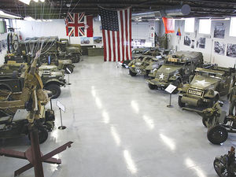
The Arsenal of Democracy Museum in St. Clair Shores features a collection of historic vehicles and exhibits that showcase the role of local industry in wartime production. (Photo by Brian C. Louwers)

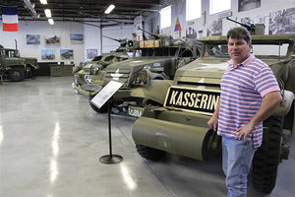
John Lind, director of the Arsenal of Democracy Museum, said much of the collection is designed to be experienced hands-on. “I’d like to make the museum fun, not just a ‘no-touch’ museum,” Lind said. “Most of the vehicles, (people will) be able to go in and touch them.” (Photo by Brian C. Louwers)
ST. CLAIR SHORES — With a couple of scattered restoration shops to house its growing collections, the Arsenal of Democracy Museum lived for years mostly through traveling exhibits that celebrated America’s military-industrial might.
The museum now has a permanent home in St. Clair Shores. It’s a place where visitors can experience hands-on history through up-close inspection of the vehicles and equipment that helped the Allies win World War II and preserve freedom in the decades that followed.
The nonprofit Arsenal of Democracy Museum, located at 22960 Industrial Drive West, will open its doors to the public for the first time at 9:30 a.m. May 10. Admission for visitors is a $5 donation.
“We want to honor, preserve and educate the general public about what the contribution of the American automotive industry was to our war effort,” said John Lind, of Shelby Township, a Marine Corps veteran, business owner and the museum’s director. “I think they’re going to find a very nice assortment of vehicles from World War II through the present day.”
The 8,500-square-foot space near Nine Mile and I-94 that formerly housed a motorcycle repair shop and, before that, Ted Stahl’s collection of historic automobiles, will feature equipment displays and vehicles from World War II to modern times.
The collection — much of it owned by the museum’s operators, with some items on loan from private parties — includes: President Dwight D. Eisenhower’s 1942 Cadillac limousine, one of 12 cars used by the U.S. Army general when he served as the supreme commander of Allied forces during World War II; a rare, military-model 1941 Harley Davidson WLC motorcycle, used in England and France during the war and eventually reclaimed from a military museum that was closing in Stuttgart, Germany; a 1944 M3A1 scout car; a 1941 White M1 half track; and a 1996 Oshkosh Defense Heavy Equipment Transporter, remanufactured in 2009.
“It’s dedicated to the efforts of the workers in the auto industry in the Detroit area,” said Ed Kaminski, of Clinton Township, a retired Air National Guard chief master sergeant who served as the head of security and law enforcement at Selfridge Air National Guard Base. “It’s a commemoration of those efforts between industry and the workers, and the products they produced, to ensure victory in the war and to maintain the peace afterward.”
Lind said much of the museum is designed to be experienced hands-on.
“On several weekends, we’ll be taking people out for rides in the vehicles. We’ll have that option available to us,” Lind said. “I’d like to make the museum fun, not just a ‘no-touch’ museum. Most of the vehicles, they’ll be able to go in and touch them. They’ll be able to get right up to it and see it. We’ll have some highlighted vehicles they’ll be able to sit in.”
The museum will also host special programs throughout the year, beginning this spring with an event June 6 on the 70th anniversary of the D-Day invasion of Normandy. Other programs will coincide with the upcoming anniversaries of Operation Market Garden during World War II and the 1964 escalation of U.S. military involvement in Vietnam. Lind said he’d also like to add a 1940s-themed USO program in December.
On May 25, several historic vehicles from the Arsenal of Democracy Museum will transport local veterans of the D-Day invasion in the 62nd St. Clair Shores Memorial Day Parade.
After the official opening May 10, the museum’s regular hours will be 1-7 p.m. Fridays and 10 a.m.-5 p.m. Saturdays.
For more about the museum and its upcoming programs, visit www.detroitarsenalofdemocracy.org or find them on Facebook under the name Arsenal of Democracy TM.

