How do I… change my beneficiary?

You can access your beneficiary information by selecting the “Benefits” option on the menu panel.
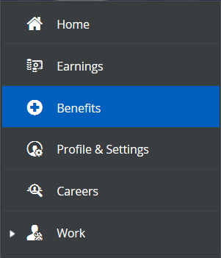
You will then select “Forms” from the options at the top of the screen.

Next, you will select “Current Beneficiary Information” from the list of available forms.
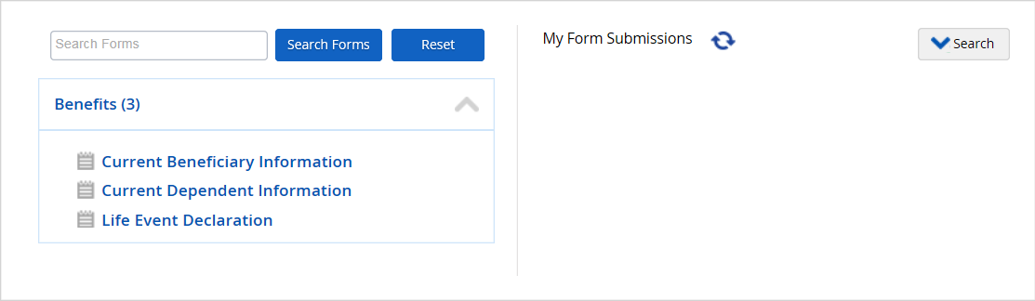

To add a beneficiary, click “Add”.
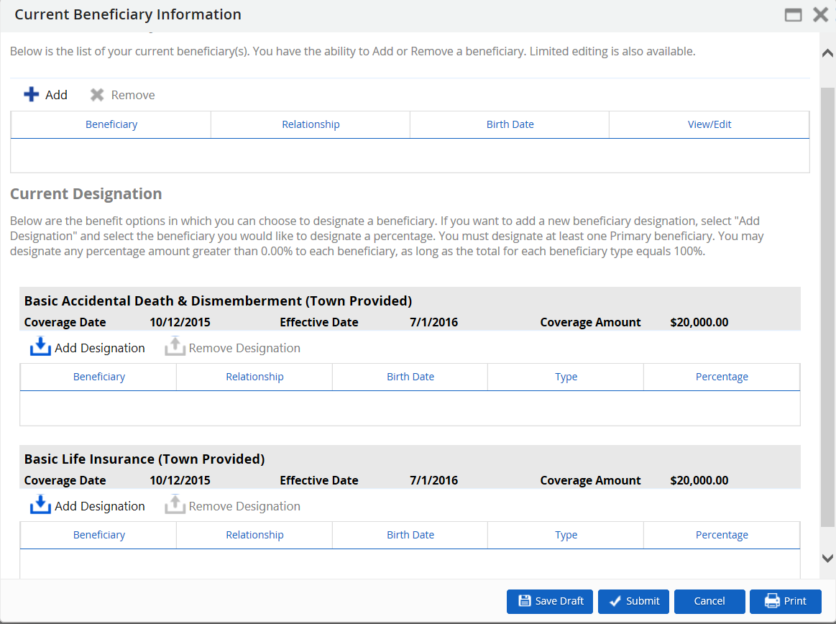
You will then be prompted to add the information below.
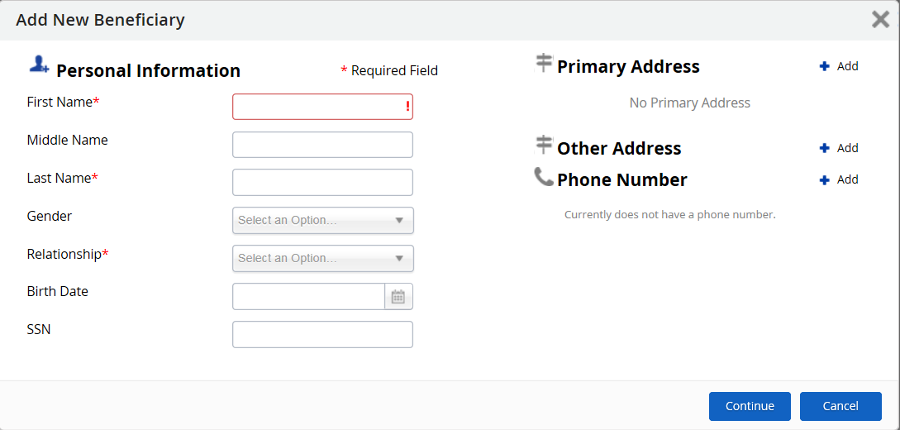
Once you have a beneficiary listed, click “Add Designation” to assign them to specific benefits.
After you have designated your beneficiaries, click “Submit”.

