This is an historical day in the world’s currency markets. Something happened in relative obscurity today that will impact the world’s economy and interest rates over the next several years and probably well beyond.
Take a good look at the currency below. Many of you may know that it is China’s currency, the Yuan (pronounced “u-aan”), or the Renminbi or “the people’s money,” as it’s mostly known within China’s boarders.
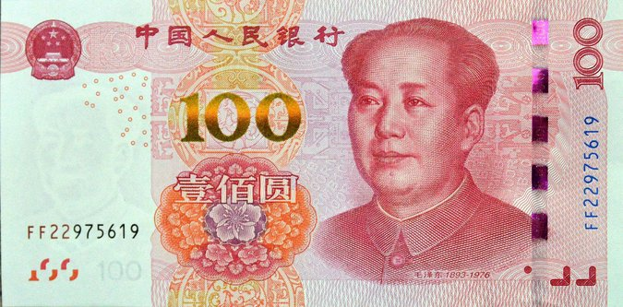

This morning the International Monetary Fund (IMF) announced that they have approved the formal entry of the Chinese currency into the world’s currency markets. While the actual mechanism of this decision is less important than the impact, here’s how the IMF structures their “currency” known as Special Drawing Rights (or SDR):
The SDR currently consists of four global currencies (with the Dollar at 42%). The table below shows the current and the likely proposed allocation for the “new” SDR:
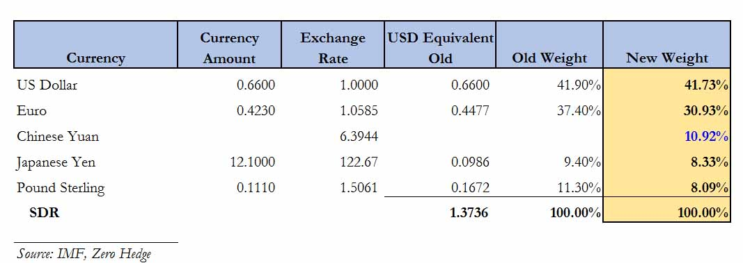
At a very high level, the SDR is significant because about $350 billion worth of it is borrowed globally from the IMF and it is directly convertible into the constituent currencies (currently the Dollar, Euro, Yen and Pound) by Central Banks for the purpose of stabilizing their own currency or enhancing their trade imbalances. You may know that the IMF was created in 1945 for the purpose of promoting international monetary stability and to promote policies impacting the system of exchange rates and international payments that enables countries (and their citizens) to transact with each other.
It is very likely that to get U.S. approval of this decision, the Dollar’s percentage allocation remained basically unchanged. However, the mere inclusion of the Yuan in this exclusive currency club gives China tremendous influence in global currency and exchange rate decisions. China’s leadership has made it a priority to join this group of currencies, naming it in October as one of their highest economic policy priorities in the coming years.
Some other consequences of this decision (which technically won’t be implemented until October 1, 2016):
- Virtually all Central Banks build their cash reserves based upon the SDR composition above. After next October, they will have to purchase billions worth of the Yuan to maintain this balance. This will impact the Yuan exchange rate dramatically with increased demand.
- The IMF decision will help pave the way for broader use of the Renminbi in trade and finance, enhancing and then securing China’s standing as a global economic power.
- China will also gain more influence in international bailouts denominated in the fund’s accounting unit, the SDR, such as Greece’s, Ireland’s and Portugal’s debt deal.
- Billions of Yuan worth of additional securities will begin to trade all over the world as China seeks to increase its economic influence globally and reduce the world’s reliance on the Dollar as a currency of choice (currently about 63% of all the world’s reserve holdings; that will likely decline dramatically over time). There are small pockets of this activity now, largely centered in London and Hong Kong, but that will drastically increase globally thereby crowding out the dollar denominated securities that currently dominate these markets, for example.
- One positive impact might be that this decision could encourage greater transparency and stability of the Chinese monetary authorities, but only time will tell.
Your personal portfolio, once this decision is implemented next October, will probably not experience any immediate impact. However, with more global commodities such as oil, coal and precious metals being traded and priced in the Yuan; additional securities issued in Yuan; and Central Banks buying up billions of Yuan, the preeminence of the Dollar will decline. This will lead to higher commodities priced in Dollars as well as a significantly higher cost to the U.S. taxpayer of funding the Treasury’s debt through higher interest rates. A 1% increase in the interest rate paid for newly issued debt increases the annual cost of paying the interest on the debt by about $100 billion. The current average interest rate on all U.S. government debt is a mere 2.4%. As the purchasing power of the dollar declines, the U.S. Federal Reserve Bank may finally get the 2% plus inflation that they have been targeting since the Great Recession ended.

