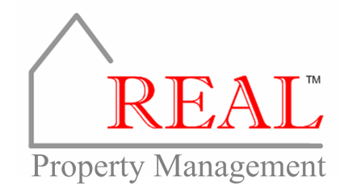
October 18, 2013
Dear Tenants,
With cold weather fast approaching REAL™ Property Management compiled a “Winter Weather Preparation Checklist” to help you facilitate a smooth transition from summer to winter in your home. This checklist is provided below. As always, if you need assistance or have any questions or concerns, please contact me at Shannon@realpm.biz or 256.783.3299.
Heating System Checklist
- Test Run
Turn the thermostat to heat mode and set it to 80°F just for testing. You should hear the furnace turn on, and warm air should blow within a few minutes. If the heater is running OK, turn the thermostat back to its normal setting. If it is not running properly, please contact us.

- Air Filter
Replace the air filter. This should be done monthly. Changing the air filter on a regular basis will help the unit run more efficiently – saving you money.

- Fuel
If you have propane, make sure to have your propane tank filled and ready to go.

- Heating Vents
Check air vents in each room to make sure air flows freely while the heater is running, ensuring the proper distribution of heat throughout your home.

- Check for Carbon Monoxide Leaks
Carbon monoxide can easily be detected with an inexpensive test badge or a battery operated alarm. Either one is an effective way to test carbon monoxide levels.

- Smoke Detectors
Test the batteries in your smoke alarms to ensure they are in working order. Batteries should be changed regularly or when the smoke detector begins to chirp.

- Ceiling Fans
Make sure all ceiling fans are switched to the reverse or clockwise position. This will blow warm air down to the floor, provide added comfort, and help your unit run more efficiently.

Exterior Checklist

- Outside Faucets
Exterior faucets need to be covered with an insulated cover. These covers are inexpensive and can be purchased at your local hardware store. Also, remember to disconnect your garden hoses from outside faucets to prevent pipes from freezing during cold weather.

- Decks
Clean leaves, dirt, and pine needles from between the boards of wooden decks to thwart mold and mildew growth.

- Gutters and Downspouts
Make sure gutters and downspouts are clean and leaves are removed. Wet leaves remaining in the gutters over winter add significant weight to the gutter when frozen and increase the risk of damage.

- Outdoor Lighting
Inspect outdoor lighting around the property to make sure that it is working properly. Good illumination will help minimize the chance of accidents on icy walkways at night.

- Vents and Openings
Ensure all outside vents and openings are properly closed and/or covered to prevent insects, birds, and rodents from getting inside your home to nest in warm places.

REAL Property Management Shannon@realpm.biz
1593 Hughes Rd 256.783.3299

Suite A

Madison, AL 35758

