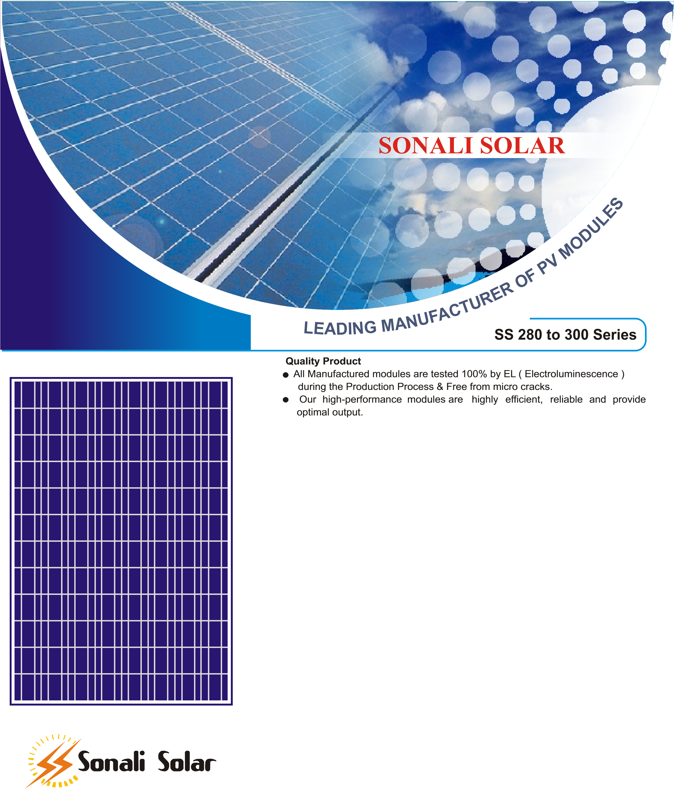
We have a team of qualified experts and engineers making sure that modules produce maximum power. We pride ourselves in caring for each individual
