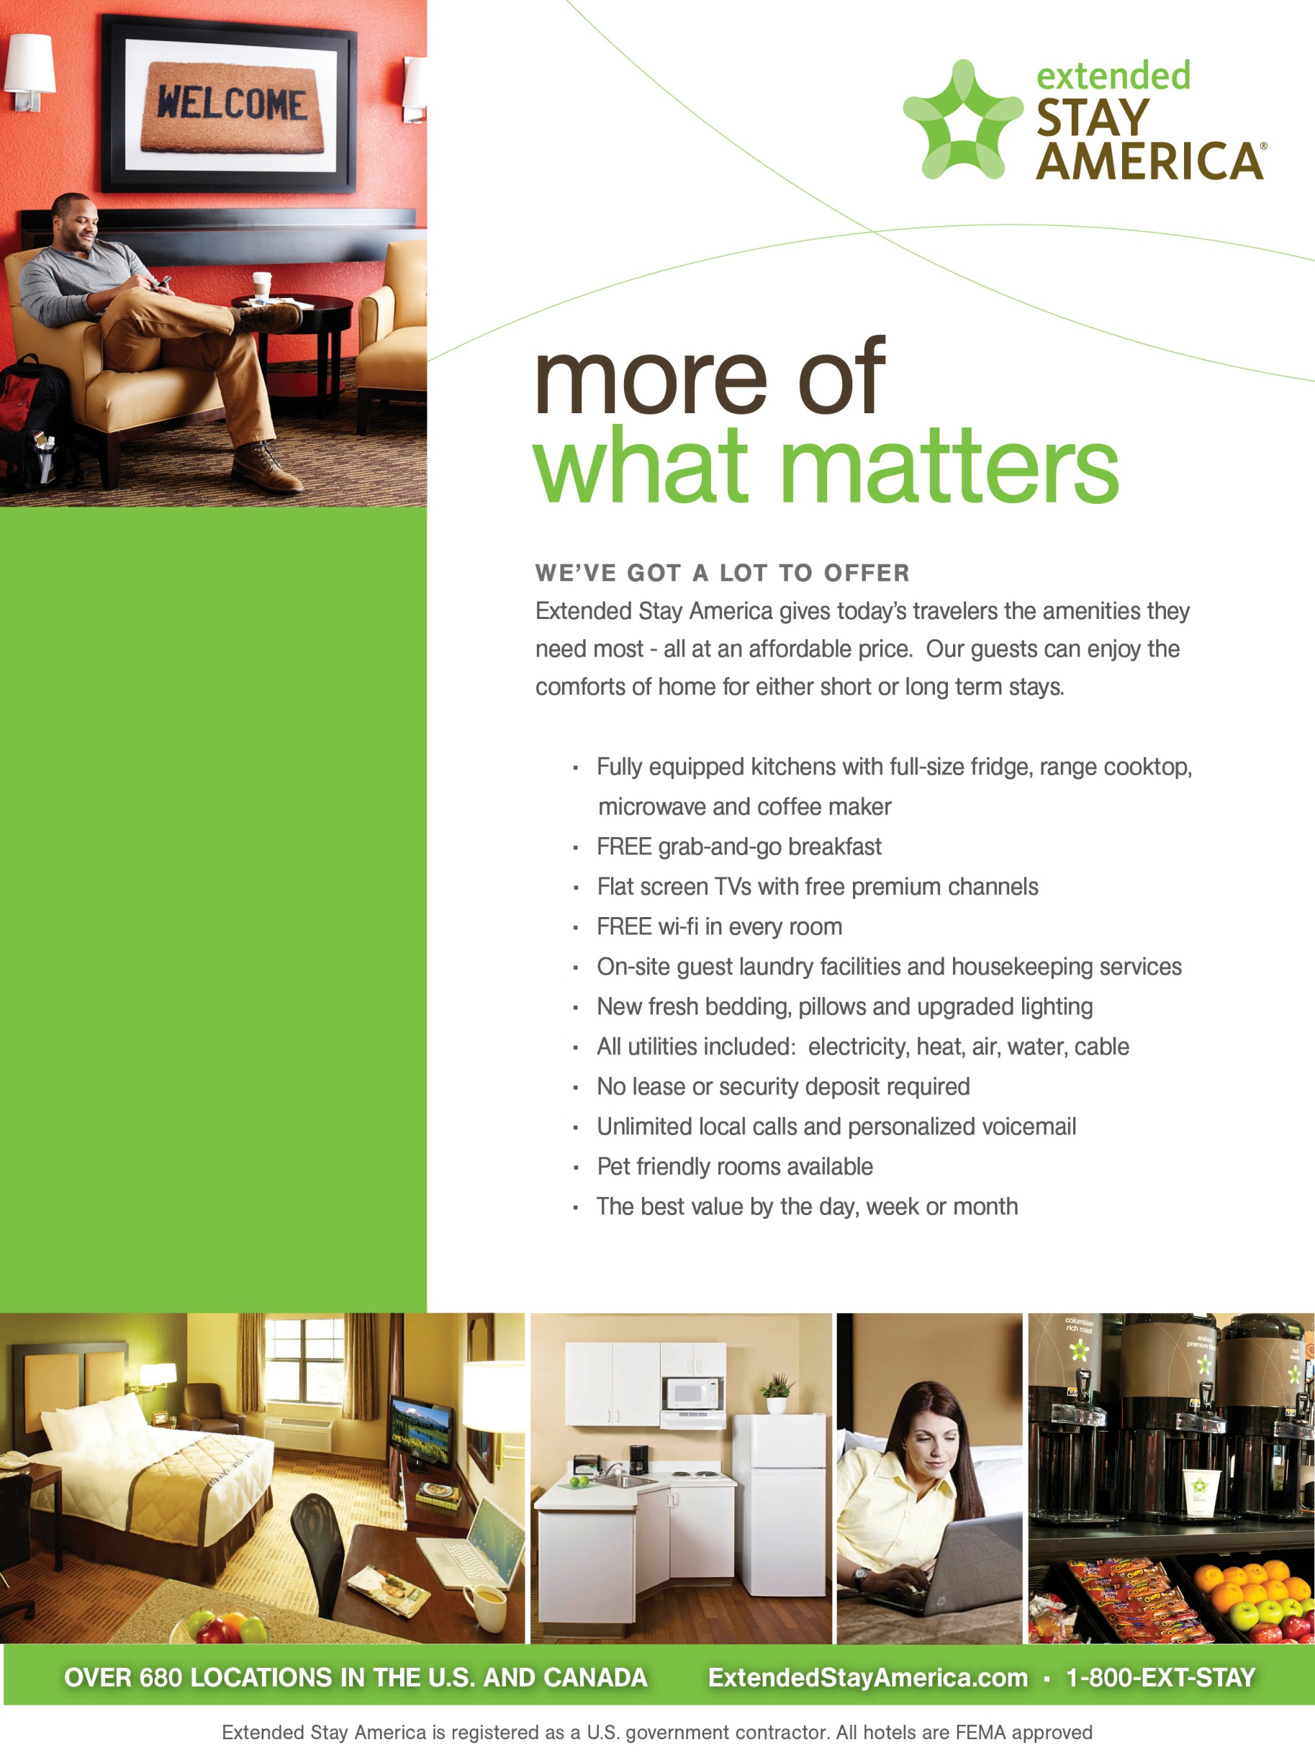

**WELCOME WSOP.**

**Mention WSOP and get 10% off at our 3 Las Vegas Locations**

Walking Distance to WSOP. Special rates offered at ***Valley View.***

$64 for 1-29 nights

$46.00 for 30+ nights one bed

$56.00 for 30+ nights two beds

***Extended Stay America Valley View***

**4270 S Valley View Blvd**

**Las Vegas, NV 89103**

**702.221.7600**

**Extended Stay America East Flamingo**

**1550 East Flamingo Road**

**Las Vegas, NV 89119 702-731-3111**

$64 for 1-29 nights

$47.00 for 30+ nights one bed

$57.00 for 30+ nights two beds

*All Suites Recently Renovated and Non-Smoking.*

**Extended Stay America- Midtown**

**3045 S Maryland Pkwy**

**Las Vegas, NV 89109 702.369.1414**

$60 for 1-29 nights

$45.00 for 30+ nights one bed

$55.00 for 30+ nights two beds

*All Suites Recently Renovated and Non-Smoking.*

On line at [www.extendedstay.com](http://www.extendedstay.com)

Company code WSOP

* Fully equipped kitchens with full-size fridge, range cooktop, microwave and coffee maker.
* FREE grab-and-go breakfast.
* Flat screen TVs with premium channels.
* On-site guest laundry facilies and housekeeping services.
* New fresh bedding, pillows and upgraded lighting.
* Unlimited local calls and personalized voicemail.
* Pet friendly rooms available at all three Las Vegas locations.
* The best value by the day, week or month.
* Pool: Valley View and Flamingo locations.
* Meeting rooms: Three at Flamingo location.
* On site Fitness Facilities: Valley View and Flamingo locations.